
LISTENING

A. Listen to the interview with David Beckham
and choose the correct option.

1. This interview is on the        Radio  TV set  Newspapers  a) b) c) | 2. In London, we can visit    London Eye  Big Ben  Eiffel Tower  a) b) c)
      3. David is… years old.  a) b) c) | 4. His favourite football team is  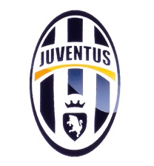  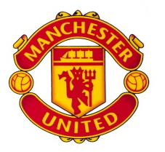  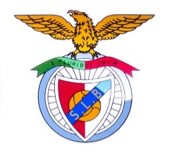  a) b) c)
- Listen to the interview again and complete the sentences with the words from the box. Pay attention: there are four extra words.
sisters | brothers | 2nd May | 12th May | London | Los Angeles | singer | model

- David Beckham is from ______________________.
- David’s birthday is on ______________________.
- David has got two jobs. He is a football player and a ______________________.
- He has got two ______________________.

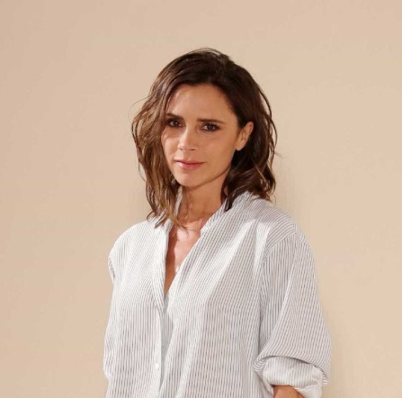
Read the text.
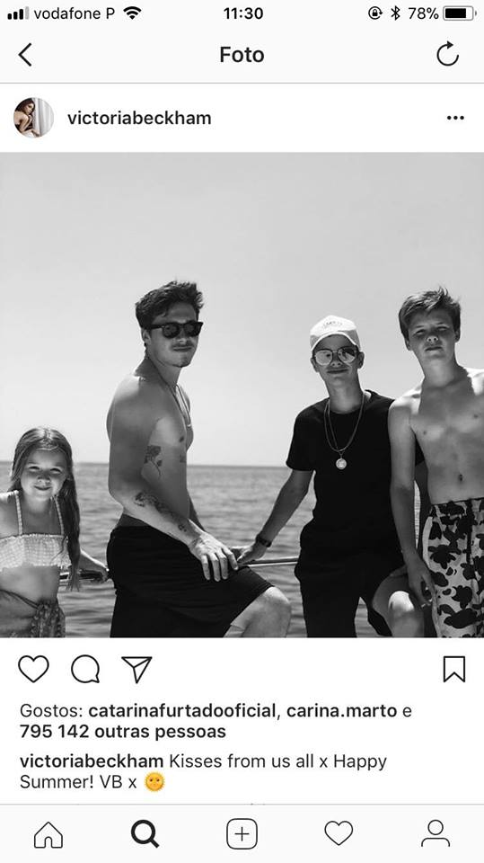
Hello! My name is Victoria Beckham and I’m from Harlow, England. I’m 44 years old and I’m a singer and a model.
My husband is David Beckham. He is a famous football player.
We have got four children. Check out my Instagram photo – aren’t they beautiful?
Brooklyn is 19 and Romeo is 16. They are models like me! Romeo’s birthday is on 1st September. We always have great birthday parties because it’s in summer! Summer is my favourite season of the year! Cruz is 13 years old and he is a singer. My daughter, Harper, is 7 years old and she is a student, but she wants to be a vet. It’s her dream job.

C. Complete Victoria’s Instagram profile.
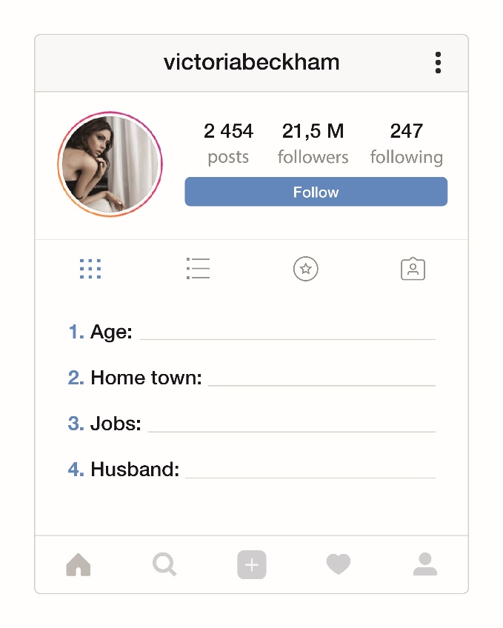

D. Answer the questions. Give complete answers.
- How old is Brooklyn? ____________________________________________________
- When is Romeo’s birthday? ______________________________________________
- What is Victoria’s favourite season?________________________________________
- What is Cruz’s job? ___________________________________________________
- Is Harper a student? ____________________________________________________
E. Look at the family tree and complete the text about the Beckham family.
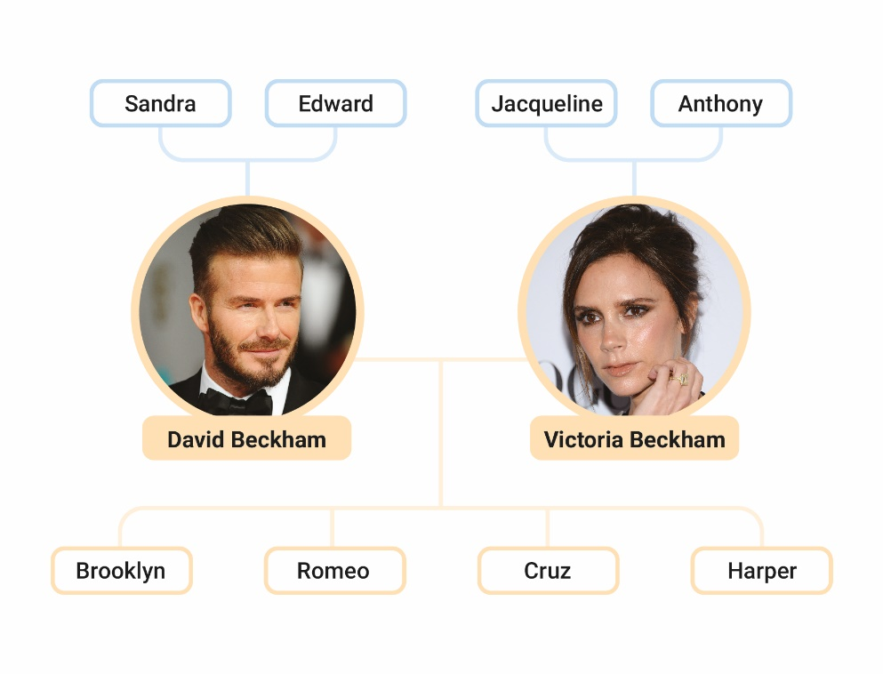
Hello! My name is Cruz and I’m 13 years old.
Edward is my grandfather.
Sandra is my ⁽¹⁾ _______________.
Anthony is my ⁽²⁾ _______________.
David is my ⁽³⁾_______________.
Victoria is my ⁽⁴⁾ _______________.
Brooklyn is my ⁽⁵⁾ _______________.
Harper is my ⁽⁶⁾ _______________.
It’s a great family! I love it!

F. Complete the sentences with the correct form of the verb to be.
- My brother ____________ 13 years old.
- His parents ___________ famous.
- I ________ a football player.
- David _________ from England.
G. Ask and answer. There is one example.
- Sandra / vet
Is Sandra a vet ? Yes, she is. .

- Anthony / mechanic
_________________________________? No, ___________________________.
- David and Victoria / famous
_________________________________? Yes, ___________________________.
- David and Victoria / actors
_________________________________? No, ___________________________.
- summer / her favourite season
_________________________________? Yes, ___________________________.
H. Circle the correct options to complete the sentences.
- My uncle is a / an firefighter.
- Victoria is from the / -- United Kingdom.
- Are you -- / an actor?
- My name is the / -- David.
I. Complete the text with the correct possessive determiner.
Hi! ⁽¹⁾ _______ name is John and I’m a big fan of David Beckham. ⁽²⁾____ wife is Victoria.
⁽³⁾____ surname is Beckham, too. They have got four children. ⁽⁴⁾_______ family is big!

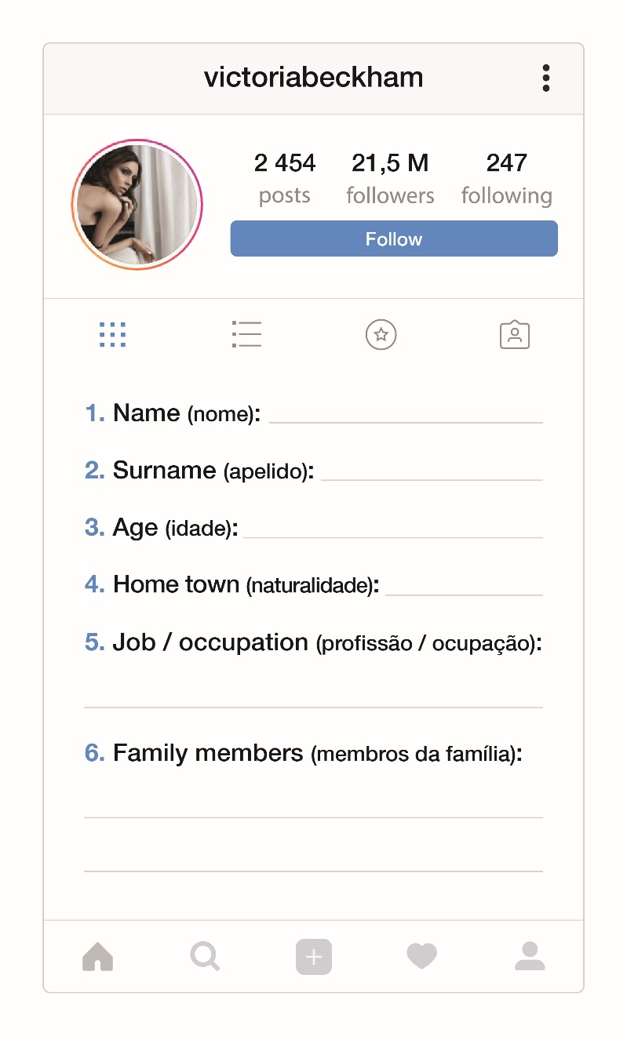
J. Complete your Instagram profile. Use that information to write a small text about you.

Script – Listening (A and B)
Interview with David Beckham.
Journalist (J) – Good afternoon! Today we are interviewing David Beckham. Hello, David. Welcome to our radio station.
David (D) – Thank you. It’s great to be here!
J – So, you live in Los Angeles, in the United States of America, but where are you from?
D – I’m from London, in England. It’s a great city. There are many beautiful places and monuments to visit, like Trafalgar Square or Big Ben.
J – When’s your birthday?
D – My birthday is on 2nd May. I’m 43 years old.
J – You are a football player, right?
D – Yes, I am, but I’m a model too.
J – What’s your favourite football team?
D – My favourite football team is Manchester United.
J – Have you got any brothers or sisters?
D – Yes, I have. I have got two sisters, Lynne and Joanne.
J – Thank you so much for this interview!
D – You’re welcome! Goodbye!

Answer Key
A. 4 x 2% = 8%
1. b) | 2. a)| 3. c) |4. c)
B. 4 x 2% = 8%
1. London | 2. 2nd May | 3. model |4. sisters
C. 5 x 1% = 5%
1. 44 | 2. Harlow (England) | 3. singer / model | 4. David Beckham
D. 5 x 3% = 15%
1. Brooklyn is 19 years old. | 2. It’s on 1st September. | 3. Victoria’s favourite season is summer. | 4. Cruz is a singer. | 5. Yes, she is.
E. 6 x 2% = 12%
1. grandmother | 2. grandfather | 3. father | 4. mother | 5. brother | 6. sister
F. 4 x 2% = 8%
1. is | 2. are | 3. am | 4. is
G. 4 x 2% = 8%
1. Is Anthony a mechanic? No, he isn’t. | 2. Are David and Victoria famous? Yes, they are. | 3. Are David and Victoria actors? No, they aren’t. | 4. Is summer her favourite season? Yes, it is.
H. 4 x 2% = 8%
1. a | 2. the | 3. an | 4. --
I. 4 x 2% = 8%
1. My | 2. His | 3. Her | 4. Their
J. 20%
Personal answer

