
LISTENING

A. Listen to the interview with David Beckham
and choose the correct option.
(Ouve a entrevista com David Beckham
e escolhe a opção correta.)

1. “Welcome to our… station.”        Radio  Newspapers  TV set  a) b) c) | 2. In London, “there are many beautiful places and monuments to visit, like Trafalgar Square or...”    Big Ben  Eiffel Tower  London Eye  a) b) c)
  3. “I’m… years old.”  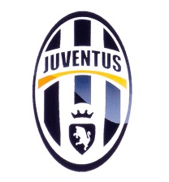    a) b) c) | 4. “My favourite football team is…”      a) b) c)

B. Listen to the interview again and circle the correct option.
(Ouve a entrevista novamente e rodeia a opção correta.)

- David Beckham is from London / Los Angeles.
- David’s birthday is on 12th April / 2nd May.
- David has got two jobs. He is a football player and a model / student.
- He has got two brothers / sisters.
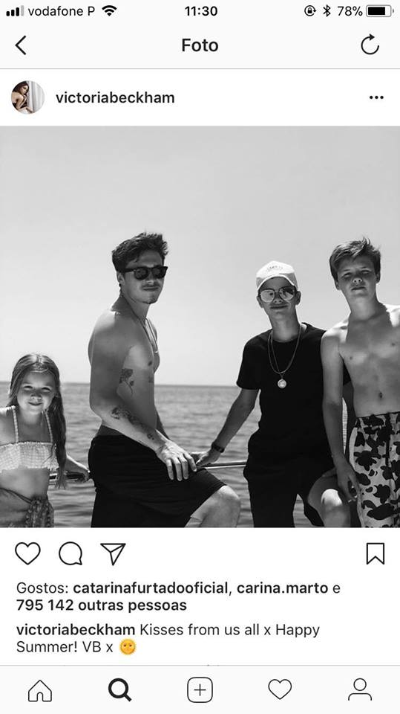
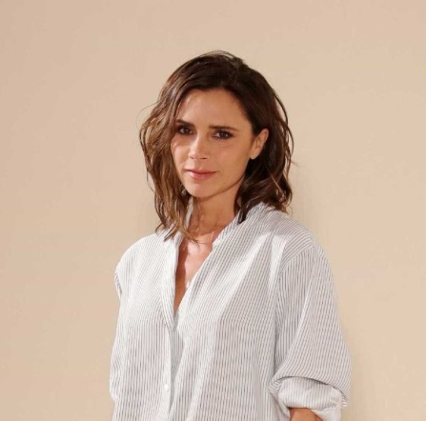
Read the text. (Lê o texto.)

Hello! My name is Victoria Beckham and I’m from Harlow,
England. I’m 44 years old and I’m a singer and a model. My husband is David Beckham. He is a famous football player.
We have got four children. Check out my Instagram photo – aren’t they beautiful?
Brooklyn is 19 and Romeo is 16. They are models like me! Romeo’s birthday is on 1st September. We always have great birthday parties because it’s in summer! Summer is my favourite season of the year! Cruz is 13 years old and he is a singer. My daughter, Harper, is 7 years old and she is a student, but she wants to be a vet. It’s her dream job.

C. Complete Victoria’s Instagram profile with the words from the box.
(Completa o perfil de Instagram da Victoria com as palavras da caixa.)
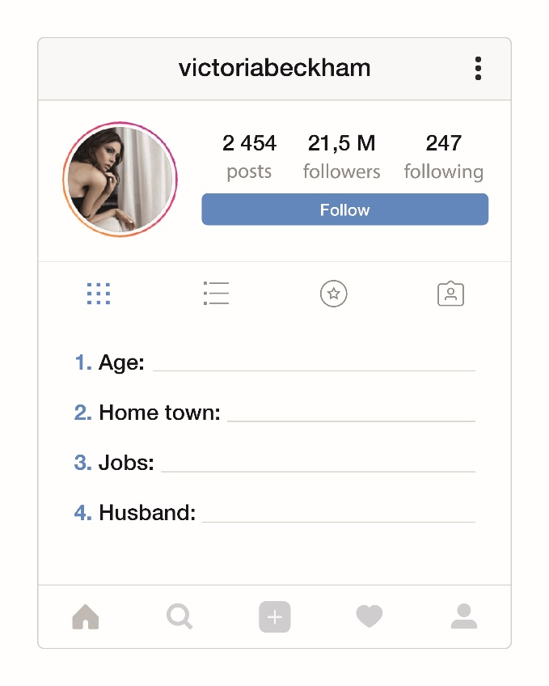
David Beckham | model
Harlow | singer | 44

D. Answer the questions. Tick ( ) the correct option.
(Responde às questões. Assinala a opção correta.)

- How old is Brooklyn?
- Brooklyn is twenty-nine years old.
- Brooklyn is nineteen years old.
- Brooklyn is nine years old.

- When is Romeo’s birthday?
- It’s on 1st November.
- It’s on 21st September.
- It’s on 1st September.

- What is Victoria’s favourite season?
- Victoria’s favourite season is summer.
- Victoria’s favourite season is winter.
- Victoria’s favourite season is spring.

- What is Cruz’s job?
- Cruz is a model. b) Cruz is a singer. c) Cruz is a student.

- Is Harper a student season?
- No, she isn’t. b) Yes, they are. c) Yes, she is.
E. Look at the family tree and complete the text about the Beckham family. Choose the words from the box.
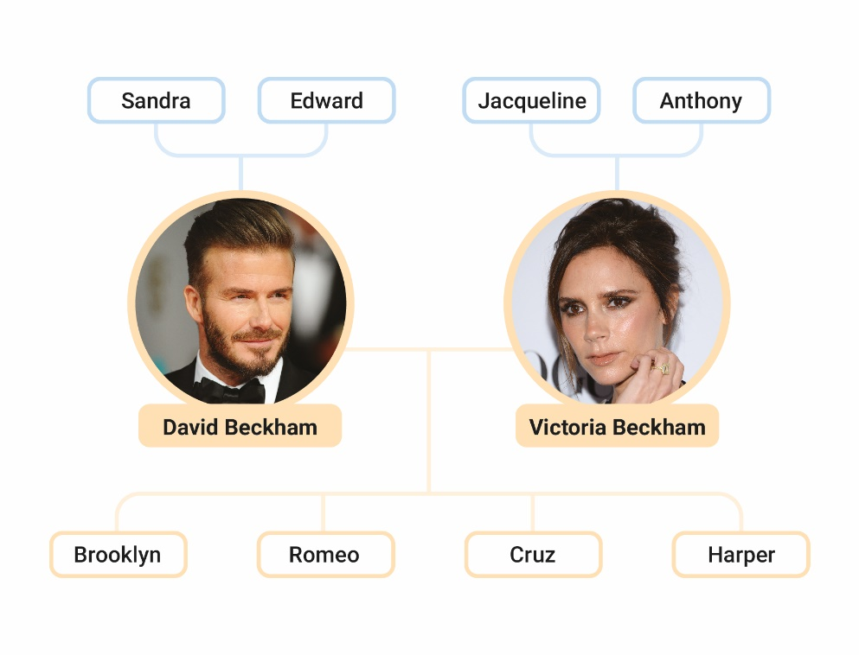
(Observa a árvore genealógica e completa o texto sobre a família Beckham. Escolhe as palavras da caixa.)
sister | brother | grandfather | father| grandmother | mother

Hello! My name is Cruz and I’m 13 years old.
Edward is my grandfather.
Sandra is my ⁽¹⁾ _______________.
Anthony is my ⁽²⁾ _______________.
David is my ⁽³⁾_______________.
Victoria is my ⁽⁴⁾ _______________.
Brooklyn is my ⁽⁵⁾ _______________.
Harper is my ⁽⁶⁾ _______________.
It’s a great family! I love it!

F. Complete the sentences with am / is / are.
(Completa as frases com am / is / are.)
- My brother ____________ 13 years old.
- His parents ___________ famous.
- I ________ a football player.
- David _________ from England.
G. Ask and answer. There is one example.
(Pergunta e responde. Segue o exemplo.)
- Sandra / vet
Is Sandra a vet? . Yes, she is. .
- Anthony / mechanic
Is _________________________________? No, ___________________.
- David and Victoria / famous
Are _________________________________? Yes, ___________________.
- David and Victoria / actors
Are _________________________________? No, ___________________.
- summer / her favourite season
Is _________________________________? Yes, ___________________.

H. Circle the correct options to complete the sentences.
(Rodeia a opção correta para completar as frases.)

- My uncle is a / an firefighter.
- Victoria is from the / -- United Kingdom.
- Are you -- / an actor?
- My name is the / -- David.
I. Complete the text with the correct possessive determiner: their / her / his / my.
(Completa o texto com os possessive determiners corretos: their / her / his / my.)

Hi! ⁽¹⁾ _______ name is John and I’m a big fan of David Beckham. ⁽²⁾ ____ wife is Victoria. ⁽³⁾ ____ surname is Beckham, too. They have got four children. ⁽⁴⁾ _______ family is big!

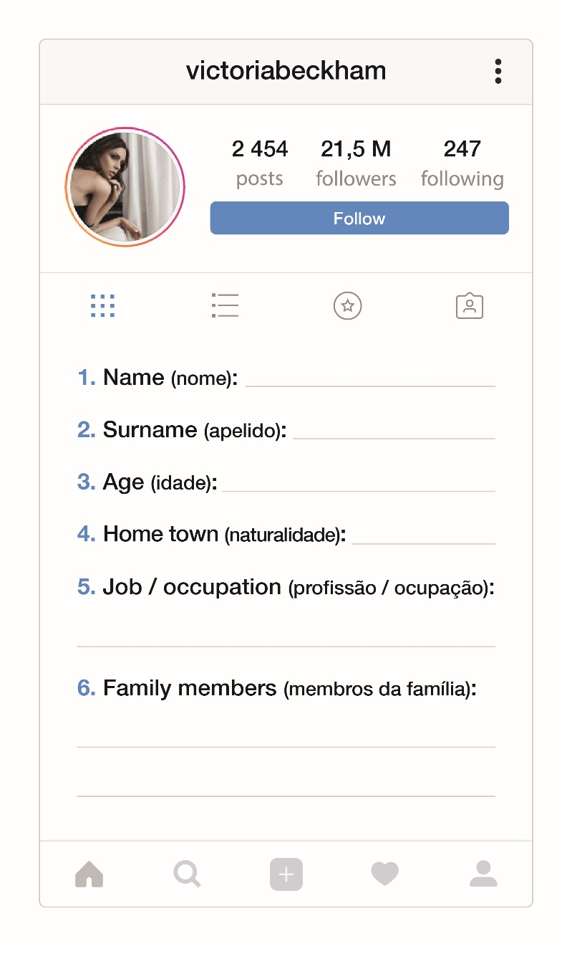
J. Complete your Instagram profile. Use that information to write a small text about you. (Completa o teu perfil de Instagram. Usa essa informação para escrever um pequeno texto sobre ti.)

Hello! My name is _____________________________________________________________
___________________________________________________________________________________________________________________________________________________________________________________________________________________________________________________________________________________________________________________________________________________________________________________________________________________________________________________________________________________________________________________________________________________________

Script – Listening (A and B)
Interview with David Beckham.
Journalist (J) – Good afternoon! Today we are interviewing David Beckham. Hello, David. Welcome to our radio station.
David (D) – Thank you. It’s great to be here!
J – So, you live in Los Angeles, in the United States of America, but where are you from?
D – I’m from London, in England. It’s a great city. There are many beautiful places and monuments to visit, like Trafalgar Square or Big Ben.
J – When’s your birthday?
D – My birthday is on 2nd May. I’m 43 years old.
J – You are a football player, right?
D – Yes, I am, but I’m a model too.
J – What’s your favourite football team?
D – My favourite football team is Manchester United.
J – Have you got any brothers or sisters?
D – Yes, I have. I have got two sisters, Lynne and Joanne.
J – Thank you so much for this interview!
D – You’re welcome! Goodbye!

Answer key
A. 4 x 2% = 8%
1. b) | 2. a) | 3. c) | 4. c)
B. 4 x 2% = 8%
1. London | 2. 2nd May | 3. model | 4. sisters
C. 5 x 1% = 5%
1. 44 | 2. Harlow (England) | 3. singer / model | 4. David Beckham
D. 5 x 3% = 15%
1. a) Brooklyn is 19 (nineteen) years old. | 2. c) It’s on 1st September. | 3. a) Victoria’s favourite season is summer. | 4. b) Cruz is a singer. | 5. c) Yes, she is.
E. 6 x 2% = 12%
- grandmother | 2. grandfather | 3. father | 4. mother | 5. brother | 6. sister
F. 4 x 2% = 8%
1. is | 2. are | 3. am | 4. is
G. 4 x 2% = 8%
1. Is Anthony a mechanic? No, he isn’t. | 2. Are David and Victoria famous? Yes, they are. |
3. Are David and Victoria actors? No, they aren’t. | 4. Is summer her favourite season? Yes, it is.
H. 4 x 2% = 8%
1. a | 2. the | 3. an | 4. --
I. 4 x 2% = 8%
1. My | 2. His | 3. Her | 4. Their
J. 20%
Personal answer.

