Progress test 1C – Year 5
Name: ___________________________ Class: ______ No. ___ Date: ___________________
Teacher: _______________ Mark: ____________________ Enc. Educação___________________

- Label the pictures with the names of the jobs from the box.
(Legenda as imagens com os nomes das profissões da caixa.)
student | singer | football player | model

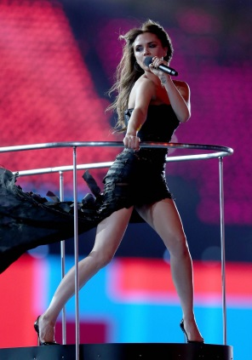
1. ______________ 2. _________________ 3. ______________ 4. _______________

B. Look at the family tree and complete the text about the Beckham family. Choose the words from the box.
(Observa a árvore genealógica e completa o texto com as palavras sobre a família. Escolhe as palavras da caixa.)

sister | brother | grandfather | father| grandmother | mother

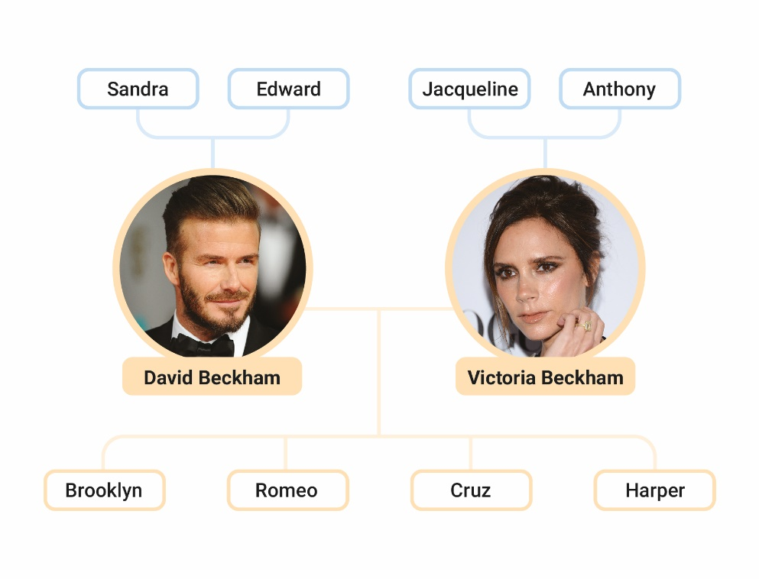
Hello! My name is Cruz and I’m 13 years old.
Edward is my grandfather.
Sandra is my ⁽¹⁾ _______________.
David is my ⁽²⁾_______________.
Victoria is my ⁽³⁾ _______________.
Brooklyn is my ⁽⁴⁾ _______________.
Harper is my ⁽⁵⁾ _______________.
It’s a great family! I love it!

´
C. Complete the sentences with am / is / are.
(Completa as frases com am / is / are.)

- My brother ____________ 13 years old.  - His parents ___________ famous. | - I ________ a football player.  - David _________ from England.






D. Look at the pictures and answer the questions using short answers. There is one example. (Observa as imagens e responde às perguntas com respostas curtas. Segue o exemplo.)

Is she a vet? Yes, she is .

Is he a mechanic? Yes,_________________________.
Is she an actor? No,_________________________.
Is he a football player? Yes,_________________________.
Is she a student? No,_________________________.

E. Circle the correct options to complete the sentences.
(Rodeia a opção correta para completar as frases.)

- My uncle is a / an firefighter.  - Victoria is from the / -- United Kingdom. | - Are you -- / an actor?  - My name is the / -- David.

F. Complete the sentences with the correct possessive determiner: their / her / his / my.
(Completa as frases com os possessive determiners corretos: their / her / his / my)

- Hello, __________ name is David and I’m 43 years old.
- He is my brother. ___________ name is Cruz.
- She is my friend. ____________ name is Harper.
- They are models. __________ names are Brooklyn and Romeo.
G. Answer the questions about you. Use complete sentences.
(Responde às questões sobre ti. Dá respostas completas.)

- What’s your name? ____________________________________________________
- What’s your surname? __________________________________________________
- How old are you? ______________________________________________________
- Where are you from? ___________________________________________________
- What’s your job? _______________________________________________________
Answer key
A. 4 x 3% = 12%
1. singer | 2. football player | 3. model | 4. student
B. 5 x 4% = 20%
1. grandmother | 2. father | 3. mother | 4. brother | 5. sister
C. 4 x 3% = 12%
1. is | 2. are | 3. am | 4. is
D. 4 x 3% = 12%
1. Yes, he is. | 2. No, she isn’t. | 3. Yes, he is. | 4. No, she isn’t.
E. 4 x 3% = 12%
1. a | 2. the | 3. an | 4. –
F. 4 x 3% = 12%
1. my | 2. His | 3. Her | 4. Their
G. 5 x 4% = 20%
1. My name is… | 2. My surname is… | 3. I am… years old. | 4. I am from… | 5. I am a student.

