
A. Read the descriptions and write the names under the correct character.

My name is Migo. I am a white monster. I am tall. I have got big blue feet and hands.
My mouth is very big and I am a happy monster!

My name is Stonekeeper and I am old. I am short and fat. My hands are big and blue and I have got a long white beard.

My name is Meechee and I am very beautiful. I am tall and slim. My hands are big and blue and my feet too. I have got long violet hair and a purple necklace.

My name is Kolka. I am medium height. My hands and my feet are big and blue. I have got blue ears. My hair is short and blonde. I am a funny monster!

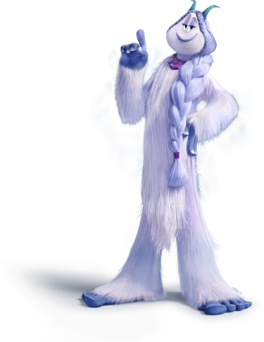
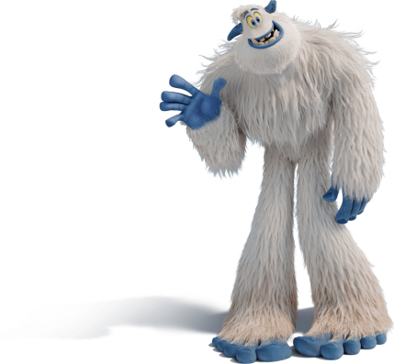
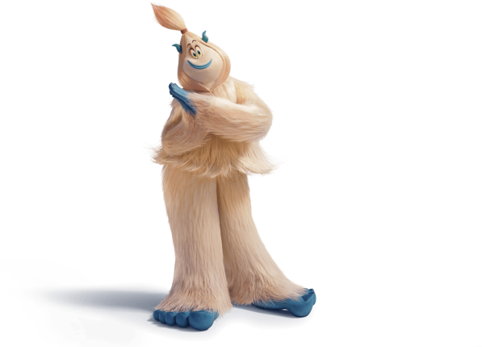
1. _______________
2. _______________
3. _______________
4. _______________
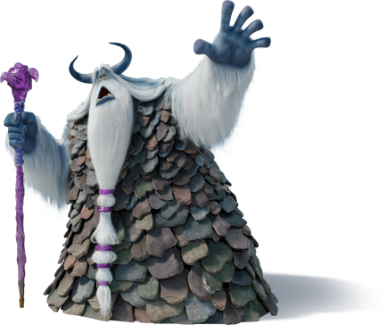



B. Use the models from A and describe yourself to the class. Don’t forget to mention:

Height – Weight – Age – Hair – Face – General appearance

You can also talk about your clothes/footwear/accessories and your personality (examples: kind, happy, polite, friendly, funny…).
Suggestion: Alternatively, you can describe one of your classmates and ask the class to guess who you’re talking about.

A. Read the dialogue.

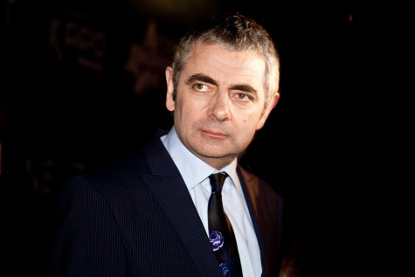
Kate: Hi, Nathan! My favourite actor is Rowan Atkinson! You know…Mr. Bean!
Nathan: Tell me a little about him! What does he look like?
Kate: He’s tall and thin. He has got big eyes and short straight hair.
Nathan: Has he got a moustache?
Kate: No, he hasn’t.
Nathan: Is he rude?
Kate: Oh, no! He is very friendly and funny.
Nathan: What about his clothes?
Kate: He usually wears a suit, a tie and a white shirt. Look at this photo! That’s me asking him for an autograph!

B. Student A – Choose one of your favourite actors/actresses; musicians; sportspeople or any other person you admire. Talk with your partner about him/her.
Student B – Ask questions about your partner’s favourite person.
Take turns.
Replace the underlined expressions from A with your information and role-play a similar dialogue.
You can write the dialogue in your notebook first.

Answer key

1. Stonekeeper | 2. Meechee | 3. Migo | 4. Kolka

