A. Match the words with the pictures. Write the numbers.
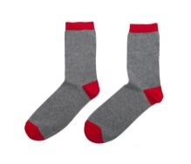
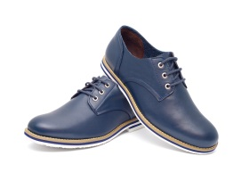
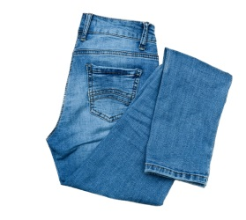
- shorts
c)
a)
b)
- coat
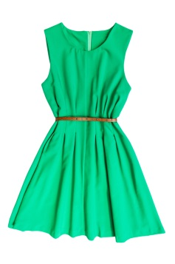
- belt
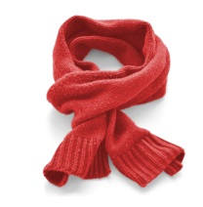
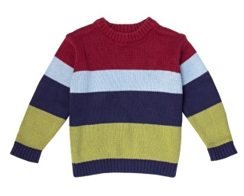
- scarf
f)
e)
d)
- sweater
- socks
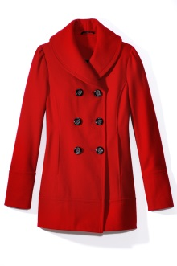
- shoes
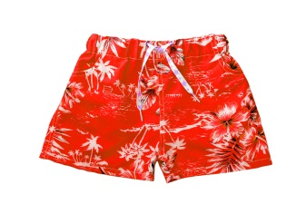
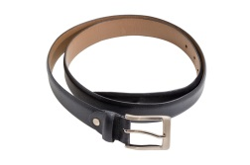
- jeans
i)
h)
g)
- dress

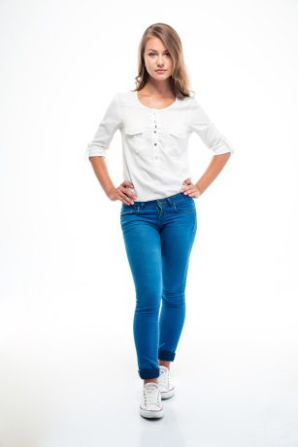
B. Look at the picture and complete the text with words from the box. There is one example.
glasses
slim
wavy
long
beautiful
elegant
blond

This is Caroline. She is tall and slim_______.
She has got ⁽¹⁾ ____________ ⁽²⁾ _______________ hair.
Her eyes are ⁽³⁾ ____________. She has got
⁽⁴⁾ __________ legs.
She hasn’t got ⁽⁵⁾ _______________.
She is an ⁽⁶⁾ _______________ girl!
C. Complete the sentences with the verb have got (affirmative / negative).
- Susie and Carol ___________________ new dresses.
- You ___________________ a yellow dress.
- I ___________________ (not) a big nose.
- The cat ___________________ a long tail.
- My mother ___________________ (not) blue eyes.
- Your sister ___________________ brown boots.
D. Complete the questions and answers with the verb have got.
- __________ you __________ long hair? No, _______________.
- __________ she __________ glasses? Yes, ____________.
- __________ your parents __________ black hair? No, _______________.
- __________ the cat __________ green eyes? No, _______________.
- __________ John __________ blue jeans? Yes, _______________.
- __________ Lucy and Kate __________ a pet? Yes, _______________.
E. Complete the gaps. Use the possessive case ( ’ / ’s). There is one example.
- Whose T-shirt is this? This is Tom’s T-shirt. (Tom)
- Whose dress is this? This is ______________ dress. (James)
- Whose trousers are these? These are ______________ trousers. (Lilly)
- Whose cap is that? That is _______________ cap. (my sister)
- Whose belt is this? This is ________________ belt. (Greg)
- Whose boots are these? These are ________________ boots. (Mary)
- Whose pet is this? This is _________________ pet. (my brothers)
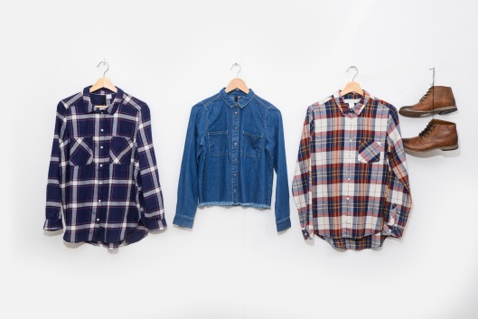
F. Circle the correct possessive pronoun.
- These are my trainers. They are yours / mine.
- That is Sarah’s house. It’s hers / ours.
- These are your shoes. They are mine / yours.
- This is Ian’s scarf. It’s his / theirs.
- This is my cousins’ house. It’s ours / theirs.
- These are our shirts. They are mine / ours.
G. Put the words in the correct order.
- short / Lucy / is / . ______________________________________________________________
- long / they / hair / have got / . _____________________________________________________
- is / Jane / a / girl / beautiful / . _____________________________________________________
- eyes / blue / are / my / . __________________________________________________________
- has got / scarf / she / a yellow / . ___________________________________________________
- long / Ian / hair / Emma / and / have got / . ___________________________________________

Answer key
A. a) 8 | b) 7 | c) 6 | d) 9 | e) 5 | f) 4 | g) 1 | h) 3 | i) 2
B. 1. wavy | 2. blond | 3. beautiful | 4. long | 5. glasses | 6. elegant
C. 1. have got | 2. have got | 3. haven’t got | 4. has got | 5. hasn’t got | 6. has got
D. 1. Have… got / I haven’t. | 2. Has… got / she has | 3. Have… got / they haven’t | 5. Has… got / it hasn’t | 6. Has… got / he has | 7. Have… got / they have
E. 1. James’s | 2. Lilly’s | 3. My sister’s | 4. Greg’s | 5. Mary’s | 6. My brothers’
F. 1. mine | 2. hers | 3. yours | 4. his | 5. theirs | 6. ours
G. 1. Lucy is short. | 2. They have got long hair. | 3. Jane is a beautiful girl. | 4. My eyes are blue. | 5. She has got a yellow scarf. | 6. Ian and Emma (Emma and Ian) have got long hair.

