A. Match the words with the pictures. Write the numbers.
(Liga as palavras às imagens. Escreve o número.)
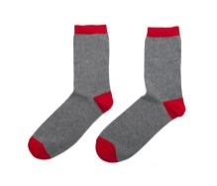
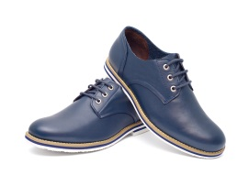
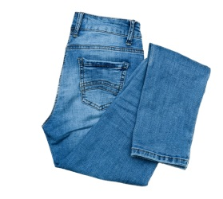
- shorts
c)
a)
b)
- coat
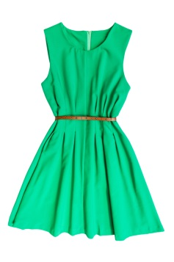
- belt
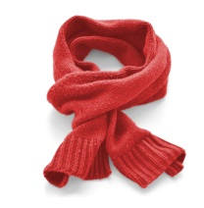
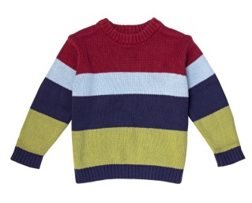
- scarf
f)
e)
d)
- sweater
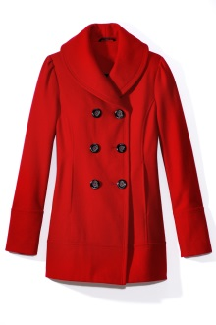
- socks
- shoes
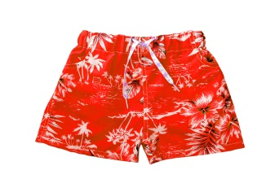
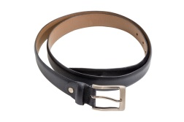
- jeans
i)
h)
g)
- dress
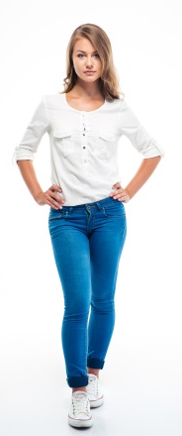

B. Circle the correct option to complete the text. There is one example.
(Rodeia a opção correta para completar o texto. Segue o exemplo.)
This is Caroline. She is tall and slim / curly. She has got ⁽¹⁾ blue / wavy ⁽²⁾ blond / curly hair.
Her eyes are ⁽³⁾ short / beautiful. She has got ⁽⁴⁾ long / brown legs. She hasn’t got
⁽⁵⁾ glasses / jeans. She is an ⁽⁶⁾ curly / elegant girl!

C. Tick () the correct option to complete the sentences with the verb have got.
(Escolhe a opção correta para completar as frases com o verbo have got.)
- Susie and Carol _________ new dresses. a) have got □ b) has got □ c) hasn’t got □
- You _________ a yellow dress. a) have got □ b) has got □ c) hasn’t got □
- I _________ (not) a big nose. a) have got □ b) has got □ c) haven’t got □
- The cat _________ a long tail. a) have got □ b) has got □ c) haven’t got □
- My mother _________ (not) blue eyes. a) havent got □ b) has got □ c) hasn’t got □
- Your sister _________ brown boots. a) have got □ b) has got □ c) haven’t got □

D. Complete the questions and answers with the verb have got. Use the words from the box. (Completa as perguntas e respostas com o verbo have got. Usa as palavras da caixa.)
- __________ you got long hair? No, I _______________.
have
has
haven’t
hasn’t
- __________ she got glasses? Yes, she ____________.
- __________ your parents got black hair? No, they _______________.
- __________ the cat got green eyes? No, it _______________.
- __________ John got blue jeans? Yes, he _______________.
- __________ Lucy and Kate got a pet? Yes, she _______________.
E. Write ’ or ’s . There is one example. (Escreve ‘ ou ‘s. Segue o exemplo.)
- Whose T-shirt is this? This is Tom’s T-shirt. (Tom)
- Whose dress is this? This is James__ dress.
- Whose trousers are these? These are Lilly__ trousers.
- Whose cap is that? That is my sister __ cap.
- Whose belt is this? This is Greg __ belt.
- Whose boots are these? These are Mary__ boots.
- Whose pet is this? This is my brothers__ pet.
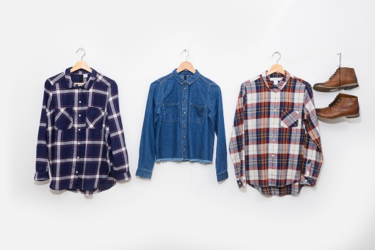
F. Circle the correct possessive pronoun. (Rodeia o pronome pessoal correto.)
- These are my trainers. They are yours / mine.
- That is Sarah’s house. It’s hers / ours.
- These are your shoes. They are mine / yours.
- This is Ian’s scarf. It’s his / theirs.
- This is my cousins’ house. It’s ours / theirs.
- These are our shirts. They are mine / ours.
G. Put the words in the correct order. (Coloca as palavras pela ordem correta.)
- short / Lucy / is / . ________________________________________________________________
- They / long hair / have got / . _______________________________________________________
- Jane is / girl / a beautiful / . _________________________________________________________
- My eyes / blue / are / . ____________________________________________________________
- scarf / She has got / a yellow / . _____________________________________________________
- long / hair / Emma and Ian have got / . ________________________________________________

Answer key
A. a) 8 | b) 7 | c) 6 | d) 9 | e) 5 | f) 4 | g) 1 | h) 3 | i) 2
B. 1. wavy | 2. blond | 3. beautiful | 4. long | 5. glasses | 6. elegant
C. 1. a) | 2. a)| 3. c) | 4. b) | 5. c) | 6. b)
D. 1. Have / haven’t. | 2. Has / has | 3. Have / haven’t | 5. Has / hasn’t | 6. Has / has | 7. Have / have
E. 1. ’s | 2. ’s | 3. ’s | 4. ’s | 5. ’s | 6. ’
F. 1. mine | 2. hers | 3. yours | 4. his | 5. theirs | 6. ours
G. 1. Lucy is short. | 2. They have got long hair. | 3. Jane is a beautiful girl. | 4. My eyes are blue. | 5. She has got a yellow scarf. | 6. Emma and Ian have got long hair.

