Progress Test 2B – Year 5
Name: ___________________________ Class: ______ No. ___ Date: ___________________
Teacher: _______________ Mark: ____________________ Enc. Educação___________________

Read the text. (Lê o texto.)
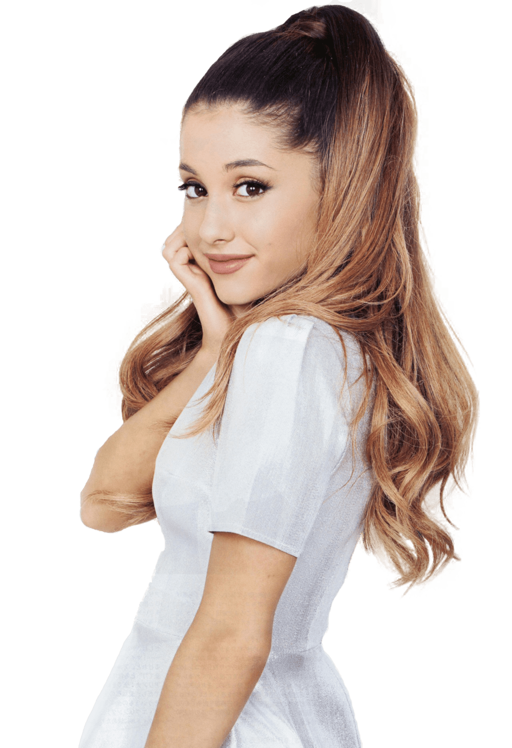
Ariana Grande is a singer from the United States of America. She is 25 years old and her birthday is on 26th June.
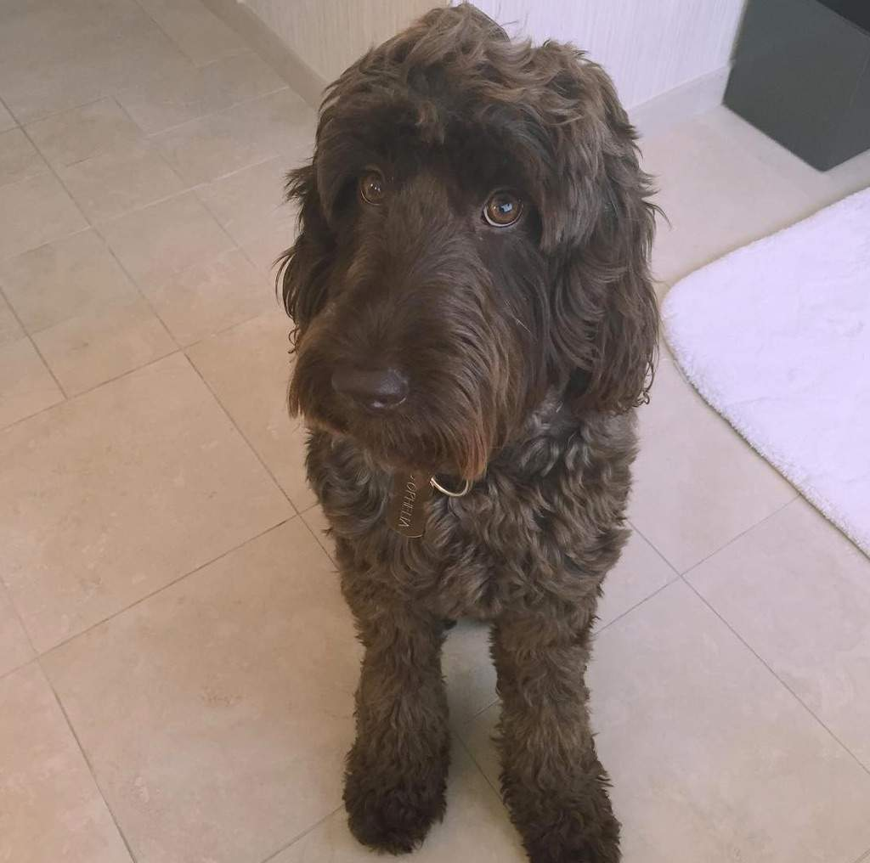
She is very beautiful. She is thin and medium height. Her hair is long, straight and brown. She has got big brown eyes. Ariana is intelligent and friendly. She loves skirts, dresses and trainers!
This year she has got a new album called Sweetener. Ariana has got lots of songs, lots of fans and lots of dogs... She has got eight dogs! They are all very funny. Look at Ophelia, one of her dogs... She is big and she has got long curly brown fur¹! So cute!!!!!
Word check:
¹ fur = pelo

A. Complete the sentences. Use the words from the box.
(Completa as frases. Usa as palavras da caixa.)
beautiful brown twenty-five
the United States of America eight

1. Ariana is from ____________________.
2. She is ____________________ years old.
3. She is ____________________.
4. She has got ____________________ dogs.
5. Ophelia has got ____________________ fur.

B. Match the questions and the answers. (Associa as perguntas às respostas.)
When is Ariana’s birthday? 1. |  | a) Her hair is brown.
Is she tall? 2. |  | b) Her favourite clothes are skirts, dresses and her favourite footwear are trainers.
What colour is her hair? 3. |  | c) Her birthday is on 26th June.
What are her favourite clothes and footwear? 4. |  | d) Yes, she has.
Has Ophelia got curly fur? 5. |  | e) No, she isn’t. She is medium height.

C. Label the pictures with the words from the box. (Legenda as imagens com as palavras da caixa.)
T-shirt shirt sweater gloves
jeans shorts dress socks

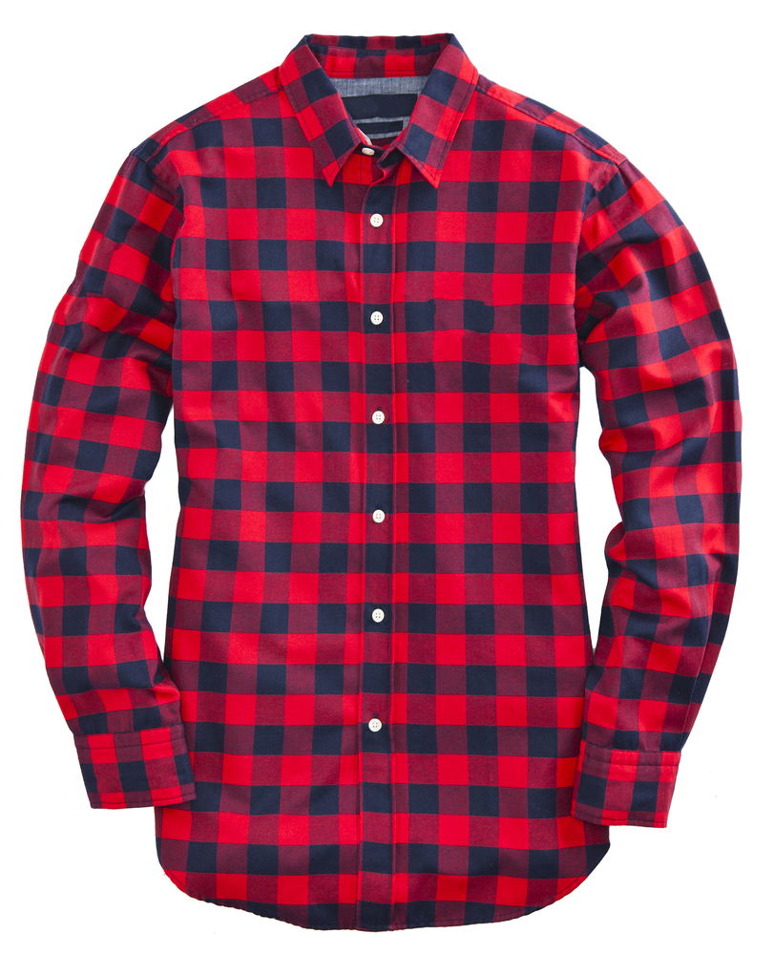
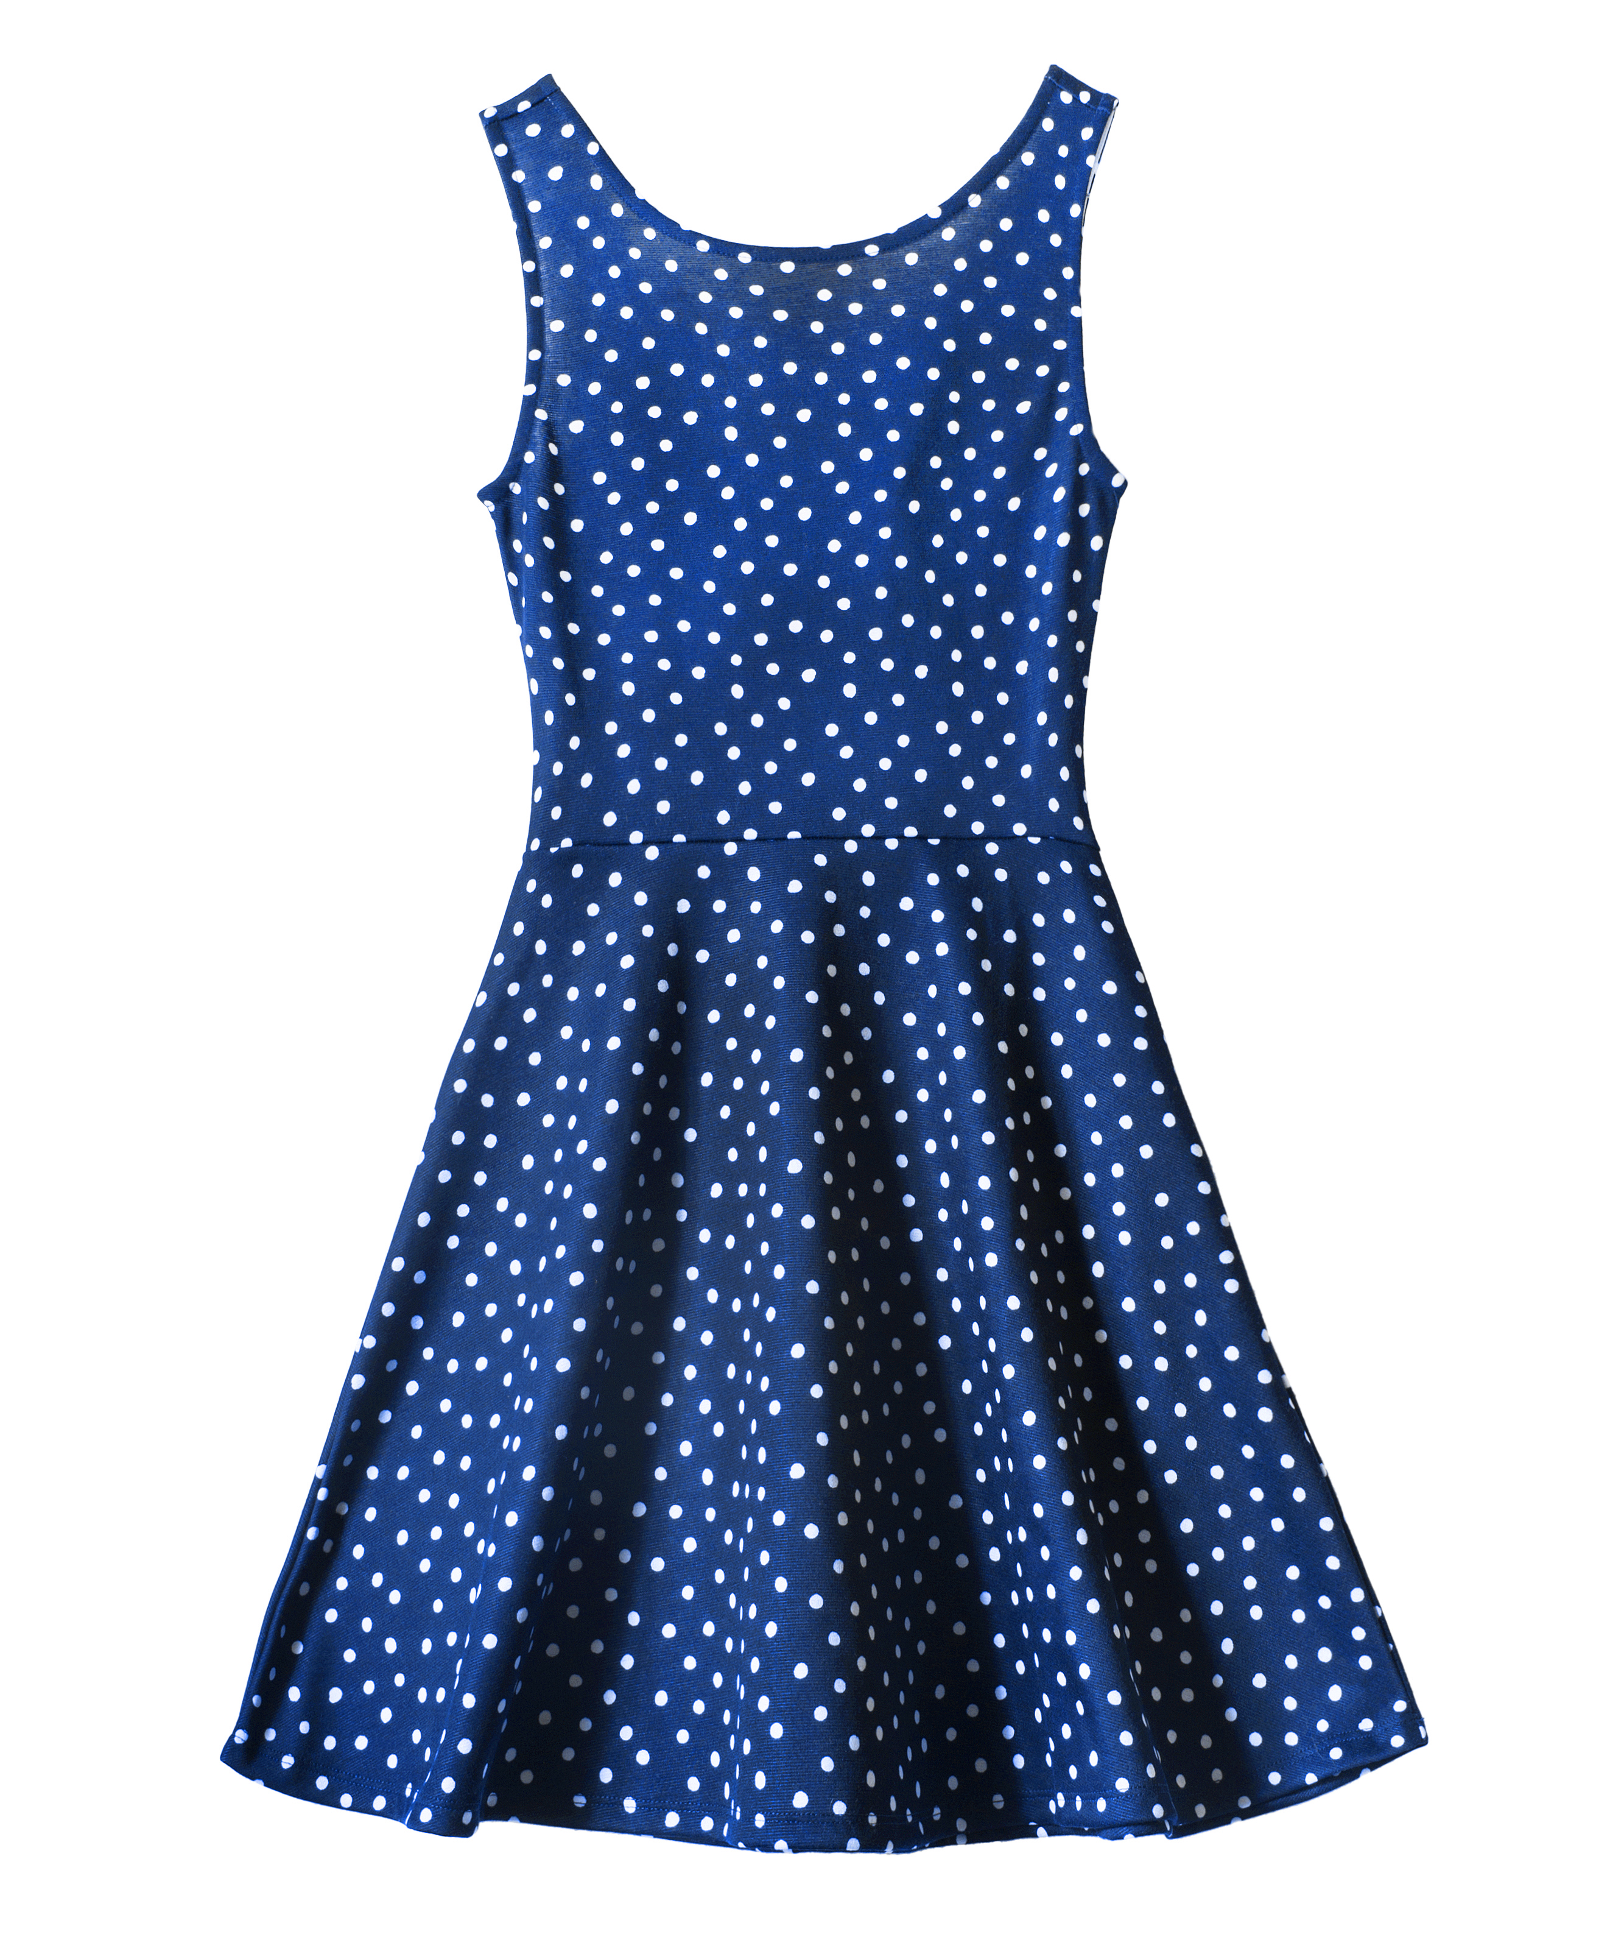
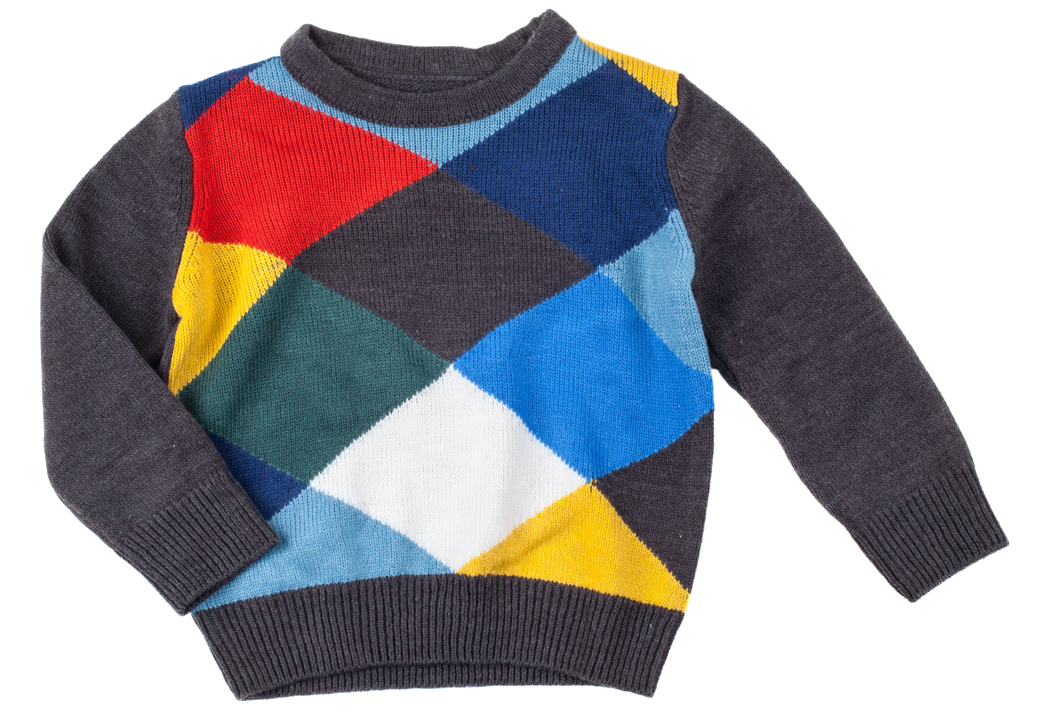
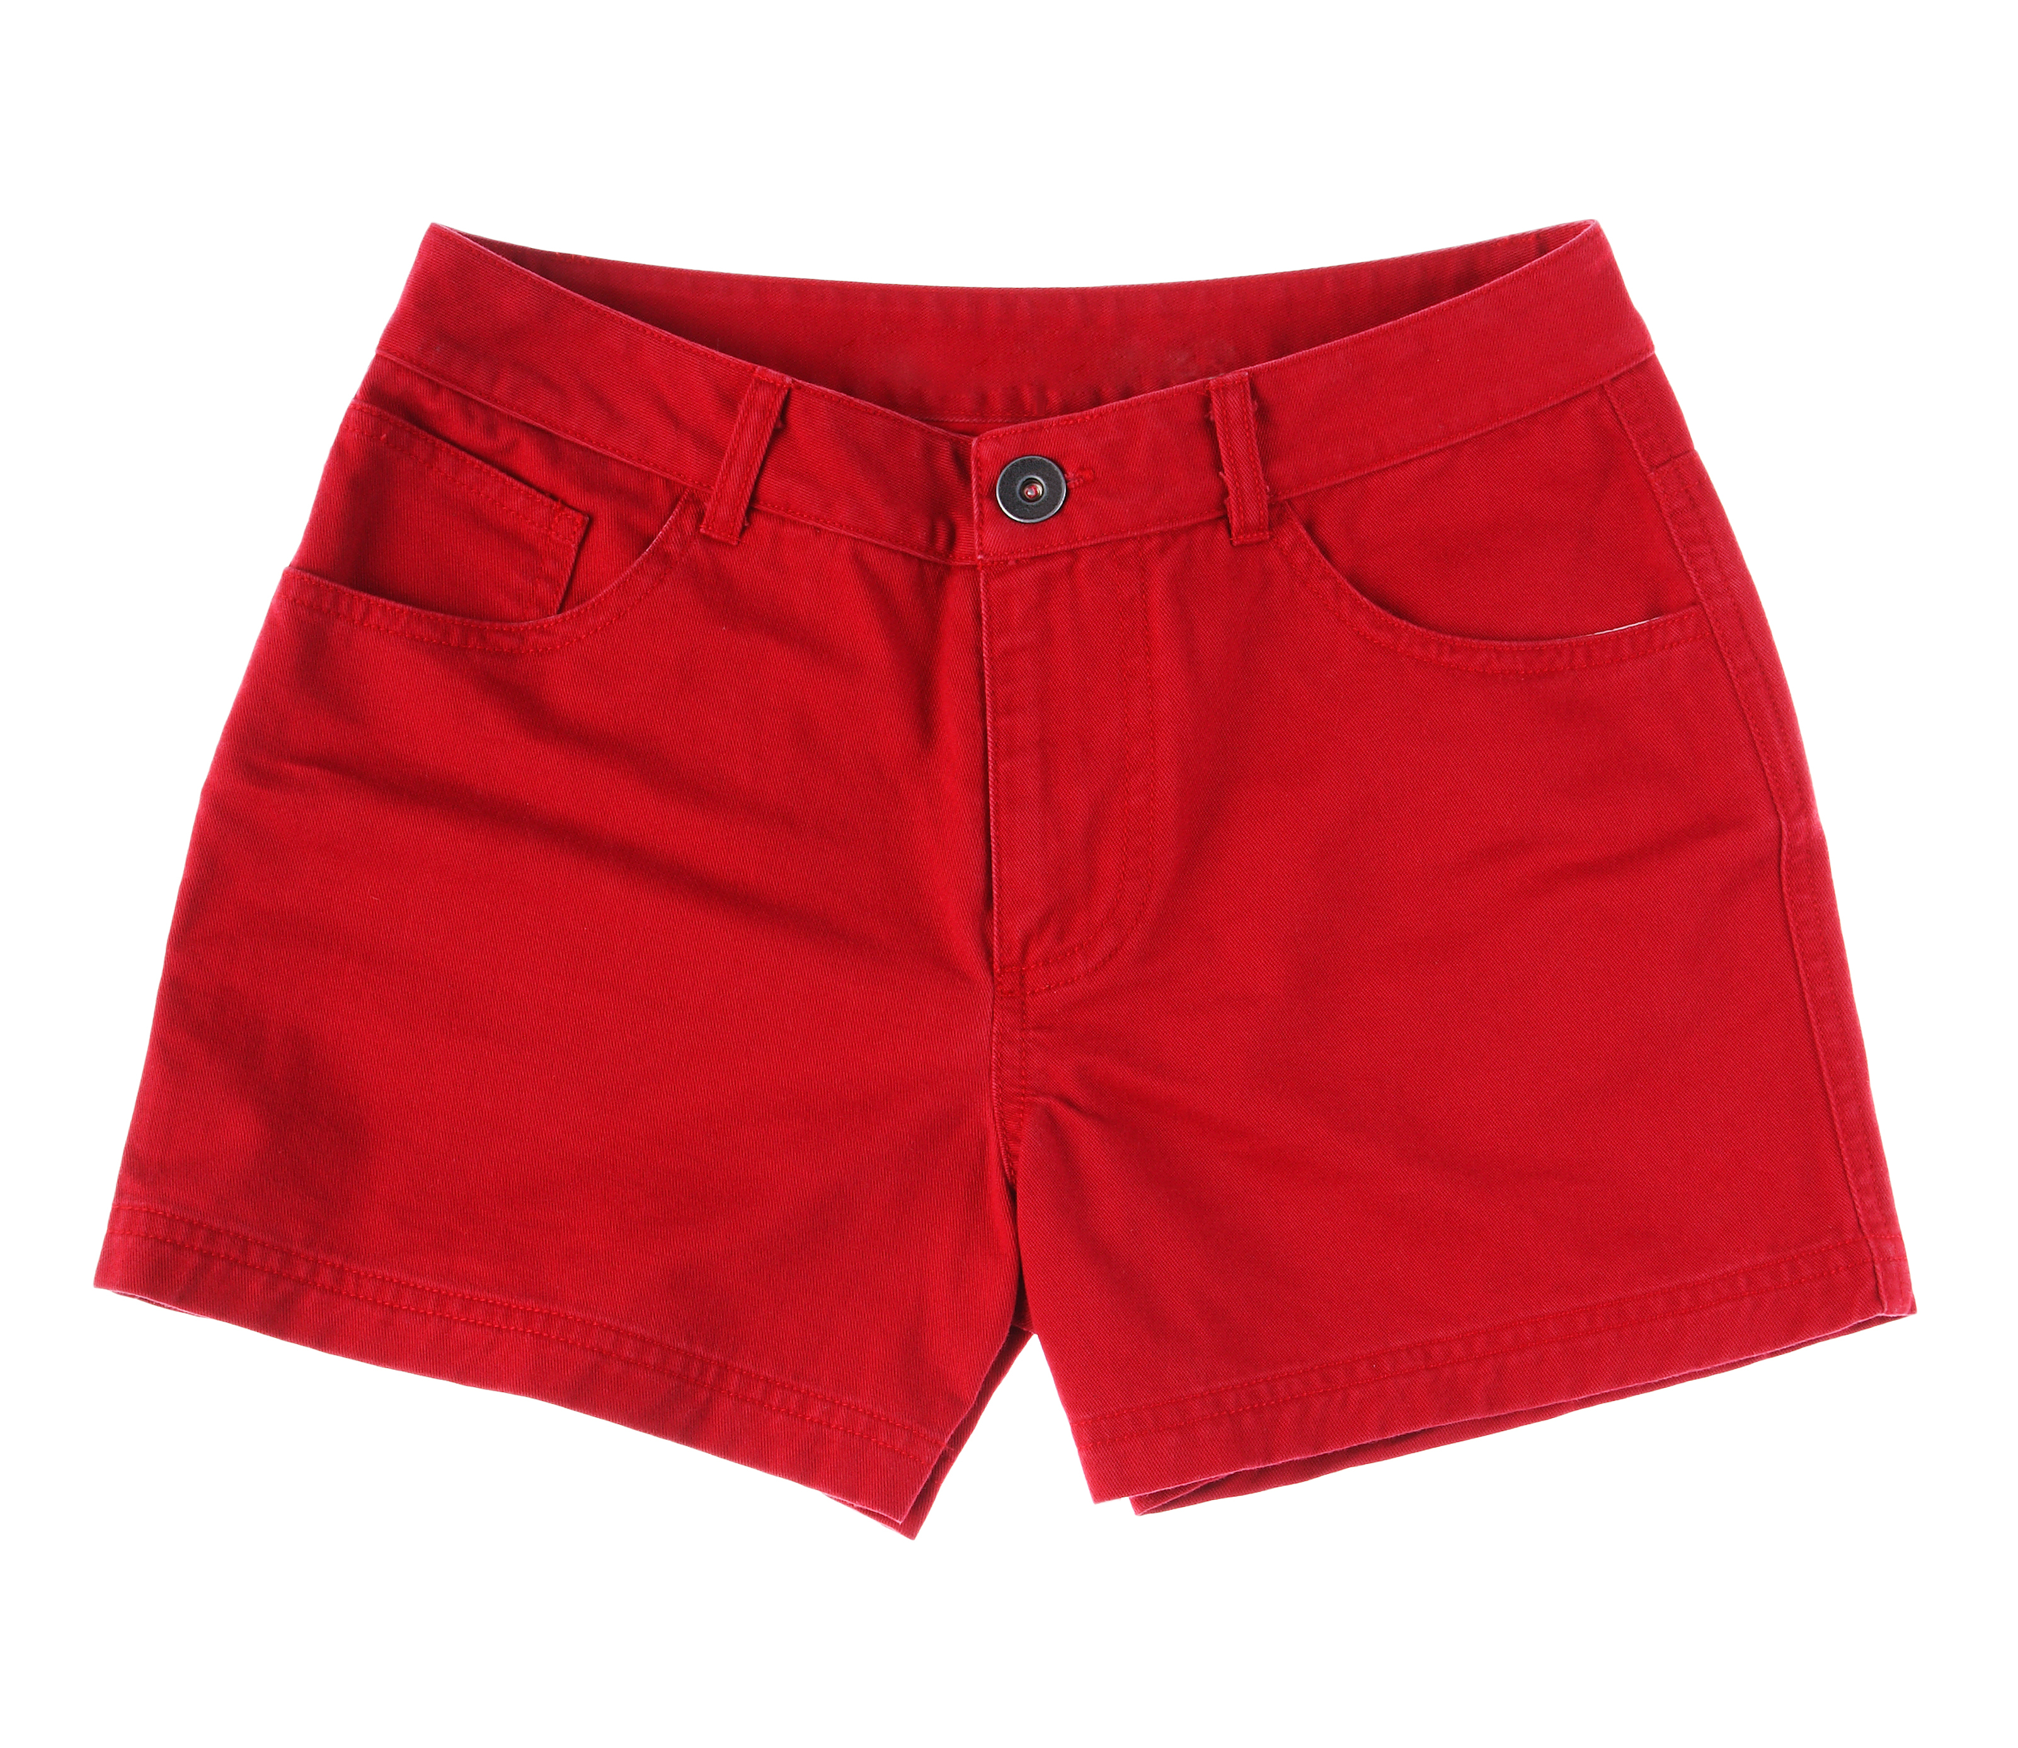

1. __________________ 2.__________________ 3.___________________ 4.______________________
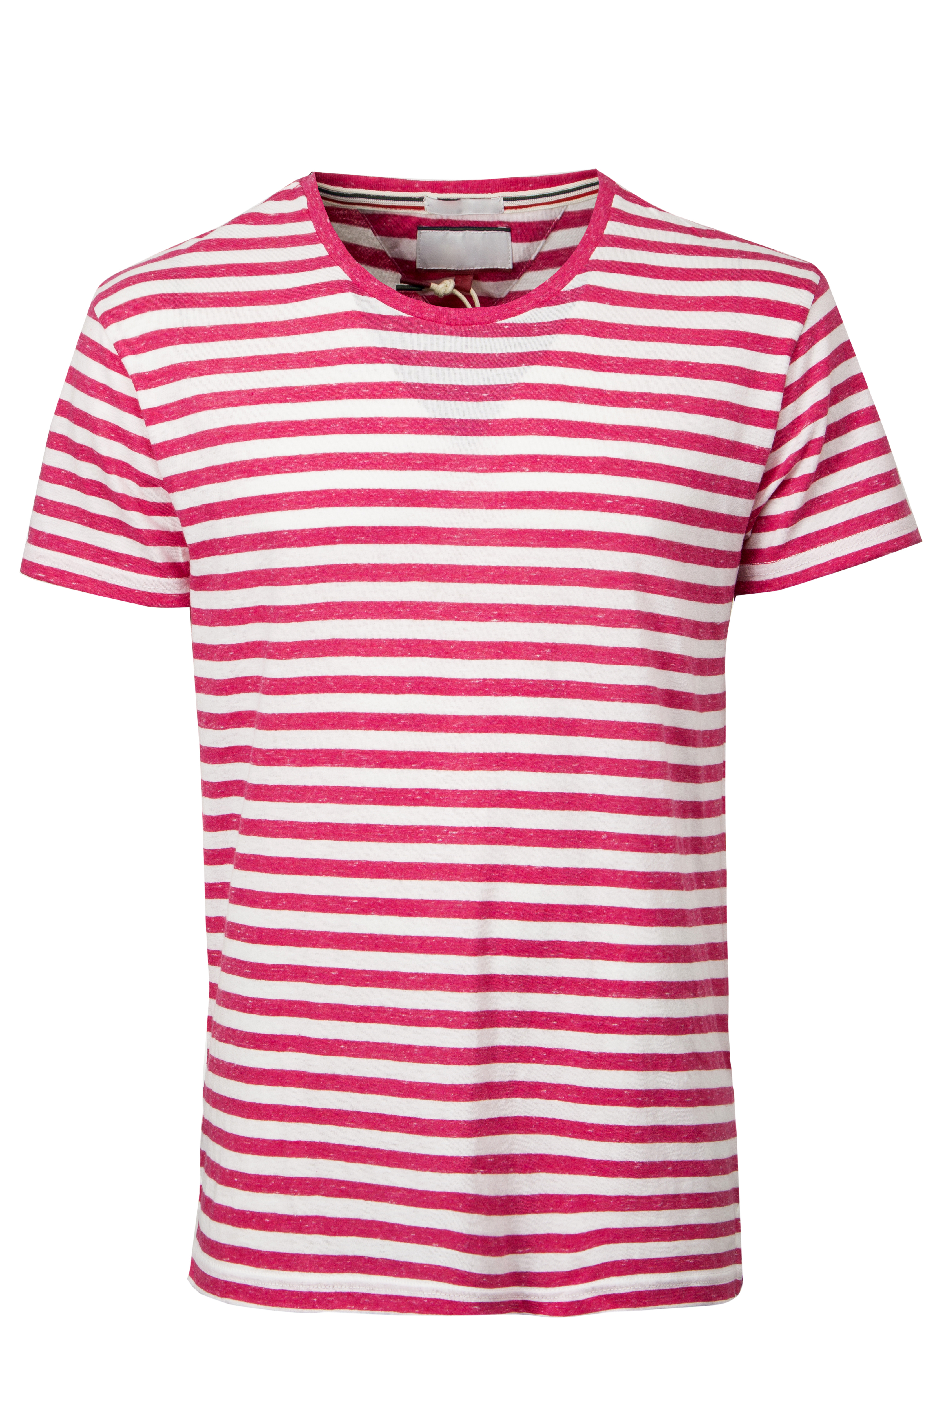
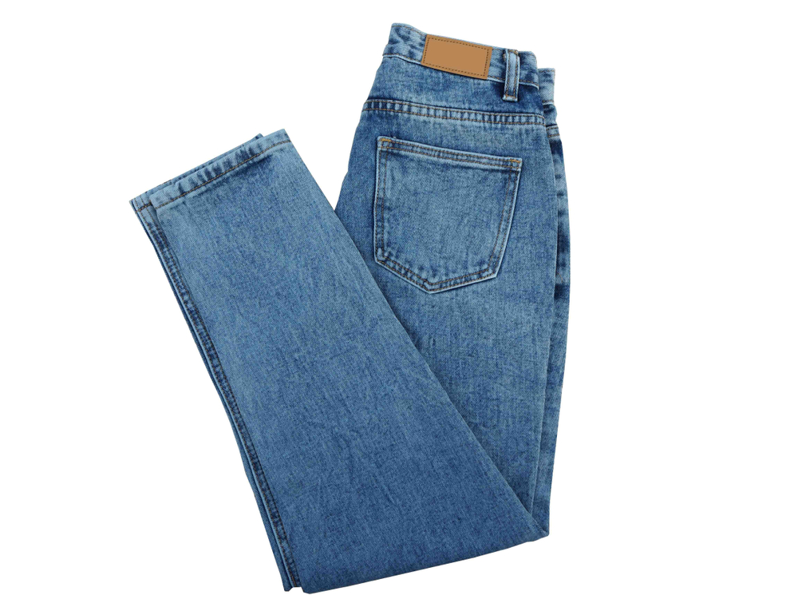
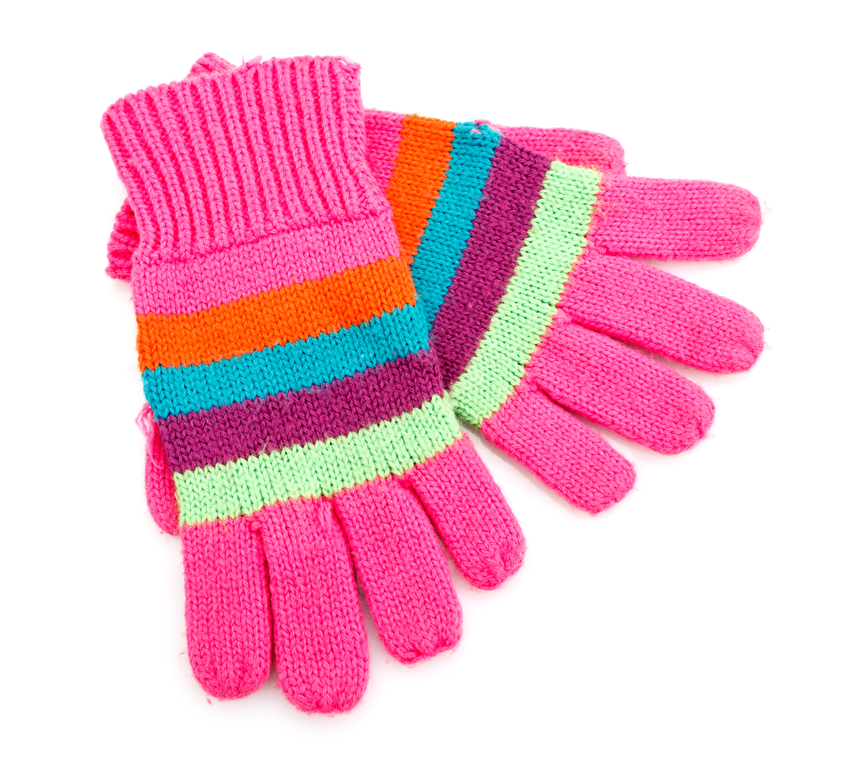
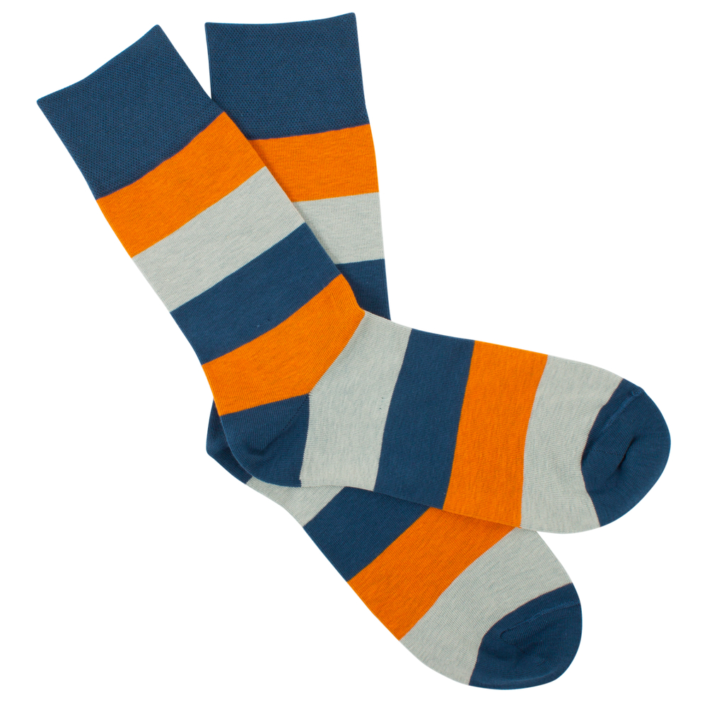

5. _________________ 6.___________________ 7.__________________ 8.______________________

D. Circle the correct form of the verb have got. (Rodeia a forma correta do verbo have got.)
1. My mother and I has got / have got nice hair.
2. Jodie and Martha haven’t got / hasn’t got glasses.

3. Chris has got / have got dark blue eyes.
Ariana Grande
4. She hasn’t got / haven’t got straight hair.
5. Our teacher have got / has got blue shorts.

E. Match the two columns. (Liga as duas colunas.)
Has Ariana got long hair? 1. |  | a) No, they haven’t. They have got shirts.
Has she got ten dogs? 2. |  | b) Yes, she has. She has got long hair.
Have Jessie and Leah got sweaters? 3. |  | c) No, they haven’t. Their hair is long.
Have they got short hair? 4. |  |   d) Yes, they have. They have got books.  Jessie and Leah
Have they got books? 5. |  | e) No, she hasn’t. She has got eight dogs.

F. Rewrite the sentences in the negative and in the interrogative. There is one example.
(Reescreve as frases na negativa e na interrogativa. Segue o exemplo.)

- I have got short hair.
Negative: I haven’t got short hair.
Interrogative: Have I got short hair?
1. My friends have got nice caps.
Negative: __________________________________________________________________.
Interrogative: _______________________________________________________________?
2. Sam has got two sisters.
Negative: __________________________________________________________________.
Interrogative: _______________________________________________________________?
3. Carol has got long legs.
Negative: __________________________________________________________________.
Interrogative: _______________________________________________________________?

G. Whose clothes are these? Follow the lines and circle the correct option. There is one example. (De quem são estas roupas? Segue as linhas e rodeia a opção correta. Segue o exemplo.)
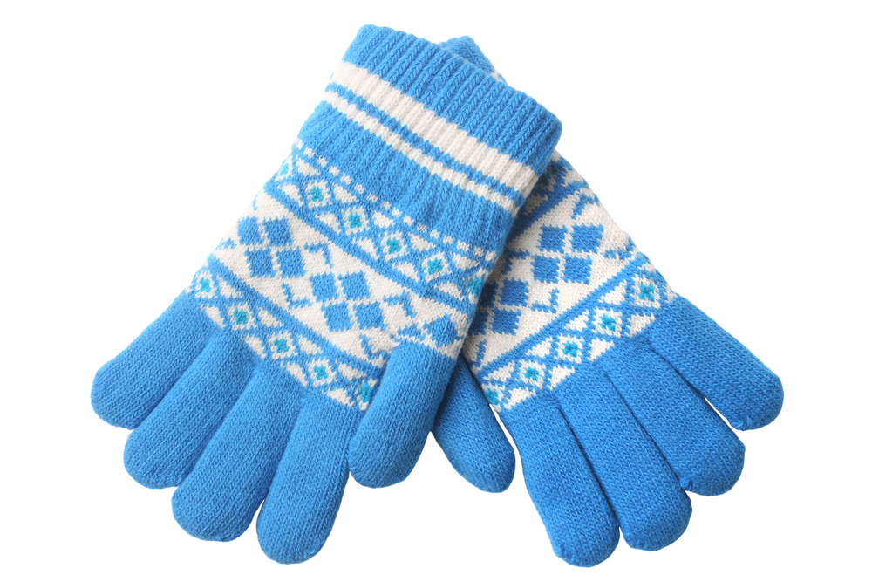
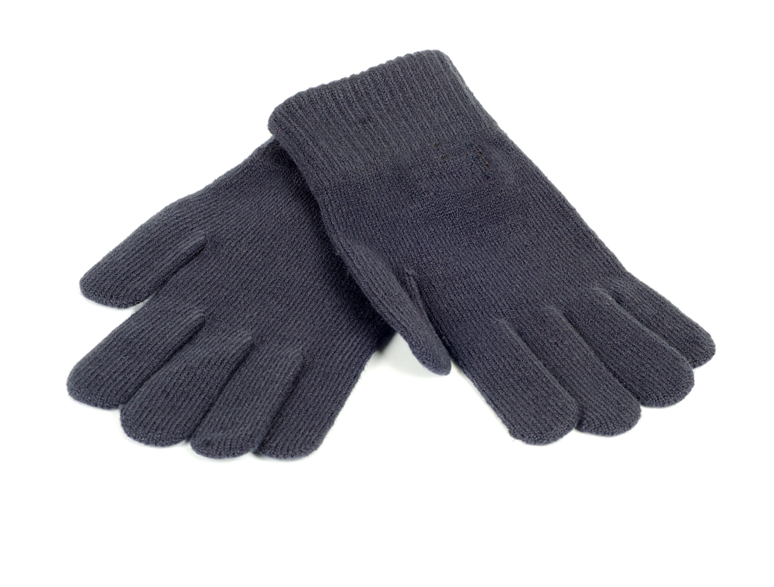
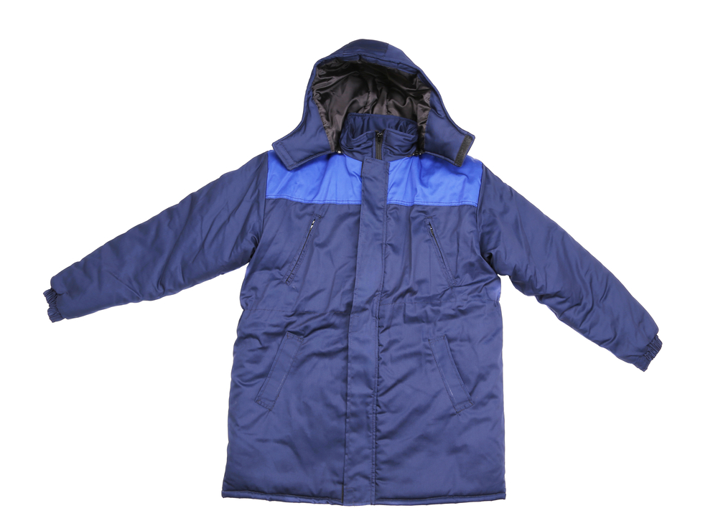
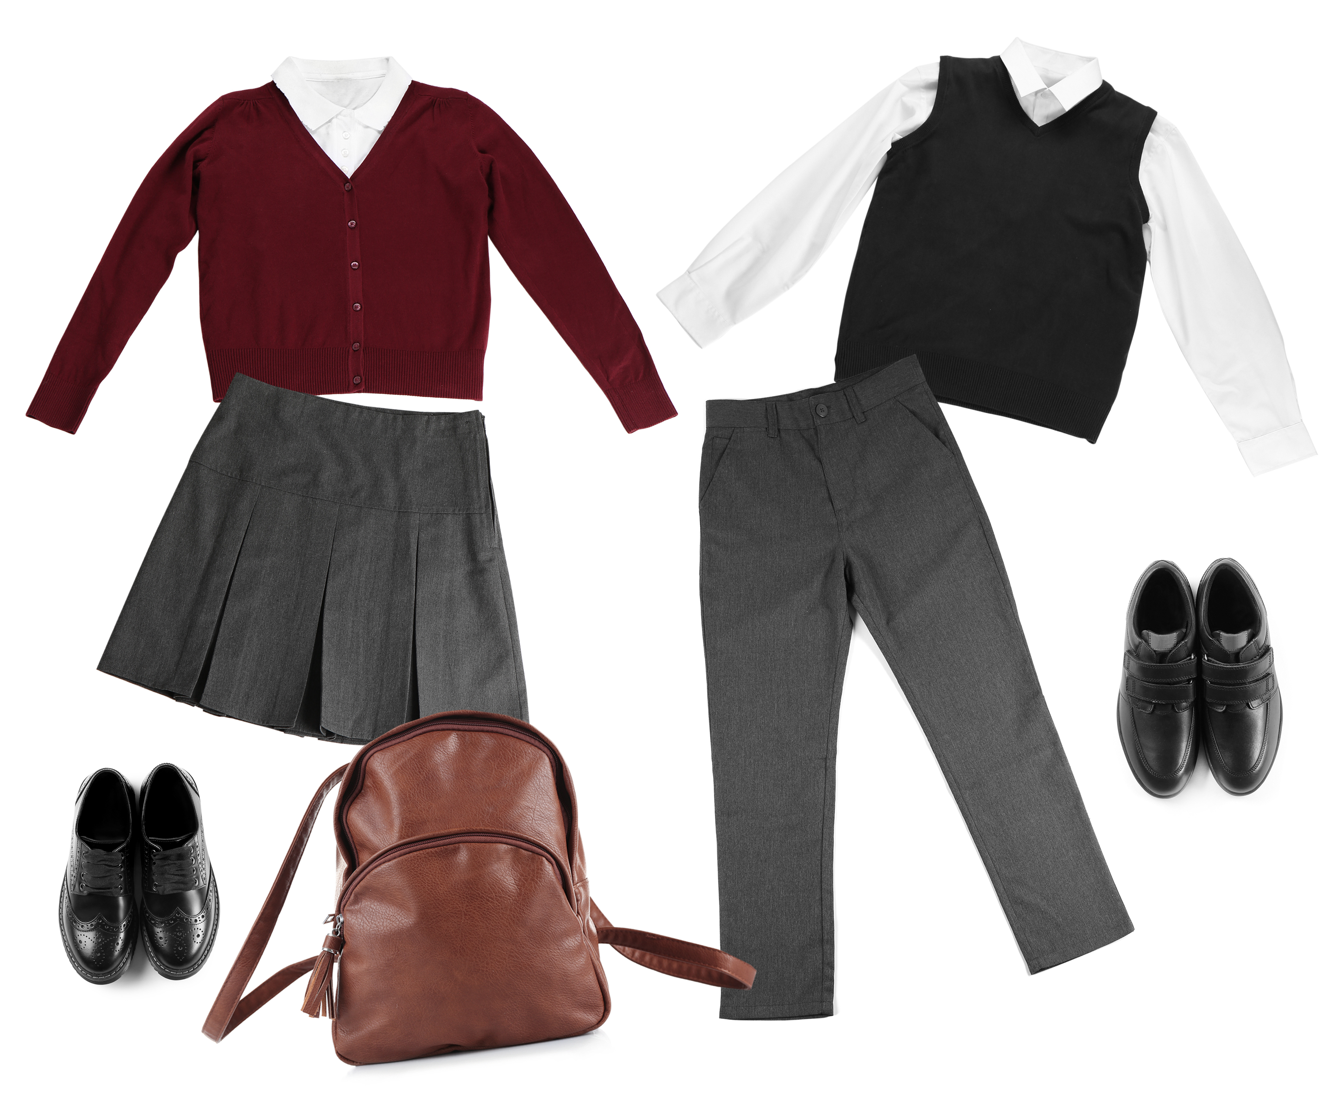
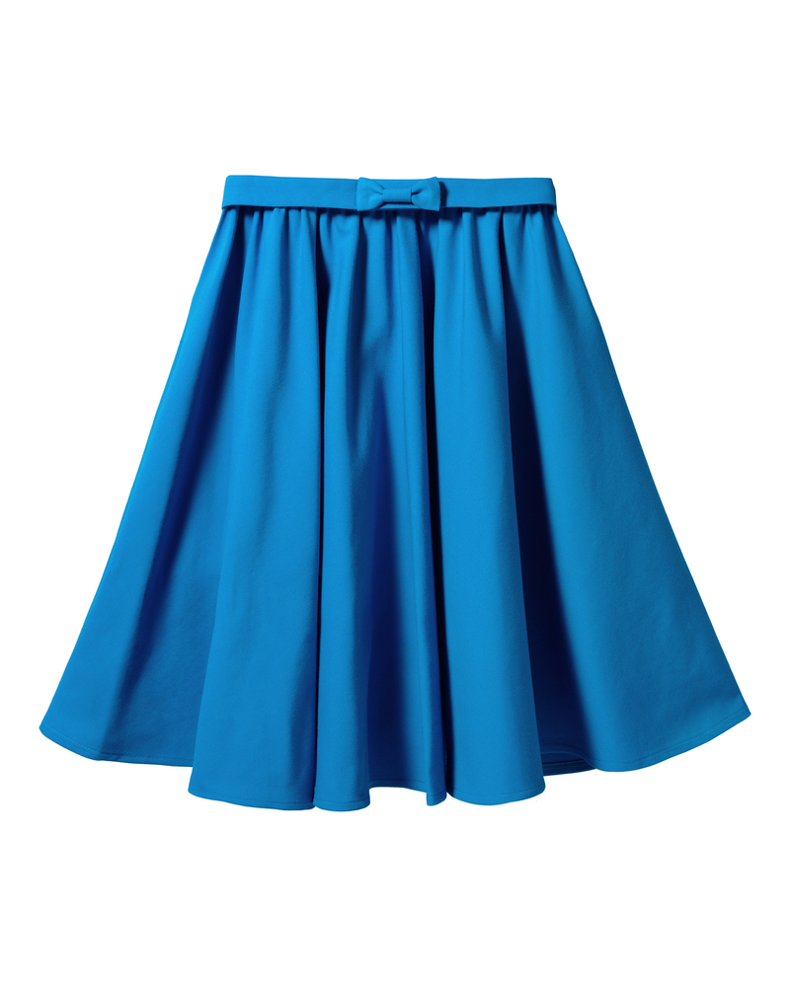
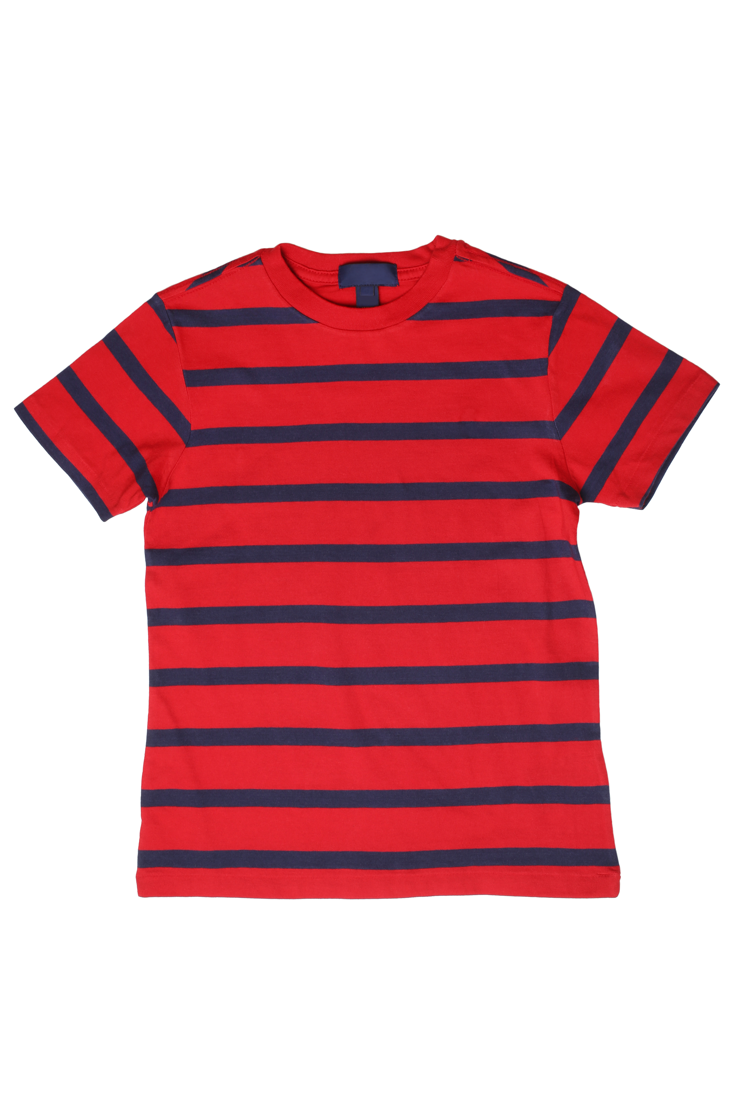
Andy and Peter
the students
Tim
Thomas
Rachel
4..
3.
2.
1.

- It’s Tim’s / Thomas’s T- shirt.
1. It’s Andy and Peter’s / Rachel’s skirt.
3. It’s Rachel’s / Thomas’s raincoat.
2. It’s the students’ / Tim’s uniform.
4. They’re Tim’s / Andy and Peter’s gloves.
H. Read the sentences and circle the correct possessive pronoun. There is one example.
(Lê as frases e rodeia o possessive pronoun correto. Segue o exemplo.)
- This isn’t my jacket. Mine / Ours is blue.
- This is your pencil. The pencil is theirs / yours.
- Those are our red shoes. They are ours / his.
- That is Anna’s house. The house is yours / hers.
- Those are Jack and Tom’s dogs. The dogs are theirs / ours.
- This is John’s new car. The car is mine / his.

I. Read the sentences and tick () the correct option. There is one example.
(Lê as frases e seleciona a opção correta. Segue o exemplo.)
- a) They have got cats white. b) They have got white cats.
- a) My parents have got a modern house. b) My parents have got a house modern.
- a) We are students polite. b) We are polite students.
- a) Ted is a boy shy. b) Ted is a shy boy.
- a) I have got a tall sister. b) I have got a sister tall.
- a) The teacher has got funny glasses. b) The teacher has got glasses funny.

J. Complete the text and circle the words about you.
(Completa o texto e rodeia as palavras que te caracterizam.)

Hello, my name is ___________________________________ and I’m ______________________________ years old.
I’m short / medium height / tall and slim / thin / fat.
My face is oval / round. I have got straight / wavy / curly hair and it is short / long and dark / blonde / brown / red. I have got big / small eyes and they are brown / black / green / blue.
I’m generous / intelligent / nice / shy.

Good work!
Your teacher

Answer key

A. (5 x 2 = 10%)
1. the United States of America | 2. twenty-five | 3. beautiful | 4. eight | 5. brown
B. (5 x 3 = 15%)
1. c) | 2. e) | 3. a) | 4. b) | 5. d)
C. (8 x 1 = 8%)
1. sweater | 2. dress | 3. shorts | 4. shirt | 5. gloves | 6. T-shirt | 7. socks | 8. jeans
D. (5 x 2 = 10%)
1. have got | 2. haven’t got | 3. has got | 4. hasn’t got | 5. has got
E. (5 x 2 = 10%)
1. b) | 2. e) | 3. a) | 4. c) | 5. d)
F. (3 x 2 = 6%)
1. My friends haven’t got nice caps. | Have my friends got nice caps?
2. Sam hasn’t got two sisters. | Has Sam got two sisters?
3. Carol hasn’t got long legs. | Has Carol got long legs?
G. (4 x 2 = 8%)
1. Rachel’s | 2. the students’ | 3. Thomas’s | 4. Andy and Peter’s
H. (5 x 2 = 10%)
1. yours | 2. ours | 3. hers | 4. theirs | 5. his
I. (5 x 2 = 10%)
1. a) My parents have got a modern house | 2. b) We are polite students | 3. b) Ted is a shy boy | 4. a) I have got a tall sister | 5. a) The teacher has got funny glasses.
J. (13%)
Personal answer.

