Progress Test 2C – Year 5
Name: ___________________________ Class: ______ No. ___ Date: ___________________
Teacher: _______________ Mark: ____________________ Enc. Educação___________________

- Label the pictures with the words from the box.
(Legenda as imagens com as palavras da caixa.)
socks sweater shirt
jeans shorts dress

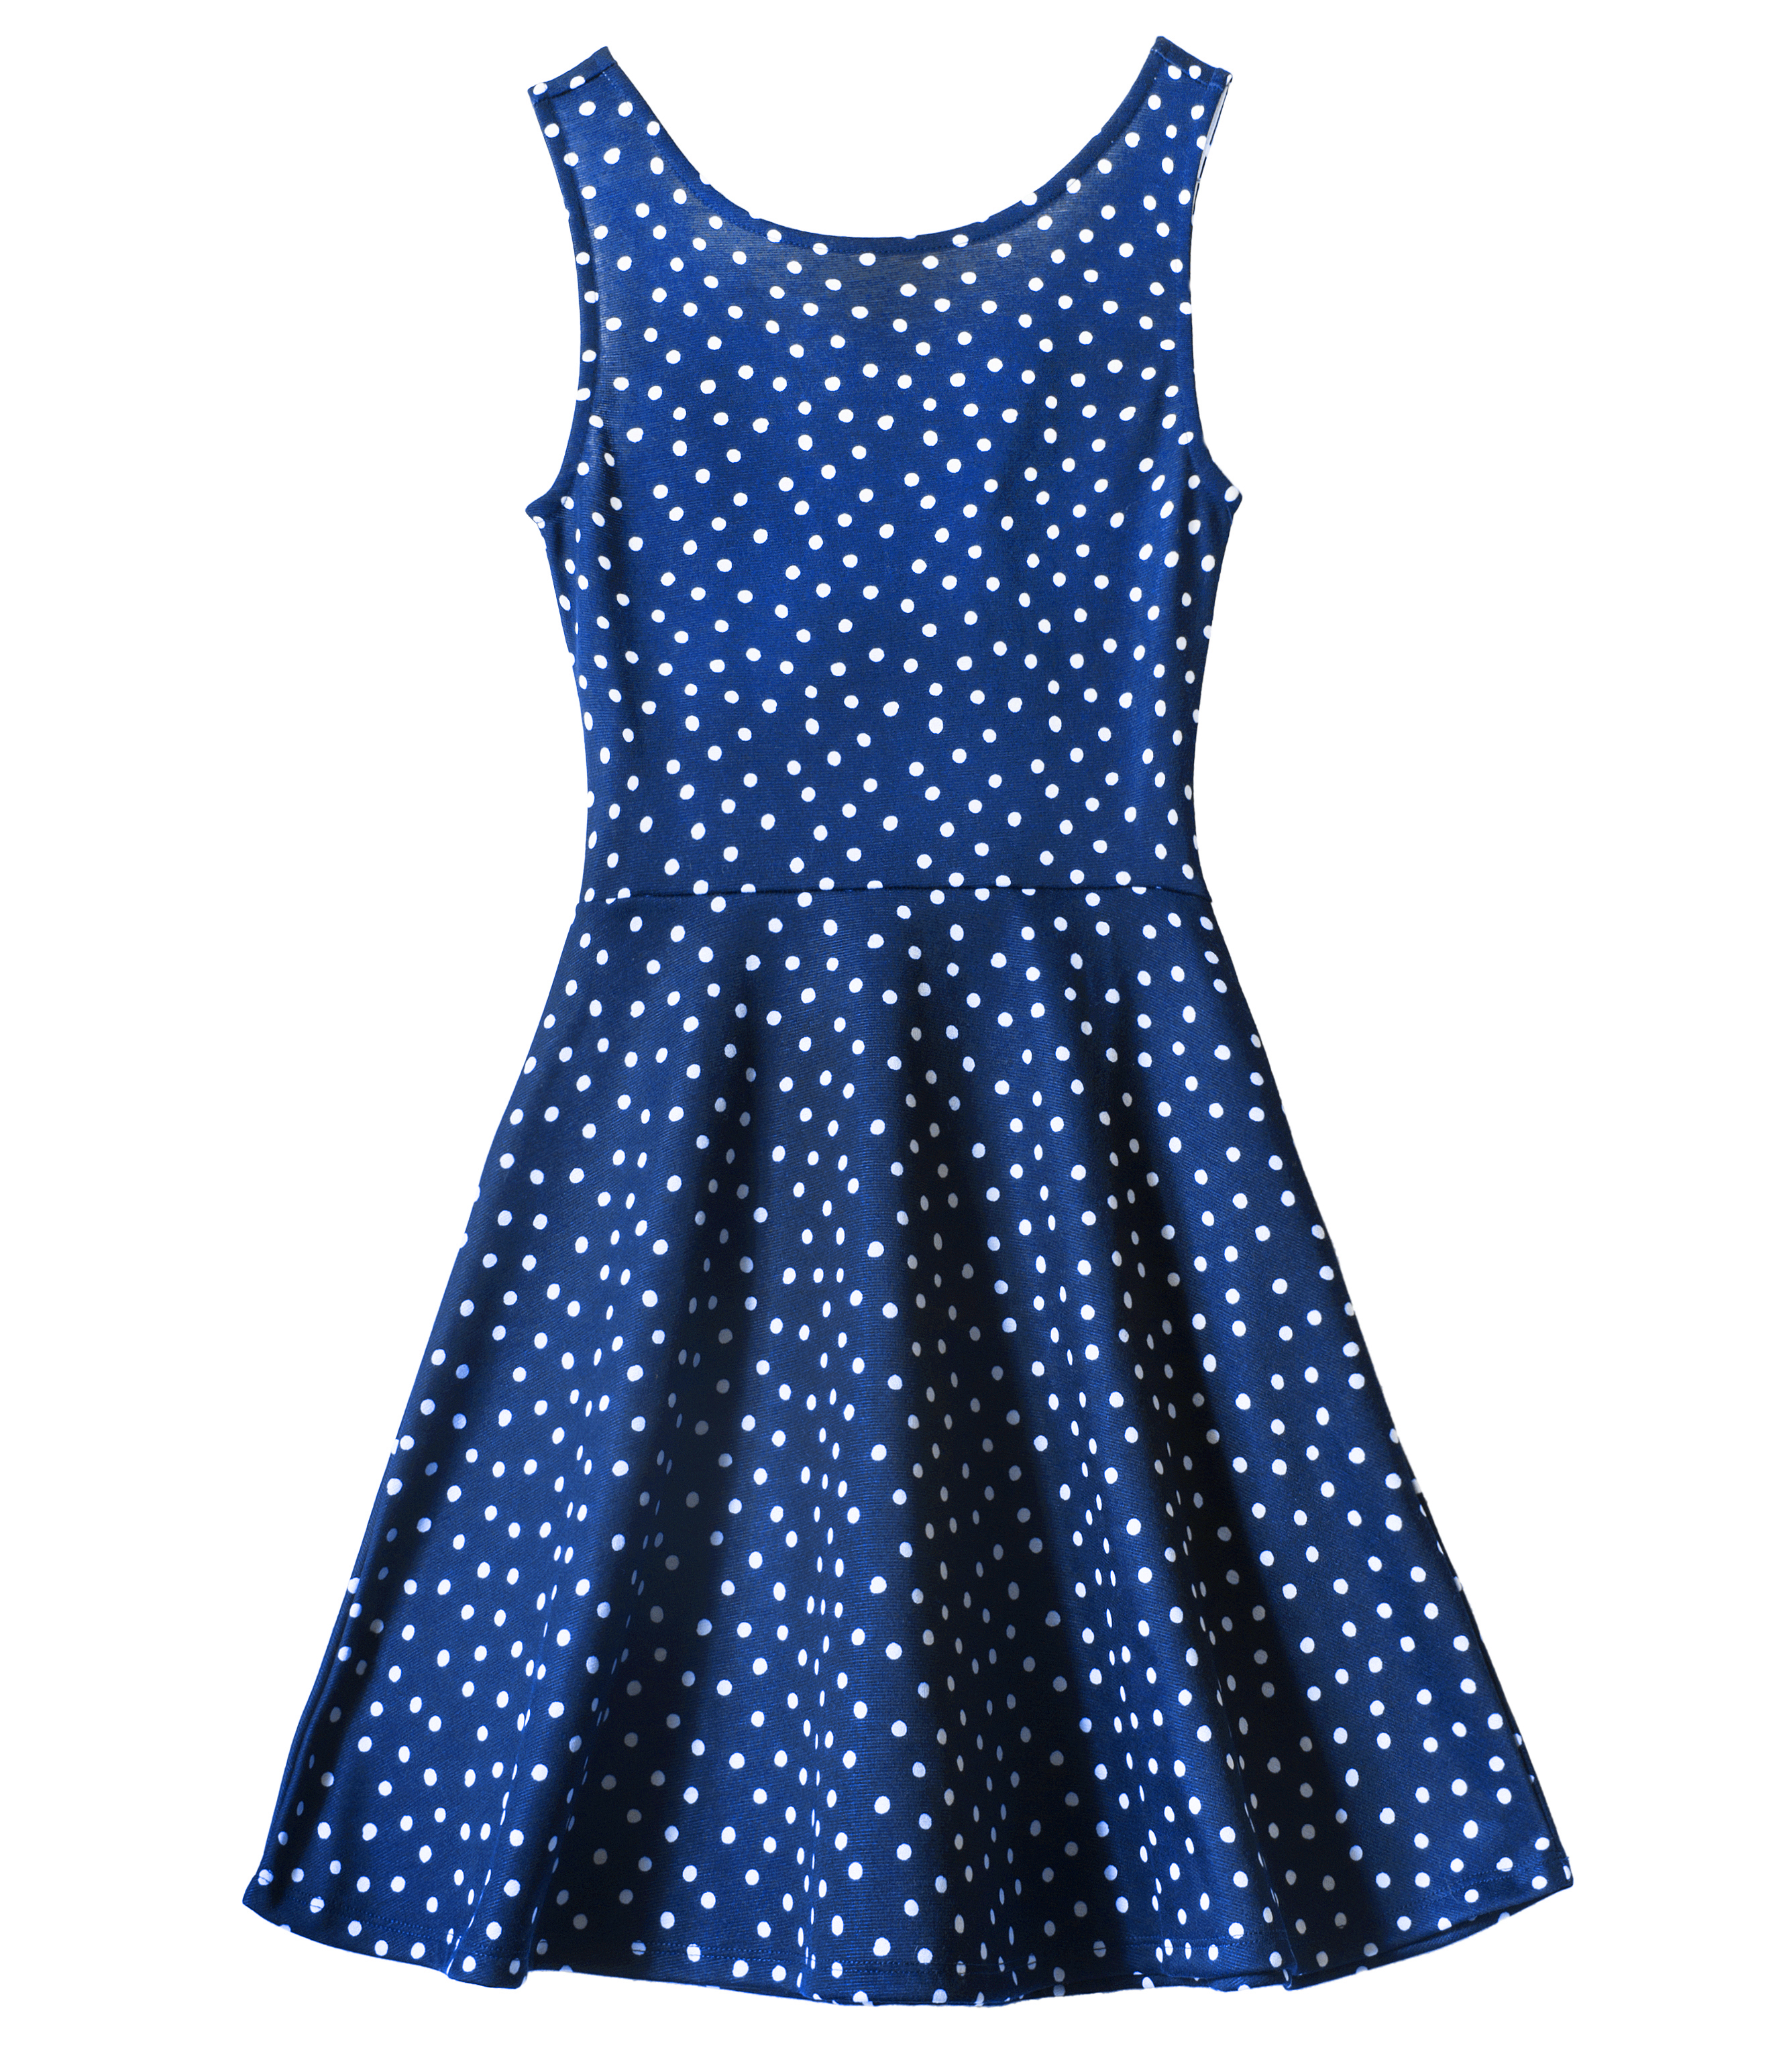
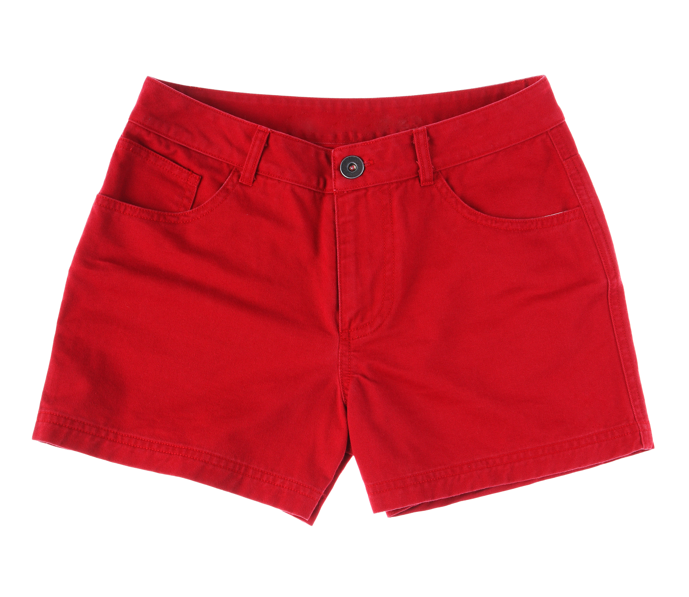
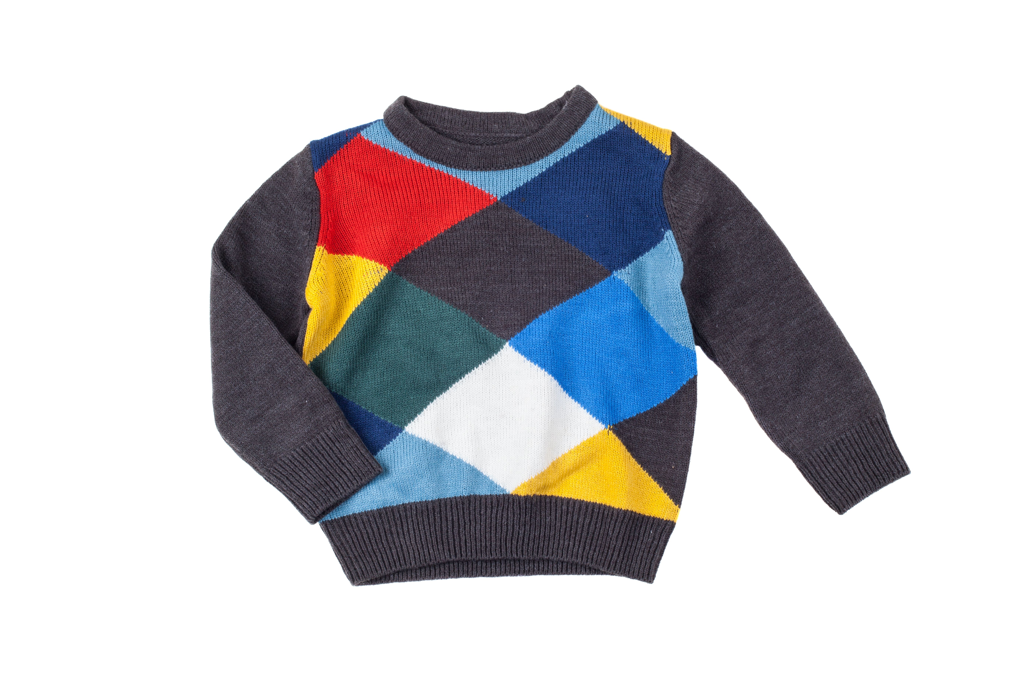

1. _______________ 2. _________________ 3. ________________
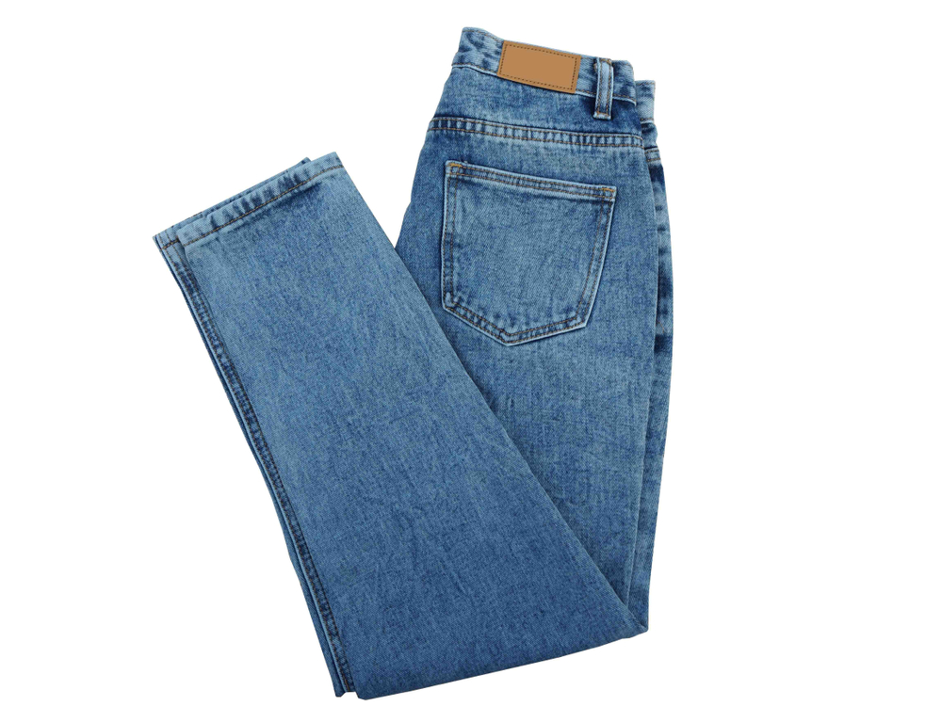
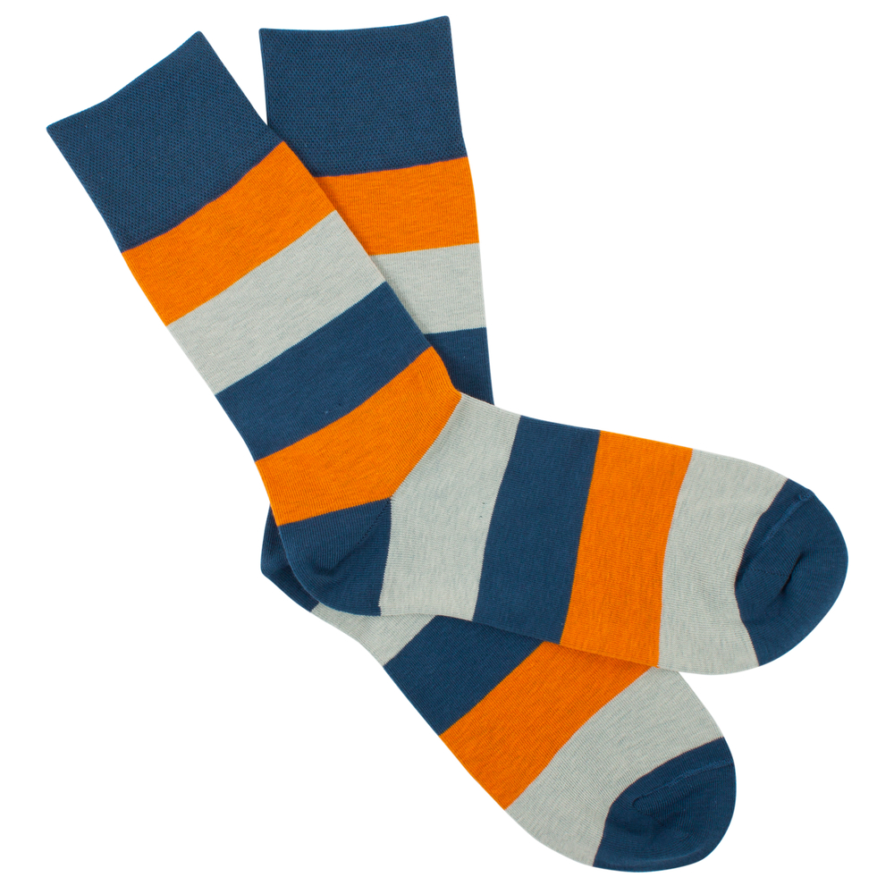
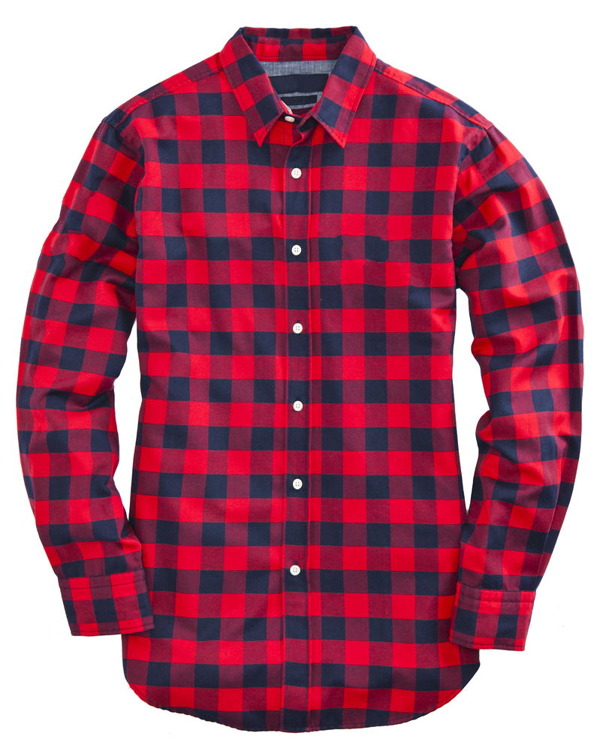

5. _______________ 6. ________________ 7. _________________

- Underline the correct form of the verb have got.
(Sublinha a forma correta do verbo have got.)

1. We has got / have got long hair.
2. They haven’t got / hasn’t got glasses.
3. He have got / has got dark blue eyes.
4. She hasn’t got / haven’t got straight hair.

C. Match the two columns. There is one example. (Liga as duas colunas. Segue o exemplo.)

1. Has Ariana got long hair? () |  | a) No, they haven’t.
2. Has she got ten dogs? () |  | b) Yes, she has.
3. Have Jessie and Leah got sweaters? () |  | c) No, he hasn’t.
4. Has Tom got short hair? () |  | d) Yes, they have.
5. Have they got presents? () |  | e) No, she hasn’t.

- Read the sentences and circle the correct option. There is one example.
Lê as frases e rodeia a opção correta. Segue o exemplo.)

- It’s Tim’s / Tim’ T- shirt.
1. It’s Rachel’ / Rachel’s skirt.
2. It’s the students’ / the students’s uniform.
3. It’s Thomas’ / Thomas’s raincoat.
4. They’re Andy’s and Peter / Andy and Peter’s gloves.

E. Read the sentences and circle the correct possessive pronoun. There is one example.
(Lê as frases e rodeia o possessive pronoun correto. Segue o exemplo.)
- This isn’t my jacket. Mine / Ours is blue.
1. This is your pencil. The pencil is theirs / yours.
2. Those are our red shoes. They are ours / his.
3. That is Anna’s house. The house is yours / hers.
4. Those are Jack and Tom’s dogs. The dogs are theirs / ours.

F. Answer the questions about you. (Responde às perguntas sobre ti.)
1. What’s your name? – My name is _____________________________________.
2. How old are you? – I’m ___________________ years old.
3. What colour is your hair? – My hair is _____________________.
4. Have you got long hair or short hair? – I have got ______________ hair.
5. What colour are your eyes? – My eyes are ______________________.

Good work!
Your teacher

Answer key

A. (6 x 4 = 24%)
1. sweater | 2. dress | 3. shorts | 4. shirt | 5. socks | 6. jeans
B. (4 x 4 = 16%)
1. have got | 2. haven’t got | 3. has got | 4. hasn’t got
C. (4 x 3 = 12%)
2. e) | 3. a) | 4. c) | 5. d)
D. (4 x 4 = 16%)
1. Rachel’s | 2. the students’ | 3. Thomas’s | 4. Andy and Peter’s
E. (4 x 3 = 12%)
1. yours | 2. ours | 3. hers | 4. theirs
F. (5 x 4 = 20%)
Personal answer

