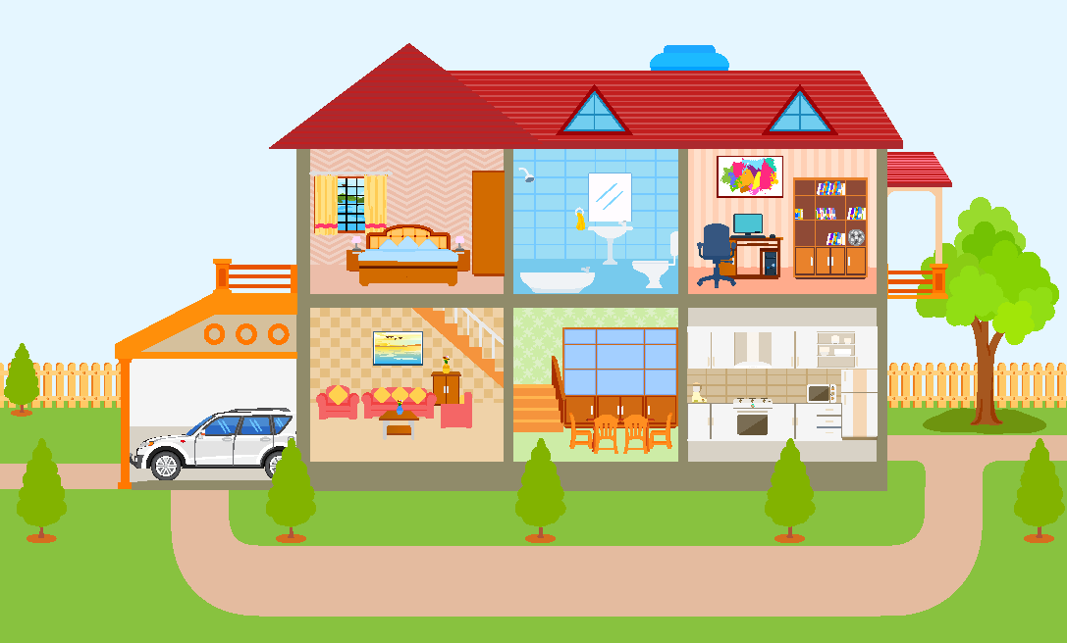
5
1
2
3
4
6
7
8
9
A. Write the names of the parts of the house.

1. |  | 4. |  | 7.
2. |  | 5. |  | 8.
3. |  | 6. |  | 9.

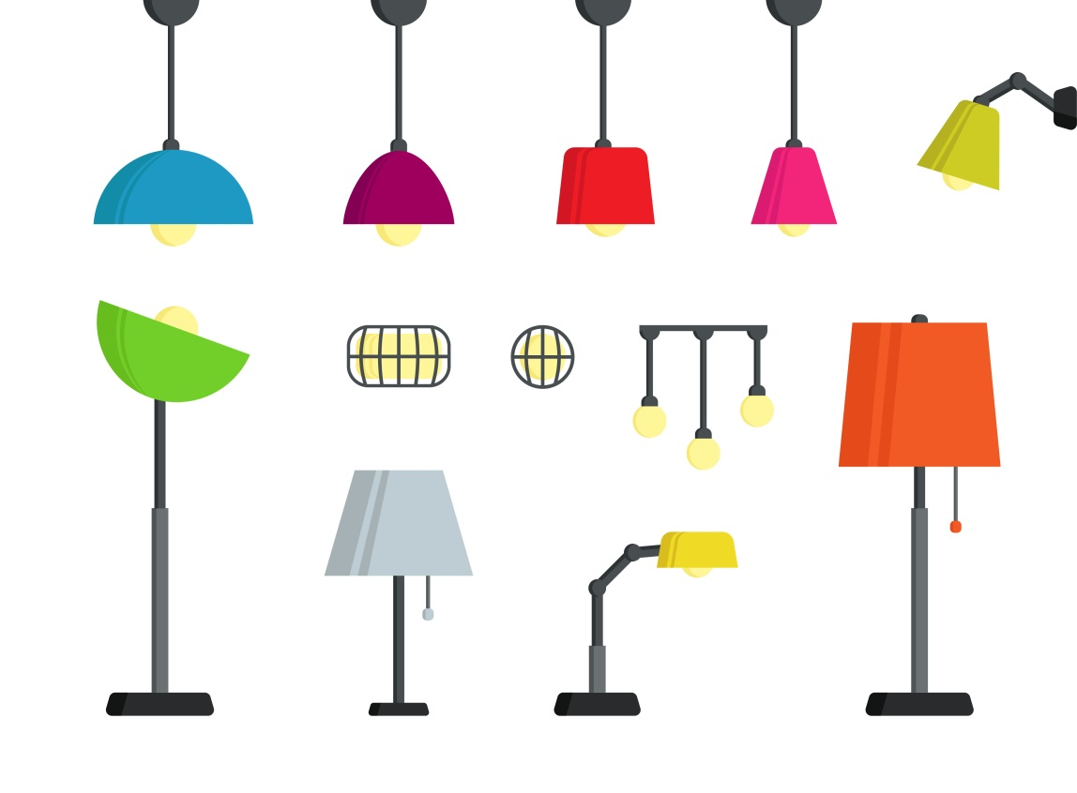

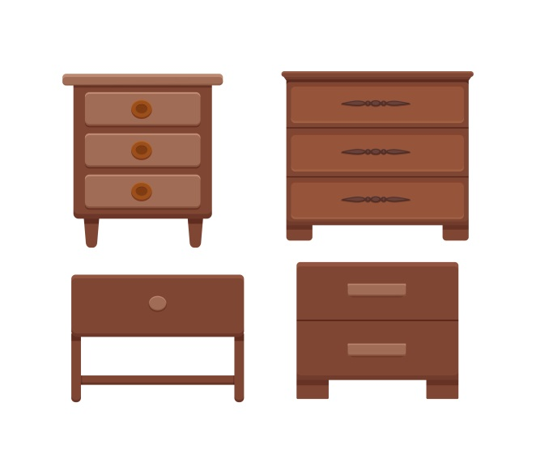
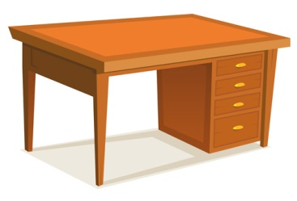
B. Label the furniture.

1. ______________ 2. ______________ 3. ______________ 4. __________________
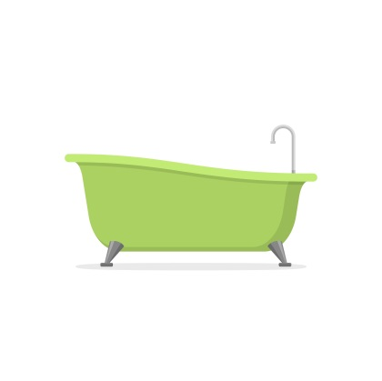
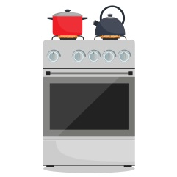
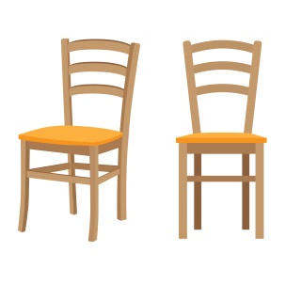
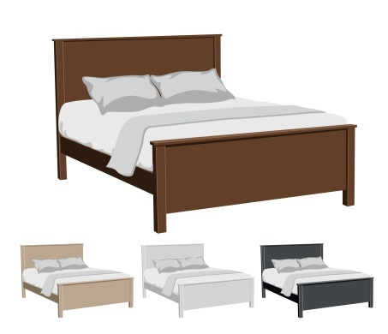

5. ______________ 6. ______________ 7. ________________ 8. ______________
C. Complete the sentences with There is or There are.
1. _____________ a garden outside. | 4. _____________ a car in the garage.
2. _____________ four chairs in the kitchen. | 5. _____________ an attic in my house.
3. _____________ some books in the study. | 6. _____________ two bedrooms upstairs.

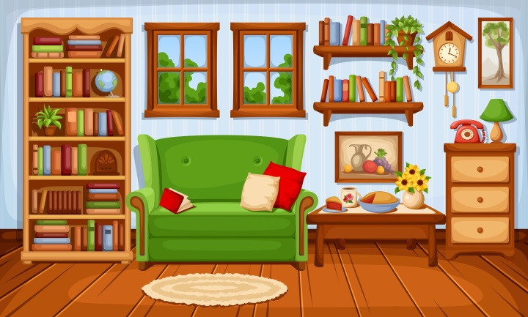
D. Look at the picture and write There is / There isn’t / There are / There aren’t.
- _______________ a sofa.
- _______________ a bed.
- _______________ an chair.
- _______________ two windows.
- _______________ a lamp.
- _______________ a lot of books.
- _______________ three rugs.
E. Complete the questions and answers using there + to be.
- _________________ a garden in your house? Yes, _________________.
- _________________ two bedrooms in your house? No, ________________.
- _________________ a kitchen downstairs? No, _________________.
- _________________ two bathrooms upstairs? Yes, _________________.
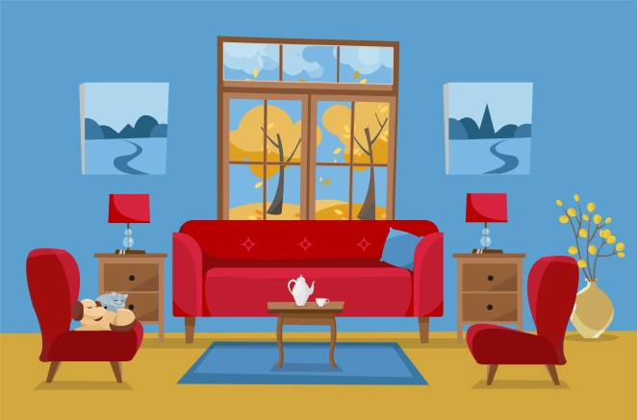
F. Complete the sentences with prepositions of place.
- The two small cupboards are ________________ the sofa.
- The window is ________________ the sofa.
- The cat is ________________ the armchair.
- The table is ________________ the sofa.
G. Complete the table with the plural of the nouns.
Singular | Plural | Singular | Plural
1. boy |  | 4. child
2. baby |  | 5. cooker
3. woman |  | 6. box
Answer key
A.
1. bedroom | 2. bathroom | 3. study | 4. balcony | 5. garage | 6. living room | 7. dining room | 8. kitchen |
9. garden
B.
1. lamp | 2. rug | 3. bedside table | 4. desk | 5. bath | 6. cooker | 7. bed | 8. chair
C.
1. There is | 2. There are | 3. There are | 4. There is | 5. There is | 6. There are
D.
1. There is | 2. There isn’t | 3. There isn’t | 4. There are | 5. There is | 6. There are | 7. There aren’t
E.
1. Is there… there is | 2. Are there… there aren’t | 3. Is there… there isn’t | 4. Are there… there are
F.
1. next to | 2. behind | 3. on | 4. in front of
G.
1. boys | 2. babies | 3. women | 4. children | 5. cookers | 6. boxes

