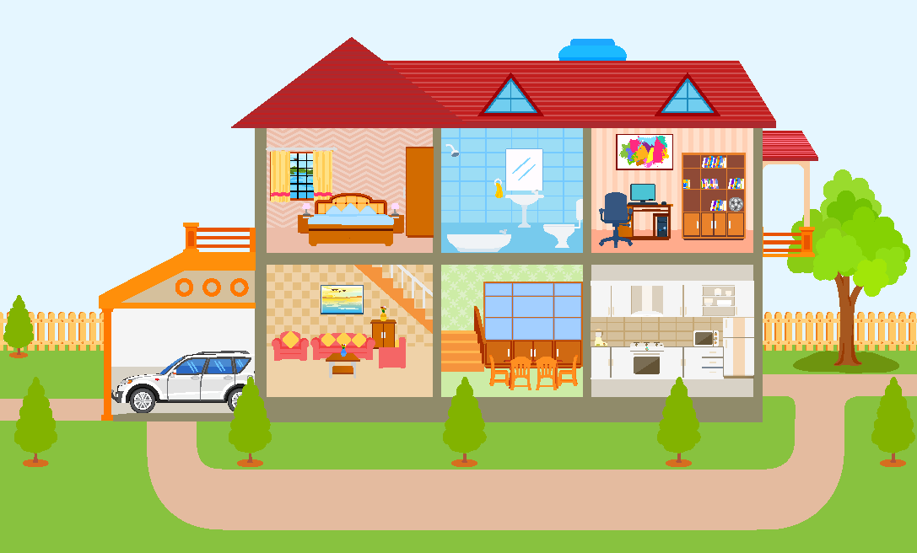
A. Complete the names of the parts of the house. (Completa os nomes das partes da casa.)
5
1
2
3
4
6
7
8
9

1. B___D___OO___ | 4. B___L___O___Y | 7. D___N___NG ___OO___
2. B___T___R___ ___ M | 5. G___R___G___ | 8. K___T___H___N
3. ___T___D___ | 6. L___V___N___ R___ ___M | 9. G___R___E___

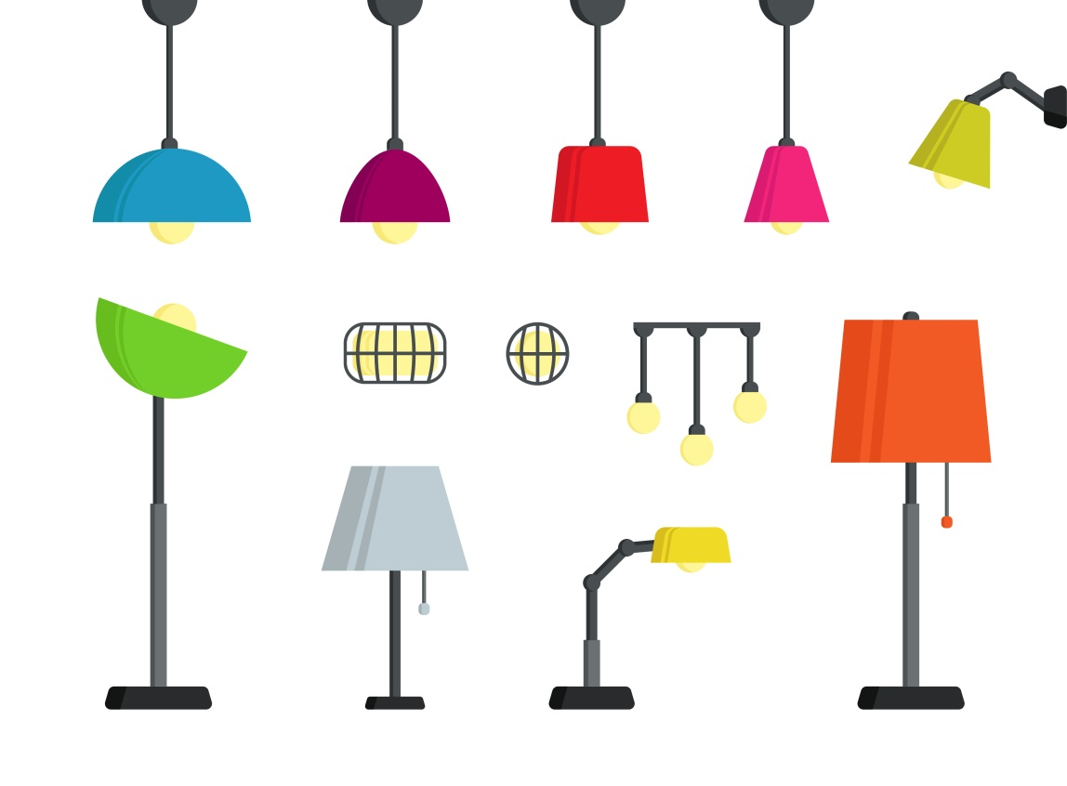

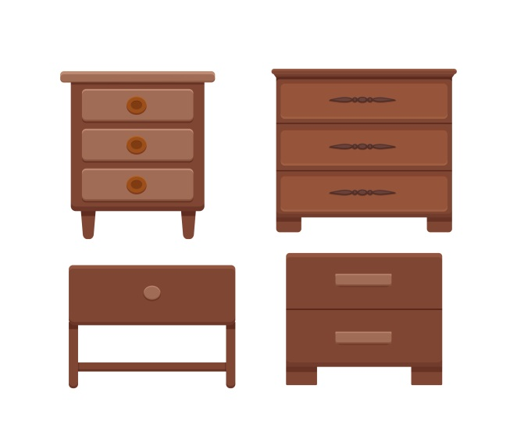
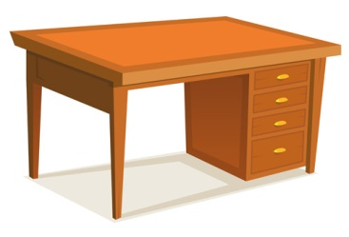
B. Label the furniture. (Legenda o mobiliário.)

1. L______________ 2. R______________ 3. B________ T_________ 4. D_________________
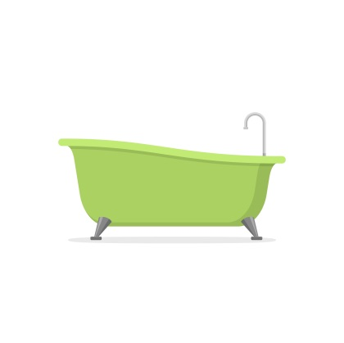
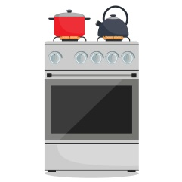
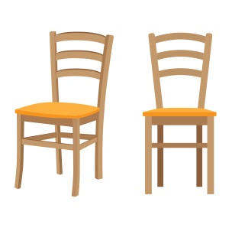
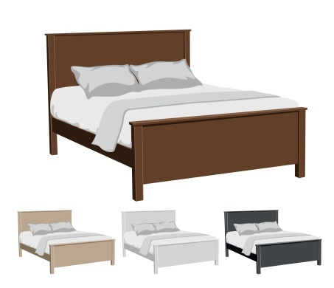

5. B______________ 6. C_______________ 7. B_____________________ 8. C______________
C. Complete the sentences with There is or There are.
(Completa as frases com There is ou There are.)
1. _____________ a garden outside. | 4. _____________ a car in the garage.
2. _____________ four chairs in the kitchen. | 5. _____________ an attic in my house.
3. _____________ some books in the study. | 6. _____________ two bedrooms upstairs.

D. Look at the picture and write There is / There isn’t / There are / There aren’t.
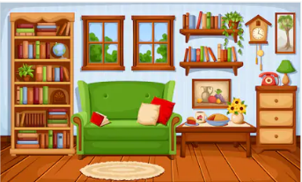
(Observa a imagem e escreve There is (existe) / There isn’t (não existe) / There are (existem) / There aren’t (não existem).)
- _______________ a sofa.
- _______________ a bed.
- _______________ an chair.
- _______________ two windows.
- _______________ a lamp.
- _______________ a lot of books.
- _______________ three rugs.
E. Circle the correct option.
(Rodeia a opção correta.)
- Is / Are there a garden in your house? Yes, there is / isn’t.
- Is / Are there two bedrooms in your house? No, there are / aren’t.
- Is / Are there a kitchen downstairs? No, there is / isn’t.
- Is / Are there two bathrooms upstairs? Yes, there are / aren’t.
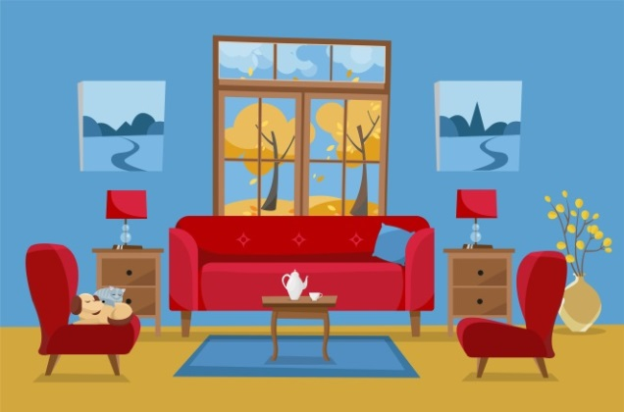
F. Circle the correct preposition of place.
(Rodeia as prepositions of place corretas.)
- The two small cupboards are above / next to the sofa.
- The window is behind / under the sofa.
- The cat is on / in the armchair.
- The table is in front of / above the sofa.

G. Complete the table with the plural of the nouns.
(Completa a tabela com o plural dos nomes.)
Singular | Plural | Singular | Plural
1. boy | bo_______ | 4. child | child_______
2. baby | ba_______ | 5. cooker | cooker_______
3. woman | wom_______ | 6. box | box_______
Answer key
A.
1. bedroom | 2. bathroom | 3. study | 4. balcony | 5. garage | 6. living room | 7. dining room | 8. kitchen |
9. garden
B.
1. lamp | 2. rug | 3. bedside table | 4. desk | 5. bath | 6. cooker | 7. bed | 8. chair
C.
1. There is | 2. There are | 3. There are | 4. There is | 5. There is | 6. There are
D.
1. There is | 2. There isn’t | 3. There isn’t | 4. There are | 5. There is | 6. There are | 7. There aren’t
E.
1. Is… is | 2. Are… aren’t | 3. Is… isn’t | 4. Are… are
F.
1. next to | 2. behind | 3. on | 4. in front of
G.
1. boys | 2. babies | 3. women | 4. children | 5. cookers | 6. boxes

