Read the text.

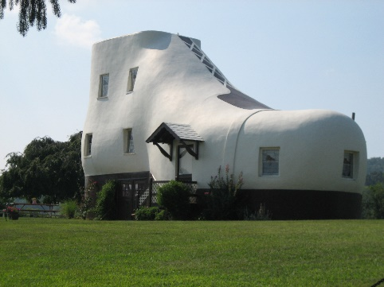
The Haines Shoe House
Hello! My name is Jane Haines and this is my uncle’s house: the Haines Shoe House. It’s a different type of house because it’s a big shoe!
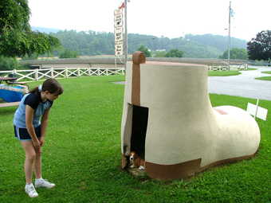
This house is in Pennsylvania, in the United States of America. There is a living room in the toe¹ and a kitchen in the ankle². The living room is my favourite part of the house! There are two bedrooms and two bathrooms, but there isn’t a dining room. Outside there is a big garden. It’s beautiful!
Next to the house, there is a doghouse and it is special because it’s also a shoe! Isn’t it funny? My dog, Peanut, and I love playing there!

Word check: ¹ toe = dedo do pé; ² ankle = tornozelo

A. Complete the sentences with ONE word.
- Jane’s surname is _______________.
- This house is a big _______________.
- In the ankle, there is a _______________.
- The house has got _______________ bedrooms.
- There is a _______________ outside.
B. Answer the questions about the text. Give complete answers.
- Where is the Haines Shoe House?
____________________________________________________________________
- Which is Jane’s favourite part of the house?
____________________________________________________________________
- Is there a dining room in the shoe house?
____________________________________________________________________
- Is the garden beautiful?
____________________________________________________________________
- Why is the doghouse special?
_____________________________________________________________________
C. Look at the pictures and complete the text about the Haines Shoe House.
The Haines Shoe House is a special house because it’s a shoe. In the bedroom there is a
⁽¹⁾ ___________________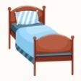, a ⁽²⁾ ________________________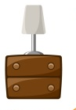and a
⁽³⁾ ________________________ 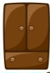 .
In the kitchen there is a ⁽⁴⁾ ___________________ 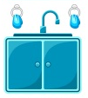and a ⁽⁵⁾ ______________ 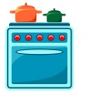.
The bathroom has got a ⁽⁶⁾ __________________ 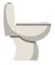, and a ⁽⁷⁾ _____________________ .
D. Complete the sentences with There is or There are.
- ________________________ an attic in my house.
- ________________________ two bedrooms in the Shoe House.
- ________________________ a doghouse next to the Shoe House.
- ________________________ some flowers in the garden.
- ________________________ a garden in front of the house.
E. Look at the picture. Make questions and answers with there + to be. There is an example.


- Is there a bed in the bedroom? Yes, there is.
- _______________ a chair in the bedroom? _____________________.
- _______________ books in the bookcase? _____________________.
- _______________ two lamps on the desk? _____________________.
- _______________ a bookcase in the bedroom? _____________________.
- _______________ a wardrobe in the bedroom? _____________________.
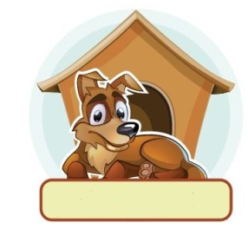
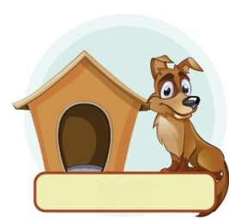
F. Complete the sentences with the correct preposition of place.

1. Peanut is the doghouse. 2. Peanut is the doghouse.

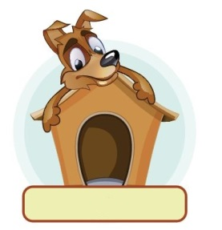

3. Peanut is the doghouse. 4. Peanut is the doghouse.

G. Complete the table with the plural of nouns.
Singular | Plural
1. watch
2. book
3. child
4. baby
5. man

H. This is Jane’s house. Describe it. Don’t forget to mention:
  - parts of the house
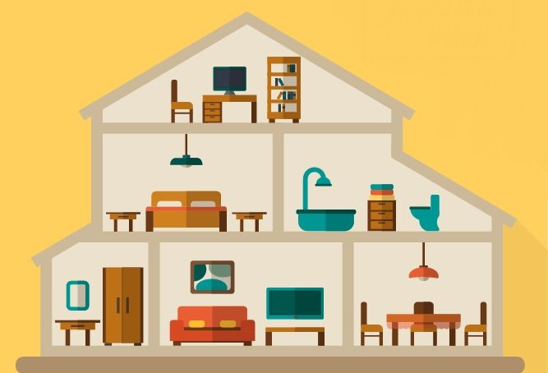
  - furniture
________________________________________________________________________________________________________________________________________________________________________________________________________________________________________________________________________________________________________________________________________________________________
Answer key
A. 5 x 3% = 15%
1. Haines | 2. shoe | 3. kitchen | 4. two | 5. garden
B. 5 x 4% = 20%
1. It’s in Pennsylvania, in the United States of America. | 2. Jane’s favourite part of the house is the living room. | 3. No, there isn’t. | 4. Yes, it is. | 4. The doghouse is special because it is also a shoe.
C. 7 x 1% = 7%
1. bed | 2. bedside table | 3. wardrobe | 4. sink | 5. cooker | 6. toilet | 7. washbasin
D. 5 x 2% = 10%
1. There is | 2. There are | 3. There is | 4. There are | 5. There is
E. 5 x 2% = 10%
1. Is there… No, there isn’t. | 2. Are there… Yes, there are. | 3. Are there… No, there aren’t. | 4. Is there… Yes, there is. | 5. Is there… No, there isn’t.
F. 4 x 2% = 8%
1. next to | 2. in front of | 3. on | 4. in
G. 5 x 2% = 10%
1. watches | 2. books | 3. children | 4. babies | 5. men
H. 20%
Suggested answer:
This is Jane’s house. Downstairs there is a hall, a living room and a dining room. Upstairs there is a bedroom and a bathroom. The bedroom has got a bed and two bedside tables. In the attic, there is a chair, a desk and a bookcase. It’s a beautiful house.

