Read the text.

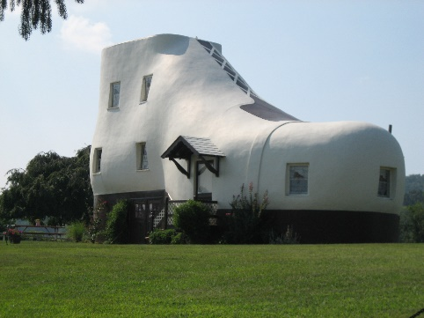
The Haines Shoe House
Hello! My name is Jane Haines and this is my uncle’s house: the Haines Shoe House. It’s a different type of house because it’s a big shoe!
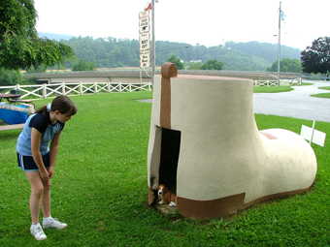
This house is in Pennsylvania, in the United States of America. There is a living room in the toe¹ and a kitchen in the ankle². The living room is my favourite part of the house! There are two bedrooms and two bathrooms, but there isn’t a dining room. Outside there is a big garden. It’s beautiful!
Next to the house, there is a doghouse and it is special because it’s also a shoe! Isn’t it funny? My dog, Peanut, and I love playing there!
Word check: ¹ toe = dedo do pé; ² ankle = tornozelo

A. Complete the sentences using with a word from the box. (Completa as frases usando uma palavra da caixa.)
- Jane’s surname is _____________.
garden Haines
kitchen
shoe two

- This house is a big _____________.
- In the ankle, there is a _____________.
- The house has got _____________ bedrooms.
- There is a _____________ outside.
B. Match the questions with the answers. (Liga as perguntas às respostas.)
Where is the Haines Shoe House? 1. |  | a) Jane’s favourite part of the house is the living room.
Which is Jane’s favourite part of the house? 2. |  | b) Yes, it is.
Is there a dining room in the shoe house? 3. |  | c) The doghouse is special because it is also a shoe.
Is the garden beautiful? 4. |  | d) It’s in Pennsylvania, in the United States of America.
Why is the doghouse special? 5. |  | e) No, there isn’t.

1. ______ 2. ______ 3. ______ 4. ______ 5. ______
C. Look at the pictures and complete the text. Use the words from the box.
(Observa as imagens e completa o texto. Usa as palavras da caixa.)
washbasin bed cooker wardrobe sink toilet bedside table

The Haines Shoe House is a special house because it’s a shoe. In the bedroom there is a
⁽¹⁾ ___________________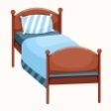, a ⁽²⁾ ________________________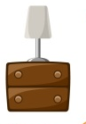and a
⁽³⁾ ________________________ 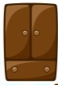 .
In the kitchen there is a ⁽⁴⁾ ___________________ 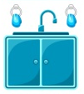and a ⁽⁵⁾ _______________ 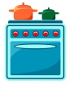.
The bathroom has got a ⁽⁶⁾ __________________ 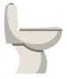, and a ⁽⁷⁾ ________________________ .
D. Complete the sentences with There is or There are. (Completa as frases com There is ou There are.)
- ________________________ an attic in my house.
- ________________________ two bedrooms in the Shoe House.
- ________________________ a doghouse next to the Shoe House.
- ________________________ some flowers in the garden.
- ________________________ a garden in front of the house.
E. Look at the picture. Circle the correct option to complete the sentences.
(Observa a imagem. Rodeia a opção correta para completar as frases.)


- Is there / Are there a chair in the bedroom? Yes, there is. / No, there isn’t.
- Is there / Are there books in the bookcase? Yes, there are. / No, there aren’t.
- Is there / Are there two lamps on the desk? Yes, there are. / No, there aren’t.
- Is there / Are there a bookcase in the bedroom? Yes, there is. / No, there isn’t.
- Is there / Are there a wardrobe in the bedroom? Yes, there is. / No, there isn’t.
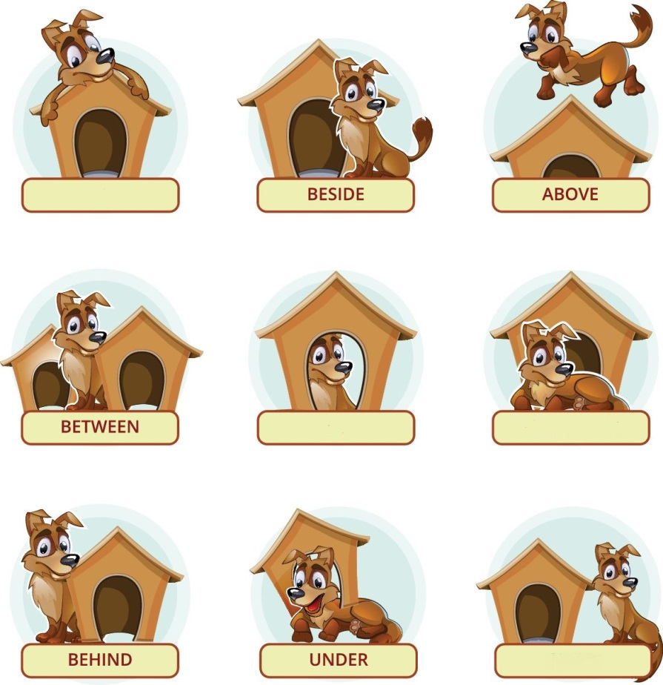
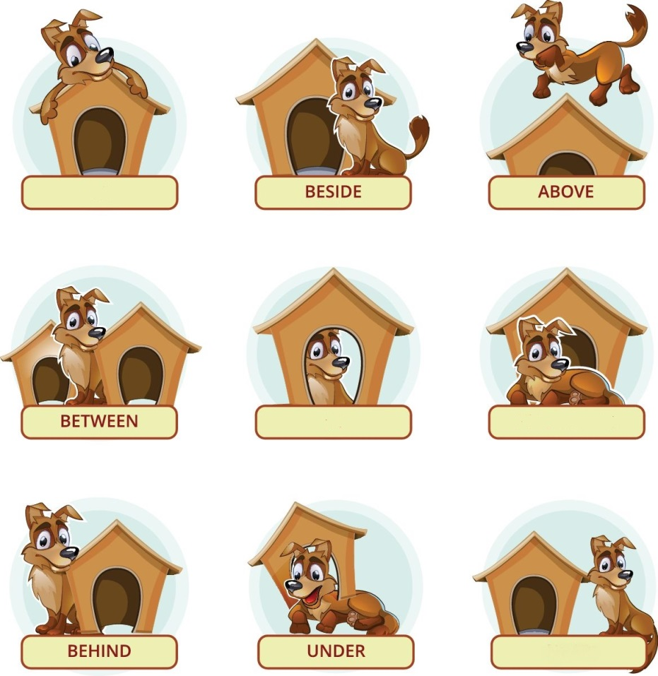
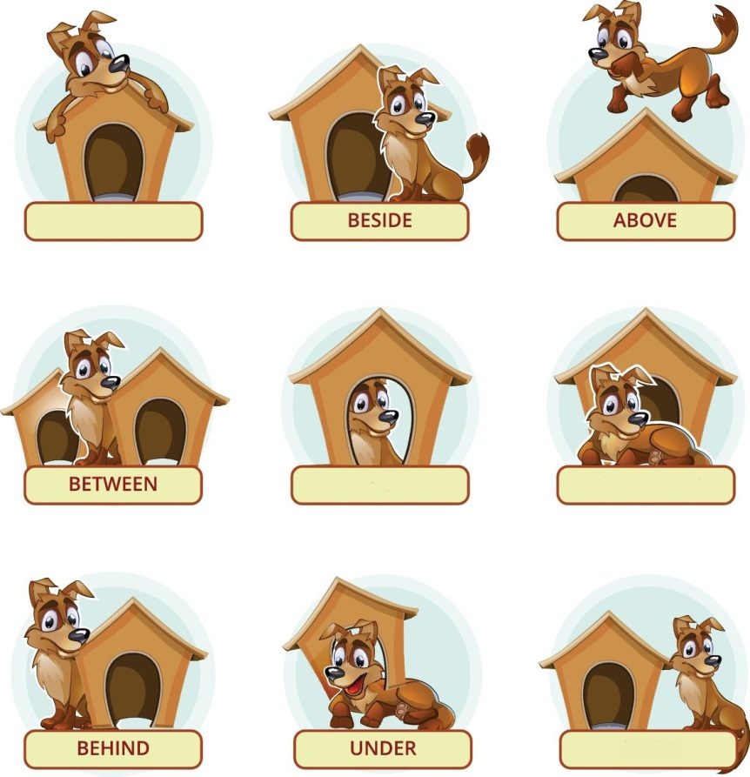
F. Circle the correct preposition of place. (Rodeia a preposição de lugar correta.)

1. Peanut is on / next to the doghouse. 2. Peanut is in front of / behind the doghouse.


3. Peanut is on / under the doghouse. 4. Peanut is above / in the doghouse.
G. Complete the words to make the plural of nouns. (Completa as palavras para formar o plural dos nomes.)
Singular | Plural
1. watch | W___T___ ___ E ___
2. book | ___ O ___ K ___
3. child | C ___ ___ L ___ R ___ N
4. baby | ___ A ___ I ___ S
5. man | M ___ N

H. Complete the text about Jane’s house. (Completa o texto sobre a casa da Jane.)

This is Jane’s house. Downstairs there is a ⁽¹⁾_______________________, a ⁽²⁾___________________ and a ⁽³⁾_______________________. Upstairs there is a ⁽⁴⁾_____________________ and a ⁽⁵⁾ _________________. The bedroom has got a ⁽⁶⁾ _____________________ and two ⁽⁷⁾_____________________. In the attic, there is a ⁽⁸⁾_____________________, a ⁽⁹⁾___________________ and a ⁽¹⁰⁾______________________. It’s a beautiful house.

Answer key
A. 5 x 3% = 15%
1. Haines | 2. shoe | 3. kitchen | 4. two | 5. garden
B. 5 x 4% = 20%
1. d) It’s in Pennsylvania, in the United States of America. | 2. a) Jane’s favourite part of the house is the living room. | 3. e) No, there isn’t. | 4. b) Yes, it is. | 5. c) The doghouse is special because it is also a shoe.
C. 7 x 1% = 7%
1. bed | 2. bedside table | 3. wardrobe | 4. sink | 5. cooker | 6. toilet | 7. washbasin
D. 5 x 2% = 10%
1. There is | 2. There are | 3. There is | 4. There are | 5. There is
E. 5 x 2% = 10%
1. Is there… No, there isn’t. | 2. Are there… Yes, there are. | 3. Are there… No, there aren’t. | 4. Is there… Yes, there is. | 5. Is there… No, there isn’t.
F. 4 x 2% = 8%
1. next to | 2. in front of | 3. on | 4. in
G. 5 x 2% = 10%
1. watches | 2. books | 3. children | 4. babies | 5. men
H. 10 x 2 = 20%
Suggested answer:
This is Jane’s house. Downstairs there is a hall, a living room and a dining room. Upstairs there is a bedroom and a bathroom. The bedroom has got a bed and two bedside tables. In the attic, there is a chair, a desk and a bookcase. It’s a beautiful house.

