A. Label the picture. Use the words from the box.
(Legenda a imagem. Usa as palavras da caixa.)

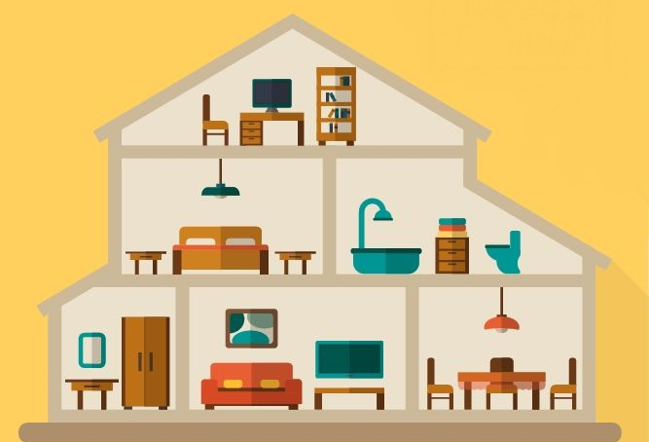

bathroom
bedroom
living room
attic
dining room

1.
2.
3.
4.

5.
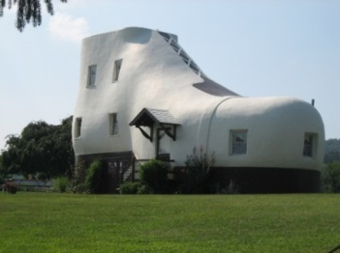
B. Look at the pictures and complete the text. Use the words from the box.
(Observa as imagens e completa o texto. Usa as palavras da caixa.)
washbasin bed cooker wardrobe
sink toilet bedside table shoe

The Haines Shoe House.
The Haines Shoe House is a special house because it’s a shoe .
In the bedroom there is a ⁽¹⁾ ______________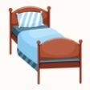, a ⁽²⁾ ________________________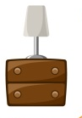
and a ⁽³⁾ ________________________ 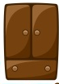 .
In the kitchen there is a ⁽⁴⁾ ___________________ 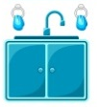and a ⁽⁵⁾ ______________ 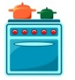.
The bathroom has got a ⁽⁶⁾ __________________ 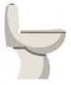 , and a ⁽⁷⁾ ________________________ .

C. Read and match. Draw lines. Remember: There is – singular; There are – plural.
(Lê e faz a ligação. Lembra-te: There is – singular; There are – plural.)
- … an attic in my house.
There is
- … two bedrooms in the Shoe House.
- … a doghouse next to the Shoe House.
There are
- … some flowers in the garden.
- … a garden in front of the house.
D. Look at the picture. Circle the correct option.
(Observa a imagem. Rodeia a opção correta.)


- Is there a chair in the bedroom? Yes, there is. / No, there isn’t.
- Are there books in the bookcase? Yes, there are. / No, there aren’t.
- Are there two lamps on the desk? Yes, there are. / No, there aren’t.
- Is there a bookcase in the bedroom? Yes, there is. / No, there isn’t.
- Is there a wardrobe in the bedroom? Yes, there is. / No, there isn’t.
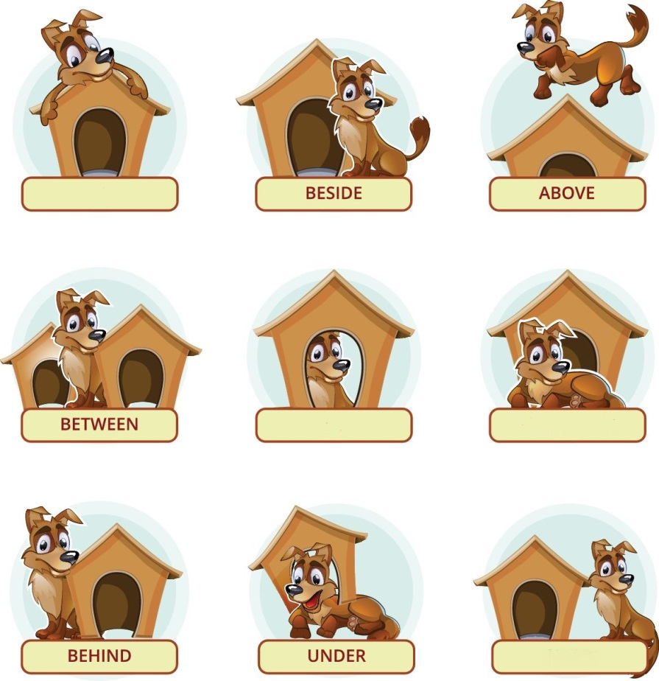
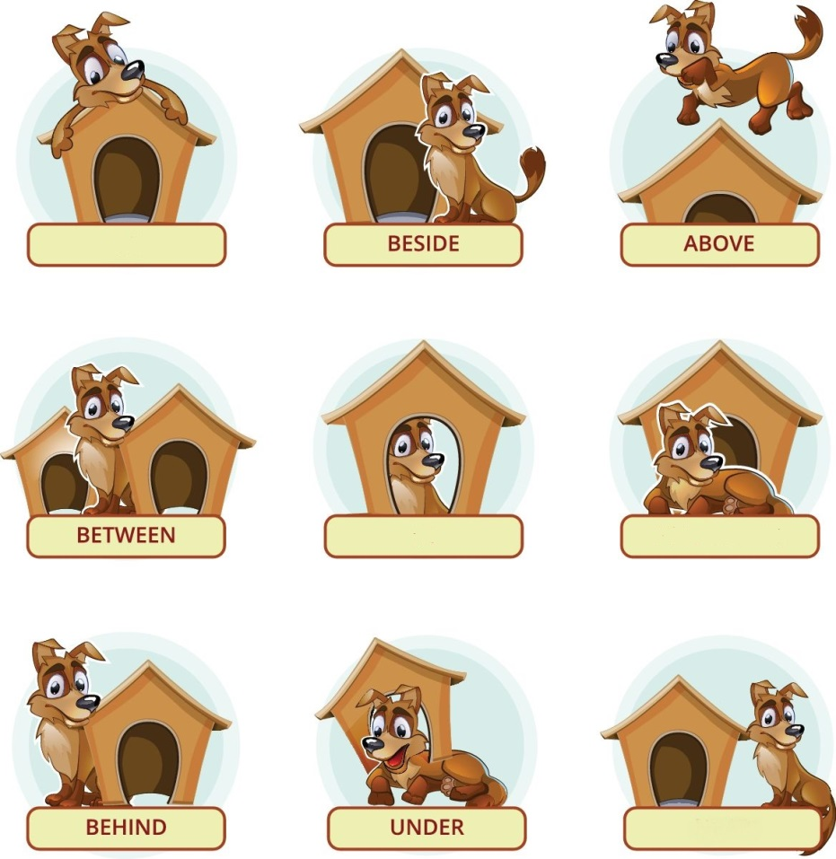
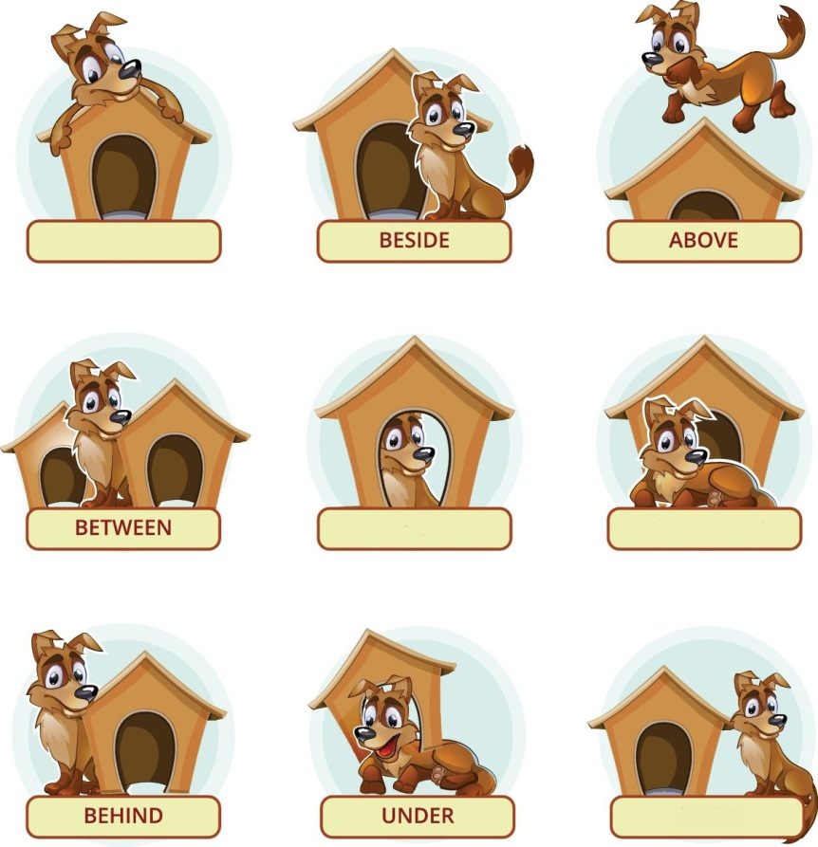
E. Circle the correct preposition of place. (Rodeia a preposição de lugar correta.)

1. Peanut is on / next to the doghouse. 2. Peanut is in front of / behind the doghouse.
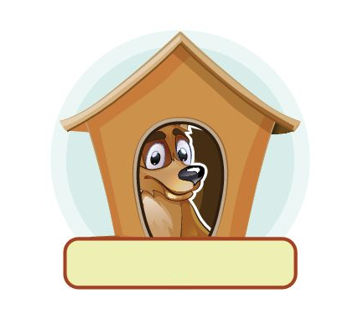

3. Peanut is on / under the doghouse. 4. Peanut is above / in the doghouse.
F. Tick (✓) the correct word to make the plural of the nouns.
(Seleciona a palavra correta para formar o plural dos nomes.)

Singular | Plural
1. watch | watchs | watches
2. book | bookes | books
3. child | child | children
4. baby | babies | babys
5. man | men | mans
Answer key
A. 5 x 4% = 20%
1. attic | 2. bedroom | 3. bathroom | 4. living room | 5. dining room
B. 7 x 2% = 14%
1. bed | 2. bedside table | 3. wardrobe | 4. sink | 5. cooker | 6. toilet | 7. washbasin
C. 5 x 4% = 20%
There is – 1; 3; 5 | There are – 2; 4
D. 5 x 3% = 15%
1. No, there isn’t. | 2. Yes, there are. | 3. No, there aren’t | 4. Yes, there is. | 5. No, there isn’t.
E. 4 x 4% = 16%
1. next to | 2. in front of | 3. on | 4. in
F. 5 x 3% = 15%
1. watches | 2. books | 3. children | 4. babies | 5. men

