VOCABULARY WORKSHEETS

Unit 1: Family members – A, page 115
A.
A | V | S | E | C | O | U | S | I | N | L | S
W | M | O | T | H | E | R | T | O | F | A | T
B | Y | D | Z | K | A | K | C | R | J | U | E
G | R | A | N | D | F | A | T | H | E | R | P
B | j | M | F | I | J | K | N | N | Y | G | S
R | T | H | U | P | B | X | P | C | L | K | I
O | T | F | A | T | H | E | R | Z | A | X | S
T | C | J | G | V | D | Y | U | L | U | D | T
H | M | E | S | I | S | T | E | R | N | N | E
E | B | U | N | C | L | E | W | H | T | T | R
R | G | R | A | N | D | M | O | T | H | E | R
B.
1. grandfather | 2. grandmother | 3. uncle | 4. aunt |
5. uncle | 6. mother | 7. father | 8. cousin |
9. cousin | 10. cousin | 11. sister | 12. sister

Unit 1: Family members – B, page 116
A.
A | V | S | E | C | O | U | S | I | N | L
W | M | O | T | H | E | R | T | O | F | A
B | Y | D | Z | K | A | K | C | R | J | U
B | J | M | F | I | J | K | N | N | Y | G
R | T | S | I | S | T | E | R | M | Q | U
O | T | H | U | P | B | X | P | C | L | K
T | T | F | A | T | H | E | R | Z | A | X
H | C | J | G | V | D | Y | U | L | U | D
E | M | U | N | C | L | E | T | T | N | N
R | B | E | S | C | T | E | W | H | T | A
G | R | A | N | D | M | O | T | H | E | R
B.
1. grandmother | 2. aunt | 3. uncle | 4. mother |
5. father | 6. cousin | 7. sister

Unit 1: Jobs – A, page 117
A.
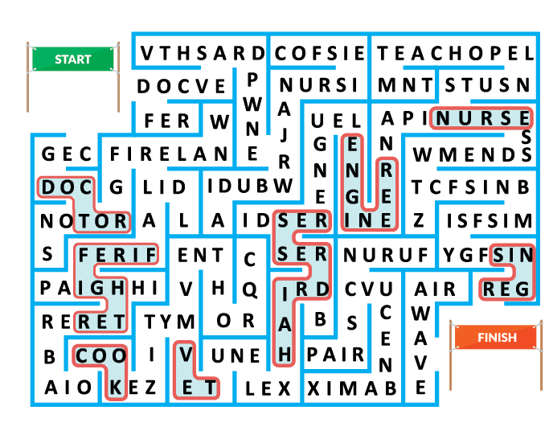
B.
1. firefighter | 2. doctor | 3. engineer | 4. nurse |
5. singer | 6. vet | 7. hairdresser | 8. cook
C.
1. teacher | 2. football player | 3. police officer
Unit 1: Jobs – B, page 118
A.
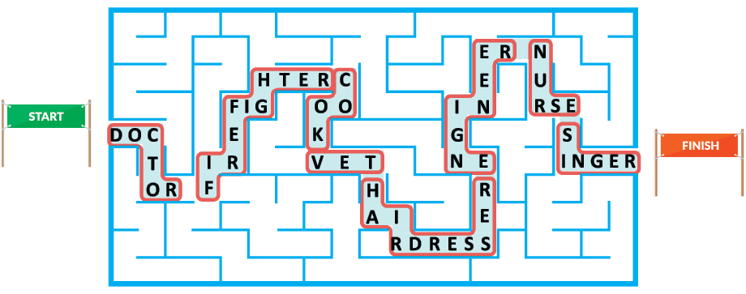
B.
1. firefighter | 2. doctor | 3. engineer | 4. nurse |
5. singer | 6. vet | 7. hairdresser | 8. cook
C.
1. teacher | 2. football player | 3. police officer

Unit 1: The human body – A, page 119
A.
1. eye | 2. nose | 3. tooth | 4. arm | 5. ear | 6. hand |
7. leg | 8. foot
B.
1. eye | 2. nose | 3. tooth | 4. arm | 5. ear |
6. hand | 7. leg | 8. foot
C.
Resposta pessoal.

Unit 1: The human body – B, page 120
A.
1. eye | 2. nose | 3. tooth | 4. arm | 5. ear | 6. hand |
7. leg | 8. foot
B.
1. eye | 2. nose | 3. tooth | 4. arm | 5. ear |
6. hand | 7. leg | 8. foot
C.
Resposta pessoal.

Unit 1: Physical features – A, page 121
A.
1. Dario | 2. Dahlia | 3. Valentino | 4. Hal |
5. Safi | 6. Asha | 7. Gabo | 8. Simon | 9. Bazeema
B.
Respostas pessoais.
Unit 1: Physical features – B, page 122
A.
1. b) | 2. a) | 3. c) | 4. a) | 5. b) | 6. c) | 7. b) | 8. c) |
9. c)

Unit 1: Clothes, footwear and
accessories – A, page 123
A.
Clothes: skirt, top, shorts, T-shirt, socks, hoodie, jeans,
shirt, coat, dress, jacket, trousers
Footwear: sandals, trainers, boots, shoes

Accessories: hat, bag, earrings, cap, watch,
sunglasses, belt, bracelet, necklace
B.
1. earrings | 2. dress | 3. bag | 4. boots | 5. jacket |
6. necklace | 7. trousers | 8. trainers
C.
Resposta pessoal.

Unit 1: Clothes, footwear and
accessories – B, page 124
A.
Clothes: top, shorts, T-shirt, socks, hoodie, jeans,
shirt, coat, dress, jacket, trousers
Footwear: trainers, boots, shoes
Accessories: bag, earrings, cap, watch, sunglasses,
belt, bracelet, necklace
B.
1. earrings | 2. dress | 3. bag | 4. boots | 5. jacket |
6. necklace | 7. trousers | 8. trainers

Unit 2: Parts of the house / Rooms – A,
page 125
A.
1. roof | 2. window | 3. door | 4. wall |
5. upstairs | 6. garden | 7. stairs | 8. downstairs
B.
1. kitchen | 2. living room | 3. bedroom | 4. dining
room | 5. bathroom

Unit 2: Parts of the house / Rooms – B,
page 126
A.
1. roof | 2. window | 3. door | 4. wall |
5. upstairs | 6. garden | 7. stairs | 8. downstairs
B.
1. kitchen | 2. living room | 3. bedroom | 4. dining
room | 5. bathroom

Unit 2: Furniture and objects – A, page
127
A.
1. washbasin | 2. cupboard | 3. pillows | 4. bed |
5. lamp | 6. bedside table | 7. mirror | 8. armchair |
9. sink | 10. sofa
B.
1. bed | 2. pillows | 3. bedside table | 4. lamp |
5. sofa | 6. armchair

Unit 2: Furniture and objects – B, page
128
A.
1. washbasin | 2. cupboard | 3. pillows | 4. bed |
5. lamp | 6. bedside table | 7. mirror | 8. armchair |
9. sink | 10. sofa
B.
1. bed | 2. pillows | 3. bedside table | 4. lamp |
5. sofa | 6. armchair

Unit 3: Free time activities / Hobbies – A,
page 129
A.
1. chatting online | 2. playing video games |
3. watching videos | 4. singing | 5. dancing |
6. playing the guitar | 7. listening to music |
8. reading

Unit 3: Free time activities / Hobbies – B,
page 130
A.
1. chatting online | 2. playing video games |
3. watching videos | 4. singing | 5. dancing |
6. playing the guitar | 7. listening to music |
8. reading

Unit 3: Food and drinks – A, page 131
A.
1. French fries | 2. milk | 3. ice cream | 4. broccoli |
5. cereal | 6. pear | 7. mushrooms | 8. bread |
9. lettuce | 10. eggs | 11. hamburger | 12. lemon
B.
a) 5 | b) 7 | c) 1 | d) 3 | e) 11 | f) 10 | g) 12 | h) 8 |
i) 2

Unit 3: Food and drinks – B, page 132
A.
1. French fries | 2. milk | 3. ice cream | 4. broccoli |
5. cereal | 6. pear | 7. mushrooms | 8. bread |
9. lettuce | 10. eggs | 11. hamburger | 12. lemon
B.
a) 5 | b) 7 | c) 1 | d) 3 | e) 11 | f) 10 | g) 12 | h) 8 |
i) 2

Unit 4: Sports – A, page 133
A.
1. tennis | 2. gymnastics | 3. basketball | 4. golf |
5. athletics | 6. swimming
B.
Indoor sports: 2, 6
Outdoor sports: 1, 3, 4, 5
C.
1. go | 2. do | 3. play | 4. go | 5. play | 6. go

Unit 4: Sports – B, page 134
A.
1. tennis | 2. gymnastics | 3. basketball | 4. golf |
5. athletics | 6. swimming
B.
1. go | 2. do | 3. play | 4. go | 5. play | 6. go

Unit 4: Daily routine – A, page 135
A.
1. get dressed | 2. brush my teeth | 3. catch the bus |
4. have lunch | 5. have a shower | 6. go to bed
B.
a) 6 | b) 1 | c) 2 | d) 4 | e) 3 | f) 5
C.
Resposta pessoal.

Unit 4: Daily routine – B, page 136
A.
1. get dressed | 2. brush my teeth | 3. catch the bus |
4. have lunch | 5. have a shower
B.
a) 1 | b) 2 | c) 4 | d) 3 | e) 5
C.
Respostas pessoais.

Unit 4: Telling the time – A, page 137
A.
1. midday | 2. half past eight | 3. a quarter past nine |
4. twenty to seven | 5. a quarter to five | 6. midnight |
7. ten past four | 8. five to three
B.
a) 4 | b) 6 | c) 3 | d) 1 | e) 5 | f) 2 | g) 8 | h) 7
C.
1. three o’clock | 2. It’s half past seven. | 3. It’s twenty
to five.

Unit 4: Telling the time – B, page 138
A.
1. midday | 2. half past eight | 3. a quarter past nine |
4. twenty to seven | 5. a quarter to five | 6. midnight
| 7. ten past four | 8. five to three
B.
1. three | 2. half | 3. twenty

GRAMMAR WORKSHEETS

Unit 1: Personal pronouns / Possessive
determiners A, page 139
A.
Personal pronouns: I, you, he, she, it, we, you, they
Possessive determiners: my, your, his, her, its, our,
your, their
B. 1. my | 2. our | 3. his | 4. your
C. 1. His | 2. his | 3. their | 4. her | 5. Her |
6. its | 7. her

Unit 1: Personal pronouns / Possessive
determiners – B, page 140
A.
Personal pronouns: I, you, he, she, it, we, you, they
Possessive determiners: my, your, his, her, its, our,
your, their
B. 1. my | 2. our | 3. his | 4. your
C. 1. His | 2. his | 3. their | 4. her | 5. Her | 6. its |
7. her

Unit 1: Verb to be – A, page 141
A. 1. is | 2. are | 3. am
B. 1. ʼm not… am | 2. aren’t… are | 3. isn’t… is
C. 1. Is The Lion King your favourite film? No, it isn’t. |
2. Are your parents at the cinema? Yes, they are.
D. 1. am | 2. am | 3. is | 4. are | 5. aren’t | 6. are |
7. is | 8. Are

Unit 1: Verb to be – B, page 142
A. 1. is | 2. are | 3. am
B. 1. ʼm not… am | 2. aren’t… are | 3. isn’t… is
C. 1. am | 2. am | 2. is | 4. are | 5. aren’t | 6. are |
7. is | 8. Are

Unit 1: Possessive pronouns – A, page
143
A.
Possessive determiners: my, your, his, her, our, your,
their
Possessive pronouns: mine, yours, his, hers, ours,
yours, theirs
B. 1. his | 2. hers | 3. theirs
C. 1. mine | 2. theirs | 3. yours | 4. hers | 5. ours

Unit 1: Possessive pronouns – B, page
144
A.
Possessive determiners: your, his, her, our, your, their
Possessive pronouns: yours, his, hers, ours, yours,
theirs
B. 1. his | 2. hers | 3. theirs
C. 1. mine | 2. theirs | 3. yours | 4. hers | 5. ours

Unit 1: Possessive case – ’s / ’ – A, page
145
A. 1. It’s James’s toy car. | 2. It’s Ann’s pencil. |
3. It’s Lewis ’s ball. |4. It’s Mark’s T-shirt.
B. 1. ’s | 2. ’s | 3. ’| 4. ’s
B. 1. Julia’s. | 2. They’re the girls’. | 3. It’s Enzo and
Luiz’s. | 4. It’s James’s. | 5. They’re my parents’.

Unit 1: Possessive case – ’s / ’ – B, page
146
A. 1. James’s | 2. Ann’s | 3. Lewis ’s | 4. Mark’s
B. 1. sister’s | 2. Mary’s | 3. parents’| 4. Mark and
Peter’s
B. 1. Julia’s | 2. the girls’ | 3. Enzo and Luiz’s |
4. James’s | 5. my parents’

Unit 1: Verb have got – A, page 147
A. 1. ’ve got | 2. ’ve got
B. 1. have got | 2. has got | 3. have got | 4. has got
C. 1. has got | 2. hasn’t got | 3. hasn’t got | 4. haven’t
got | 5. have got
D. 1. Has… got; she, hasn’t | 2. Have… got; they have |
3. Has… got; she has | 4. Have… got; they haven’t
E. 1. have got | 2. have got | 3. has got | 4. has got |
5. haven’t got | 6. have got | 7. Have… got

Unit 1: Verb have got – B, page 148
A. 1. ’ve got
B. 1. have got | 2. has got | 3. have got | 4. has got
C. 1. has got | 2. hasn’t got | 3. hasn’t got | 4. haven’t
got | 5. have got
D. 1. Has; hasn’t | 2. Have; have | 3. Has; has |
4. Have; haven’t
E. 1. ’ve got | 2. ’ve got | 3. ’s got | 4. ’s got |
5. haven’t got | 6. ’ve got | 7. Have

Unit 2: There + to be – A, page 149
A. 1. There is | 2. There are | 3. There is |
4. There are | 5. There are | 6. There is
B. 1. There is a pink roof. | 2. There isn’t a swimming
pool. | 3. There are some windows. | 4. There aren’t
five floors.
C. 1. There is a bedroom upstairs. | 2. Is there a
bathroom downstairs? | 3. There isn’t a garden
outside. | 4. Are there two doors in the kitchen?
D. 1. Yes, there is. | 2. No, there aren’t. | 3. Yes, there
is. | 4. Yes, there are. | 5. No, there isn’t.

Unit 2: There + to be – B, page 150
A. 1. There is | 2. There are | 3. There is |
4. There are | 5. There are | 6. There is
B. 1. There is | 2. There isn’t | 3. There are | 4. There
aren’t
C. 1. There is | 2. Is there | 3. There isn’t | 4. Are
there
D. 1. No, there aren’t. | 2. Yes, there is. | 3. Yes, there
are. | 4. No, there isn’t.

Unit 2: Prepositions of place – A,
page 151
A.
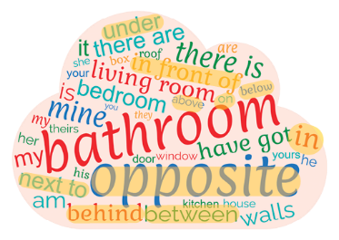
B. 1. in | 2. next to | 3. on | 4. above | 5. under |
6. behind
Unit 2: Prepositions of place – B,
page 152
A.
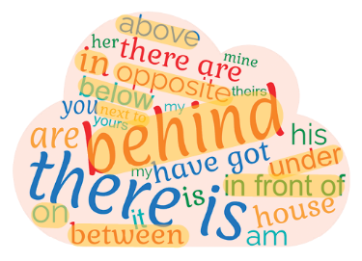
B. 1. in | 2. next to | 3. on | 4. above | 5. under |
6. behind

Unit 2: Plurals – A, page 153
A.
1. sofas | 2. city | 3. knives | 4. bus | 5. potatoes |
6. children | 7. man | 8. feet
B. three cats; two dogs; two fish; two birds; two mice
C. 1. There are five wolves. | 3. My grandfather has
got three sheep. | 6. My teeth are white.

Unit 2: Plurals – B, page 154
A.
1. sofas | 2. cities | 3. knives | 4. buses | 5. potatoes |
6. children | 7. men | 8. feet
B. cats; dogs; fish; birds; mice
C. 1. There are five wolves. | 3. My grandfather has
got three sheep. | 6. My teeth are white.

Unit 2: Articles: the, a/an – A, page 155
A. 1. an | 2. a | 3. a | 4. an
B. 1. a) | 2. a) | 3. c) | 4. b) | 5. c)
C. 1. the | 2. Ø | 3. The | 4. Ø | 5. Ø
D. 1. Ø | 2. a | 3. the | 4. a | 5. an | 6. The | 7. a

Unit 2: Articles: the, a/an – B, page 156
A. 1. an | 2. a | 3. a | 4. an
B. 1. a) | 2. a) | 3. b) | 4. b) | 5. b)
C. 1. the | 2. Ø | 3. The | 4. Ø | 5. Ø
D. 1. Ø… a | 2. the | 3. a | 4. an | 5. The… a

Unit 3: Present continuous – A, page 157
A. 1. They aren’t chatting. They are taking a selfie. |
2. “I’m not camping. I’m surfing.”
B. 1. Is the cameraman reading? No, he isn’t. | 2. Is
the photographer taking pictures? Yes, she is. | 3. Are
the people watching the competition? Yes, they are. |
4. Are they playing the piano? No, they aren’t.
C. 1. isn’t skateboarding | 2. is playing | 3. are
practising | 4. are… doing

Unit 3: Present continuous – B, page 158
A. 1. They aren’t chatting. They are taking a selfie. |
2. “I’m not camping. I’m surfing.”

B. 1. Is the cameraman reading? No, he isn’t. |
2. Is the photographer taking pictures? Yes, she is. |
3. Are the people watching the competition? Yes, they
are. | 4. Are they playing the piano? No, they aren’t.
C. 1. isn’t | 2. playing | 3. are | 4. doing

Unit 3: Quantifiers: some/any – A,
page 159
A. 1. some | 2. some | 3. some | 4. any | 5. any |
6. some | 7. some | 8. some | 9. any | 10. some |
11. some | 12./13./14. Respostas pessoais.

Unit 3: Quantifiers: some/any – B,
page 160
A. 1. some | 2. some | 3. some | 4. any | 5. any |
6. some | 7. some | 8. some | 9. any | 10. some |
11. some | 12./13./14. Respostas pessoais.

Unit 3: Expressing preferences – A,
page 161
A.
J | U | R | T | I | Y | T | I | U | N | T | P | F | B | D | N | D | X | E | Z
U | O | T | Z | T | M | W | M | M | L | O | V | E | E | E | Q | I | J | C | M
K | C | H | A | T | E | G | F | T | O | B | F | D | C | T | J | U | P | K | X
L | E | A | R | N | E | N | J | O | Y | B | I | I | D | E | Q | E | N | Y | F
A | L | O | O | P | Z | X | X | Q | H | R | R | S | K | S | B | N | K | O | Z
P | L | A | Y | Q | L | I | K | E | R | T | A | L | R | T | R | S | J | K | P
X | L | L | P | W | W | R | I | T | E | Z | R | I | K | I | Y | M | C | A | E
O | M | B | K | D | E | P | R | E | F | E | R | K | D | R | I | N | K | L | A
Z | T | E | A | O | G | Y | J | G | L | I | R | E | S | T | U | D | Y | L | T
E | W | W | P | K | O | H | A | V | E | G | O | T | X | W | E | R | G | N | B
B. 1. love | 2. enjoy | 3. dislike | 4. hate
C. 1. driving | 2. going | 3. participating | 4. cooking |
5. buying | 6. eating

Unit 3: Expressing preferences – B,
page 162
A.
R | T | P | C | M | P | D | W | E | Z | M | I | P | O | E | C | I | B | X | C
F | A | Y | J | Z | L | A | U | L | A | W | J | W | Y | F | K | B | D | Y | E
U | H | Z | J | R | X | C | D | J | P | R | M | W | W | K | Q | K | M | X | N
D | A | Z | A | A | A | P | S | L | N | T | I | U | K | Q | A | H | Z | K | J
I | T | N | E | R | E | B | Q | J | T | T | A | Q | J | D | Z | P | F | Y | O
S | E | N | X | Q | D | T | X | I | Q | B | V | G | K | S | T | K | T | K | Y
L | Z | X | Q | S | B | K | W | K | D | N | K | L | S | Q | K | W | V | S | V
I | G | E | E | Z | L | O | C | B | P | G | Y | I | A | X | F | L | G | O | O
K | X | N | E | C | M | D | E | T | E | S | T | K | W | P | R | E | F | E | R
E | W | W | F | W | K | V | A | I | L | O | V | E | N | V | V | J | H | J | Y
B. 1. love | 2. enjoy | 3. dislike | 4. hate
C. 1. driving | 2. going | 3. participating | 4. cooking |
5. buying | 6. eating
Unit 4: Verb like – A, page 163
A. 1. likes | 2. like | 3. likes | 4. like
B. 1. doesn’t like | 2. likes | 3. likes | 4. doesn’t like |
5. likes | 6. doesn’t like
C. 1. Do they like lemonade? | 2. Does Ruth like tea? |
3. Do your friends and you like cake?
D. 1. Do… like | 2. do | 3. Do… like | 4. don’t |
5. don’t like | 6. likes | 7. doesn’t like | 8. don’t like |
9. like

Unit 4: Verb like – B, page 164
A. 1. likes | 2. like | 3. likes | 4. like
B. 1. doesn’t like | 2. likes | 3. likes | 4. doesn’t like |
5. likes | 6. doesn’t like
C. 1. Do… like | 2. Does… like | 3. Do… like
D. 1. Do you like | 2. do | 3. Do you like | 4. don’t |
5. don’t like | 6. likes | 7. doesn’t like | 8. don’t like |
9. like

Unit 4: Present simple – A, page 165
A. 1. depends | 2. doesn’t give… give | 3. does…
grow | 4. is | 5. don’t look… distracts| 6. doesn’t
mean… don’t believe| 7. haven't got | 8. grows |
9. don’t… win | 10. counts| 11. isn’t… has got |
12. there is

Unit 4: Present simple – B, page 166
A. 1. depends | 2. doesn’t give… give | 3. does…
grow | 4. is | 5. don’t look… distracts| 6. doesn’t
mean… | 7. haven't got | 8. grows |
9. don’t… win | 10. counts| 11. isn’t… has got |
12. there is

Unit 4: Adverbs of frequency – A,
page 167
A. always; usually; often; sometimes; never
B. 1. sometimes | 2. usually | 3. never | 4. always
C. 1. They are never late for school. | 2. My sister
often watches Pokémon on TV. | 3. Playing with
friends is always fun. | 4. Jessica usually buys new
cards.

Unit 4: Adverbs of frequency – B,
page 168
A. always; usually; often; sometimes; never
B. 1. sometimes | 2. usually | 3. never | 4. always
C. 1. They are never late for school. | 2. My sister
often watches Pokémon on TV. | 3. Playing with
friends is always fun. | 4. Jessica usually buys new
cards.

