 | Find the personal pronouns and possessive determiners in the word snake. Then write  them in the table.
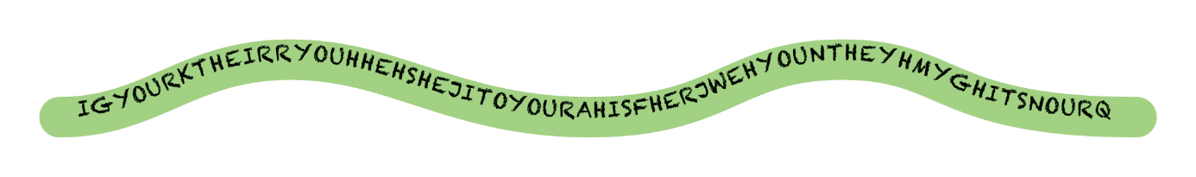
Personal pronouns | Possessive determiners
________________  ________________  ________________  ________________  ________________  ________________  ________________  ________________ | ________________  ________________  ________________  ________________  ________________  ________________  ________________  ________________
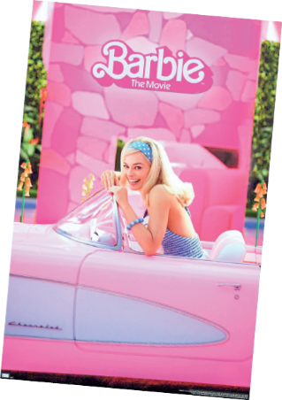
   | Circle the correct option to complete the sentences.
- Hi! I’m Kate and my / your favourite film is Barbie.
- My sister and I collect Barbie dolls. It’s their / our hobby.
- Tom loves watching films, but their / his favourite film isn’t Barbie.
- And you? What’s your / our favourite film?

 | Complete the texts with the possessive determiners from the box.
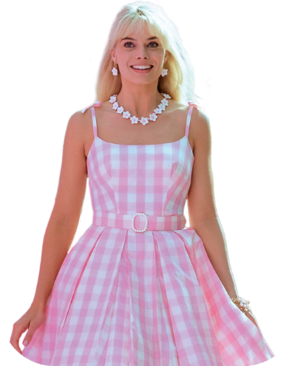
This is Ken. ¹_____ hair is short and
²____ eyes are blue. Barbie and Ken
live in a big and comfortable house.
It’s ³_____ house.
This is Barbie. She’s tall and ⁴_____
hair is blond. ⁵_____ car is a
Chevrolet. ⁶_____ colour is pink,
because pink is ⁷_____ favourite
colour!
her (x3) • his (x2) • its • their

