 | Write the personal pronouns and possessive determiners from the box in the correct  place.
my • she • it • we • your (x2) • their • they
his • her • its • our • I • you (x2) • he
Personal pronouns | Possessive determiners
________________  ________________  ________________  ________________  ________________  ________________  ________________  ________________ | ________________  ________________  ________________  ________________  ________________  ________________  ________________  ________________
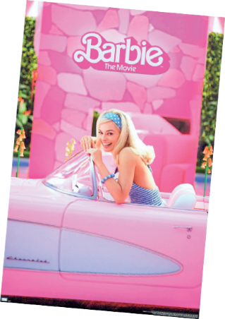
   | Circle the correct option to complete the sentences.
- Hi! I’m Kate and my / your favourite film is Barbie.
- We collect Barbie dolls. It’s their / our hobby.
- He loves watching films, but their / his favourite film isn’t Barbie.
- And you? What’s your / our favourite film?

 | Circle the correct option to complete the texts.
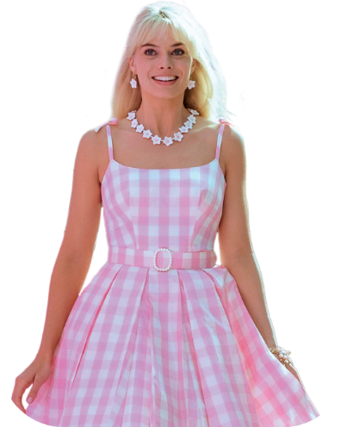
This is Ken. ¹ His / Her hair is short
and ² their / his eyes are blue. Barbie
and Ken live in a big and comfortable
house. It’s ³ their / my house.
This is Barbie. She’s tall and ⁴ my /
her hair is blond. ⁵ Our / Her
car is a Chevrolet. ⁶ Its / Our
colour is pink because pink is
⁷ her / your favourite colour!

