 | Complete the quotes from The Lion King with am, is, are.

3. I _____ Simba, son
of Mufasa.
2. We _____ all
connected in the
Great Circle of Life.
1. Because it _____
your responsibility.

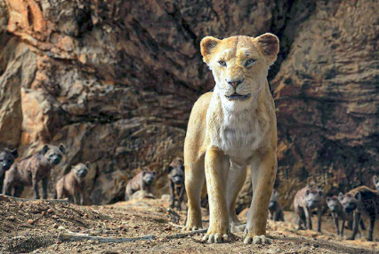 | 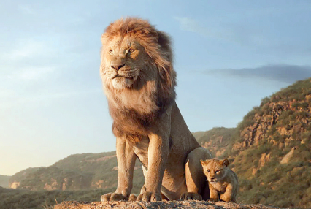 | 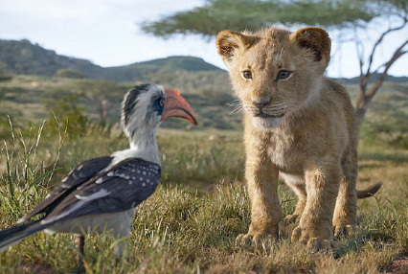

 | Complete the sentences with the verb to be in the affirmative or in the negative.

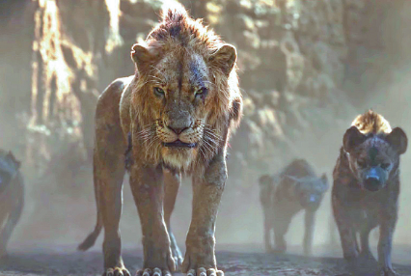 | 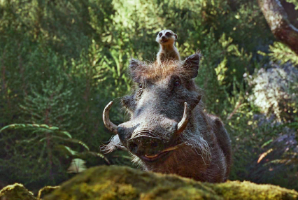 | 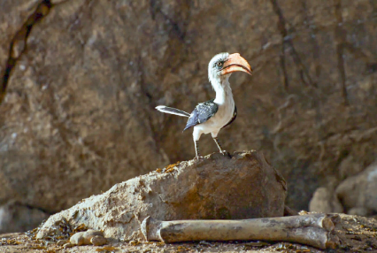
1. “I _______ (not) small.  I _______ big.” | 2. Timon and Pumbaa  _______ (not) siblings.  Timon and Pumbaa _____  friends. | 3. Zazu _______ (not)  a dog.  Zazu _______ a bird.

 | Write questions and short answers. There is one example.
● Nala / my favourite character / ? / ✓
________________________________ _______, _________.
Is Nala my favourite character?
she is
Yes
- The Lion King / your favourite film / ? / ✗
________________________________ _______, _________.
- your parents / at the cinema / ? / ✓
________________________________ _______, _________.

 | Complete the text with the correct form of the verb to be.
Hi! I ¹ __________ Sofia and I ² __________ ten years old. My brother Pedro ³ __________
twelve. Now, we ⁴ __________ at the cinema – we ⁵ __________ (not) at school. We
⁶ __________ Disney fans! Our favourite film ⁷ __________ The Lion King. And you?
⁸ __________ you a Disney fan?

