 | Complete the quotes from The Lion King with am, is, are.

2. We _____ all
connected in the
Great Circle of Life.
1. Because it _____
your responsibility.
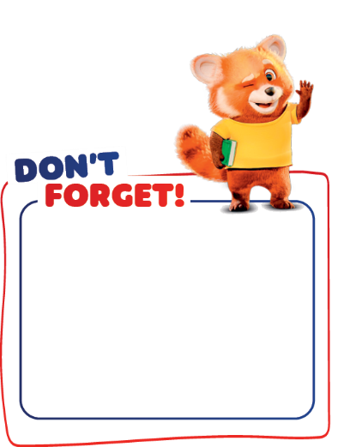
Verb to be (affirmative)
I am
You are
He/She/It is
We/You/They are
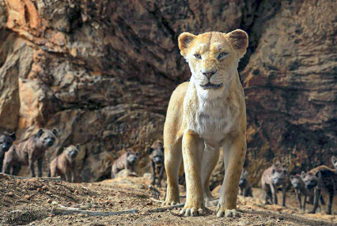 |  | 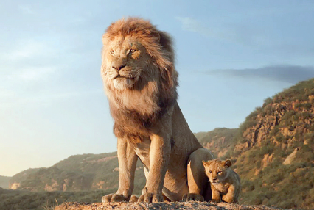
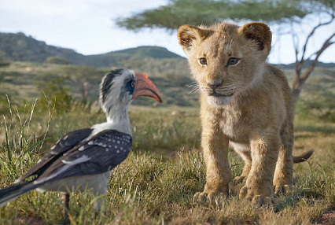
3. I _____ Simba, son
of Mufasa.

 | Complete the sentences with the verb to be in the affirmative or in the negative. Use  the words from the box.
am • is • are • ’m not • isn’t • aren’t

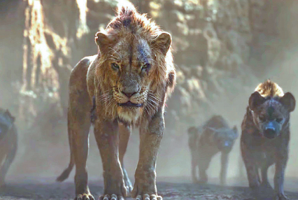 | 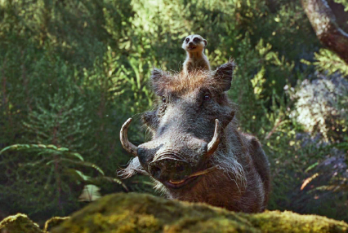 | 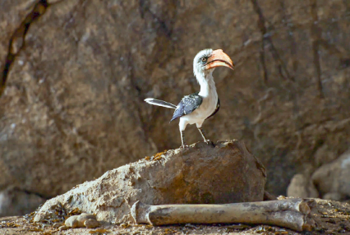
1. “I _______ (not) small.  I _______ big.” | 2. Timon and Pumbaa  _______ (not) siblings.  Timon and Pumbaa  _______ friends. | 3. Zazu _______ (not)  a dog.  Zazu _______ a bird.

 |   Circle the correct option to complete the text.
Hi! I ¹ am / is Sofia and I ² are / am ten years old. My brother Pedro ³ are / is twelve. Now,
we ⁴ are / am at the cinema – we ⁵ isn’t / aren’t at school. We ⁶ are / am Disney fans! Our
favourite film ⁷ is / are The Lion King. And you? ⁸ Are / Is you a Disney fan?

