 | Write the possessive determiners and possessive pronouns from the box in the table.
my • their • mine
yours (x2) • his • hers
ours • theirs • his
her • our • your (x2)
Possessive determiners | Possessive pronouns
________________  ________________  ________________  ________________  ________________  ________________  ________________ | ________________  ________________  ________________  ________________  ________________  ________________  ________________

 | Choose the correct possessive pronoun from exercise A to complete the sentences.

 | 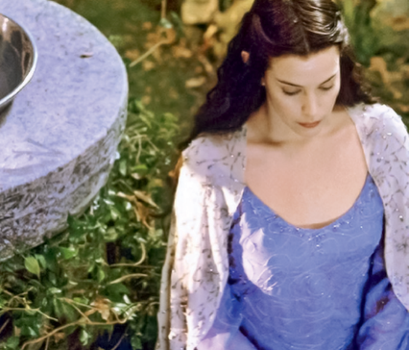 | 
1. The ring is _______. | 2. The dress is _______. | 3. The adventure is ______.

 | Replace the underlined words with a possessive pronoun. There is one example.

● This is Frodo’s house. The house is _______.
his
- I’ve got a big house. The house is _______.
- My parents’ TV is big. The TV is _______.
- You’ve got a ring. The ring is _______.
- My sister’s book is green. The book is _______.
- We’ve got a great job. The job is _______.

