 | Write the possessive determiners and possessive pronouns from the box in the table.  There is one example.
my • their • mine
yours (x2) • his • hers
ours • theirs • his
her • our • your (x2)
Possessive determiners | Possessive pronouns
________________  ________________  ________________  ________________  ________________  ________________  ________________ | ________________  my  mine  ________________  ________________  ________________  ________________  ________________  ________________

   | Circle the correct possessive pronoun to complete the sentences.

 | 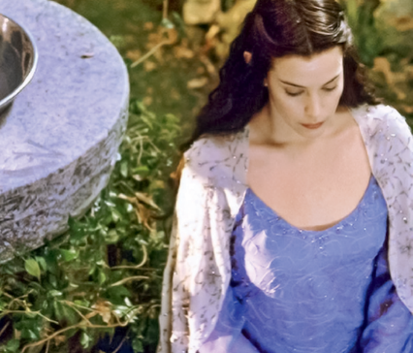 | 
1. The ring is his / theirs. | 2. The dress is hers / ours. | 3. The adventure is mine / theirs.

 | Choose the correct possessive pronoun from the box to complete the sentences. There  is one example.
his
hers • ours • theirs • his • mine • yours

● This is Frodo’s house. The house is _______.
- I’ve got a big house. The house is _______.
- My parents’ TV is big. The TV is _______.
- You’ve got a ring. The ring is _______.
- My sister’s book is green. The book is _______.
- We’ve got a great job. The job is _______.

