 | Look at the pictures. Write sentences using the possessive case. There is one example.

● |  |  | 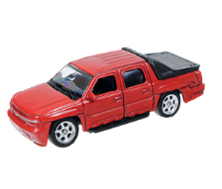 | toy car | ● ______________________.  1. ______________________.  2. ______________________.  3. ______________________.  4. ______________________.  It’s Lisa’s notebook
1 |  |  | 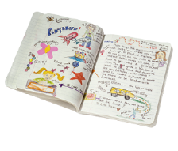 | notebook
2 |  |  | 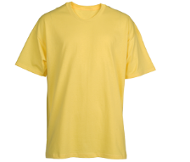 | T-shirt
3 |  |  | 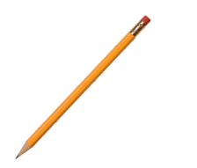 | pencil
4 |  |  |  | ball

 | Write ’ or ’s.
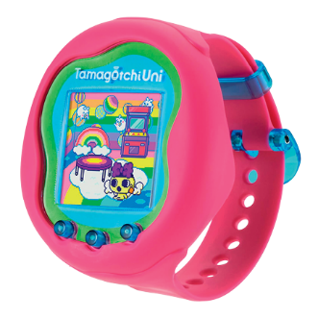
- This is my sister _______ Tamagotchi.
- These are Mary _______ toys.
- This is my parents _______ bedroom.
- This is Mark and Peter _______ house.

 | Whose things are these? Answer the questions. Use the possessive case. There is one  example.
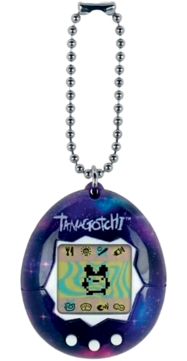
● Whose books are these? (John)
They’re John’s.
- Whose Tamagotchi is this? (Julia) It’s
- Whose toys are these? (the girls)
- Whose ball is this? (Enzo and Luiz)
- Whose watch is this? (James)
- Whose bikes are these? (my parents)

