 | Look at the pictures. Complete the sentences using the possessive case. There is one  example.

● |  |  | 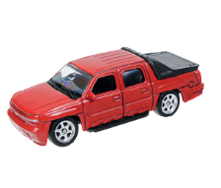 | toy car | ● It’s __________ notebook.  1. It’s __________ toy car.  2. It’s __________ pencil.  3. It’s __________ ball.  4. It’s __________ T-shirt.  Lisa's
1 |  |  | 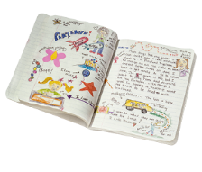 | notebook
2 |  |  | 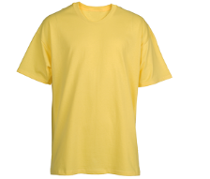 | T-shirt
3 |  |  | 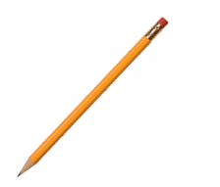 | pencil
4 |  |  |  | ball
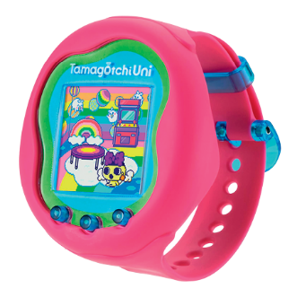
   | Circle the correct option to complete the sentences.
- This is my sister’s / sister’ Tamagotchi.
- These are Marys’s / Mary’s toys.
- This is my parents’ / parent’s bedroom.
- This is Mark and Peter’s / Mark’s and Peter’s house.

 | Whose things are these? Complete the answers. Use the possessive case. There is one  example.
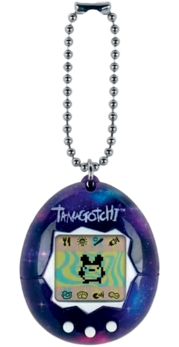
● Whose books are these? (John) They’re .
John’s
- Whose Tamagotchi is this? (Julia) It’s .
- Whose toys are these? (the girls) They’re .
- Whose ball is this? (Enzo and Luiz) It’s .
- Whose watch is this? (James) It’s .
- Whose bikes are these? (my parents) They’re .

