 | Complete Mirabel’s quotes with the correct form of the verb have got.

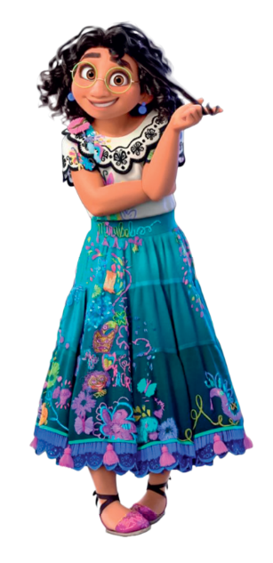
The miracle is not something magic that
you ¹__________. The miracle is YOU.

You don’t have to worry about me because
I ²__________ an amazing family.

 | Complete the sentences with have got or has got.

- I __________ big eyes.  - Mirabel __________ glasses. | - Bruno and Julieta __________ dark hair.  - Luisa __________ two sisters.
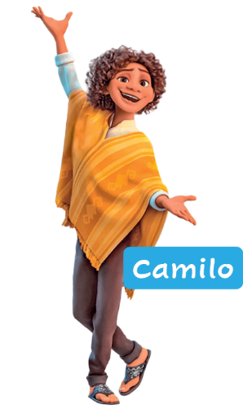
 | 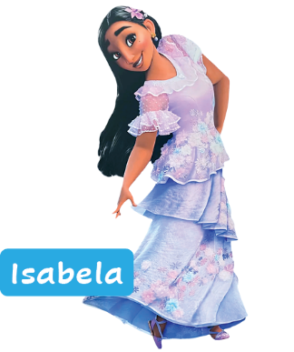  Look at the pictures and complete the sentences with  have got, haven’t got, has got or hasn’t got.
- Camilo __________ curly hair.
- Isabela __________ short hair.
- Camilo __________ a beard.
- Camilo and Isabela __________ glasses.
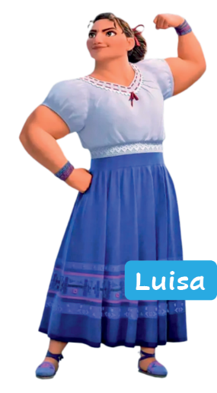
- They __________ a beautiful smile.
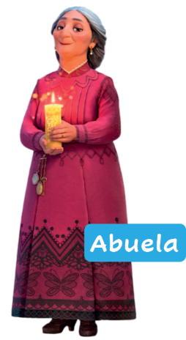
 | Look at the pictures. Complete the questions and short answers.
- “______ Abuela ______ short hair?” “No, ______.”
- “______ Luisa and Abuela ______ a big nose?” “Yes, ______.”
- “______ Luisa ______ strong arms?” “Yes, ______.”
- “______ Abuela and Luisa ______ glasses?” “No, ______.”
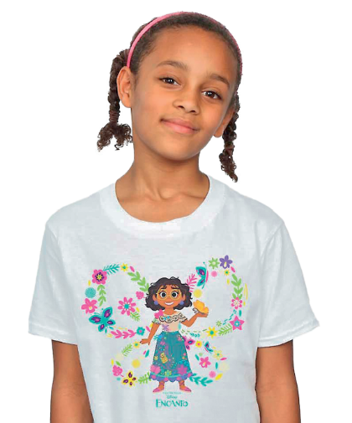
 | Complete the text with the correct form of the verb have got.
Hi! I’m Luna and I love Mirabel from Encanto! I ¹_________ a
T-shirt with her face! But we’re very different. I ²_________ small
eyes and she ³_________ big eyes. She ⁴_________ glasses,
but I ⁵_________ (not) glasses. We ⁶_________ dark hair. And
you? ⁷_________ you dark hair?

