 | Choose the correct option to complete Mirabel’s quote.
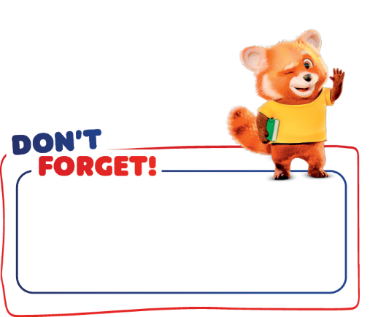

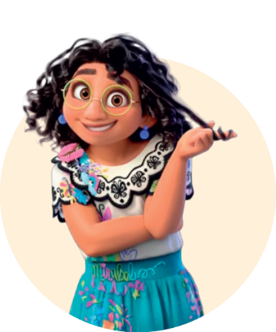
Verb have got (affirmative)
I/You/We/They have got
He/She/It has got
The miracle is not
something magic that
you ’ve got / ’s got.
The miracle is YOU.

 | Complete the sentences with have got or has got.

- I __________ big eyes.  - Mirabel (she) ________ glasses. | - Bruno and Julieta (they) __________ dark hair.  - Luisa (she) __________ two sisters.

 | Complete the sentences with have got, haven’t got, has got or hasn’t got.
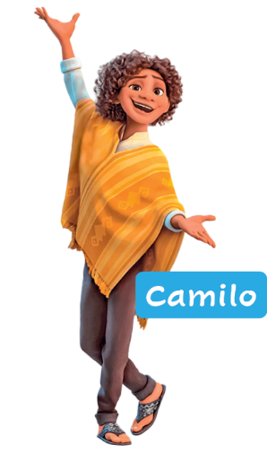
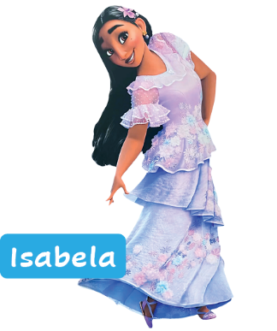
- Camilo __________ curly hair. 
- Isabela __________ short hair. 
- Camilo __________ a beard.
- Camilo and Isabela __________ glasses.
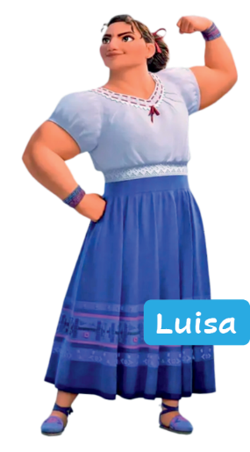
- They __________ a beautiful smile.
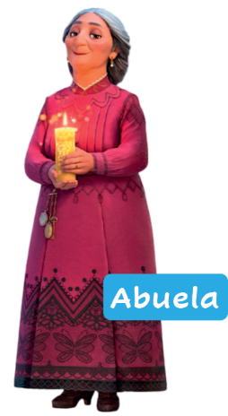
 | Look at the pictures. Complete the questions  and short answers with has, hasn’t, have or haven’t.
- “______ Abuela got short hair?” “No, she ______.”
- “______ Luisa and Abuela got a big nose?” “Yes, they ______.”
- “______ Luisa got strong arms?” “Yes, she ______.”
- “______ Abuela and Luisa got glasses?” “No, they ______.”
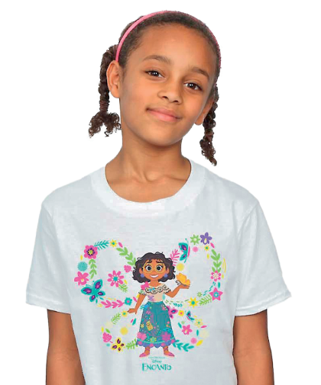
   | Circle the correct option to complete the text.
Hi! I’m Luna and I love Mirabel from Encanto! I ¹ ’ve got / ’s got
a T-shirt with her face! But we’re very different. I ² ’ve got / ’s got
small eyes and she ³ ’ve got / ’s got big eyes. She ⁴ ’ve got / ’s got
glasses, but I ⁵ haven’t got / hasn’t got glasses. We ⁶ ’ve got / ’s got
dark hair. And you? ⁷ Have / Has you got dark hair?

