 | Complete the sentences about Gabby’s bedroom. Write There is or There are.
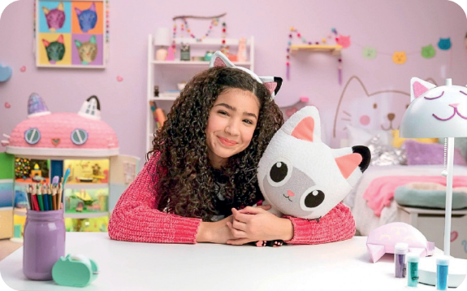
- ______________ a doll house.
- ______________ two windows.
- ______________ a big bed.
- ______________ some pencils.
- ______________ many cat toys.
- ______________ a purple wall.

 | Look at the picture. Write affirmative and negative sentences about Gabby’s doll house.  There is one example.
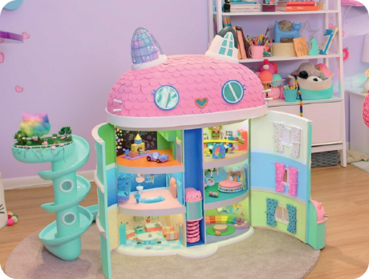
● (a bathroom)
There is a bathroom.
- (a pink roof)
- (a swimming pool)
- (some windows)
- (five floors)

 | Write sentences with there + to be in the affirmative, negative and interrogative. There  is one example.
● not / a dog / in her house / .
There isn't a dog in her house.
- a bedroom / upstairs / .
- a bathroom / downstairs / ?
- not / a garden / outside / .
- two doors / in the kitchen / ?

 | Look at the picture of Gabby’s bedroom. Answer the questions using short answers.
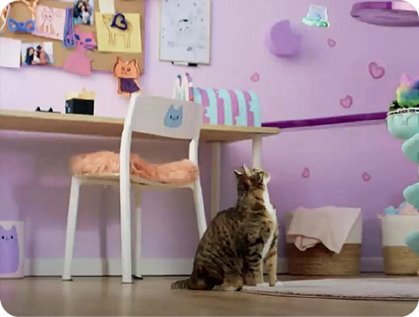
- Is there a chair? ______, _________________.
- Are there windows? ______, _________________.
- Is there a cat? ______, _________________.
- Are there papers on the wall? ______, _________________.
- Is there a chimney? ______, _________________.

