 | Complete the sentences about Gabby’s bedroom. Write There is or There are.
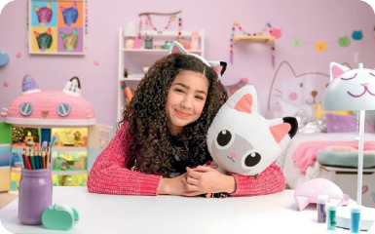
- _________ a doll house.  - _________ two windows.  - _________ a big bed. | - _________ some pencils.  - _________ many cat toys.  - _________ a purple wall.

 | Affirmative | Negative | Interrogative
Singular | There is… | There isn’t… | Is there…?
Plural | There are… | There aren’t… | Are there…?

 | Complete the sentences about Gabby’s doll house. Write There is, There isn’t, There are  or There aren’t.
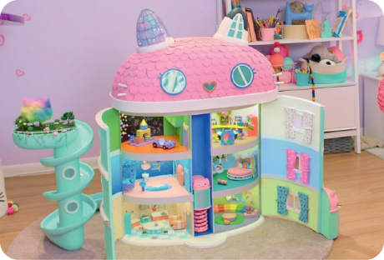
- _____________________ a pink roof. 
- _____________________ a swimming pool. 
- _____________________ some Windows.
- _____________________ five floors.

 | Complete the sentences with the verb forms from the box. There are two extra options.
- ______________ a bedroom upstairs.
There is • There are
There isn’t • There aren’t
Is there • Are there
- ______________ a bathroom downstairs
- ______________ (not) a garden outside.
- ______________ two doors in the kitchen?

 | Answer the questions about the picture using short answers. There is one example.
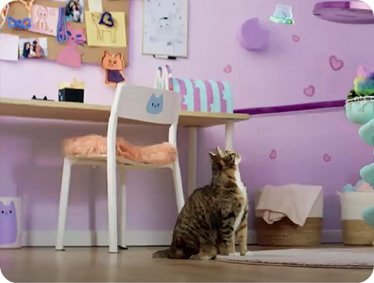
● Is there a chair? ______, _____________.
there is
Yes
- Are there windows? ______, _____________.
- Is there a cat? ______, _____________.
- Are there papers on the wall? ______, _____________.
- Is there a chimney? ______, _____________.

