 | Find 10 prepositions of place in the word cloud. Then write them.
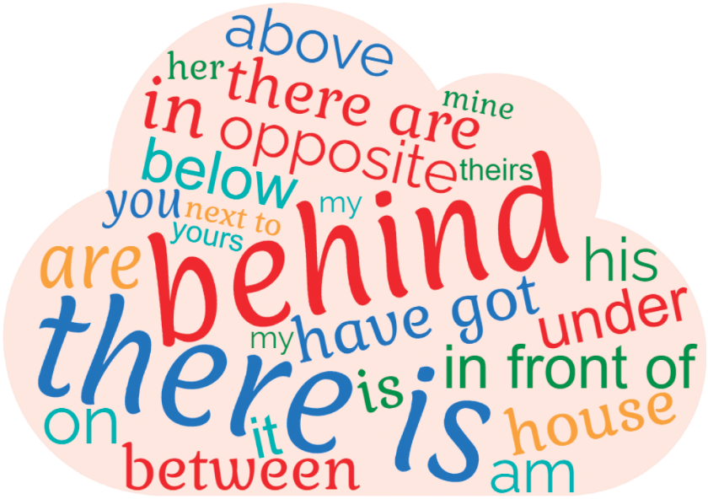
_____________
_____________
_____________
_____________
_____________
_____________
_____________
_____________
_____________
_____________

 | Complete the sentences with the prepositions from the box.
next to • behind • in • under • above • on

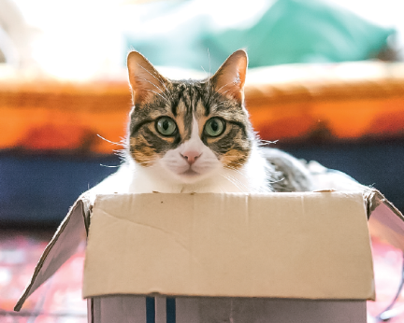 | 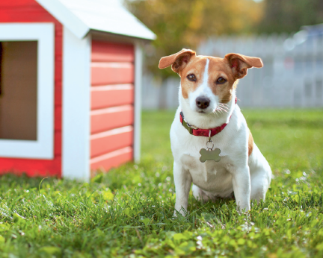 | 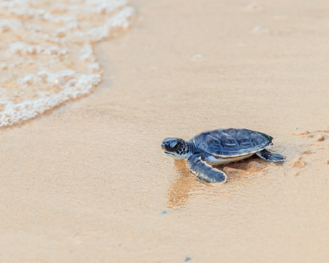
1. The cat is _____ the box. | 2. The dog is ________  the house. | 3. The turtle is________  the sand.
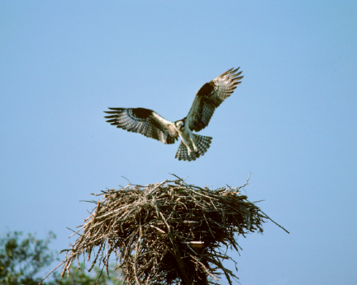 | 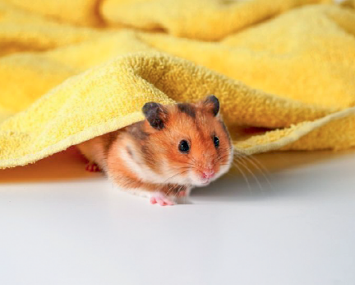 | 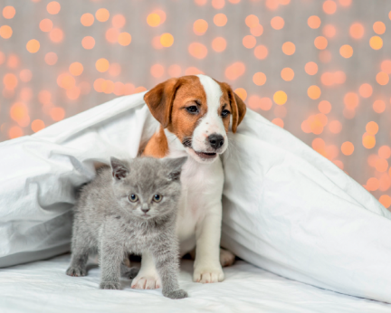
4. The bird is________  the nest. | 5. The hamster is________  the towel. | 6. The dog is________  the cat.

