 | Complete the table. Write the words in the singular or plural.

Singular | Plural
sofa  2___________  knife  4___________  potato  child  7___________  foot | 1___________  cities  3___________  buses  5___________  6___________  men  8___________

 | Look at the picture. What pets are there? Complete the list with the words from the  box.
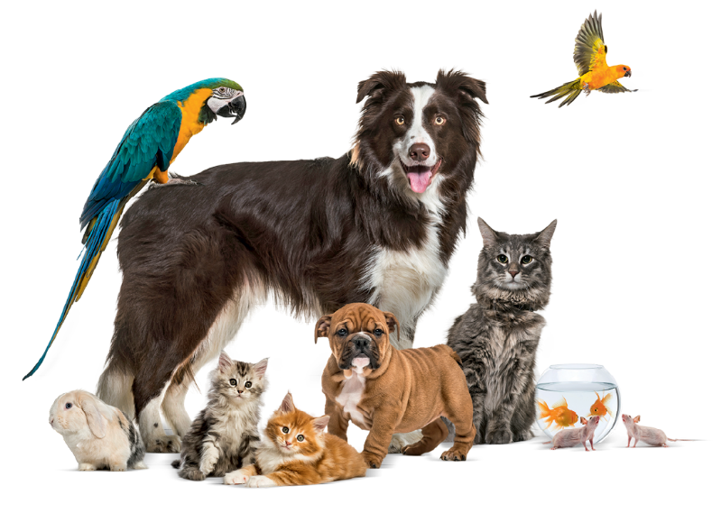
One rabbit
rabbit
cat
dog
fish
bird
mouse
__________________, __________________, __________________.
__________________, __________________, __________________.

 | Cross (✗) the THREE wrong sentences. Then correct them.

 |  | Correction
- There are five wolfs. |  | _______________________________
- There are seven days in a week. |  | _______________________________
- My grandfather has got three sheeps. |  | _______________________________
- How many dishes are there? |  | _______________________________
- I’ve got two brushes. |  | _______________________________
- My tooths are white. |  | _______________________________

