 | Complete the table. Write the words in the plural.

Singular | Plural
sofa  city  knife  bus  potato  child  man  foot | 1______________  2______________  3______________  4______________  5______________  6______________  7______________  8______________

 | Look at the picture. What pets are there? Complete the list with the words from the box.
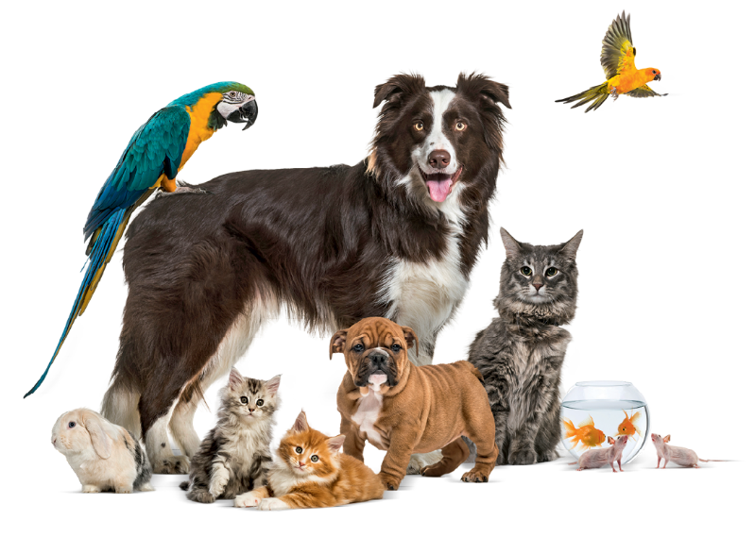
cat
dog
fish
bird
mouse
d
c
One rabbit, three ________________, two ________________,
m
b
f
two ______________, two ______________, two ______________.

 | These sentences are wrong. Correct them.
- There are five wolfs.
- My grandfather has got three sheeps.
- My tooths are white.

