 | Complete with a/an.

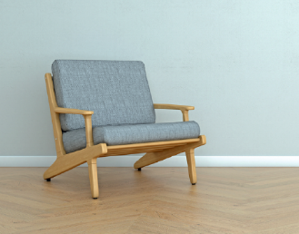 | 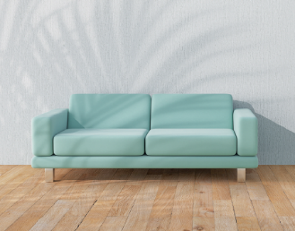 | 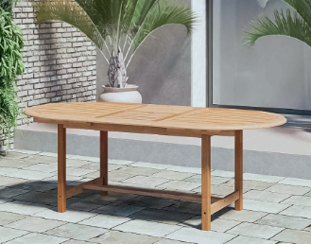 | 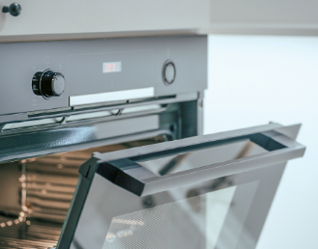
1. _______ armchair | 2. _______ sofa | 3. _______ table | 4. _______ oven

 | Tick (✓) the correct option to complete the sentences.

- There is _______ bathroom upstairs. | a) a | b) an | c) Ø
- The kitchen is _______ room in the house. | a) a | b) an | c) Ø
- There are _______ chairs in the kitchen. | a) a | b) an | c) Ø
- There is _______ orange bed in the bedroom. | a) a | b) an | c) Ø
- There are _______ eggs in the fridge. | a) a | b) an | c) Ø

 | Complete the sentences with the / Ø.
- He lives in _______ United States of America.
- _______ Alfred has got a big house.
- _______ bedrooms of the house are very comfortable.
- They have got _______ big windows.
- My sister is from _______ London.

   | Circle the correct option to complete the text.
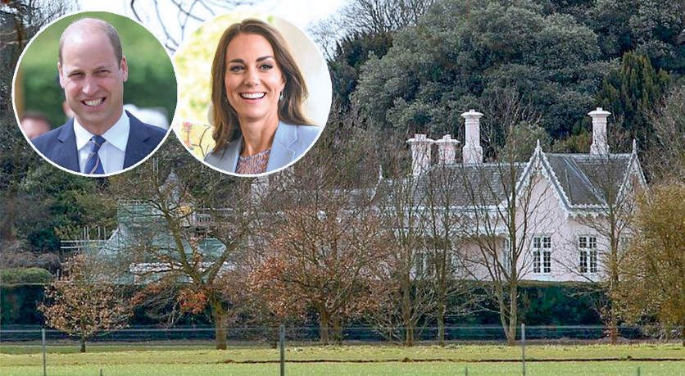
¹ The / Ø William and Kate live in ² a / an
house called Adelaide Cottage. It’s in
³ an / the United Kingdom. There is
⁴ the / a big garden outside. Inside there
are four bedrooms, two living rooms and
⁵ Ø / an attic. ⁶ A / The house is not ⁷ Ø / a
castle, but it’s big and beautiful!

