 | Complete with a/an.

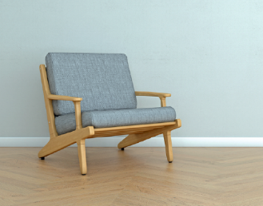 | 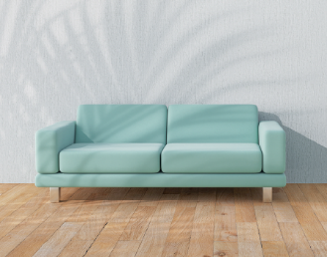 | 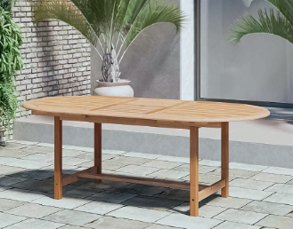 | 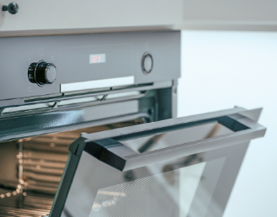
1. _______ armchair | 2. _______ sofa | 3. _______ table | 4. _______ oven

 | Tick (✓) the correct option to complete the sentences.

a + consonant
an + vowel
- There is _______ bathroom upstairs. | a) a | b) an
- The kitchen is _______ room in the house. | a) a | b) Ø
- There are _______ chairs in the kitchen. | a) a | b) Ø
- There is _______ orange bed in the bedroom. | a) a | b) an
- There are _______ eggs in the fridge. | a) a | b) Ø

   | Circle the correct option to complete the sentences.
- He lives in the / Ø United States of America.
- The / Ø Alfred has got a big house.
- The / Ø bedrooms of the house are very comfortable.
- They have got the / Ø big windows.
- My sister is from the / Ø London.

 | Circle the correct option to complete the sentences.
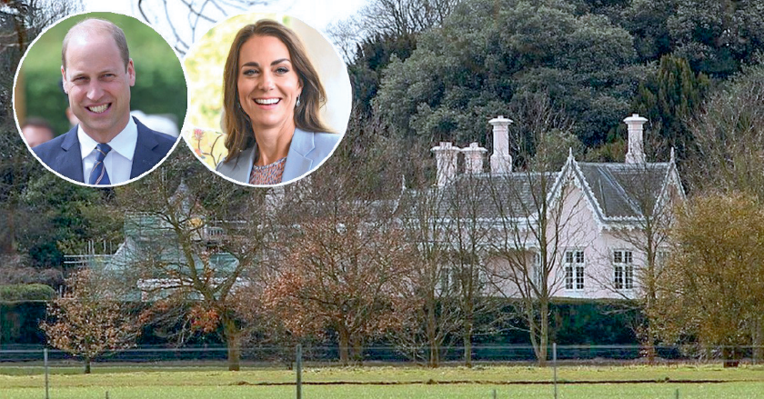
- The / Ø William and Kate live in a / an
house called Adelaide Cottage.
- It’s in an / the United Kingdom.
- There is the / a big garden outside.
- Inside there is Ø / an attic.
- A / The house is not Ø / a castle, but
it’s big and beautiful!

