 | Look at the pictures. Complete the sentences with the present continuous (affirmative  and negative). There is one example.

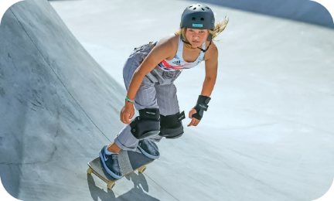 |  | 
dance / skateboard | chat / take a selfie | camp / surf
• Sky Brown .  She .  is skateboarding  isn’t dancing | 2. They ________________.  They ________________. | 3. I ____________________.  I ____________________.

 | Use the words to make questions. Then answer the questions with short answers,  according to the picture. There is one example.
• Sky Brown / skateboard
No
she isn't
Is Sky Brown skateboarding
_____________________________? _____, ___________.
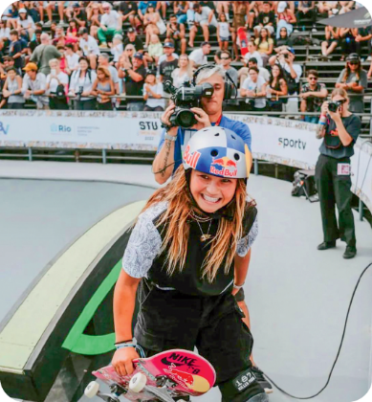
- the cameraman / read
_____________________________? _____, ___________.
- the photographer / take pictures
_____________________________? _____, ___________.
- the people / watch the competition
_____________________________? _____, ___________.
- they / play the piano
_____________________________? _____, ___________.

 | Complete the text with the present continuous form of the verbs in brackets.
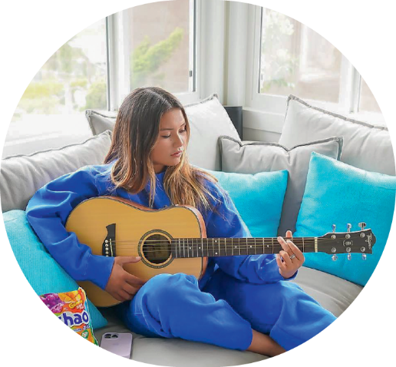
Sky Brown is a British skater. At the moment, she
¹_______________________ (not skateboard), she
²___________________ (play) the guitar in the living
room. Her brother and her father are also skaters, so
they ³__________________ (practise) outside.
And you? What ⁴______ you __________ (do) at the
moment?

