 | Look at the pictures. Complete the sentences with the present continuous (affirmative  and negative). There is one example.

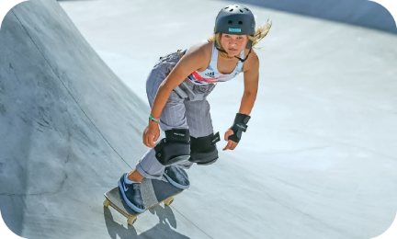 |  | 
• Sky Brown  (not dance).  She  (skateboard).  isn’t dancing  is skateboarding | 2. They  (not chat).  They  (take) a selfie. | 3. I  (not camp).  I  (surf).

 | Use the words to make questions. Then answer the questions with short answers,  according to the picture. There is one example.
• Sky Brown / skateboard
she isn't
No
Is Sky Brown skateboarding
______________________________? _____, ___________. 

- the cameraman / read
Is ____________________________? _____, ___________.
- the photographer / take pictures
Is ____________________________? _____, ___________. 
- the people / watch the competition
Are __________________________? _____, ___________.
- they / play the piano
Are __________________________? _____, ___________.

   | Circle the correct option to complete the text.

Sky Brown is a British skater. At the moment, she
¹ isn’t / aren’t skateboarding, she is ² play / playing
the guitar in the living room. Her brother and her
father are also skaters, so they ³ am / are practicing
outside. And you? What are you ⁴ doing / do at the
moment?

