 | Look at the posts about school lunches in different countries. Complete the texts with  some or any. Then draw a typical school lunch in your country and complete the text.

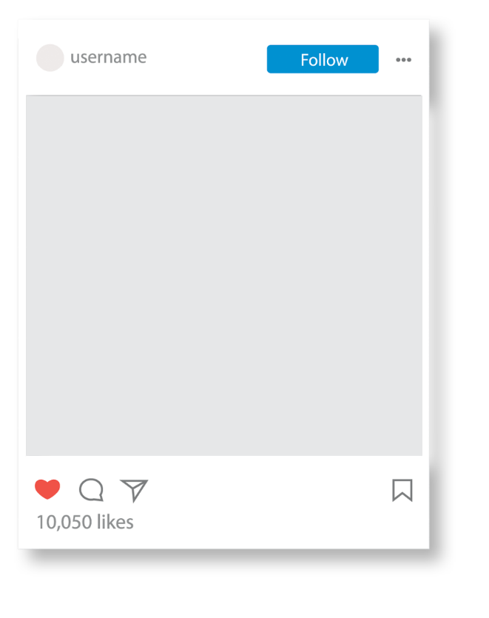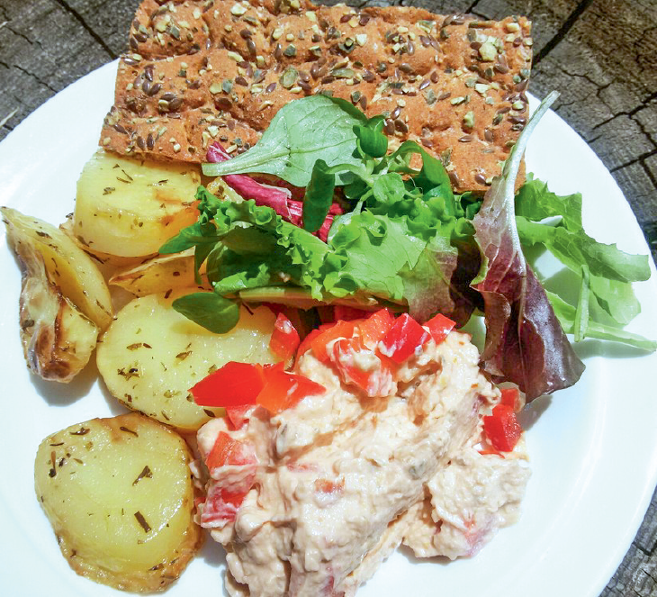  Finland:  There are ¹_____ potatoes, ²_____  lettuce and ³_____ bread. But there  isn’t ⁴_____ soup. | 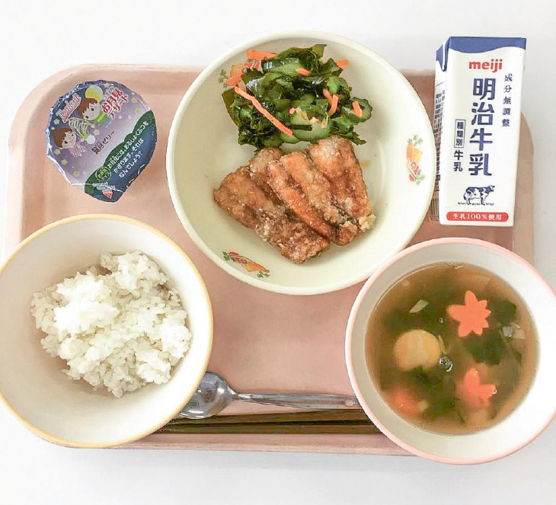  Japan:  There isn’t ⁵_____ salad. There is  ⁶_____ rice and ⁷_____ soup. To  drink, there is ⁸_____ milk.
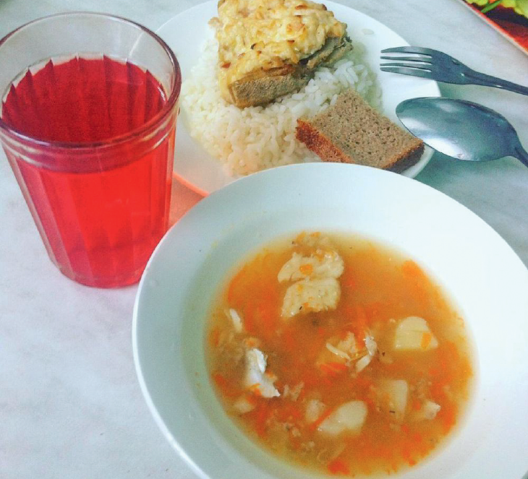  Russia:  There isn’t ⁹_____ water, but there  is ¹⁰_____ juice to drink. There is  ¹¹_____ fish soup, fish and rice. | _______________ (your country):  In my school lunch there is  ¹²______________, but there isn’t  ¹³______________. Is there ¹⁴_____  bread? _____, there _____.

