 | Look at the posts about school lunches in different countries. Complete the texts with  some or any. Then draw a typical school lunch in your country and complete the text.

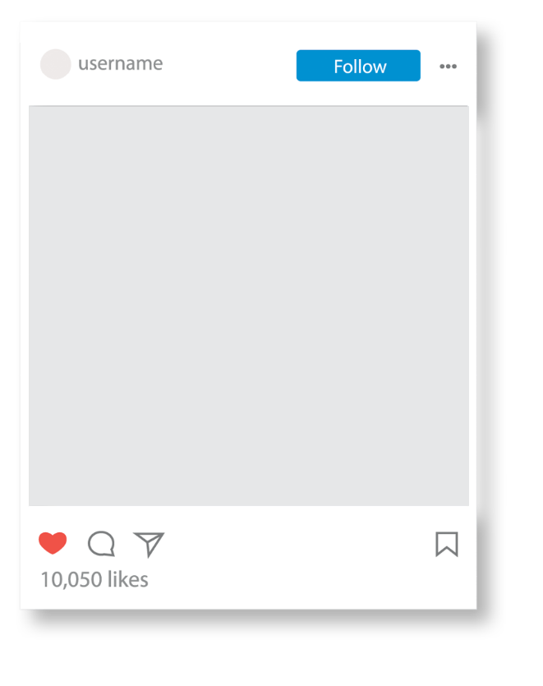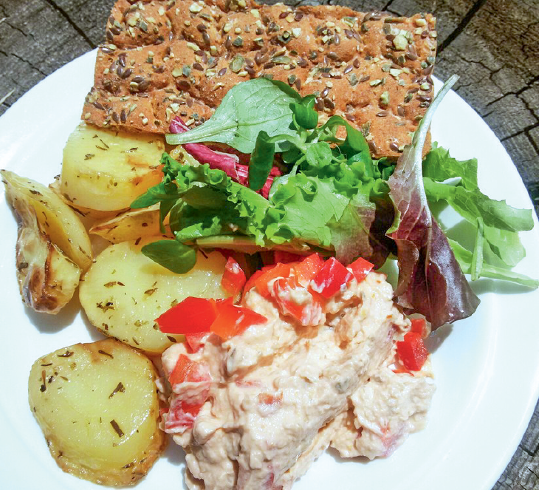  Finland:  There are ¹_____ potatoes,  ²_____ lettuce and ³_____  bread. But there isn’t ⁴_____ soup. |   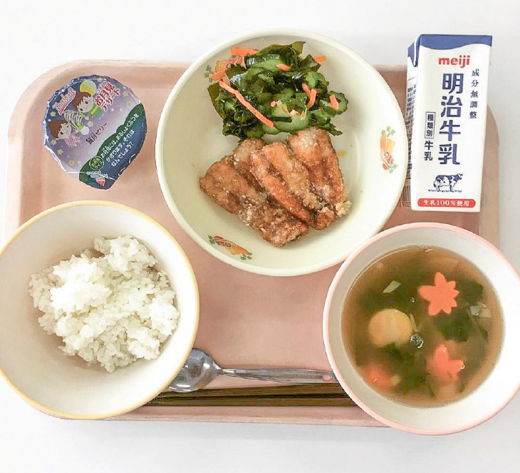  some:  affirmative  any: negative,  interrogative  Japan:  There isn’t ⁵_____ salad. There is  ⁶_____ rice and ⁷_____ soup. To  drink, there is ⁸_____ milk.
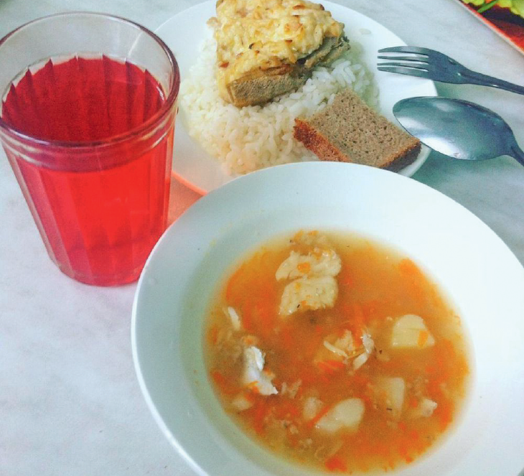  Russia:  There isn’t ⁹_____ water, but there  is ¹⁰_____ juice to drink. There is  ¹¹_____ fish soup, fish and rice. | _______________ (your country):  In my school lunch there is  ¹²________________, but there isn’t ¹³______  ___________. Is there ¹⁴_____ bread? ______, there _________________.

