 | Find 7 verbs used to express preferences in the word search (↓ →). Then write them.

R | T | P | C | M | P | D | W | E | Z | M | I | P | O | E | C | I | B | X | C
F | A | Y | J | Z | L | A | U | L | A | W | J | W | Y | F | K | B | D | Y | E
U | H | Z | J | R | X | C | D | J | P | R | M | W | W | K | Q | K | M | X | N
D | A | Z | A | A | A | P | S | L | N | T | I | U | K | Q | A | H | Z | K | J
I | T | N | E | R | E | B | Q | J | T | T | A | Q | J | D | Z | P | F | Y | O
S | E | N | X | Q | D | T | X | I | Q | B | V | G | K | S | T | K | T | K | Y
L | Z | X | Q | S | B | K | W | K | D | N | K | L | S | Q | K | W | V | S | V
I | G | E | E | Z | L | O | C | B | P | G | Y | I | A | X | F | L | G | O | O
K | X | N | E | C | M | D | E | T | E | S | T | K | W | P | R | E | F | E | R
E | W | W | F | W | K | V | A | I | L | O | V | E | N | V | V | J | H | J | Y
_______________  _______________ | _______________  _______________ | _______________  _______________ | _______________

   | Circle the correct option to label the pictures.
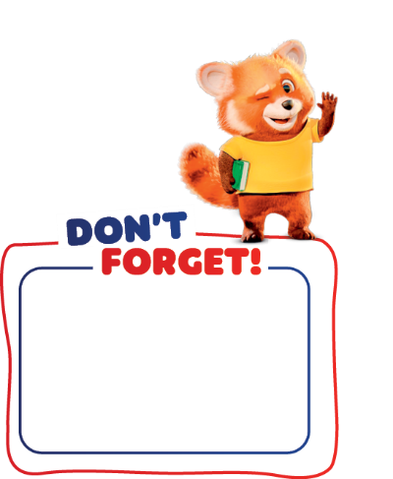
like/love/hate/
enjoy… + -ing verb

I like cooking.
 |  |  | 
1. love / hate | 2. dislike / enjoy | 3. like / dislike | 4. hate / love

 | Complete the text with the correct form of the verbs in brackets.

My name is Jaxon Porter and I’m a racing driver. I like ¹_________ (drive) karts. I’m very good at it! I just love ²_________ (go) fast! I enjoy ³_____________ (participate) in competitions – it’s so much fun!
When I’m at home, my family and I love ⁴______________ (cook) together. We don’t like ⁵______________ (buy) junk food – we prefer
⁶______________ (eat) healthy food, like fruit and vegetables.

