   | Circle the correct option to complete the sentences.
- The cat like / likes fish.
- I like / likes cats. They’re my favourite animal.
- My friend Silvia like / likes cats, but she prefers dogs.
- Dogs like / likes sausages.

 | Look at the pictures. Complete the sentences with the correct form of the verb like  (affirmative or negative).
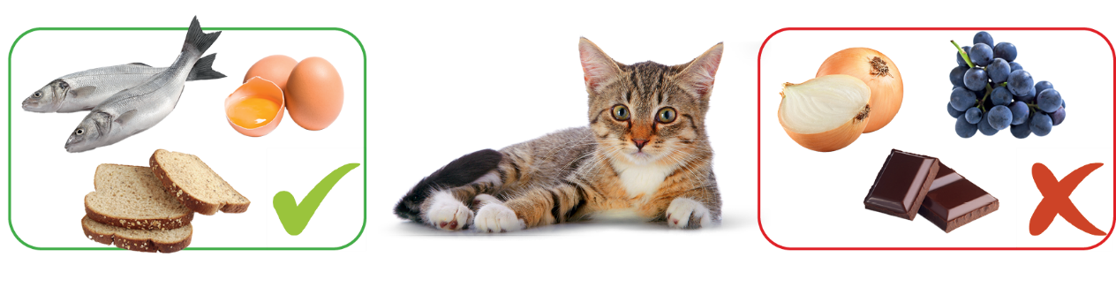
- Alfred _____________ grapes.  - Alfred _____________ fish.  - Alfred _____________ bread. | - Alfred _____________ onion.  - Alfred _____________ eggs.  - Alfred _____________ chocolate.

 | Write questions. There is one example.
● __________________________________? Yes, he does. Peter likes orange juice.
Does Peter like orange juice
- __________________________________? Yes, they do. They like lemonade.
- __________________________________? No, she doesn’t. Ruth doesn’t like tea.
- __________________________________? Yes, we do. My friends and I like cake.

 | Complete the dialogue with the correct form of the verb like.
Gordon: ¹_______ you ____________ cooking?

Jamie: Yes, I ²_______. I love cooking!
Gordon: ³_______ you chocolate?
Jamie: No, I ⁴_________. I ⁵____________ (not) desserts
with chocolate. My favourite dessert is cheesecake. My sister
⁶________ chocolate, but she ⁷__________ (not) cheesecake.
Gordon: I ⁸____________ (not) cheesecake, but I
⁹____________ ice cream.

