   |   Circle the correct option to complete the sentences.  Verb like – affirmative  I/You/We/They like  He/She/It likes
- The cat like / likes fish.
- I like / likes cats. They’re my favourite animal.
- My friend Silvia like / likes cats, but she prefers dogs.
- Dogs like / likes sausages.

 | Look at the pictures and complete the sentences with likes / doesn’t like.
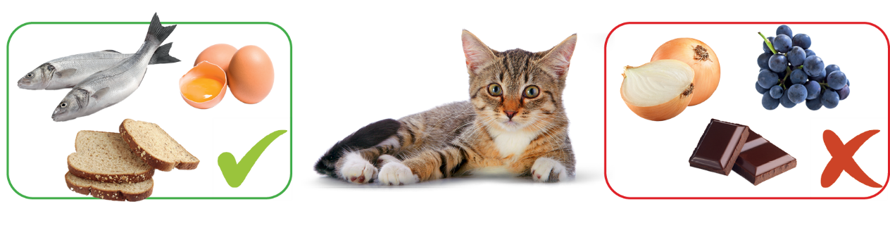
- Alfred _____________  grapes.  - Alfred _____________  fish.  - Alfred _____________ bread. | - Alfred _____________ onion.  - Alfred _____________ eggs.  - Alfred _____________ chocolate.

 | Complete the questions. There is one example.
● _______ Peter _________ orange juice? Yes, he does.
Does
like
- _______ they _____________ lemonade? Yes, they do.

- _______ Ruth _____________ tea? No, she doesn’t.
- _______ your friends and you _________ cake? Yes, we do.

 | Circle the correct option to complete the dialogue.

Gordon: ¹ Do you like / Does you like cooking?
Jamie: Yes, I ² do / does. I love cooking!
Gordon: ³ Do you likes / Do you like chocolate?
Jamie: No, I ⁴ doesn’t / don’t. I ⁵ don’t like / doesn’t like desserts
with chocolate. My favourite dessert is cheesecake. My sister
⁶ like / likes chocolate, but she ⁷ don’t like / doesn’t like cheesecake.
Gordon: I ⁸ don’t like / doesn’t like cheesecake, but I ⁹ like / likes ice cream.

