 | Complete the sentences with the present simple form of the verbs in brackets.
Life advice from film characters
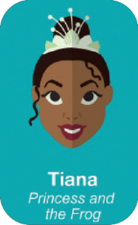 | 1. Fairy tales can come  true. It all _________  (depend) on you. |  | 2. Life _________  (not give) us  happiness. We _______  (give) life happiness. |  | 
3. How high_________  a tree ________ (grow)?  If you cut it down, you  never know. |  |  | 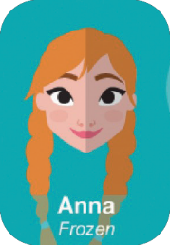 | 4. Love _________ (be)  an open door.
 | 5. I ______________  (not look) back. It  ___________ (distract)  me from the present. |  | 6. Just because I can’t  see, it ______________  (not mean) I _________  (not believe) it. |  | 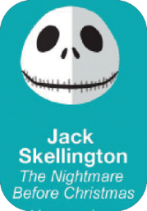
7. I ________________  (not have got) fear. |  |  |  | 8. The flower that  ___________ (grow) in  difficult times is more  beautiful.
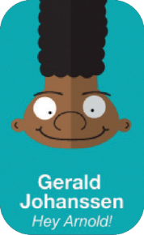 | 9. This is real life and  in real life you _________  always _______________  (not win). |  | 10. It is not the beard  on the outside that  _____________ (count).  It’s the bear on the inside. |  | 
11. A hero ___________  (not be) the one who  is only strong, but the  one who ___________  (have got) a big heart. |  | 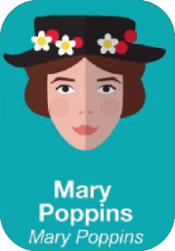 | 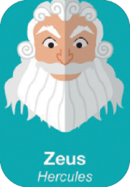 | 12. In every job ______  ________ (there to be)  some fun.

