   | Circle the correct option to complete the sentences.
Life advice from film characters
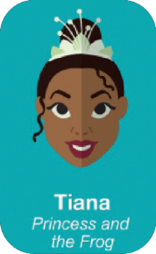 | 1. Fairy tales can come  true. It all depend /  depends on you. |  |  | 2. Life don’t give /  doesn’t give us  happiness. We give /  gives life happiness. |  | 
3. How high do / does  a tree grow / grows?  If you cut it down, you  never know. |  |  |  | 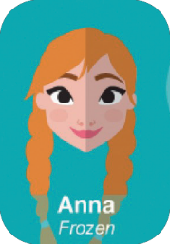 | 4. Love is / are an  open door.
 | 5. I don’t look /  doesn’t look back. It  distract / distracts me  from the present. |  | 6. Just because I can’t see, it  don’t mean / doesn’t mean  I don’t believe. |  |  | 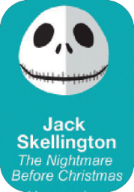
7. I havenʼt got /  hasnʼt got fear. |  | 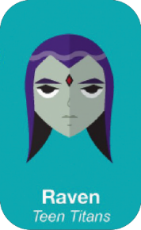 |  |  | 8. The flower that  grow / grows in  difficult times is more  beautiful.
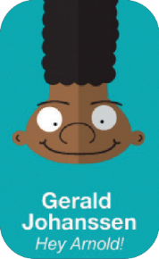 | 9. This is real life and  in real life you don’t /  doesn’t always win /  wins. |  |  | 10. It is not the beard  on the outside that  count / counts. It’s the  bear on the inside. |  | 
11. A hero isn’t /  don’t be the one who  is only strong, but the  one who have got /  has got a big heart. |  |  |  | 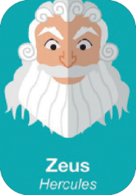 | 12. In every job there is /  there are some fun.

