 | Find 5 adverbs of frequency in the word snake.

_____________ | _____________ | _____________ | _____________ | _____________

 | How often do they play Pokémon? Use the adverbs from the box.

 | Monday | Tuesday | Wednesday | Thursday | Friday | Saturday | Sunday
Elsa |  | 
Ana
James
Tom

- Elsa ____________ plays Pokémon.
- Ana ____________ plays Pokémon.
always • never
sometimes • usually
- James ____________ plays Pokémon.
- Tom ____________ plays Pokémon.

 | Rewrite the sentences and put the adverb of frequency in the correct place. There is one  example.
● Afonso plays Pokémon after school. (sometimes)
Afonso sometimes plays Pokémon after school.
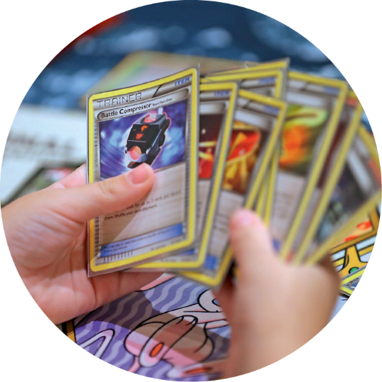
- They are late for school. (never)

- My sister watches Pokémon on TV. (often)

- Playing with friends is fun. (always)

- Jessica buys new cards. (usually)

