 | Find 5 adverbs of frequency in the word snake.

_____________ | _____________ | _____________ | _____________ | _____________

 | How often do they play Pokémon? Use the adverbs from the box.
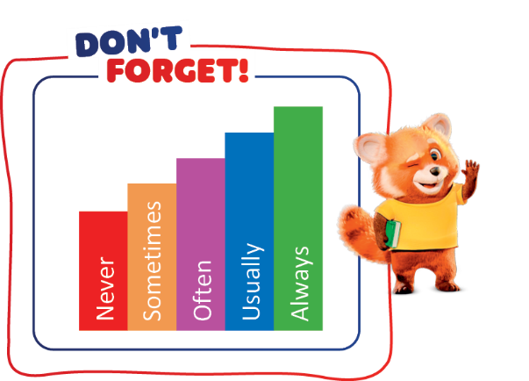
 | Monday | Tuesday | Wednesday | Thursday | Friday | Saturday | Sunday
Elsa |  | 
Ana
James
Tom
- Elsa ____________ plays Pokémon.
always
never
sometimes
usually
- Ana ____________ plays Pokémon.
- James ____________ plays Pokémon.
- Tom ____________ plays Pokémon.

 | Rewrite the sentences and put the adverb of frequency in the correct place. There is one  example.

● Afonso plays Pokémon after school. (sometimes)
adverb of frequency + verb
But:
verb to be + adverb of
frequency
Afonso sometimes plays Pokémon after school.

- They are late for school. (never)

- My sister watches Pokémon on TV. (often)

- Playing with friends is fun. (always)

- Jessica buys new cards. (usually)

