
Unit 1 What do we look like and what are we wearing?
Test 1 – breakdown

TEST A  Standard | No. of  questions | Types of questions | Marks per  question | Total
Listening  Metas:  L 1, 2, 3, 4, 5 | 2 | 1. Listen and order.  Physical description (page 26) | 5 x 2 = 10 | 20
Listening  Metas:  L 1, 2, 3, 4, 5 | 2 | 2. Listen and draw a line.  Clothes (page 34) | 5 x 2 = 10 | 20
Vocabulary  Metas:  ID 8.3, 8.4 | 2 | 1. Look and draw lines.  Face and hair (page 30) | 6 x 1 = 6 | 20
Vocabulary  Metas:  ID 8.3, 8.4 | 2 | 2. Look and write.  Accessories (page 38) | 7 x 2 = 14 | 20
Reading  Metas:  R 4.3, 4.4, 4.6 | 2 | 1. Read and draw a line.  Sentences related to the text | 5 x 2 = 10 | 20
Reading  Metas:  R 4.3, 4.4, 4.6 | 2 | 2. Read and answer the questions.  Two comprehension questions about the text and a personal question | 2 x 3 = 6  1 x 4 = 4 | 20
Reading  Metas:  R 4.3, 4.4, 4.6 | 3 | 1. Read and write the correct verb: to be or have got.  Verb to be / Verb to have (got) in the present simple (pages 28-29) | 10 x 1 = 10 | 20
Reading  Metas:  R 4.3, 4.4, 4.6 | 3 | 2. Look and write Whose, ’s or ’.  Question word Whose + possessive case (page 36) | 10 x 0,5 = 5 | 20
Reading  Metas:  R 4.3, 4.4, 4.6 | 3 | 3. Look and write. Choose one word.  Possessive determiners and personal pronouns (page 40) | 10 x 0,5 = 5 | 20
Writing  Metas: W 5.1, 6 | 2 | 1. Read and answer the questions about you.  Personal questions | 5 x 2 = 10 | 20
Writing  Metas: W 5.1, 6 | 2 | 2. Write a profile of a character with the information provided. | 5 x 2 = 10 | 20
 |  |  |  | 100%

TEST B  Easy-to-correct | No. of  questions | Types of questions | Marks per  question | Total
Listening  Metas:  L 1, 2, 3, 4, 5 | 2 | 1. Listen and order.  Physical description (page 26) | 5 x 2 = 10 | 20
Listening  Metas:  L 1, 2, 3, 4, 5 | 2 | 2. Listen and draw a line.  Clothes (page 34) | 5 x 2 = 10 | 20
Vocabulary  Metas:  ID 8.3, 8.4 | 2 | 1. Look, read and tick the correct word.  Face and hair (page 30) | 6 x 1 = 6 | 20
Vocabulary  Metas:  ID 8.3, 8.4 | 2 | 2. Look and write Yes or No.  Accessories (page 38) | 7 x 2 = 14 | 20
Reading  Metas:  R 4.3, 4.4, 4.6 | 3 | 1. Read and complete.  Sentences related to the text | 5 x 2 = 10 | 20
Reading  Metas:  R 4.3, 4.4, 4.6 | 3 | 2. Read and order the sentences. | 6 x 1 = 6 | 20
Reading  Metas:  R 4.3, 4.4, 4.6 | 3 | 3. Answer the question about you.  Two comprehension questions about the text and a personal question | 1 x 4 = 4 | 20
Grammar  Metas:  LG 8.5, 8.6, 8.9,  8.17, 8.23, 8.28 | 3 | 1. Read and circle.  Verb to be / Verb to have (got) in the present simple (pages 28-29) | 10 x 1 = 10 | 20
Grammar  Metas:  LG 8.5, 8.6, 8.9,  8.17, 8.23, 8.28 | 3 | 2. Look and choose whose or what. Then, write ’s.  Question word Whose + possessive case (page 36) | 10 x 0,5 = 5 | 20
Grammar  Metas:  LG 8.5, 8.6, 8.9,  8.17, 8.23, 8.28 | 3 | 3. Read and circle.  Possessive determiners and personal pronouns (page 40) | 10 x 0,5 = 5 | 20
Writing  Metas: W 5.1, 6 | 2 | 1. Read and answer the questions about you.  Personal questions | 5 x 2 = 10 | 20
Writing  Metas: W 5.1, 6 | 2 | 2. Write a profile of a character with the information provided. | 5 x 2 = 10 | 20
 |  |  |  | 100%

TEST C  NEE |  | No. of  questions | Types of questions | Marks per  question | Total
Part I | Listening  Metas:  L 1, 2, 3, 4, 5 | 2 | 1. Listen and order.  Physical description (page 26) | 5 x 2 = 10 | 20
Part I | Listening  Metas:  L 1, 2, 3, 4, 5 | 2 | 2. Listen and match.  Clothes (page 34) | 5 x 2 = 10 | 20
Part II | Vocabulary  Metas:  ID 8.3, 8.4 | 2 | 3. Match.  Face and hair (page 30) | 5 x 2 = 10 | 20
Part II | Vocabulary  Metas:  ID 8.3, 8.4 | 2 | 4. Write.  Accessories (page 38) | 5 x 2 = 10 | 20
Part II | Reading  Metas:  R 4.3, 4.4, 4.6 | 2 | 5. Match.  Sentences related to the text | 5 x 2 = 10 | 20
Part II | Reading  Metas:  R 4.3, 4.4, 4.6 | 2 | 6. Answer.  One comprehension question about a text and a personal question | 5 x 2 = 10 | 20
 |  |  |  |  | 100%
Test 1 – breakdown
TEST C  NEE |  | No. of  questions | Types of questions | Marks per  question | Total
Part II | Grammar  Metas:  LG 8.5, 8.6, 8.9,  8.17, 8.23, 8.28 | 3 | 7. Read and write the correct verb: to be or have got.  Verb to be / Verb to have (got) in the present simple (pages 28-29) | 8 x 1 = 8 | 20
Part II | Grammar  Metas:  LG 8.5, 8.6, 8.9,  8.17, 8.23, 8.28 | 3 | 8. Write Whose, ’s or ’.  Question word Whose + possessive case (page 36) | 8 x 0,5 = 4 | 20
Part II | Grammar  Metas:  LG 8.5, 8.6, 8.9,  8.17, 8.23, 8.28 | 3 | 9. Write. Choose one word.  Possessive determiners / personal pronouns (page 40) | 8 x 1 = 8 | 20
Part II | Writing  Metas: W 5.1, 6 | 2 | 10. Answer the questions about you.  Personal questions | 5 x 2 = 10 | 20
Part II | Writing  Metas: W 5.1, 6 | 2 | 11. Write a profile of a character with the information provided. | 5 x 2 = 10 | 20
 |  |  |  |  | 100%

TEST D  Cambridge-like | No. of  questions | Types of questions | Marks per  question | Total
PART 1  Listening &  Vocabulary  Metas:  L 1, 2, 3, 4, 5  ID 8.3, 8.4 | 1 | Listen and order.  Physical description (page 24)  Listen and draw a line.  Clothes (page 34) | 5 x 2,5 = 12,5  5 x 2,5 = 12,5 | 25
PART 2  Reading &  Vocabulary  Metas: R 4.3, 5.5  ID 8.3, 8.4 | 1 | Look and read. Put a or a in the box.  Physical description (page 26) | 5 x 5 = 25 | 25
PART 3  Reading,  Vocabulary &  Grammar  Metas: R 4.3, 4.5,  4.6, LG 8.6 ID 8.3,  8.4 | 1 | Read the story. Choose a word from the box. Write the correct  words next to the numbers 1-5.  Physical description (pages 26, 30)  Clothes and accessories (pages 34, 38)  Order of adjectives (page 33) | 5 x 5 = 25 | 25
PART 4  Writing &  Vocabulary  Metas: W 5  ID 8.3, 8.4 | 1 | Look at the pictures and read the questions.  Write one-word answers.  Physical description (pages 26, 30)  Clothes and accessories (pages 34, 38) | 5 x 5 = 25 | 25
 |  |  |  | 100%

TEST E  Alternative/Extra | No. of  questions | Types of questions | Marks per  question | Total
Listening  Metas:  L 1, 2, 3, 4, 5 | 2 | 1. Listen and order.  Face and hair (page 30) | 5 x 2 = 10 | 20
Listening  Metas:  L 1, 2, 3, 4, 5 | 2 | 2. Listen and draw a line.  Accessories (page 38) | 5 x 2 = 10 | 20
Vocabulary  Metas:  ID 8.3, 8.4 | 2 | 1. Look and draw a line.  Physical description (page 26) | 6 x 1 = 6 | 20
Vocabulary  Metas:  ID 8.3, 8.4 | 2 | 2. Look and write.  Clothes (page 34) | 7 x 2 = 14 | 20
Grammar  Metas:  LG 8.5, 8.6, 8.9,  8.17, 8.23, 8.28 | 3 | 1. Look and complete the sentences with the correct verb: to be or  have got.  Verb to be / Verb to have (got) in the present simple (pages 28-29) | 10 x 1 = 10 | 20
Grammar  Metas:  LG 8.5, 8.6, 8.9,  8.17, 8.23, 8.28 | 3 | 2. Look and write Whose, (name)’s or (name)’.  Question word Whose + possessive case (page 36) | 10 x 0,5 = 5 | 20
Grammar  Metas:  LG 8.5, 8.6, 8.9,  8.17, 8.23, 8.28 | 3 | 3. Read and order the words.  Order of adjectives (page 33) | 5 x 1 = 5 | 20
Writing  Metas: W 5.1, 6 | 2 | 1. Read and answer the questions about you.  Personal questions | 5 x 2 = 10 | 20
Writing  Metas: W 5.1, 6 | 2 | 2. Write a profile of a person with the information provided. | 5 x 2 = 10 | 20
 |  |  |  | 100%

Test 1 version A – standard test
School |  | Evaluation
Name _____________ Surname _____________ Class: 5th ____  Date _________________________________________, 20 ___  Signatures _____________________/______________________  (Teacher) (Parent/E.E.) |  | ____%  Muito Bom Bom Suficiente  Insuficiente Muito Insuficiente

Listening
- Listen and order. There is one example.
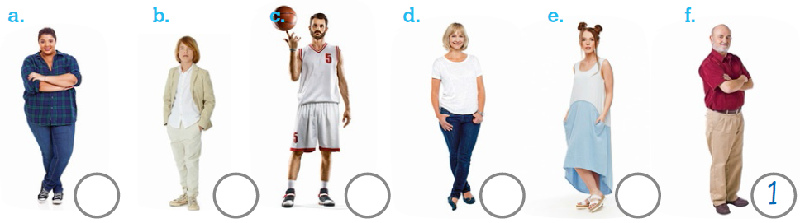
- Listen and draw a line. There is one example.
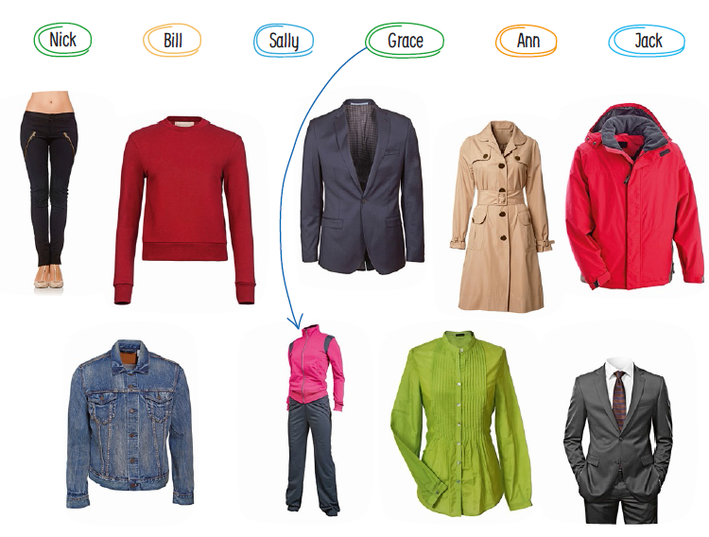

Test 1 version A – standard test
School |  | Evaluation
Name _____________ Surname _____________ Class: 5th ____  Date _________________________________________, 20 ___  Signatures _____________________/______________________  (Teacher) (Parent/E.E.) |  | ____%  Muito Bom Bom Suficiente  Insuficiente Muito Insuficiente

Vocabulary
- Look and draw a line.
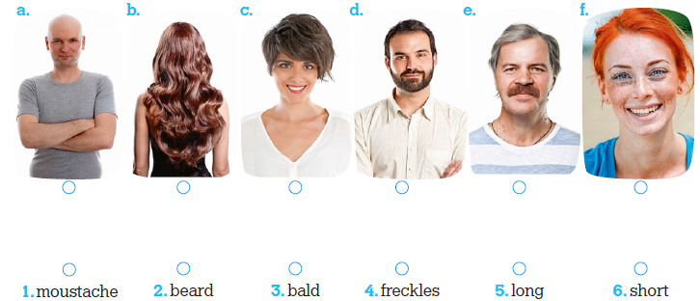

- Look and write.
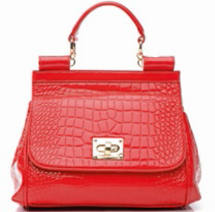 | 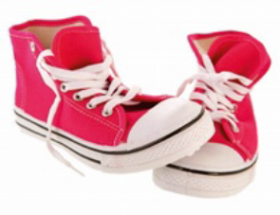 |  | 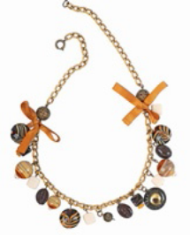 |  | 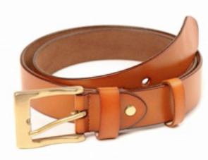
- ______________ | - _______________ |  | - ___________ |  | - ______________
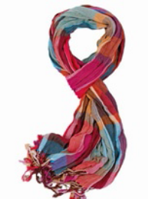 |  | 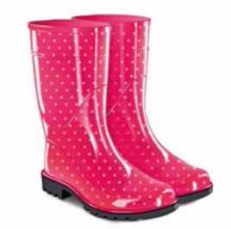 |  | 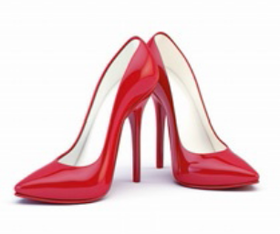
- _______________ |  | - _______________ |  | - _______________

Reading
Read the text.
My new friend
My name is Luana and I have got a new friend. Her name’s May. May’s surname is Wilson. May isn’t from England. She’s American. She’s nine years old. This is what she looks like: She is tall and thin so she isn’t short or fat. She’s young and pretty, like me. She’s got short straight brown hair and lovely big brown eyes. I’ve got a round face, but May’s got a long face. It’s very pretty. May’s favourite clothes are blouses and leggings. She also likes colourful wellies and raincoats. May’s raincoat is red. Can you guess what her favourite colour is?
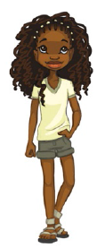
- Read and draw a line. There is one example.
- Luana’s new friend 1. pretty.
- May is from 2. eyes.
- This text 3. straight brown hair.
- She’s got brown 4. is about May.
- She’s young and 5. is American.
- She’s got short 6. the USA.

- Read and answer the questions.
- What is May like?
____________________________________________
- What are her favourite clothes?
____________________________________________
- What are your favourite clothes?
____________________________________________

Grammar
- Read and write the correct verb: to be or have got. There is one example.
- May is from the USA. She _____________(not) English.
- She _____________ nine years old.
- _____________ she fat? No, she _____________ (not).
- She _____________ (not) an oval face.
- _____________ May got straight hair? No, she _____________ (not).
- May’s favourite clothes _____________ (not) suits.
- She _____________ colourful wellies.
- Her raincoat _____________ red.

- Look and write whose, (name)’s or (name)’. There is one example.
- Whose blouse is it? It’s Pat’s blouse. (Pat)
- Whose leggings are they? They are _____________ leggings. (Mary)
- _____________ tracksuits are they? They’re _____________ tracksuits. (the boys)
- _____________ suit is it? It’s _____________ suit. (Paul)
- _____________ pullover is it? It’s my _____________ pullover. (mother)
- _____________ sweatshirts are they? They’re my _____________ sweatshirts. (parents)

- Look and write. Choose one word. There is one example.
- We (Her / We / I) are Grace and Kim. _____ (My / Our / His) wellies are lovely.
- This is Ann’s cat. _____ (Its / Her / Our) cat is black. _____ (They / Its / My) name is
- Blacky. _____ (His / Their / Our) eyes are yellow.
- _____ (She / I / They) am Sally and this is _____ (my / her / his) handbag.
- These are Ben’s high-tops. _____ (His / Her / Our) high-tops are cool. _____ (He / It /
- They) are blue and red.
- Jack, where is _____ (their / your / his) scarf? Don’t forget to wear _____ (they / it / we).
It’s cold.

Writing
- Read and answer the questions about you.
- Are you tall? _________________________________________________
- What is your face like? _________________________________________
- Have you got short straight brown hair? ____________________________
- What are your eyes like? _______________________________________
- Are you pretty? _______________________________________________

- Look at Moana and write her profile. Use the words in the box.
Height: Short Weight: Slim
Age: Young Face: Round
Adjectives: Brown, pretty, wavy,
long, big

__________________________________________________
__________________________________________________
__________________________________________________
__________________________________________________
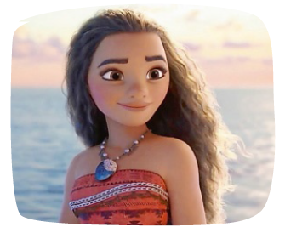
__________________________________________________

Keep calm and work hard! Happy Halloween!
Your teacher, ____________________________

Answer key and marking criteria
Test 1 version A – answer key and marking criteria

Section | Answer key | Marking criteria
Listening | Question 1: Listen and order.  Answer key: a. 5 b. 3 c. 2 d. 6 e. 4 | 5 x 2 = 10  2 marks per correct answer.  Only accept an answer if one number is written in  each box.
Listening | Question 2: Listen and draw a line.  Answer key: Bill – jackets, Ann – anoraks,  Jack – raincoats, Sally – leggings, Nick – suits | 5 x 2 = 10  2 marks per correct answer.  Only accept an answer if one line is drawn correctly  per answer.
Vocabulary | Question 1: Look and draw a line.  Answer key: a. 3 b. 5 c. 6 d. 2 e. 1 f. 4 | 6 x 1 = 6  1 mark per correct answer.  Only accept an answer if one line is drawn correctly  per answer.
Vocabulary | Question 2: Look and write.  Answer key: a. handbag b. high-tops c.  necklace d. belt e. scarf f. wellies g. high heels | 7 x 2 = 14  2 marks per correct answer.  -0,5 marks if there is a spelling mistake.
Reading | Question 1: Read and draw a line.  Answer key: b. 6 c. 4 d. 2 e. 1 f. 3 | 5 x 2 = 10  2 marks per correct answer.  Only accept an answer if one line is drawn correctly  per answer.
Reading | Question 2: Read and answer the questions.  Answer key:  a. May is tall and thin.  b. Her favourite clothes are blouses and leggings.  c. Personal answer | a./b. 2 x 3 = 6  3 marks per correct  answer.  -0,5 marks if there is a  spelling mistake.  -0,5 marks if there is a  verb mistake.  -0,5 marks if the word  order isn’t correct. | c. 1 x 4 = 4  4 marks per a correct  answer.  -0,5 marks if there is a  spelling mistake.  -0,5 marks if there is a  verb mistake.  -0,5 marks if the word  order isn’t correct.
Grammar | Question 1: Read and write the correct verb: to be  or have got.  Answer key: a. isn’t b. is c. Is, isn’t  d. hasn’t got e. Has, hasn’t f. aren’t g. has got  h. is | 10 x 1 = 10  1 mark per correct answer (allocate 0,5 marks for  choosing the correct verb + 0,5 marks for  conjugating it correctly).  -0,5 marks if there is a spelling mistake.
Grammar | Question 2: Look and write whose, (name)’s or  (name)’.  Answer key: b. Whose; Mary’s  c. Whose; the boys’ d. Whose; Paul’s e. Whose;  mother’s f. Whose; parents’ | 10 x 0,5 = 5  0,5 marks per correct answer.
Grammar | Question 3: Look and write. Choose one word.  Answer key: a. Our b. Her, Its, Its c. I, my  d. His, They e. your, it | 10 x 0,5 = 5  0,5 marks per correct answer.
Writing | Question 1: Read and answer the questions about  you.  Answer key: Personal answer | 5 x 2 = 10  2 marks per correct answer.  -0,5 marks if the word order isn’t correct.  -0,5 marks if there are 2 or more spelling mistakes.  -1 mark if there is a verb mistake.
Writing | Question 2: Look at Moana and write her profile.  Use the words in the box.  Answer key – suggested answer: Moana is short  and slim. She is young and pretty. She’s got long  wavy brown hair. She’s got big brown eyes. Her  face is round. | 5 x 2 = 10  2 marks per correct sentence.  -0,5 marks if the word order isn’t correct.  -0,5 marks if there are 2 or more spelling mistakes  in the sentence.  -1 mark if there is a verb mistake.

Listening script
Test 1 version A – listening script

Exercise 1 – Listen and order. There is one example.
1.
Woman – What’s your name and what do you look like?
Man – I’m Jack and I’m medium height and a bit chubby.
Woman – Are you medium height and chubby? Ok. Have
you got straight brown hair?
Man – No, I haven’t. I’m bald. That’s because I’m old.
Woman – So, are you old and bald?
Man – Yes, I am. Hee hee!
Can you see the number one under the picture of the old
bald man?
This is an example. Now, you try.
2.
Boy – Hi. My name is Nick.
Girl – Hi Nick. Wow! You’re very tall and thin!
Boy – Yes, I am. I am very tall and thin.
Girl – I like your beard. You’re very handsome!
Boy – Really? Do you like my beard? Thanks!
3.
Girl – What’s your name? What do you look like?
Boy – I’m Dan and I’m short and slim.
Girl – Are you short and slim? How old are you?
Boy – I’m young. I’m ten years old.
Girl – Yes. I can see that. I guess that’s why you’re still
short.
4.
Girl 1 – Hello. I’m Ann and I’m twenty years old. I’m
young.
Girl 2 – Yes, you’re young. You’re young and very pretty
too.
Girl 1 – Am I pretty? Thank you!
5.
Boy – Hi. What’s your name?
Girl – My name is Daisy and I’m tall and a bit fat.
Boy – So, you’re tall and a bit fat. And how old are you?
Girl – I’m thirty years old. I’m still young, aren’t I?
Boy – Yes, you are. You’re still very young.
6.
Woman 1 – Hi. How old are you? Are you middle-aged?
Woman 2 – Yes, I am. I am middle-aged. I’m fifty years old.
Woman 1 – Fifty! I think you are tall and slim! And very
pretty too!
Woman 2 – Oh…Thank you. That’s so nice of you.

Exercise 2 – Listen and draw a line. There is one
example.
1.
Girl 1 – Hello. What’s your name?
Girl 2 – My name is Grace.
Girl 1 – Grace? Is that G-R-A-C-E?
Girl 2 – Yes, it is.
Girl 1 – What are your favourite clothes?
Girl 2 – My favourite clothes are tracksuits.
Girl 1 – Your favourite clothes are tracksuits? Really?
Girl 2 – Yes! Tracksuits! They’re very comfortable! I’m a
Physical Education teacher.
Girl 1 – Oh! Of course, Grace. P.E. teachers love tracksuits!
Can you see the line from the name Grace to the
tracksuit? This is an example. Now you try.
2.
Boy – Hi. My name is Bill. That’s B-I-L-L.
Girl – Bill?
Boy – Yes. And guess what my favourite clothes are!
Girl – Suits?
Boy – No! Not suits. My favourite clothes are jackets.
Girl – Jackets! Really?
Boy – Yes, jackets. They’re nice and warm.
3.
Girl 1 – Hello. What’s your name?
Girl 2 – My name is Ann.
Girl 1 – Ann? Is that A-N-N?
Girl 2 – Yes, it is. Look! My favourite clothes are anoraks.
This one is lovely!
Girl 1 – Are your favourite clothes anoraks? Really?
Girl 2 – Yes! Anoraks! They’re very cool.
Girl 1 – Oh! Of course, Ann.
4.
Boy – Hi. My name is Jack. That’s J-A-C-K.
Girl – Jack?
Boy – Yes. And guess what my favourite clothes are!
Girl – Raincoats?
Boy – Yes! Raincoats! My favourite clothes are raincoats!
Girl – Why?
Boy – Well, because it’s always raining in London.
5.
Girl 1 – Hello. What’s your name?
Girl 2 – My name is Sally.
Girl 1 – Sally? Is that S-A-L-L-Y?
Girl 2 – Yes, it is. Look! My favourite clothes are leggings.
Girl 1 – Your favourite clothes are leggings? Really?
Girl 2 – Yes! Leggings! They’re very comfortable! I’m a
yoga teacher!
Girl 1 – Oh! Of course, Sally! Yoga teachers love leggings!
6.
Boy – Hi. My name is Nick. That’s N-I-C-K.
Girl – Nick?
Boy – Yes. And guess what my favourite clothes are!
Girl – Anoraks?
Boy – No! Not anoraks! My favourite clothes are suits!
Girl – Really?
Boy – Yes, suits. Suits make you look handsome!

Test 1 version B – easy-to-correct test
School |  | Evaluation
Name _____________ Surname _____________ Class: 5th ____  Date _________________________________________, 20 ___  Signatures _____________________/______________________  (Teacher) (Parent/E.E.) |  | ____%  Muito Bom Bom Suficiente  Insuficiente Muito Insuficiente

Listening
- Listen and order. There is one example.
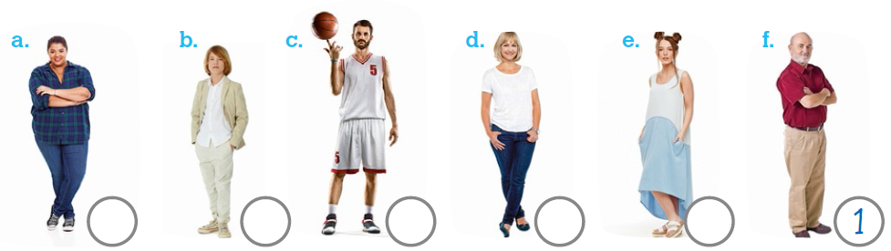
- Listen and draw a line. There is one example.
Test 1 version B – easy-to-correct test
School |  | Evaluation
Name _____________ Surname _____________ Class: 5th ____  Date _________________________________________, 20 ___  Signatures _____________________/______________________  (Teacher) (Parent/E.E.) |  | ____%  Muito Bom Bom Suficiente  Insuficiente Muito Insuficiente

Vocabulary
- Look, read and tick the correct word.
a. |  | b. | 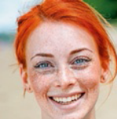 | c. |  | d. | 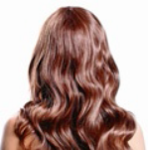 | e. |  | f. | 
 | 1. short |  | 1. round |  | 1. moustache |  | 1. short |  | 1. beard |  | 1. bald
 | 2. curly |  | 2. freckles |  | 2. bald |  | 2. long |  | 2. bald |  | 2. moustache
 | 3. bald |  | 3. oval |  | 3. Beard |  | 3. Straight |  | 3. Moustache |  | 3. oval and thin

- Look and write Yes or No.
a. It’s a  scarf. |  | b. They are  high-tops. |  | c. It’s a  necklace. |  | d. It’s a  belt. |  | e. It’s a tie. |  | f. They are  socks. |  | g. They are  ballerinas.

Reading
Read the text.
My new friend
My name is Luana and I have got a new friend. Her name’s May. May’s surname
is Wilson. May isn’t from England. She’s American. She’s nine years old. This is
what she looks like: She is tall and thin so she isn’t short or fat. She’s young
and pretty, like me. She’s got short straight brown hair and lovely big brown
eyes. I’ve got a round face, but May’s got a long face. It’s very pretty. May’s
favourite clothes are blouses and leggings. She also likes colourful wellies and
raincoats. May’s raincoat is red. Can you guess what her favourite colour is?
- Read and complete. There is one example.
a. Luana’s new friend is American . d. She’s got _____________ eyes.
b. May is from ___________________ . e. She’s ____________ and pretty.
c. This text is about _______________. f. She’s got short ____________ brown hair.

- Read the text again and order the sentences according to the text. There is
one example.
____ She is very pretty.
____ May’s raincoat is red.
____ May is tall and thin.
____ Her favourite clothes are blouses and leggings.
____ May likes colourful wellies.
1 May is Luana’s new friend.
____ May’s got a long face.

- Answer the question about you.
What are your favourite clothes?
My favourite clothes are ____________ and ____________.

Grammar

- Read and circle. There is one example.
- May ____________ from the USA.
  - is 2. aren’t 3. are
- She ____________ English.
  - aren’t 2. isn’t 3. are
- She ____________ nine years old.
  - is 2. aren’t 3. are
- ____________ she fat?
  - Are 2. Has 3. Is
- No, she ____________.
  - isn’t 2. aren’t 3. Has
- She ____________ an oval face.
  - aren’t 2. hasn’t got 3. haven’t got
- ____________ May got straight hair?
  - Have 2. Are 3. Has
- No, she ____________.
  - hasn’t 2. has 3. haven’t
- May’s favourite clothes ____________ suits.
  - hasn’t 2. isn’t 3. aren’t
- She ____________ colourful wellies.
  - is 2. has got 3. have got
- Her raincoat ____________ red.
  - has 2. are 3. is

- Look and choose Whose or What. Then, write ’s or ’. There is one example.
- Whose / What blouse is it? It’s Pat ’s blouse.
- Whose / What leggings are they? They are Mary ____ leggings.
- What / Whose tracksuits are they? They’re the boys____ tracksuits.
- Whose / What suit is it? It’s Paul ____ suit.
- What / Whose pullover is it? It’s my mother ____ pullover.
- Whose / What sweatshirts are they? They’re my parents ____ sweatshirts.

- Read and circle. There is one example.
- We / Our names are Grace and Kim. We / Our wellies are lovely.
- This is Ann’s cat. Her / Its cat is black. Its / My name is Blacky. Its / Their eyes are
yellow.
- I / My am Sally. This is my / I handbag.
- These are Ben’s high-tops. Your / His high-tops are cool. They / Your are blue and red.
- Jack, where is your / you scarf? Don’t forget to wear it / he. It’s cold today.

Writing

- Read and answer the questions about you.
- Are you tall? ____________________________
- What is your body like? ___________________
- What is your hair like? ____________________
- Have you got a round face? _______________
- Are you pretty? _________________________

- Look at Moana and write her profile. Use the words in the box.
She is _______________ and _______________.
She is _______________ and _______________.
She’s got ____________________________ hair.
She’s got ___________________________ eyes.
Her face is ______________________________ .

Height: Short Weight: Slim
Age: Young Face: Round
Adjectives: Brown, pretty, wavy,
long, big

Keep calm and work hard! Happy Halloween!
Your teacher, ___________________________

Answer key and marking criteria
Test 1 version B – answer key and marking criteria

Section | Answer key | Marking criteria
Listening | Question 1: Listen and order.  Answer key: a. 5 b. 3 c. 2 d. 6 e. 4 | 5 x 2 = 10  2 marks per correct answer.  Only accept an answer if one number is written in  each box.
Listening | Question 2: Listen and draw a line.  Answer key: Bill – jackets, Ann – anoraks,  Jack – raincoats, Sally – leggings, Nick – suits | 5 x 2 = 10  2 marks per correct answer.  Only accept an answer if one line is drawn correctly  per answer.
Vocabulary | Question 1: Look, read and tick the correct word.  Answer key: a. 1 b. 2 c. 3 d. 2 e. 3 f. 1 | 6 x 1 = 6  1 mark per correct answer.  Only accept an answer if one tick is written correctly  per answer.
Vocabulary | Question 2: Look and write Yes or No.  a. No b. Yes c. Yes d. Yes e. No f. No  g. No | 7 x 2 = 14  2 marks per correct answer.  -0,5 marks if there is a spelling mistake.
Reading | Question 1: Read and complete.  Answer key: b. the USA c. May  d. lovely big brown e. young f. straight | 5 x 2 = 10  2 marks per correct answer.  -0,5 marks if there is a spelling mistake.  Accept more than one word in d and f.
Reading | Question 2: Read and order the sentences.  Answer key: 3, 7, 2, 5, 6, 1, 4  Question 3: Answer the question about you.  Answer key: Personal answer | 6 x 1 = 6  1 mark per correct answer.  1 x 4 = 4  4 marks per correct answer.  -0,5 marks if there is a spelling mistake.
Grammar | 6 x 1 = 6  1 mark per correct answer.  1 x 4 = 4  4 marks per correct answer.  -0,5 marks if there is a spelling mistake. | 10 x 1 = 10  1 mark per correct answer.
Grammar | Question 2: Look and choose. Write ’s or ’.  Answer key: b. Whose, Mary’s c. Whose, boys’ d.  Whose, Paul’s e. Whose, mother’s f. Whose,  parents’ | 10 x 0,5 = 5  0,5 marks per correct answer.
Grammar | Question 3: Read and circle.  Answer key: a. Our b. Her, Its, Its  c. I, my d. His, They e. your, it | 10 x 0,5 = 5  0,5 marks per correct answer.
Writing | Question 1: Read and answer the questions about  you.  Answer key: Personal answer | 5 x 2 = 10  2 marks per correct sentence.  -0,5 marks if the word order is incorrect.  -0,5 marks if there are 2 or more spelling mistakes.  -1 mark if there is a verb mistake.
Writing | Question 2: Look at Moana and write her profile.  Use the words in the box.  Answer key – suggested answer:  Moana is short and slim. She is young and pretty.  She’s got long wavy brown hair. She’s got big  brown eyes. Her face is round. | 5 x 2 = 10  2 marks per correct sentence.  -0,5 marks if the word order isn’t correct.  -0,5 marks if there are 2 or more spelling mistakes  in the sentence.  -1 mark if there is a verb mistake.

Note: Listening script – see page 12.

Test 1 version C – NEE test
School |  | Evaluation
Name _____________ Surname _____________ Class: 5th ____  Date _________________________________________, 20 ___  Signatures _____________________/______________________  (Teacher) (Parent/E.E.) |  | ____%  Muito Bom Bom Suficiente  Insuficiente Muito Insuficiente

Part I
- Listen and order. There is one example.
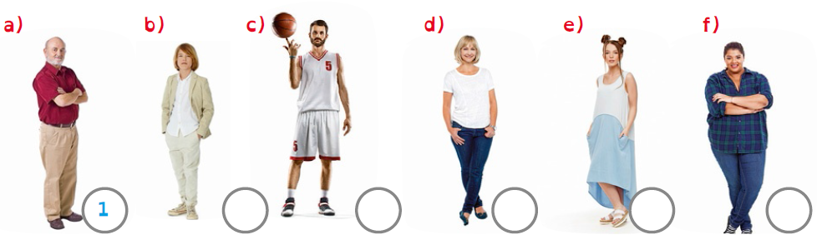

 | Boy – Hi. My name is Nick.  Girl – Hi Nick. Wow! You’re very tall and thin!  Boy – Yes, I am. I am very tall and thin.  Girl – I like your beard. You’re very handsome!  Boy – Really? Do you like my beard? Thanks!

 | Girl – What’s your name? What do you look like?  Boy – I’m Dan and I’m short and slim.  Girl – Are you short and slim? How old are you?  Boy – I’m young. I’m ten years old.  Girl – Yes. I can see that. I guess that’s why you’re still short.

 | Girl 1 – Hello. I’m Ann and I’m twenty years old. I’m young.  Girl 2 – Yes, you’re young. You’re young and very pretty too.  Girl 1 – Am I pretty? Thank you!

 | Boy – Hi. What’s your name?  Girl – My name is Daisy and I’m tall and a bit fat.  Boy – So, you’re tall and a bit fat. And how old are you?  Girl – I’m thirty years old. I’m still young, aren’t I?  Boy – Yes, you are. You’re still very young.

 | Woman 1 – Hi. How old are you? Are you middle-aged?  Woman 2 – Yes, I am. I am middle-aged. I’m fifty years old.  Woman 1 – Fifty! I think you are tall and slim! And very pretty too!  Woman 2 – Oh… Thank you. That’s so nice of you.

- Listen and match ( ).
Grace | Bill | Sally | Ann | Nick | Jack

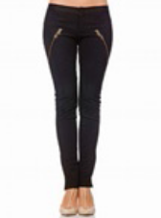 | 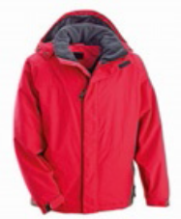 | 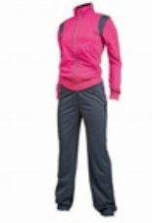 | 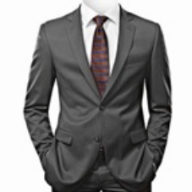 | 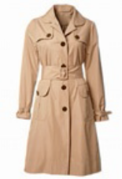 | 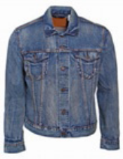

Part II
3. Match ( ).
a) |  | b) |  | c) |  | d) |  | e) |  | f)

 | moustache |  | bald |  | beard |  | freckles |  | long |  | short

4. Write.
a) | b) | c) | d)
handbag | _ _ _ _ - _ _ _ _ | _ _ _ _ _ _ _ _ | _ _ _ _

e) | f) | g)
scarf | _ _ _ _ _ _ _ | _ _ _ _ _ _ _ _ _

1  2  3  4  5  6  7  8 | My new friend  My name is Luana and I have got a new friend.  Her name’s May. May’s surname is Wilson. May isn’t from England. She’s  American. She’s nine years old.  This is what she looks like: she is tall and thin so she isn’t short or fat. She’s  young and pretty, like me. She’s got short straight brown hair and lovely big brown  eyes. I’ve got a round face, but May’s got a long face. It’s very pretty.  May’s favourite clothes are blouses and leggings. She also likes colourful  wellies and raincoats. May’s raincoat is red. Can you guess what her favourite  colour is?

5. Match ( ).

Luana’s new friend |  |  |  | pretty.
May is |  |  |  | eyes.
Her favourite clothes |  |  |  | straight brown hair.
She’s got brown |  |  |  | are blouses and leggings.
She’s young and |  |  |  | is American.
She’s got short |  |  |  | from the USA.

6. Answer.
a) What is May like?

b) What are your favourite clothes?

7. Write the correct verb: to be or have got.
isn’t
is
- May from the USA. She English.

- She nine years old.

- she fat? No, she .

- She an oval face.

- May straight hair? No, she .

- May’s favourite clothes suits.

8. Write whose, ’s or ’.
’s
Whose
- blouse is it? It’s Pat blouse.

- leggings are they? They are Mary leggings.

- tracksuits are they? They’re the boys tracksuits.

- suit is it? It’s Paul suit.

- pullover is it? It’s my mother pullover.

9. Write. Choose one word.
  - (Her / We) are Grace and Kim. (My / Our) wellies are lovely.

Our
We
  - This is Ann’s cat. (His / Her) cat is black.

(They / Its) name is Blacky.

  - (She / I) am Sally and this is (my / his) handbag.

  - These are Ben’s high-tops. (His / Our) high-tops are cool. (It /
They) are blue and red.

  - Jack, where is (their / your) scarf? Don’t forget to wear (they /
it). It’s cold.
10. Answer about you.

- Are you tall?

- What is your face like?

- Have you got short straight brown hair?

- What are your eyes like?

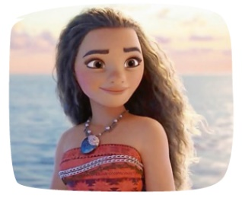
- Are you pretty?
11. Look at Moana and complete her profile.

Moana is .

She eyes.

a round face.

She has got hair.
Height: Short Weight: Slim
Age: Young Face: Round
Adjectives: Brown, pretty,
wavy, long, big

pretty!

Answer key and marking criteria
Test 1 version C – answer key and marking criteria

Section |  | Answer key | Marking criteria
Part I | (Listening) | Question 1: Listen and order.  Answer key: b) 3 c) 2 d) 6 e) 4 f) 5 | 5 x 2 = 10  2 marks per correct answer.  Only accept an answer if one number is written in  each box.
Part I | (Listening) | Question 2: Listen and match.  Answer key: Bill – jackets, Ann – anoraks,  Jack – raincoats, Sally – leggings, Nick – suits | 5 x 2 = 10  2 marks per correct answer.  -0,5 marks if there is a spelling mistake.
Part II | (Vocabulary) | Question 3: Match.  Answer key: b) long c) short d) beard  e) moustache f) freckles | 5 x 2 = 10  2 marks per correct answer.  Only accept an answer if one line is drawn correctly  per answer.
Part II | (Vocabulary) | Question 4: Write.  Answer key: b) high-tops c) necklace  d) belt f) wellies g) high heels | 5 x 2 = 10  2 marks per correct answer.  -0,5 marks if there is a spelling mistake.
Part II | (Reading) | Question 5: Match.  Answer key: May is from the USA. / Her favourite  clothes are blouses and leggings. / She’s got brown  eyes. / She’s young and pretty. / She’s got short  straight brown hair. | 5 x 2 = 10  2 marks per correct answer.  Only accept an answer if one line is drawn correctly  per answer.
Part II | (Reading) | Question 6: Answer.  Answer key: a) May is tall and thin.  b) Personal answer | a + b: 2 x 5 = 10  5 marks per correct answer.  -0,5 marks if there is a spelling mistake.  -0,5 marks if there is a verb mistake.  -0,5 marks if the word order is incorrect.
Part II | (Grammar) | Question 7: Write the correct verb: to be or have  got.  Answer key: b) is c) Is, isn’t d) has got  e) Has, got, hasn’t f) aren’t | 8 x 1 = 8  1 mark per correct answer.  (0,5 marks for choosing the correct verb + 0,5  marks for conjugating it correctly).  -0,5 marks if there is a spelling mistake.
Part II | (Grammar) | Question 8: Write whose, ’s or ’.  Answer key: b) Whose, Mary’s c) Whose, the  boys’ d) Whose, Paul’s e) Whose, mother’s | 8 x 0,5 = 4  0,5 marks per correct answer.
Part II | (Grammar) | Question 9: Write. Choose one word.  Answer key: b) Her, Its c) I, my d) His, They  e) your, it | 8 x 1 = 8  1 mark per correct answer.
Part II | (Writing) | Question 10: Answer about you.  Answer key: Personal answer | 5 x 2 = 10  2 marks per correct answer.  -0,5 marks if the word order is incorrect.  -0,5 marks if there are 2 or more spelling mistakes.  -1 mark if there is a verb mistake.
Part II | (Writing) | Question 11: Look at Moana and complete her  profile.  Answer key: Moana is short and slim. She’s got big  brown eyes. She has got a round face. She’s got  long wavy brown hair. Moana is young and pretty. | 5 x 2 = 10  2 marks per correct sentence.  -0,5 marks if the word order is incorrect.  -0,5 marks if there are 2 or more spelling mistakes  in the sentence.  -1 mark if there is a verb mistake.

Note: Students with Specific Learning Disorders may benefit from different marking criteria, namely as far as spelling mistakes are
concerned.

Note: Listening script – see page 12.

Test 1 version D – Cambridge-like test
School |  | Evaluation
Name _____________ Surname _____________ Class: 5th ____  Date _________________________________________, 20 ___  Signatures _____________________/______________________  (Teacher) (Parent/E.E.) |  | ____%  Muito Bom Bom Suficiente  Insuficiente Muito Insuficiente

Part 1
- Listen and order. There is one example.
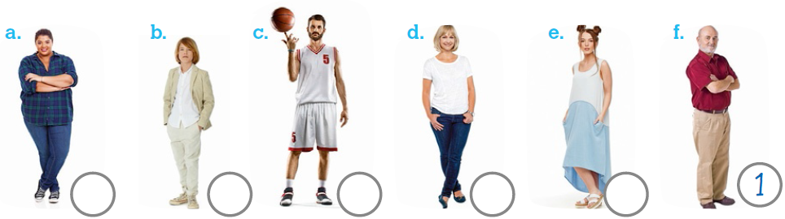
- Listen and draw a line. There is one example.

Part 2
Look and read. Put a tick () or a cross () in the circle. There are two examples.
Examples:
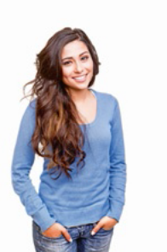 |  | She is slim. | 
 |  | He is thin. | 
Questions:

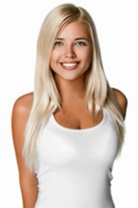 | She is handsome. | 

 | She is middle-aged.

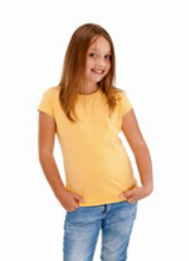 | She is young.

 | He is chubby.

 | She is old.

Part 3
Read this. Choose a word from the box. Write the correct word next to the

numbers 1-5. There is one example.
His name is Jack. He is tall and slim . He is forty years old.
He is (1)_________ and very (2) _________.
He’s got an (3) _________ face and a beard. He’s got short
(4) _________ brown hair. He’s wearing a suit and a
(5) _________.

Example: | 
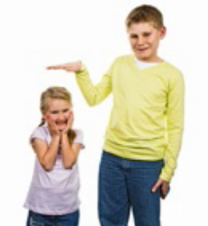 |  |  |  | 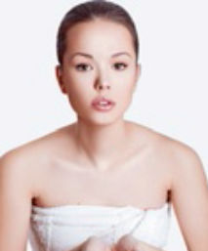
tall | slim | beard | handsome | oval
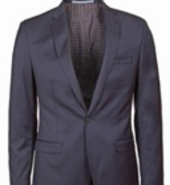 | 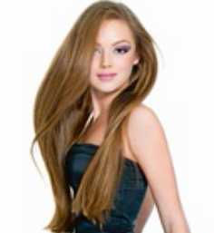 | 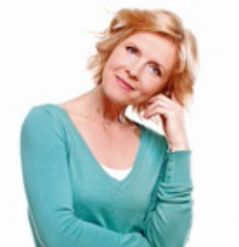 | 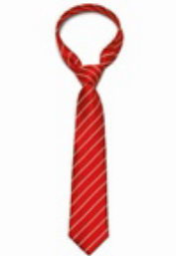 | 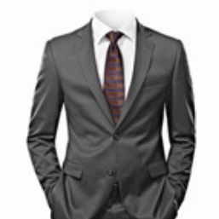
blazer | straight | middle-aged | tie | suit

Part 4
Look at the pictures and read the questions. Write one-word answers.
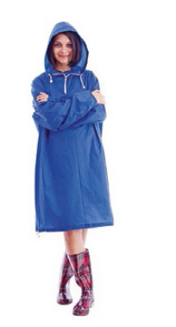 |  | 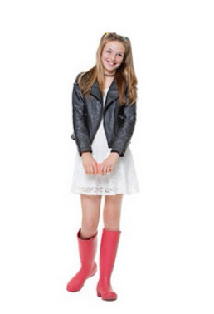 | 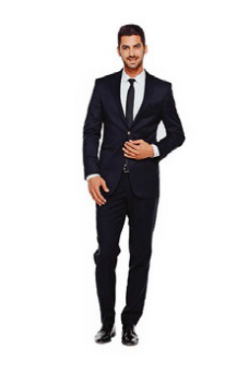 | 

Examples:
How many men in suits are there? _ Two_____
What shoes are the girls wearing? _ Wellies___
Questions:
- How many raincoats are there? _____________
- What colour is the handbag? It’s __________
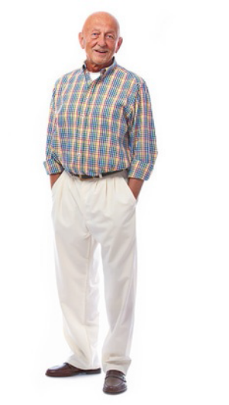 | 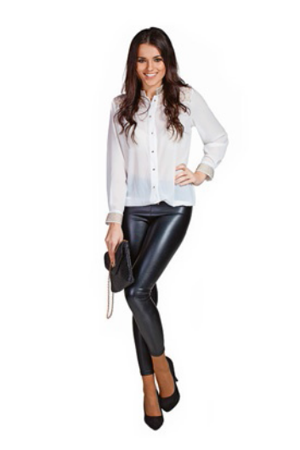 | 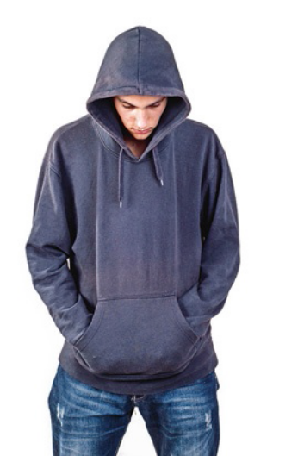

- What is her hair like? _____________
- What is he like? _____________
- What is the boy wearing? a ____________

Marking key:
( ) = Acceptable extra words are placed in brackets

/ = A single slash is placed between acceptable
alternative words within an answer

// = A double slash is placed between acceptable
alternative complete answers.

Part 1 – 25 marks  Exercise 1  a. 5  b. 3  c. 2  d. 6  e. 4  Exercise 2  Bill – jackets  Ann – anoraks  Jack – raincoats  Sally – leggings  Nick – suits | Part 2 – 25 marks  1  2  3  4  5  Part 3 – 25 marks  1 middle-aged  2 handsome  3 oval  4 straight  5 tie  Part 4 – 25 marks  1 (There are) two/2  2 red  3 (It’s) long/wavy/brown  4 (He is) old/chubby/bald  5 hoodie
Note: Listening script – see page 12.

Test 1 version E – alternative/extra test
School |  | Evaluation
Name _____________ Surname _____________ Class: 5th ____  Date _________________________________________, 20 ___  Signatures _____________________/______________________  (Teacher) (Parent/E.E.) |  | ____%  Muito Bom Bom Suficiente  Insuficiente Muito Insuficiente

Listening
- Listen and draw. There is one example.
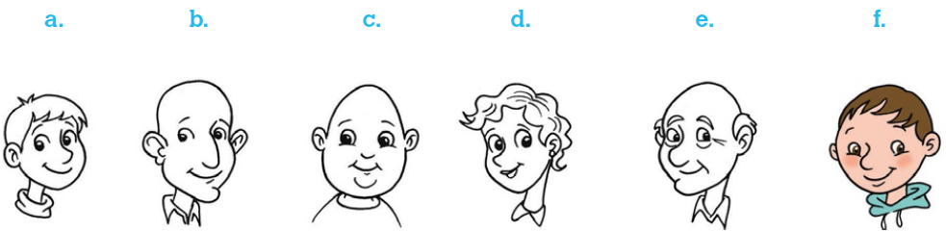
- Listen and draw a line. There is one example.
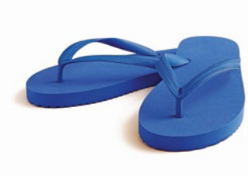  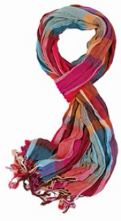  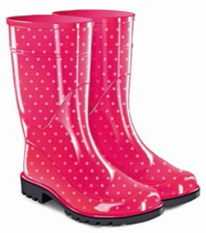 | Sunday  Monday  Tuesday  Wednesday  Thursday  Friday  Saturday | 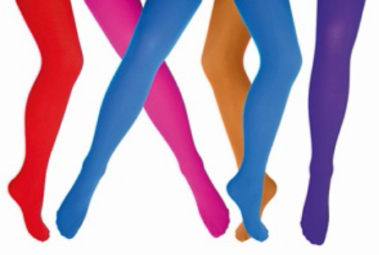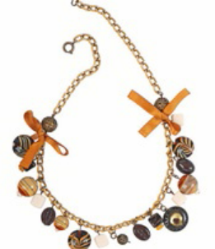  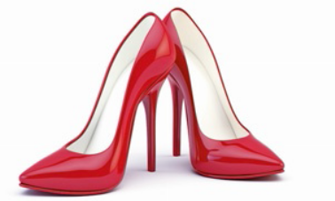

Test 1 version E – alternative/extra test
School |  | Evaluation
Name _____________ Surname _____________ Class: 5th ____  Date _________________________________________, 20 ___  Signatures _____________________/______________________  (Teacher) (Parent/E.E.) |  | ____%  Muito Bom Bom Suficiente  Insuficiente Muito Insuficiente

Vocabulary
- Look and draw a line.
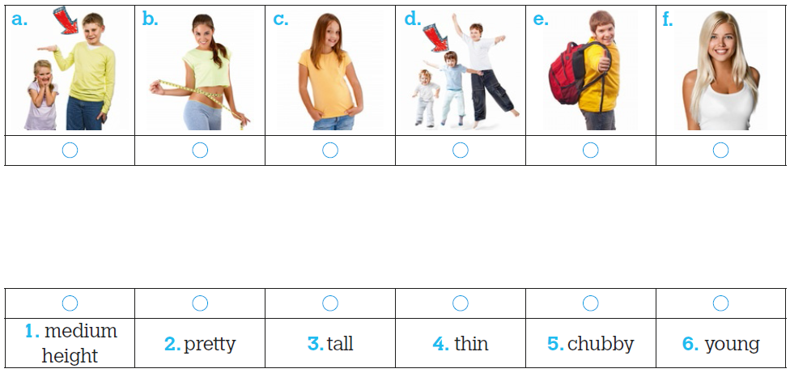

- Look and write.
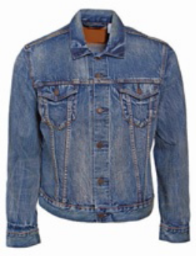 | 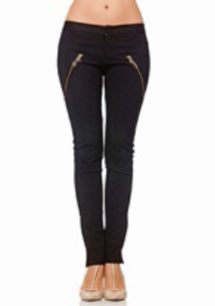 |  | 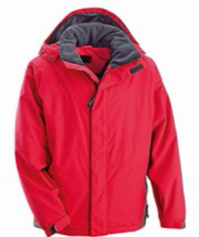 |  | 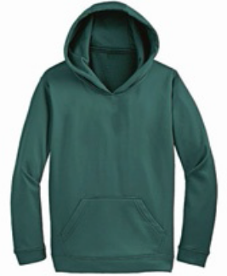
a. | b. |  | c. |  | d.
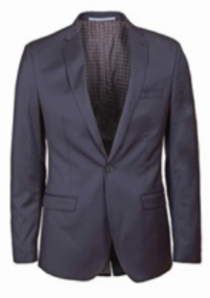 |  | 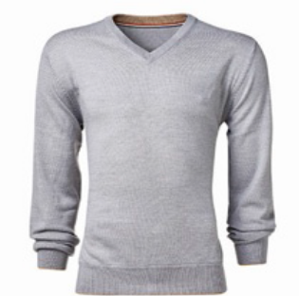 |  | 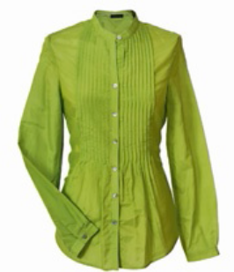
e. |  | f. |  | g.
Reading
Read the text.
My new friend
My name is Luana and I have got a new friend. Her name’s May. May’s
surname is Wilson. May isn’t from England. She’s American. She’s nine
years old. This is what she looks like: She is tall and thin so she isn’t short
or fat. She’s young and pretty, like me. She’s got short straight brown hair
and lovely big brown eyes. I’ve got a round face, but May’s got a long
face. It’s very pretty. May’s favourite clothes are blouses and leggings. She
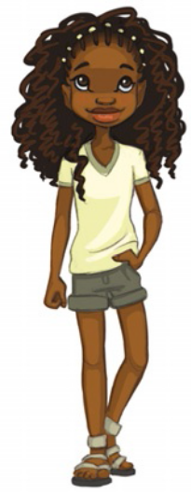
also likes colourful wellies and raincoats. May’s raincoat is red. Can you
guess what her favourite colour is?

- Read and draw a line. There is one example.
a. Luana’s new friend 1. is red.
b. May’s surname 2. or fat.
c. May is 3. is Wilson.
d. May isn’t short 4. colourful wellies.
e. She likes 5. isn’t from England.
f. May’s raincoat 6. nine years old.

- Read and answer the questions.
a. What is May’s hair like? _______________________________________________________
b. What are her favourite clothes? _________________________________________________
c. What are your favourite clothes? ________________________________________________

Grammar
- Look and complete the sentences with the correct verb: to be or have got.
There is one example.

 | Height |  | Weight |  | Hair |  | Hair colour
 | tall | short | fat | slim | short | long | brown | blond(e)
Pat
Peter

a. Pat is tall but she _________ short.
b. Peter _________ slim. He _________ fat.
c. Pat _________ short hair. Peter _________ short hair. He _________ long hair.
d. Pat _________ blonde hair. She _________ brown hair.
e. Peter _________ blond hair. He _________ brown hair.

- Look and write whose, (name)’s or (name)’. There is one example.
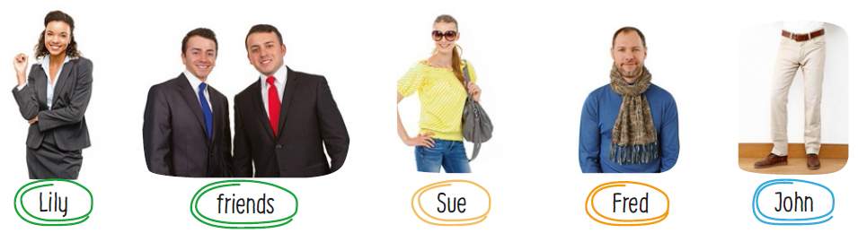
a. Whose blouse is it? It’s Sue’s blouse. d. ______blazer is it? It’s ______
blazer.
b. ______ handbag is it? It’s ______ handbag. e. _____belt is it? It’s _____ belt.
c. ______ scarf is it? It’s ______ scarf. f. ____suits are they? They’re our
______ suits.

- Read and order the words.
a. Fred / short / has got / hair / straight / .
____________________________________________________________________
b. have got / We / eyes / small / brown / nice / .
____________________________________________________________________
- has got / eyes / big / She / green / lovely / .
____________________________________________________________________
- have got / I / short / hair / blonde / beautiful / .
____________________________________________________________________
- brown / big / They / have got / eyes / .
____________________________________________________________________

Writing
- Read and answer about you.
a. Are you thin? _______________________________________________________
b. Are you chubby? ____________________________________________________
c. What colour are your eyes? ___________________________________________
d. What is your hair like? _______________________________________________
e. Are you handsome/pretty? ____________________________________________

- Complete the fact file about your best friend. Then, write a small paragraph.
__________________________________________________
Height: ____ Weight: ____
Age: ____ Face: ____
Adjectives: ________, _______,
________, _______
__________________________________________________
__________________________________________________
__________________________________________________
__________________________________________________

Answer key and marking criteria
Test 1 version E – answer key and marking criteria
Section | Answer key | Marking criteria
Listening | Question 1: Listen and draw.  Answer key: a. 1 (blond hair, moustache) b. 3  (short brown hair, beard) c. 4 (long wavy black  hair, moustache) d. 2 (brown hair, big brown  eyes) e. 5 (bald, freckles) | 5 x 2 = 10  2 marks per correct answer.  Only accept if the features are on the correct face.  Each feature is 1 point.
Listening | Question 2: Listen and draw a line.  Answer key: 1. Saturday – wellies 2. Wednesday  – high heels 3. Sunday – flip-flops 4. Thursday –  scarf 5. Tuesday – tights | 5 x 2 = 10  2 marks per correct answer.  Only accept an answer if one line is drawn correctly  per answer.
Vocabulary | Question 1: Look and draw a line.  Answer key: a. 3 b. 4 c. 6 d. 1 e. 5 f. 2 | 6 x 1 = 6  1 mark per correct answer.  Only accept an answer if one line is drawn correctly  per answer.
Vocabulary | Question 2: Look and write.  Answer key: a. jacket b. leggings c. anorak  d. hoodie e. blazer f. pullover g. blouse | 7 x 2 = 14  2 marks per correct answer.  -0,5 if there is a spelling mistake.
Reading | Question 1: Read and draw a line.  Answer key: b. 3 c. 6 d. 2 e. 4 f. 1 | 5 x 2 = 10  2 marks per correct answer.  Only accept an answer if one line is drawn correctly  per answer.
Reading | Question 2: Read and answer the questions.  Answer key: a. May has got brown hair.  b. Her favourite clothes are blouses and leggings.  c. Personal answer | a./b. 2 x 3 = 6  3 marks per correct  answer.  -0,5 marks if there is a  spelling mistake.  -0,5 marks if there is a  verb mistake.  -0,5 marks if the word  order is incorrect. | c. 1 x 4 = 4  4 marks per correct  answer.  -0,5 marks if there is a  spelling mistake.  -0,5 marks if there is a  verb mistake.  -0,5 marks if the word  order is incorrect.
Grammar | Question 1: Read and write the correct verb: to be  or have got.  Answer key: a. isn’t b. is, isn’t c. has got, hasn’t  got, has got d. hasn’t got, has got e. has got,  hasn’t got | 10 x 1 = 10  1 mark per correct answer (0,5 for choosing the  correct verb + 0,5 for conjugating it properly).  -0,5 marks if there is a spelling mistake.
Grammar | Question 2: Look and write whose, (name)’s or  (name)’.  Answer key: b. Whose, Sue’s c. Whose,  Fred’s d. Whose, Lily’s e. Whose, John’s  f. Whose, friends’ | 10 x 0,5 = 5  0,5 marks per correct answer.
Grammar | Question 3: Read and order the words.  Answer key: a. Fred has got short straight hair.  b. We have got nice small brown eyes. c. She has  got lovely big green eyes. d. I have got beautiful  short blonde hair. e. They have got big brown eyes. | 5 x 1 = 5  1 mark per correct answer.  -0,5 marks if there are 2 or more spelling mistakes  in the sentence.  -0,5 marks if there is a verb mistake.  Only accept if the word order is correct.
Writing | Question 1: Read and answer about you.  Answer key: Personal answer | 5 x 2 = 10  2 marks per correct answer.  -0,5 marks if the word order is incorrect.  -0,5 marks if there are 2 or more spelling mistakes.  -1 mark if there is a verb mistake.
Writing | Question 2: Complete the fact file about your best  friend. Then, write a small paragraph.  Answer key: Personal answer | 5 x 2 = 10  2 marks per correct sentence.  -0,5 marks if the word order is incorrect.  -0,5 marks if there are 2 or more spelling mistakes  in the sentence.  -1 mark if there is a verb mistake.

Listening script
Test 1 version E – listening script

Exercise 1 – Listen and draw.
Teacher – Can you see the boy with the round face?
Student – The boy with the round face?
Teacher – Yes, the boy with the round face. Good. He has got short brown hair.
Student – Ok. He has got short brown hair. What colour
are his eyes?
Teacher – He has got small black eyes. Draw small black eyes.
Student – Ok. He has got small black eyes.
Can you see the boy with the short brown hair and small
black eyes? This is an example. Now you try.
1.
Teacher – Can you see the man with the short hair?
Student – The man with the short hair?
Teacher – Yes, the boy with the short hair. Colour it blond.
He has got short blond hair.
Student – Ok. He has got short blond hair.
Teacher – He’s got a moustache too. Please, draw a
moustache.
Student – Ok. He’s got a moustache.
2.
Teacher – Can you see the woman with the short wavy
hair?
Student – Yes, I can see the woman with the short wavy
hair.
Teacher – Good. Colour it brown, please. She’s got short
wavy brown hair.
Student – Ok. She’s got brown hair. Can I colour her eyes brown?
Teacher – Yes. She’s got big brown eyes.
Student – Great. She’s got big brown eyes.
3.
Teacher – Can you see the man with the big ears?
Student – The man with the big ears?
Teacher – Yes. He’s got big ears and a long and thin face.
Student – Yes, I see him.
Teacher – He’s got short brown hair and a beard. Please, draw short brown hair and a beard.
Student – A beard?
Teacher – Yes. He’s got short brown hair and a beard.
Student – Ok.
4.
Teacher – Can you see the boy with an oval face? He’s
standing between the woman and the man with a beard.
Student – The boy with an oval face? Yes, I can see him.
Teacher – Good. He’s got long wavy black hair. Please,
draw long wavy black hair.
Student – Ok. He’s got long wavy black hair.
Teacher – Oh… and he’s got a moustache too. Please,
draw a moustache.
Student – A moustache? Ok.
5.
Teacher – Can you see the man standing between the
woman and the boy with the brown hair?
Student – The man standing between the woman and the boy with the brown hair? Yes, I can.
Teacher – Good. He’s bald but he’s got freckles.
Student – Is he bald?
Teacher – Yes. He hasn’t got any hair. He’s bald. But he’s got freckles. Please, draw some freckles.
Student – Ok. He’s bald and he’s got some freckles.

Exercise 2 – Listen and draw a line.
Woman 1 – It’s Monday. What’s this?
Woman 2 – It’s my necklace. I love my necklace and I wear my necklace on Mondays.
Woman 1 – It’s a lovely necklace.
Can you see the line from the day of the week to the
necklace? This is an example. Now you try.
1.
Girl – It’s Saturday! Let’s go to the park!
Woman – Yes, it’s Saturday but it’s raining.
Girl – That’s ok. Look! I can wear my wellies!
Woman – Wear your wellies? On a Saturday?
Girl – Yes, mum! I really want to go to the park today. It’s
Saturday, and I can wear my wellies. All my friends are
there.
2.
Woman 1 – Is it Wednesday today?
Woman 2 – Yes, it’s Wednesday. Why?
Woman 1 – Oh... I’ve got an important meeting today.
Where are my high heels? I need my high heels today.
Woman 2 – Here are your high heels. Good luck with your meeting.
3.
Man – It’s Sunday today and the sun is shining.
Woman – Is it Sunday?
Man – Yes. It’s Sunday. Let’s go to the beach.
Woman – Ok. But I need my flip-flops. Where are my
flip-flops?
Man – Your flip-flops are here. Here you are.
Woman – Great! Let’s go to the beach. What a lovely
Sunday!
4.
Woman – It’s Thursday today and it’s cold.
Boy – Is it Thursday? And is it cold?
Woman – Yes. Take your scarf because it’s cold.
Boy – Where is my scarf, mum?
Woman – It’s in your bedroom! Get your scarf, please.
Today it’s cold and you need it.
Boy – Ok, mum!
5.
Woman 1 – Today, it’s Tuesday and I’ve got an important party at work.
Woman 2 – A party? On a Tuesday?
Woman 1 – Yes. It’s my boss’ birthday party today. I need my dress and my tights.
Woman 2 – Your dress and tights? It’s an important party, then.
Woman 1 – Yes, it is. Can you help me find my tights,
please?
Woman 2 – Here they are. Enjoy the party!

