
Test 2 – breakdown
Unit 2 Who is in our family and what do they do?

TEST A  Standard | No. of  questions | Types of questions | Marks per  question | Total
Listening  Metas:  L 1, 2, 3, 4, 5 | 2 | 1. Listen and write about Anne’s family.  Family and psychological features (pages 48, 52) | 5 x 2 = 10 | 20
Listening  Metas:  L 1, 2, 3, 4, 5 | 2 | 2. Listen and draw a line.  Jobs (page 60) | 5 x 2 = 10 | 20
Vocabulary  Metas: ID 6.3, 8.1,  8.2, 8.3 | 2 | 1. Look, read and write.  Family (page 48) | 10 x 1 = 10 | 20
Vocabulary  Metas: ID 6.3, 8.1,  8.2, 8.3 | 2 | 2. Read and write the job.  Jobs (page 56) | 5 x 2 = 10 | 20
Reading  Metas:  R 4.3, 4.4, 4.5, 4.6 | 2 | 1. Read and write.  Sentences related to the text | 5 x 2 = 10 | 20
Reading  Metas:  R 4.3, 4.4, 4.5, 4.6 | 2 | 2. Read and answer the questions.  Two comprehension questions about a text and a personal question | 2 x 3 = 6  1 x 4 = 4 | 20
Grammar  Metas:  LG 8.1, 8.3, 8.12,  8.13, 8.28 | 3 | 1. Read and write the sentences in the plural.  Plural of nouns (page 55) | 10 x 1 = 10 | 20
Grammar  Metas:  LG 8.1, 8.3, 8.12,  8.13, 8.28 | 3 | 2. Read and circle the correct word.  Personal pronouns: subject and object forms (page 62) | 5 x 1 = 5 | 20
Grammar  Metas:  LG 8.1, 8.3, 8.12,  8.13, 8.28 | 3 | 3. Read, choose and write the correct word.  Possessive pronouns (pages 50-51) | 5 x 1 = 5 | 20
Writing  Metas: W 5.1, 6 | 2 | 1. Read and answer about you.  Personal questions | 5 x 2 = 10 | 20
Writing  Metas: W 5.1, 6 | 2 | 2. Describe a famous family. | 5 x 2 = 10 | 20
 |  |  |  | 100%

TEST B  Easy-to-correct | No. of  questions | Types of questions | Marks per  question | Total
Listening  Metas:  L 1, 2, 3, 4, 5 | 2 | 1. Listen and write.  Family and psychological features (pages 48, 52) | 5 x 2 = 10 | 20
Listening  Metas:  L 1, 2, 3, 4, 5 | 2 | 2. Listen and draw a line.  Jobs (page 60) | 5 x 2 = 10 | 20
Vocabulary  Metas: ID 6.3, 8.1,  8.2, 8.3 | 2 | 1. Look, read and circle.  Family (page 48) | 10 x 1 = 10 | 20
Vocabulary  Metas: ID 6.3, 8.1,  8.2, 8.3 | 2 | 2. Read and draw a line.  Jobs (page 56) | 5 x 2 = 10 | 20
Reading  Metas:  R 4.3, 4.4, 4.5, 4.6 | 2 | 1. Read and write T (True) or F (False).  Sentences related to the text | 5 x 2 = 10 | 20
Reading  Metas:  R 4.3, 4.4, 4.5, 4.6 | 2 | 2. Read the questions and complete the answers.  Two comprehension questions about a text and a personal question | 2 x 3 = 6  1 x 4 = 4 | 20
Grammar  Metas:  LG 8.1, 8.3, 8.12,  8.13, 8.28 | 3 | 1. Read and write the words in the plural.  Plural of nouns (page 55) | 10 x 1 = 10 | 20
Grammar  Metas:  LG 8.1, 8.3, 8.12,  8.13, 8.28 | 3 | 2. Read and tick the correct word.  Personal pronouns: subject and object forms (page 62) | 5 x 1 = 5 | 20
Grammar  Metas:  LG 8.1, 8.3, 8.12,  8.13, 8.28 | 3 | 3. Read and circle the correct word.  Possessive pronouns (pages 50-51) | 5 x 1 = 5 | 20
Writing  Metas: W 5.1, 6 | 2 | 1. Read and answer about you.  Personal questions | 5 x 2 = 10 | 20
Writing  Metas: W 5.1, 6 | 2 | 2. Describe a famous family. | 5 x 2 = 10 | 20
 |  |  |  | 100%

TEST C  NEE |  | No. of  questions | Types of questions | Marks per  question | Total
Part I | Listening  Metas:  L 1, 2, 3, 4, 5 | 2 | 1. Listen and write.  Family and psychological features (pages 48, 52) | 5 x 2 = 10 | 20
Part I | Listening  Metas:  L 1, 2, 3, 4, 5 | 2 | 2. Listen and match.  Jobs (page 60) | 5 x 2 = 10 | 20
Part II | Vocabulary  Metas: ID 6.3,  8.1, 8.2, 8.3 | 2 | 3. Match.  Family (page 48) | 5 x 2 = 10 | 20
Part II | Vocabulary  Metas: ID 6.3,  8.1, 8.2, 8.3 | 2 | 4. Write the job.  Jobs (page 56) | 5 x 2 = 10 | 20
Part II | Reading  Metas:  R 4.3, 4.4,  4.5, 4.6 | 2 | 5. Match.  Sentences related to the text | 5 x 2 = 10 | 20
Part II | Reading  Metas:  R 4.3, 4.4,  4.5, 4.6 | 2 | 6. Answer.  One comprehension question about a text and a personal question | 5 x 2 = 10 | 20

TEST C  NEE |  | No. of  questions | Types of questions | Marks per  question | Total
Part II | Grammar  Metas:  LG 8.1, 8.3,  8.12, 8.13, 8.28 | 3 | 7. Write the sentences in the plural.  Plural of nouns (page 55) | 3 x 3 = 9 | 20
Part II | Grammar  Metas:  LG 8.1, 8.3,  8.12, 8.13, 8.28 | 3 | 8. Write. Choose one word.  Possessive pronouns (pages 50-51) | 6 x 1 = 6 | 20
Part II | Grammar  Metas:  LG 8.1, 8.3,  8.12, 8.13, 8.28 | 3 | 9. Write. Choose one word.  Personal pronouns: subject and object (page 62) | 5 x 1 = 5 | 20
Part II | Writing  Metas: W 5.1, 6 | 2 | 10. Read and answer about you.  Personal questions | 5 x 2 = 10 | 20
Part II | Writing  Metas: W 5.1, 6 | 2 | 11. Describe a famous family. | 5 x 2 = 10 | 20
 |  |  |  |  | 100%

TEST D  Cambridge-like | No. of  questions | Types of questions | Marks per  question | Total
PART 1  Listening &  Vocabulary  Metas:  L 1, 2, 3, 4, 5,  ID 8.1, 8.2, 8.3 | 2 | 1. Listen and write.  Family and psychological features (pages 48, 52) | 5 x 2,5 = 12,5 | 25
 | 2 | 2. Listen and draw a line.  Jobs (page 60) | 5 x 2,5 = 12,5 | 25
PART 2  Reading &  Vocabulary  Metas: R 4.3, 4.5,  ID 8.2 | 1 | Look and read. Write Yes or No.  Jobs (page 60) | 5 x 5 = 25 | 25
PART 3  Reading,  Vocabulary &  Grammar  Metas: R 4.3, 4.5,  4.6 ID 8.1 | 1 | Read this. Choose a word from the box. Write the correct word next to the numbers 1-5.  Family (page 48) | 5 x 5 = 25 | 25
PART 4  Writing &  Vocabulary  Metas: W 5 ID 8.2,  8.3 R 4.3, 4.5 | 1 | Look at the pictures and read the story. Write one-word answers.  Family and jobs (pages 48, 60) | 5 x 5 = 25 | 25
 |  |  |  | 100%

TEST E  Alternative/Extra | No. of  questions | Types of questions | Marks per  question | Total
Listening  Metas:  L 1, 2, 3, 4, 5 | 2 | 1. Listen and draw a line.  Jobs (page 56) | 5 x 2 = 10 | 20
Listening  Metas:  L 1, 2, 3, 4, 5 | 2 | 2. Listen and write one word.  Family (page 48) | 5 x 2 = 10 | 20
Vocabulary  Metas:  ID 8.2, 8.3 | 2 | 1. Look and write.  Psychological features (page 52) | 6 x 1 = 6 | 20
Vocabulary  Metas:  ID 8.2, 8.3 | 2 | 2. Look and draw a line.  Jobs (page 60) | 7 x 2 = 14 | 20
Reading  Metas:  R 4.3, 4.4, 4.5, 4.6 | 3 | 1. Read and draw a line.  Sentences related to the text | 10 x 1 = 10 | 20
Reading  Metas:  R 4.3, 4.4, 4.5, 4.6 | 3 | 2. Read and answer the questions.  Two comprehension questions about a text and a personal question | 2 x 3 = 6  1 x 4 = 4 | 20
Grammar  Metas:  LG 8.1, 8.3, 8.13,  8.28 | 2 | 1. Read and write the sentences in the plural.  Plural of nouns (page 55) | 5 x 2 = 10 | 20
Grammar  Metas:  LG 8.1, 8.3, 8.13,  8.28 | 2 | 2. Read and correct the sentences.  Possessive pronouns (pages 50-51) | 5 x 1 = 5 | 20
Grammar  Metas:  LG 8.1, 8.3, 8.13,  8.28 | 2 | 3. Read and write the, a or an.  Definite and indefinite articles (pages 58-59) | 5 x 1 = 5 | 20
Writing  Metas: W 5.1, 6 | 2 | Writing  Metas: W 5.1, 6 | 5 x 2 = 10 | 20
Writing  Metas: W 5.1, 6 | 2 | 2. Describe a famous person. | 5 x 2 = 10 | 20
 |  |  |  | 100%

School |  | Evaluation
Name _____________ Surname _____________ Class: 5th ____  Date _________________________________________, 20 ___  Signatures _____________________/______________________  (Teacher) (Parent/E.E.) |  | ____%  Muito Bom Bom Suficiente  Insuficiente Muito Insuficiente
Test 2 version A – standard test
Listening
- Listen and write about Ann’s family. There is one example.

Ann’s family
parents happy__
1. twin sister __________
2. nephew __________
3. nieces __________
4. godmother __________
5. grandparents __________

- Listen and draw a line. There is one example.
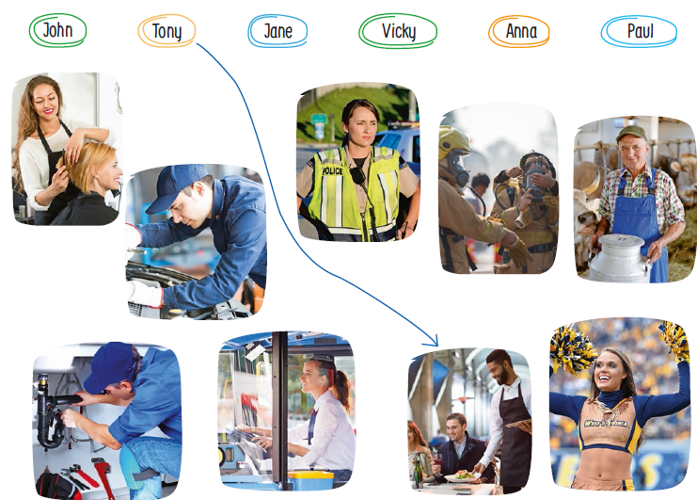

Test 2 version A – standard test
School |  | Evaluation
Name _____________ Surname _____________ Class: 5th ____  Date _________________________________________, 20 ___  Signatures _____________________/______________________  (Teacher) (Parent/E.E.) |  | ____%  Muito Bom Bom Suficiente  Insuficiente Muito Insuficiente

Vocabulary
- Look, read and write. There is one example.
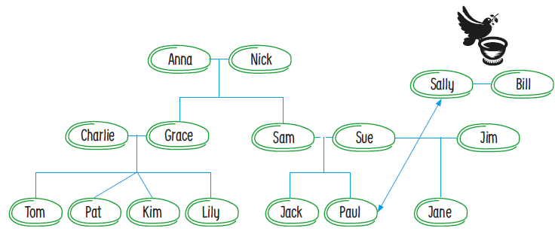

- Anna and Nick are Pat’s _______________.
- Grace is Anna’s _____________________.
- Tom is Charlie’s _____________________.
- Sally is Paul’s _______________________.
- Kim is Pat’s twin _____________________.
- Jim is Jack’s ________________________.
- Paul is Grace’s ______________________.
- Kim is Sam’s _______________________.
- Bill is Paul’s ________________________.
- Sue and Jim are Jane’s _______________.

- Read and write the job.
- He wears tracksuits and plays football. __________________
- She is the person you see when you are sick. __________________
- He looks after your teeth. __________________
- He flies planes. He wears a uniform. __________________
- She looks after pets and other animals. __________________
Reading
Read the text.
My family
Ann – Tell me, who is in your family and what is it like?
May – I’ve got a big family. I live with my parents, my twin brother, my sister, my aunt and my cousin.
Ann – Wow. So how many people are there in your family?
May – There are fifteen people in my family.
Ann – That’s amazing. And what are their jobs?
May – My parents are doctors and my aunt is a vet. They are intelligent and work very hard. And you? Who is in your family?
Ann – I’ve got a small family. I live with my mother and my stepfather. He’s a bit silly and bubbly sometimes but I love him.

- Read and write. There is one example.

- May’s got a big family.
- She has got a ____________ brother.
- There are ____________ people in her family.
- May’s parents are ____________ and her aunt is a ____________.
- Ann’s family is ____________.

- Read and answer the questions.

- Who does May live with?
__________________________________________________________________________
- What is Ann’s stepfather like?
__________________________________________________________________________
- What is your family like?
__________________________________________________________________________

Grammar
- Read and write the sentences in the plural. Make the necessary changes.
There is one example.

- I have got a big family. We have got big families.
- The man is serious. ________________________
- The baby has got toys. ________________________
- The lady is tall. ________________________
- The child is chubby. ________________________
- The mouse is small. ________________________

- Read and circle the correct word. There is one example.

- You have got my book. Give it to me / I.
- The policeman wears a uniform. Give it to him / he.
- We are students. Our friends go to school with we / us.
- Our teacher has got lots of students. She likes we / them.
- This is my tablet. I use it / me.
- She is Daisy. This book belongs to her / she.

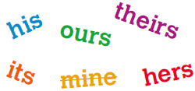
- Read, choose and write the correct word. There is one example.

- Look! That’s my car. It’s mine .
- Jack is a doctor. This is his phone. It’s _______.
- My grandparents have got a house. It’s _______.
- We have got lots of books. They are _______.
- This is Ann’s dog. It’s ______. And this is the dog’s bone. It’s _______.

Writing
- Read and answer the questions about you.

- Have you got any brothers? _____________________________
- What is your father’s job? _______________________________
- What is your mother’s job? ______________________________
- What are your parents like? _____________________________
- What is your dream job? ________________________________

- Describe Prince William’s family. Use the information in the box.
William: Pilot, serious and quiet

Kate: Photographer, kind and
Intelligent

Children: Happy, bubbly and
polite
__________________________________________________
__________________________________________________
__________________________________________________
__________________________________________________
__________________________________________________
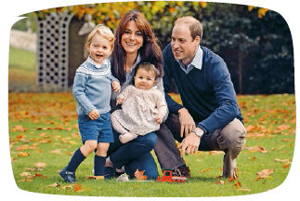

Keep calm and work hard! Merry Christmas!
Your teacher, ____________________________

Answer key and marking criteria
Test 2 version A – answer key and marking criteria

Section | Answer key | Marking criteria
Listening | Question 1: Listen and write about Ann´s family.  Answer key: 1. kind 2. silly 3. intelligent  4. polite 5. funny | 5 x 2 = 10  2 marks per correct answer.  -0,5 marks if there is a spelling mistake.
Listening | Question 2: Listen and draw a line.  Answer key: John – firefighter / Jane – police  officer / Vicky – cheerleader / Anna – hairdresser /  Paul – bus driver | 5 x 2 = 10  2 marks per correct answer.  Only accept an answer if one line is drawn correctly  per answer.
Vocabulary | Question 1: Look, read and write.  Answer key: a. grandparents b. daughter c. son  d. godmother e. sister f. stepfather  g. nephew h. niece i. godfather j. parents | 10 x 1 = 10  1 mark per correct answer.  -0,5 marks if there is a spelling mistake.
Vocabulary | Question 2: Read and write the job.  Answer key: a. footballer b. doctor c. dentist  d. pilot e. vet | 5 x 2 = 10  2 marks per correct answer.  -0,5 marks if there is a spelling mistake.
Reading | Question 1: Read and write.  Answer key: b. twin c. fifteen d. doctors, vet  e. small | 5 x 2 = 10  2 marks per correct answer.
Reading | Question 2: Read and answer the questions.  Answer key: a. May lives with her parents, twin  brother, sister, aunt and cousin. b. He is a bit silly  and bubbly. c. Personal answer | a./b. 2 x 3 = 6  3 marks per correct  answer.  -0,5 marks if there is a  spelling mistake.  -0,5 marks if there is a  verb mistake.  -0,5 marks if the word  order isn’t correct. | c. 1 x 4 = 4  4 marks per correct  answer.  -0,5 marks if there is a  spelling mistake.  -0,5 marks if there is a  verb mistake.  -0,5 marks if the word  order isn’t correct.
Grammar | Question 1: Read and write the sentences in the  plural.  Answer key: b. The men are serious. c. The  babies have got toys. d. The ladies are tall.  e. The children are chubby. f. The mice are small. | 5 x 2 = 10  2 marks per correct answer.  -0,5 marks if there is a verb mistake.  -0,5 marks if there is a spelling mistake.  -0,5 marks if words are left in the singular.  -0,5 marks if indefinite articles are not removed.
Grammar | Question 2: Read and circle the correct word.  Answer key: b. him c. us d. them e. it f. her | 5 x 1 = 5  1 mark per correct answer.
Grammar | Question 3: Read, choose and write the correct  word.  Answer key: b. his c. theirs d. ours e. hers, its | 5 x 1 = 5  1 mark per correct answer.  Only accept an answer if one word is chosen per  answer.
Writing | Question 1: Read and answer the questions about  you.  Answer key: Personal answer | 5 x 2 = 10  2 marks per correct answer.  -0,5 marks if the word order incorrect.  -0,5 marks if there are 2 or more spelling mistakes.  -1 mark if there is a verb mistake.
Writing | Question 2: Describe Prince William’s family. Use  the information in the box.  Answer key: His name is William and he is a pilot.  He’s serious and quiet. Her name is Kate and she is  a photographer. She is kind and intelligent. The  children are happy, bubbly and polite. | 5 x 2 = 10  2 marks per correct sentence.  -0,5 marks if the word order is incorrect.  -0,5 marks if there are 2 or more spelling mistakes  in the sentence.  -1 mark if there is a verb mistake.

Listening script
Test 2 version A – listening script
Exercise 1 – Listen and write about Ann’s family.
Woman 1 – Hello. How are you today?
Woman 2 – I’m ok.
Woman 1 – Can I ask you some questions about your
family?
Woman 2 – Yes, of course.
Woman 1 – Are your parents happy or serious?
Woman 2 – My parents are always very happy.
Woman 1 – So are your parents always happy then?
Woman 2 – Yes, they are.
Can you see the word happy in front of “parents”? This is
an example. Now it’s your turn.
1.
Woman 1 – Have you got a twin sister?
Woman 2 – Yes, I’ve got a twin sister.
Woman 1 – What’s she like?
Woman 2 – She’s kind to everyone.
Woman 1 – That’s nice. It’s good to be kind to other
people.
2.
Woman 2 – And I’ve got one nephew too. He’s a bit silly
sometimes.
Woman 1 – Is your nephew silly?
Woman 2 – Yes. But he’s only five years old. Small children
are silly, you know?
Woman 1 – Yes, you’re right. Small children are a bit silly.
3.
Woman 1 – Have you got any nieces?
Woman 2 – Yes. I’ve got two nieces.
Woman 1 – What are they like?
Woman 2 – They’re very intelligent.
Woman 1 – Really? Very intelligent?
Woman 2 – Yes. They love school and get good marks.
4.
Woman 1 – Is there someone who is very polite in your
family?
Woman 2 – Yes, there is. My godmother. She is very polite.
Woman 1 – So you are like your godmother then. You are both very polite.
Woman 2 – Yes, that’s true. My godmother is very polite. I really like her.
5.
Woman 1 – Have you got any grandparents?
Woman 2 – Yes. But they are very old now.
Woman 1 – What are they like? Are they serious?
Woman 2 – No, they are not serious. They are funny!
Woman 1 – Funny? Really?
Woman 2 – Yes, funny! They tell funny stories all the time and make me laugh. I really love them.

Exercise 2 – Listen and draw a line.
Boy 1 – Hello, Tony.
Boy 2 – Hi.
Boy 1 – So, Tony, what’s your favourite job?
Boy 2 – My favourite job is a waiter.
Boy 1 – A waiter, Tony? Really?
Boy 2 – Yes, a waiter. Waiters wear black and white suits and black is my favourite colour.
Can you see the line from Tony to the waiter? This is an
example. Now you try.
1.
Girl 1 – Hello, Vicky. How about you? What’s your favourite
job? Is it a cheerleader?
Girl 2 – Yes, it is. My favourite job is a cheerleader. How do you know?
Girl 1 – You’re always dancing and singing, Vicky. It’s easy to see.
Girl 2 – Yes, you’re right. I also love football and I love to
sing and dance in football matches.
2.
Girl – Hi Paul. What’s that?
Paul – Hello. It’s a big yellow bus! It’s a school bus.
Girl – A school bus, Paul? Why are you playing with a
school bus?
Paul – I want to be a bus driver when I’m big.
Girl – A bus driver?
Paul – Yes, a bus driver. Driving a bus is fun!
3.
Girl 1 – Hello, Anna. What’s your favourite job?
Girl 2 – I want to be a hairdresser.
Girl 1 – A hairdresser, Anna?
Girl 2 – Yes. I love doing different things with my hair.
Girl 1 – That’s great, Anna. Good choice!
4.
Boy – Hello John.
John – Hello.
Boy – What’s your favourite job, John?
John – I want to be a firefighter.
Boy – A firefighter, John? That’s dangerous!
John – Well, yes, but I want to help people.
Boy – That’s great, John.
5.
Boy – Hi Jane.
Jane – Hello. Guess what I want to be when I’m big...
Boy – A cheerleader?
Jane – No, silly! I want to be a police officer.
Boy – A police officer, Jane? That’s great.
Jane – Yes, police officers keep people safe!
Boy – Yes, they do.

Test 2 version B – easy-to-correct test
School |  | Evaluation
Name _____________ Surname _____________ Class: 5th ____  Date _________________________________________, 20 ___  Signatures _____________________/______________________  (Teacher) (Parent/E.E.) |  | ____%  Muito Bom Bom Suficiente  Insuficiente Muito Insuficiente

Listening
- Listen and write about Ann’s family. There is one example.
Ann’s family
parents happy__
1. twin sister __________
2. nephew __________
3. nieces __________
4. godmother __________
5. grandparents __________
- Listen and draw a line. There is one example.
Test 2 version B – easy-to-correct test
School |  | Evaluation
Name _____________ Surname _____________ Class: 5th ____  Date _________________________________________, 20 ___  Signatures _____________________/______________________  (Teacher) (Parent/E.E.) |  | ____%  Muito Bom Bom Suficiente  Insuficiente Muito Insuficiente

Vocabulary
- Look, read and circle.

- Anna and Nick are Pat’s grandparents / parents.
- Grace is Anna’s niece / daughter.
- Tom is Charlie’s nephew / son.
- Sally is Paul’s godmother / niece.
- Kim is Pat’s twin sister / daughter.
- Jim is Jack’s stepfather / godfather.
- Paul is Grace’s son / nephew.
- Kim is Sam’s niece / daughter.
- Bill is Paul’s son / godfather.
- Sue and Jim are Jane’s parents / grandparents.

- Read and draw a line.

- He wears tracksuits and he likes to play football. 1. doctor
- She is the person you see when you are sick. 2. vet
- He looks after your teeth. 3. pilot
- He flies planes. He wears a uniform. 4. footballer
- She looks after dogs and all animals. 5. dentist

Reading
Read the text.
My family
Ann – Tell me, who is in your family and what is it like?
May – I’ve got a big family. I live with my parents, my twin brother, my sister, my aunt and my cousin.
Ann – Wow. So how many people are there in your family?
May – There are fifteen people in my family.
Ann – That’s amazing. And what are their jobs?
May – My parents are doctors and my aunt is a vet. They are intelligent and work very hard. And you? Who is in your family?
Ann – I’ve got a small family. I live with my mother and my stepfather. He’s a bit silly and bubbly sometimes but I love him.

- Read and write T (True) or F (False).

- May’s got a big family. ____________
- She hasn’t got a brother. ____________
- There are twenty people in her family. ____________
- Her parents are doctors. ____________
- Ann lives with her mother and stepfather. ____________

- Read and answer the questions.

- Who does May live with?
She lives with ______________________________________________________________
- What is Ann’s stepfather like?
He is _____________________________________________________________________
- What is your family like?
My family is ________________________________________________________________

Grammar
- Read and write the words in the plural. There is one example.

- I have got a big family. We have got big families .
- The man is serious. The ________ ________ serious.
- The baby has got toys. The ________ ________ got toys.
- The lady is tall. The ________ ________ tall.
- The child is chubby. The ________ ________ chubby.
- The mouse is small. The ________ ________ small.

- Read and tick the correct word. There is one example.

- You have got my book. Give it to ________.
 | me |  | I |  | them
- This is Tom’s pencil. Give it to ________.
 | him |  | he |  | her
- We are students. Our friends go to school with ________.
 | it |  | us |  | me
- Our teacher has got lots of students. She likes ________.
 | his |  | we |  | them
- This is my tablet. I use ________.
 | me |  | it |  | them
- She is Daisy. This book belongs to ________.
 | me |  | her |  | she

- Read and circle the correct word. There is one example.

- Look! That’s my car. It’s mine / his.
- Jack is a doctor. This is his phone. It’s ours / his.
- My grandparents have got a house. It’s theirs / mine.
- We have got lots of books. They are ours / theirs.
- This is Ann’s dog. It’s hers / his. And this is the dog’s bone. It’s its / mine.

Writing
- Read and answer the questions about you.

- Have you got any brothers? _____________________________
- What is your father’s job? _______________________________
- What is your mother’s job? ______________________________
- What are your parents like? _____________________________
- What is your dream job? ________________________________

- Describe Prince William’s family. Use the information in the box.
His name is _____________ and he is a ____________.
He is _________________ and ___________________.
Her name is ____________ and she is a ____________.
She is ________________ and ___________________.
The children are _________, _________and _________.

William: Pilot, serious and quiet

Kate: Photographer, kind and intelligent

Children: Happy, bubbly and polite

Keep calm and work hard! Merry Christmas!
Your teacher, ____________________________

Answer key and marking criteria
Test 2 version B – answer key and marking criteria

Section | Answer key | Marking criteria
Listening | Question 1: Listen and write about Ann’s family.  Answer key: 1. kind 2. silly 3. intelligent  4. polite 5. funny | 5 x 2 = 10  2 marks per correct answer.  -0,5 marks if there is a spelling mistake.
Listening | Question 2: Listen and draw a line.  Answer key: John – firefighter / Jane – police  officer / Vicky – cheerleader / Anna – hairdresser /  Paul – bus driver | 5 x 2 = 10  2 marks per correct answer.  Only accept an answer if one line is drawn correctly  per answer.
Vocabulary | Question 1: Look, read and circle.  Answer key: a. grandparents b. daughter c. son  d. godmother e. sister f. stepfather g.  nephew h. niece i. godfather j. parents | 10 x 1 = 10  1 mark per correct answer.  -0,5 marks if there is a spelling mistake.
Vocabulary | Question 2: Read and draw a line.  Answer key: a. 4 b. 1 c. 5 d. 3 e. 2 | 5 x 2 = 10  2 marks per correct answer.  -0,5 marks if there is a spelling mistake.
Reading | Question 1: Read and write T (True) or F (False).  Answer key: a. T b. F c. F d. T e. T | 5 x 2 = 10  2 marks per correct answer.
Reading | Question 2: Read the questions and complete the  answers.  Answer key: a. She lives with her parents, twin  brother, sister, aunt and cousin. b. He is a bit silly  and bubbly. c. Personal answer | a./b. 2 x 3 = 6  3 marks per correct  answer.  -0,5 marks if there is  spelling mistake.  -0,5 marks if there is a  verb mistake.  -0,5 marks if the word  order isn’t correct. | c. 1 x 4 = 4  4 marks per correct  answer.  -0,5 marks if there is a  spelling mistake.  -0,5 marks if there is a  verb mistake.  -0,5 marks if the word  order is incorrect.
Grammar | Question 1: Read and write the words in the plural.  Answer key: b. The men are serious. c. The  babies have got toys. d. The ladies are tall. e.  The children are chubby. f. The mice are small. | 10 x 1 = 10  1 mark per correct answer.  -0,5 marks if there is a verb mistake.  -0,5 marks if there is a spelling mistake.  -0,5 marks if words are left in the singular.  -0,5 marks if indefinite articles are not removed.
Grammar | Question 2: Read and tick the correct word.  Answer key: b. him c. us d. them e. it f. her | 5 x 1 = 5  1mark per correct answer
Grammar | Question 3: Read and circle the correct word.  Answer key: b. his c. theirs d. ours e. hers, its | 5 x 1 = 5  1mark per correct answer.  Only accept an answer if one word is circled per  answer.
Writing | Question 1: Read and answer the questions about  you.  Answer key: Personal answer | 5 x 2 = 10  2 marks per correct answer.  -0,5 marks if the word order is incorrect.  -0,5 marks if there are 2 or more spelling mistakes.  -1 mark if there is a verb mistake.
Writing | Question 2: Describe Prince William’s family. Use  the information in the box.  Answer key: His name is William and he is a pilot.  He’s serious and quiet. Her name is Kate and she is  a photographer. She is kind and intelligent. The  children are happy, bubbly and polite. | 5 x 2 = 10  2 marks per correct sentence.  -0,5 marks if the word order is incorrect.  -0,5 marks if there are 2 or more spelling mistakes  in the sentence.  -1 mark if there is a verb mistake.

Note: Listening script – see page 41.

Test 2 version C – NEE test

School |  | Evaluation
Name _____________ Surname _____________ Class: 5th ____  Date _________________________________________, 20 ___  Signatures _____________________/______________________  (Teacher) (Parent/E.E.) |  | ____%  Muito Bom Bom Suficiente  Insuficiente Muito Insuficiente

Part I
- Listen and write.
Ann’s family
parents | happy |  | 3) nieces
1) twin sister |  |  | 4) godmother
2) nephew |  |  | 5) grandparents

 | Woman 1: Have you got a twin sister?  Woman 2: Yes, I’ve got a twin sister.  Woman 1: What’s she like?  Woman 2: She’s kind to everyone.  Woman 1: That’s nice. It’s good to be kind to other people.
   | Boy – Hi. My name is Nick.  Girl – Hi Nick. Wow! You’re very tall and thin!  Boy – Yes, I am. I am very tall and thin.  Girl – I like your beard. You’re very handsome!  Boy – Really? Do you like my beard? Thanks!
    Boy – Hi. My name is Nick.
    Girl – Hi Nick. Wow! You’re very tall and thin!
    Boy – Yes, I am. I am very tall and thin.
    Girl – I like your beard. You’re very handsome!
    Boy – Really? Do you like my beard? Thanks!

 | Woman 2: And I’ve got one nephew too. He’s a bit silly sometimes.  Woman 1: Is your nephew silly?  Woman 2: Yes. But he’s only five years old. Small children are silly, you know?  Woman 1: Yes, you’re right. Small children are a bit silly.

 | Woman 1: Have you got any nieces?  Woman 2: Yes. I’ve got two nieces.  Woman 1: What are they like?  Woman 2: They’re very intelligent.  Woman 1: Really? Very intelligent?  Woman 2: Yes. They love school and get good marks.

 | Woman 1: Is there someone who is very polite in your family?  Woman 2: Yes, there is. My godmother. She is very polite.  Woman 1: So you are like your godmother then. You are both very polite.  Woman 2: Yes, that’s true. My godmother is very polite. I really like her.

 | Woman 1: Have you got any grandparents?  Woman 2: Yes. But they are very old now.  Woman 1: What are they like? Are they serious?  Woman 2: No, they are not serious. They are funny!  Woman 1: Funny? Really?  Woman 2: Yes, funny! They tell funny stories all the time and make me laugh. I really love them.

- Listen and match ( ).
Tony | John | Jane | Vicky | Anna | Paul

 |  |  |  |  | 
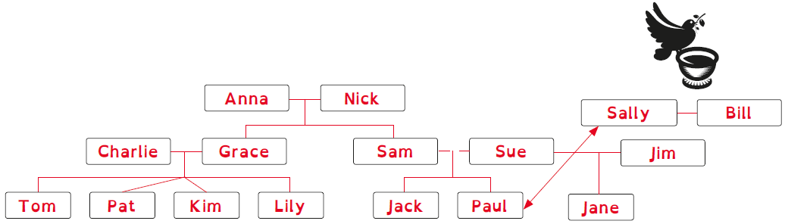
Part II
- Match ( ).

a) Anna and  Nick are  Pat’s | b) Grace is  Anna’s | c) Tom is  Charlie’s | d) Sally is  Paul’s | e) Kim is  Pat’s | f) Jim is  Jack’s

stepfather | grandparents | godmother | daughter | son | twin sister

- Write the job.
 | a)   | b)   | c)  
nurse | _ _ _ _ _ _ _ _ _ _ | _ _ _ _ _ _ | _ _ _ _ _ _ _

 | d)   | e)  
photographer | _ _ _ _ _ | _ _ _

 | My family
1 | Ann – Tell me, who is in your family and what is it like?
2 | May – I’ve got a big family. I live with my parents, my twin brother, my sister, my
3 | aunt and my cousin.
4 | Ann – Wow. So how many people are there in your family?
5 | May – There are fifteen people in my family.
6 | Ann – That’s amazing. And what are their jobs?
7 | May – My parents are doctors and my aunt is a vet. They are intelligent and work
8 | very hard. And you? Who is in your family?
9 | Ann – I’ve got a small family. I live with my mother and my stepfather. He’s a bit
10 | silly and bubbly sometimes but I love him.

- Match ( ).

May’s got a |  |  |  | mother and her stepfather.
She has got a |  |  |  | is a vet.
May’s parents |  |  |  | is small.
May’s aunt |  |  |  | twin brother and a sister.
Ann’s family |  |  |  | big family.
Ann lives with her |  |  |  | are doctors.

- Answer.

- Who does May live with?

- What is your family like?

- Write the sentences in the plural.

 | I have got a big family. | We have got big families.

The man is serious.

The baby has got toys.

The lady is tall.

- Write. Choose one word.

 | You have got my book. Give it to |  | (me / I).

 | You have got my book. Give it to |  | (him / he).

 | We are students. Our friends go to school with |  | (we / us).

 | Our teacher has got lots of students. She likes |  | (we / them).

 | This is my tablet. I use |  | (it / me).

 | She is Daisy. This book belongs to |  | (her / she).

- Write. Choose one word.

 | Look! That’s my car. It’s |  | (me / I).

 | Jack is a doctor. This is his phone. It’s |  | (him / he).

 | My grandparents have got a house. It’s |  | (we / us).

 | We have got lots of books. They are |  | (we / them).

 | This is Ann’s dog. It’s |  | (hers / his). And this is the dog’s bone. It’s

(its / mine).

- Read and answer the questions about you.

Have you got any brothers?

What is your father’s job?

What is your mother’s job?

What are your parents like?

What is your dream job?

- Describe Prince William’s family.

His name is |  | and he is a |  | .
.
He is |  | and |  | .

Her name is |  | and she is a |  | .

She is |  | and |  | .
The children are |  | , |  | .

and |  | . They are a happy family!
William: Pilot, serious and quiet

Kate: Photographer, kind and intelligent

Children: Happy, bubbly and polite

Keep calm and work hard! Merry Christmas!
Your teacher, ____________________________

Answer key and marking criteria
Test 2 version C – answer key and marking criteria
 | Section | Answer key | Marking criteria
Part I | Listening | Question 1: Listen and write.  Answer key: 1) kind 2) silly 3) intelligent  4) polite 5) funny | 5 x 2 = 10  2 marks per correct answer.  -0,5 marks if there is a spelling mistake.
Part I | Listening | Question 2: Listen and match.  Answer key: John – firefighter / Jane – police  officer / Vicky – cheerleader / Anna – hairdresser /  Paul – bus driver | 5 x 2 = 10  2 marks per correct answer.  Only accept an answer if one line is drawn correctly  per answer.
Part II | Vocabulary | Question 3: Match.  Answer key: b) daughter c) son d) godmother  e) twin sister f) stepfather | 5 x 2 = 10  2 marks per correct answer.  -0,5 marks if there is a spelling mistake.
Part II | Vocabulary | Question 4: Write the job.  Answer key: a) footballer b) doctor c) dentist  d) pilot e) vet | 5 x 2 = 10  2 marks per correct answer.  -0,5 marks if there is a spelling mistake.
Part II | Reading | Question 5: Match.  Answer key: She has got a twin brother and a  sister. / May’s parents are doctors. / May’s aunt is a  vet. / Ann’s family is small. / Ann lives with her  mother and her stepfather. | 5 x 2 = 10  2 marks per correct answer.  Only accept an answer if one line is drawn correctly  per answer.
Part II | Reading | Question 6: Answer.  Answer key: a) May lives with her parents, her twin  brother, her sister, her aunt and her cousin.  b) Personal answer | a. 1 x 5 = 5  5 marks per correct  answer.  -0,5 marks if there is a  spelling mistake.  -0,5 marks if there is a  verb mistake.  -0,5 marks if the word  order is incorrect. | b. 1 x 5 = 5  5 marks per correct  answer.  -0,5 marks if there is a  spelling mistake.  -0,5 marks if there is a  verb mistake.  -0,5 marks if the word  order is incorrect.
Part II | Grammar | Question 7: Write the sentences in the plural.  Answer key: a) me. b) The men are serious.  c) The babies have got toys. d) The ladies are tall. | 3 x 3 = 9  2 marks per correct answer.  -0,5 marks if there is a verb mistake.  -0,5 marks if there is a spelling mistake.  -0,5 marks if words are left in the singular.  -0,5 marks if indefinite articles are not removed.
Part II | Grammar | Question 8: Write. Choose one word.  Answer key: a) me b) him c) us d) them  e) it f) her | 6 x 1 = 6  1 mark per correct answer.
Part II | Grammar | Question 9: Write. Choose one word.  Answer key: b) his c) theirs d) ours e) hers, its | 5 x 1 = 5  1 mark per correct answer.
Part II | Writing | Question 10: Read and answer the questions about  you.  Answer key: Personal answer | 5 x 2 = 10  2 marks per correct answer.  -0,5 marks if the word order is incorrect.  -0,5 marks if there are 2 or more spelling mistakes.  -1 mark if there is a verb mistake.
Part II | Writing | Question 11: Describe Prince William’s family.  Answer key: His name is William and he is a pilot.  He is serious and quiet. Her name is Kate and she is  a photographer. She is kind and intelligent. The  children are happy, bubbly and polite. They are a  happy family! | 5 x 2 = 10  2 marks per correct sentence.  -0,5 marks if the word order is incorrect.  -0,5 marks if there are 2 or more spelling mistakes  in the sentence.  -1 mark if there is a verb mistake.

Note: Students with Specific Learning Disorders may benefit from different marking criteria, namely as far as spelling mistakes are
concerned.

Note: Listening script – see page 41.

Test 2 version D – Cambridge-like test
School |  | Evaluation
Name _____________ Surname _____________ Class: 5th ____  Date _________________________________________, 20 ___  Signatures _____________________/______________________  (Teacher) (Parent/E.E.) |  | ____%  Muito Bom Bom Suficiente  Insuficiente Muito Insuficiente

Part 1
- Listen and write about Ann’s family. There is one example.
Ann’s family
parents happy__
1. twin sister __________
2. nephew __________
3. nieces __________
4. godmother __________
5. grandparents __________
- Listen and draw a line. There is one example.
Test 2 version D – Cambridge-like test
School |  | Evaluation
Name _____________ Surname _____________ Class: 5th ____  Date _________________________________________, 20 ___  Signatures _____________________/______________________  (Teacher) (Parent/E.E.) |  | ____%  Muito Bom Bom Suficiente  Insuficiente Muito Insuficiente

Part 2
Look and read. Write Yes or No.
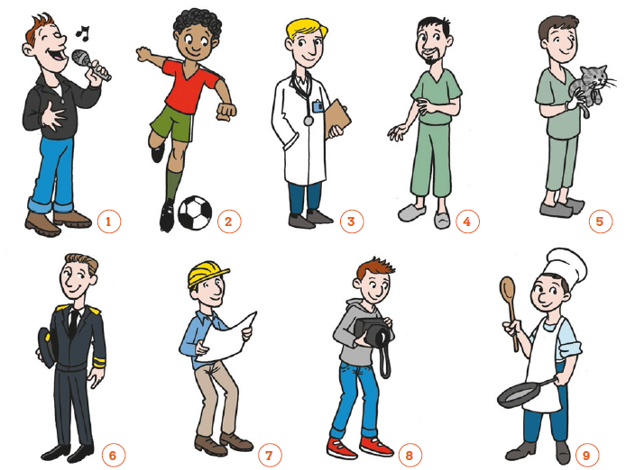

Examples:
Number 2: He is a doctor. No____
Number 8: He is a photographer. Yes___

Questions:
- Number 6: He is a pilot. ___________
- Number 1: He is a nurse. ___________
- Number 9: He is a cook. ___________
- Number 5: He is a dentist. ___________
- Number 7: He is an engineer. ___________
Part 3
Read this. Choose a word from the box. Write the correct word next to the
numbers 1-5. There is one example.

This is my family. Aren’t they great? My grandparents are 80 years old. Aren’t they polite?
My mother is standing next to my grandparents. She is my grandparents’ (1)________________.
Look at Daisy. She’s my cousin and my father’s (2) _________________. Daisy’s brother is Nick.
He’s my cousin so he’s my mother’s (3) ___________________. I’m standing next to my brother.
His name is Pete. He’s my parents’ (4) ____________________. We are ten years old. He is my
(5) ____________________ brother. I love Pete. He’s a little mean sometimes, but he loves me.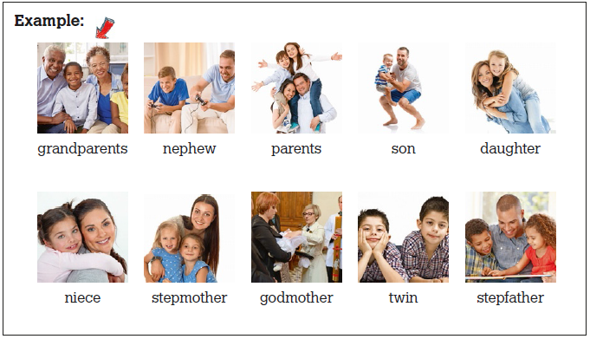
Part 4

Look at the pictures and read the story. Write one-word answers.
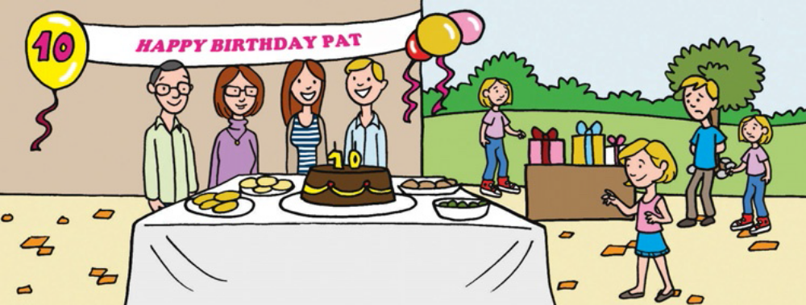

My name is Pat. Today it’s Saturday and it’s my birthday. I’m ten years old today. I’m feeling
very happy and excited. Can you see who is at my birthday party? Look at my parents. They
are standing near the cake. My mother is a secretary and my father is an engineer. And look
at my grandparents! My grandfather is a nurse and my grandmother is a teacher. She is very
serious and kind. Look at all my presents. I can’t wait to open them! My twin sisters and my
brother look a bit sad. They want a present too!

Examples:
Pat’s birthday is today . She is ten years old.

Questions:
- Pat is very happy and ____________ today. It’s her birthday party.
- Her parents are standing _________________________ the cake.
- Her mother is a secretary and her father is an ________________.
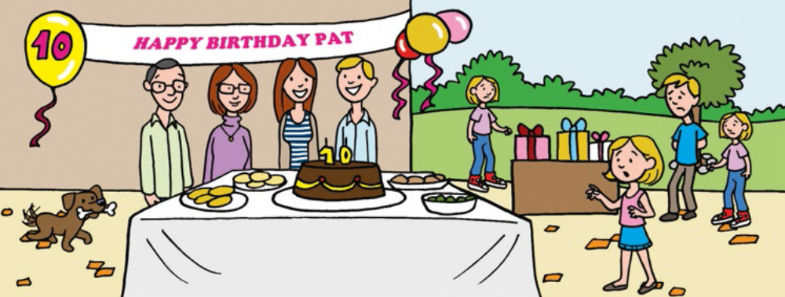

Oh dear. Look who’s there! It’s Tim. He is running. “Watch out Tim! It’s my birthday cake. Be
careful!” says Pat. Look! Tim has got something in his mouth. It’s a bone! It’s a present for
me. “Oh dear, Tim! I don’t like bones. I like toys!” says Pat.

- Tim is a ____________.
- Tim has got a ____________ in his mouth for Pat.

Marking key:
Test 2 version D – answer key and marking criteria
( ) = Acceptable extra words are placed in brackets

/ = A single slash is placed between acceptable
alternative words within an answer

// = A double slash is placed between acceptable
alternative complete answers.

Part 1 – 25 marks

Exercise 1
1 kind
2 silly
3 intelligent
4 polite
5 funny

Exercise 2
1 John – firefighter
2 Jane – police officer
3 Vicky – cheerleader
4 Anna – hairdresser
5 Paul – bus driver

Part 2 – 25 marks
1 Yes
2 No
3 Yes
4 No
5 Yes

Part 3 – 25 marks
1 daughter
2 niece
3 nephew
4 son
5 twin

Part 4 – 25 marks
1 excited
2 near
3 engineer
4 dog
5 bone

Note: Listening script – see page 41.

Test 2 version E – alternative/extra test
School |  | Evaluation
Name _____________ Surname _____________ Class: 5th ____  Date _________________________________________, 20 ___  Signatures _____________________/______________________  (Teacher) (Parent/E.E.) |  | ____%  Muito Bom Bom Suficiente  Insuficiente Muito Insuficiente

Listening
- Listen and draw a line. There is one example.
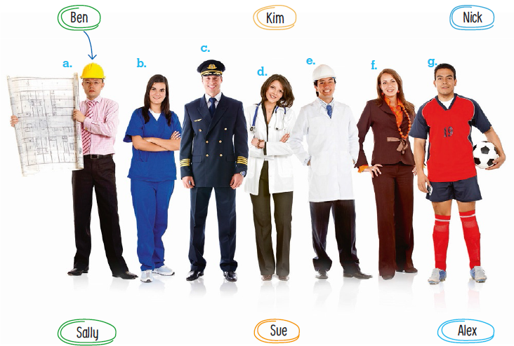

- Listen and write one word. There is one example.
- Kim is my twin sister.
- Sam is my ____________________________.
- Tony is my mother’s ____________________.
- Anna is my mother’s ____________________.
- Paul is my ____________________________.
- Alex is my godmother’s __________________.

School  Test 2 version E – alternative/extra test |  | Evaluation
Name _____________ Surname _____________ Class: 5th ____  Date _________________________________________, 20 ___  Signatures _____________________/______________________  (Teacher) (Parent/E.E.) |  | ____%  Muito Bom Bom Suficiente  Insuficiente Muito Insuficiente

Vocabulary
- Look and write.
a.   | b. | c.   | d.   | e.   | f.  

a. _ _ _ _ _ _ _ _ _ _ _ |  | b. _ _ _ _ |  | c. _ _ _ _ _

- _ _ _ _ _ _ |  | - _ _ _ _ |  | - _ _ _ _ _ _

- Look and draw a line.

a.   | b. | c.   | d.   | e.   | f.   | g.  

cheerleader | waiter | firefighter | secretary | fisherman | mechanic | farmer

Reading
Read the text.
My family
Ann – Tell me, who is in your family and what is it like?
May – I’ve got a big family. I live with my parents, my twin brother, my sister, my aunt and my cousin.
Ann – Wow. So how many people are there in your family?
May – There are fifteen people in my family.
Ann – That’s amazing. And what are their jobs?
May – My parents are doctors and my aunt is a vet. They are intelligent and work very hard. And you? Who is in your family?
Ann – I’ve got a small family. I live with my mother and my stepfather. He’s a bit silly and bubbly sometimes but I love him.

- Read and draw a line.

- May has got 1. her mother and her stepfather.
- She has got a twin 2. are doctors.
- May’s parents 3. stepfather.
- Her aunt is 4. a big family.
- Ann lives with 5. brother and a sister.
- Ann loves her 6. a vet.

- Read and answer the questions.

- What is Ann’s stepfather like? __________________________________
- Is Ann’s family big? __________________________________________
- What is your family like? ______________________________________

Grammar

- Read and write the sentences in the plural. Make the necessary changes.
There is one example.

- I have got a big family. We have got big families.____
- The child is intelligent. ________________________________
- The baby has got toys. ________________________________
- The lady is polite. ________________________________
- Your dog is silly. ________________________________
- The boy is handsome. ________________________________

- Read and correct the sentences. There is one example.

- Look! That’s my car. It’s my. It’s mine.________________________________
- Jack is a doctor. This is his phone. It’s hers. ___________________________________
- My grandparents have got a house. It’s mine. __________________________________
- We have got lots of books. They are theirs. ____________________________________
- This is Ann’s dog. And this is the dog’s bone. It’s yours. __________________________
- You and Nick have got phones. They are theirs. ________________________________

- Read and write The, a or an. There is one example.

- My hero is a singer. _____ singer is Omi.
- He sings _____ famous song. It’s _____ amazing song.
- _____ song is “Cheerleader”.
- _____ album’s name is “Me 4 U”.

Writing

- Read and answer the questions about you.

- Who do you live with? _____________________________________________________
- Have you got any sisters? __________________________________________________
- What is your mother’s job? _________________________________________________
- Have you got a godfather and a godmother? ___________________________________
- Is your father an engineer? _________________________________________________

- Write about Johnny Depp and Jack Sparrow. Use the information in the box.
Johnny Depp: Actor, funny,
Intelligent

Jack Sparrow: Pirate, bubbly,
silly

___________________________________________________
___________________________________________________
___________________________________________________
___________________________________________________

___________________________________________________
___________________________________________________

Keep calm and work hard! Merry Christmas!
Your teacher, _____________________________
Answer key and marking criteria
Test 2 version E – answer key and marking criteria

Section | Answer key | Marking criteria
Listening | Question 1: Listen and draw a line.  Answer key: b. Sue – nurse c. Alex – pilot  d. Kim – doctor f. Sally – actress g. Nick –  footballer | 5 x 2 = 10  2 marks per correct answer.  -0,5 marks if there is a spelling mistake.  Only accept an answer if one line is drawn correctly  per answer.
Listening | Question 2: Listen and write one word.  Answer key: b. stepfather c. nephew d. niece  e. godfather f. son | 5 x 2 = 10  2 marks per correct answer.
Vocabulary | Question 1: Look and write.  Answer key: a. intelligent b. bubbly d. mean  e. silly f. polite | 6 x 1 = 6  1 mark per correct answer.  -0,5 marks if there is a spelling mistake.
Vocabulary | Question 2: Look and draw a line.  Answer key: a. fisherman b. mechanic  c. cheerleader d. waiter e. firefighter f. farmer  g. secretary | 7 x 2 = 14  2 marks per correct answer.  -0,5 marks if there is a spelling mistake.
Reading | Question 1: Read and draw a line.  Answer key: a. 4 b. 5 d. 6 e. 1 f. 3 | 5 x 2 = 10  2 marks per correct answer.  Only accept an answer if one line is drawn correctly  per answer.
Reading | Question 2: Read and answer the questions.  Answer key: a. He is a bit silly and bubbly.  b. No, it isn’t. (It’s small.) c. Personal answer | a./b. 2 x 3 = 6  3 marks per correct  answer.  -0,5 marks if there is a  spelling mistake.  -0,5 marks if there is a  verb mistake.  -0,5 marks if the word  order is incorrect. | c. 1 x 4 = 4  4 marks per correct  answer.  -0,5 marks if there is a  spelling mistake.  -0,5 marks if there is a  verb mistake.  -0,5 marks if the word  order is incorrect.
Grammar | Question 1: Read and write the sentences in the  plural.  Answer key: b. The children are intelligent.  c. The babies have got toys. d. The ladies are  polite. e. Your dogs are silly. f. The boys are  handsome. | 5 x 2 = 10  2 marks per correct answer.  -0,5 marks if there is a verb mistake.  -0,5 marks if there is a spelling mistake.  -0,5 marks if words are left in the singular.  -0,5 marks if indefinite articles are not removed.
Grammar | Question 2: Read and correct the sentences.  Answer key: b. It’s his. c. It’s theirs.  d. They are ours. e. It’s its. f. They are yours. | 5 x 1 = 5  1 mark per correct answer.
Grammar | Question 3: Read and write The, a or an.  Answer key: a. The b. a, an c. The d. The | 5 x 1 = 5  1 mark per correct answer.
Writing | Question 1: Read and answer the questions about  you.  Answer key: Personal answer | 5 x 2 = 10  2 marks per correct answer.  -0,5 marks if the word order is incorrect.  -0,5 marks if there are 2 or more spelling mistakes.  -1 mark if there is a verb mistake.
Writing | Question 2: Write about Johnny Depp and Jack  Sparrow.  Answer key: His name is Johnny Depp and he’s an  actor. He is funny and intelligent.  His name is Jack Sparrow. He’s a pirate. He is  bubbly and silly. | 5 x 2 = 10  2 marks per correct sentence.  -0,5 marks if the word order is incorrect.  -0,5 marks if there are 2 or more spelling mistakes  in the sentence.  -1 mark if there is a verb mistake.

Listening script
Test 2 version E – listening script

Exercise 1 – Listen and draw a line.
Man 1 – Hello, what’s your name?
Man 2 – My name is Ben. That’s B-E-N.
Man 1 – Ben?
Man 2 – Yes, my name is Ben.
Man 1 – What is your job?
Man 2 – I’m an engineer.
Man 1 – So, Ben, you are an engineer.
Man 2 – Yes, I am.
Can you see the line from the name Ben to the picture of
the engineer? This is an example. Now you try.
1.
Girl 1 – Hello. What’s your name?
Girl 2 – Hi. My name is Sally. That’s S-A-L-L-Y.
Girl 1 – Nice to meet you, Sally. What’s your job?
Girl 2 – I’m an actress.
Girl 1 – An actress?
Girl 2 – Yes, I’m an actress.
Girl 1 – That’s exciting, Sally.
2.
Man – Hello. I’m Alex.
Woman – Alex?
Man – Yes. Alex. That’s A-L-E-X.
Woman – Are you a pilot?
Man – Yes, I am. I am a pilot. I love planes.
Woman – Is flying easy?
Man – Yes, it is.
3.
Woman 1 – Hello. My name is Sue.
Woman 2 – Excuse me?
Woman 1 – That’s S-U-E. Sue.
Woman 2 – Oh... Sue. Nice to meet you.
What’s your job?
Woman 1 – I am a nurse.
Woman 2 – Where do you work?
Woman 1 – I work in a big hospital in the city.
Woman 2 – Great!
4.
Girl – Hi! What’s your name?
Boy – Hello. I’m Nick. That’s N-I-C-K.
Girl – Hi Nick. What’s your job?
Boy – I’m a footballer.
Girl – Really? A footballer?
Boy – Yes, I’m a famous footballer. I play for a big club.
Girl – That’s so cool!
5.
Woman – Hello. My name is Kim.
Man – Excuse me?
Woman – Kim. That’s K-I-M.
Man – Nice to meet you, Kim. What is your job?
Woman – Well, I work with sick people. I make them feel
better. I’m a doctor.
Man – Are you a doctor?
Woman – Yes, I am a doctor. I love working with sick
people.
Exercise 2 – Listen and write one word.
Boy – Hi Kim. Who’s this in the photo? Is this your cousin?
Girl – No, it’s my twin sister.
Boy – Your twin sister? Really?
Girl – Yes, this girl is my twin sister. She’s very
intelligent.
Can you see the words twin sister? This is an example.
Now, you try.
1.
Boy 1 – Hi. Who’s this?
Boy 2 – This is Sam.
Boy 1 – Who’s Sam? Is he your father?
Boy 2 – No, he isn’t. Sam is my stepfather.
Boy 1 – Oh, I’m sorry! So, Sam is your stepfather.
Boy 2 – Yes.
2.
Girl – Who is Tony?
Girl 2 – Tony? He’s my mother’s nephew.
Girl 1 – Excuse me?
Girl 2 – Tony is my mother’s nephew.
Girl 1 – Oh, I see. So, Tony is your mother’s nephew and
your cousin.
Girl 2 – Yes, that’s right.
3.
Girl 1 – And is this your cousin too?
Girl 2 – Yes, that’s Anna. She’s my mother’s niece.
Girl 1 – She’s your mother’s niece?
Girl 2 – Yes, she is. My mother’s sister has got a daughter.
So Anna is my mother’s niece.
4.
Boy – What’s this picture?
Girl – This is my baptism.
Boy – Baptism? Who is this man?
Girl – He is my godfather.
Boy – What’s his name?
Girl – His name is Paul and he’s my godfather. I really like
him.
5.
Boy – Who is this boy next to your godmother?
Girl – His name is Alex.
Boy – Who is he?
Girl – He’s my godmother’s son and he’s my best friend.
Boy – Excuse me?
Girl – Alex is my godmother’s son. He’s very funny and a
bit silly. I like playing with him!

