
Unit 3 What do our houses look like and what do we eat?
Test 3 – breakdown

TEST A  Standard | No. of  questions | Types of questions | Marks per  question | Total
Listening  Metas:  L 1, 2, 3, 4, 5 | 2 | 1. Listen and colour.  House and furniture (pages 70, 74) | 5 x 2 = 10 | 20
Listening  Metas:  L 1, 2, 3, 4, 5 | 2 | 2. Listen and write.  Snacks (page 82) | 5 x 2 = 10 | 20
Vocabulary  Metas:  ID 6.1, 8.6, 8.7 | 2 | 1. Look and write the words in the box.  House (page 70) | 12 x 1 = 12 | 20
Vocabulary  Metas:  ID 6.1, 8.6, 8.7 | 2 | 2. Look and write.  Food (page 78) | 8 x 1 = 8 | 20
Reading  Metas:  R 4.3, 4.5, 4.6 | 2 | 1. Read and write True (T) or False (F). Correct the false sentences.  Sentences related to the text | 5 x 1 = 5  False 2 x 2,5 = 5 | 20
Reading  Metas:  R 4.3, 4.5, 4.6 | 2 | 2. Read and answer the questions.  Two comprehension questions about a text and a personal question | 2 x 3 = 6  1 x 4 = 4 | 20
Grammar  Metas: LG 8.8, 8.16,  8.17, 8.18, 8.23,  8.28  Language  Awareness | 3 | 1. Look, read and write the correct form of the verb there + to be.  Verb there + to be (pages 72-73) | 10 x 1 = 10 | 20
 | 3 | 2. Read and write some or any.  Countable / uncountable and some / any (pages 80-81) | 10 x 0,5 = 5 | 20
 | 3 | 3. Read and complete the sentences with because, but, and or so.  Write each word only once.  Conjunctions (pages 84-85) | 5 x 1 = 5 | 20
Writing  Metas: W 5.1, 6.1,  6.3 | 2 | 1. Read and answer about your dream house.  Personal questions | 5 x 2 = 10 | 20
Writing  Metas: W 5.1, 6.1,  6.3 | 2 | 2. Look at the picture and describe the house. | 5 x 2 = 10 | 20
 |  |  |  | 100%

TEST B  Easy-to-correct | No. of  questions | Types of questions | Marks per  question | Total
Listening  Metas:  L 1, 2, 3, 4, 5 | 2 | 1. Listen and colour.  House and furniture (pages 70, 74) | 5 x 2 = 10 | 20
Listening  Metas:  L 1, 2, 3, 4, 5 | 2 | 2. Listen and write.  Snacks (page 82) | 5 x 2 = 10 | 20
Vocabulary  Metas:  ID 6.1, 8.6, 8.7 | 2 | 1. Look and match.  House (page 70) | 12 x 1 = 12 | 20
Vocabulary  Metas:  ID 6.1, 8.6, 8.7 | 2 | 2. Look and tick.  Food (page 78) | 8 x 1 = 8 | 20
Reading  Metas:  R 4.3, 4.5, 4.6 | 3 | 1. Read and write True (T) or False (F).  Sentences related to the text | 5 x 2 = 10 | 20
Reading  Metas:  R 4.3, 4.5, 4.6 | 3 | 2. Read and answer the questions.  Two comprehension questions about a text and a personal question | 2 x 3 = 6  1 x 4 = 4 | 20
Grammar  Metas: LG 8.8, 8.16,  8.17, 8.18, 8.23,  8.28 | 3 | 1. Look, read and write Yes or No.  Verb there + to be (pages 72-73) | 5 x 1 = 5 | 20
Grammar  Metas: LG 8.8, 8.16,  8.17, 8.18, 8.23,  8.28 | 3 | 2. Read and circle. Then, write.  Conjunctions (pages 84-85) | 5 x 1 = 5 | 20
Grammar  Metas: LG 8.8, 8.16,  8.17, 8.18, 8.23,  8.28 | 3 | 3. Read and circle.  Countable / uncountable and some / any (pages 80-81) | 10 x 1 = 10 | 20
Writing  Metas: W 5.1, 6.1,  6.3 | 2 | 1. Read and answer about your dream house.  Personal questions | 5 x 2 = 10 | 20
Writing  Metas: W 5.1, 6.1,  6.3 | 2 | 2. Look at the picture and describe the house. | 5 x 2 = 10 | 20
 |  |  |  | 100%

TEST C  NEE |  | No. of  questions | Types of questions | Marks per  question | Total
Part I | Listening  Metas:  L 1, 2, 3, 4, 5 | 2 | 1. Listen and colour.  House and furniture (pages 70, 74) | 4 x 2,5 = 10 | 20
Part I | Listening  Metas:  L 1, 2, 3, 4, 5 | 2 | 2. Listen and match.  Snacks (page 82) | 5 x 2 = 10 | 20
Part II | Vocabulary  Metas:  ID 6.1, 8.6, 8.7 | 2 | 3. Write.  House (page 70) | 10 x 1 = 10 | 20
Part II | Vocabulary  Metas:  ID 6.1, 8.6, 8.7 | 2 | 4. Write.  Food (page 78) | 5 x 2 = 10 | 20
Part II | Reading  Metas:  R 4.3, 4.5, 4.6 | 2 | 5. Write True (T) or False (F).  Sentences related to the text | 5 x 2 = 10 | 20
Part II | Reading  Metas:  R 4.3, 4.5, 4.6 | 2 | 6. Answer.  One comprehension question about a text and a personal question | 5 x 2 = 10 | 20
 |  |  |  |  | 100%

TEST C  NEE |  | No. of  questions | Types of questions | Marks per  question | Total
Part II | Grammar  Metas: LG 8.8,  8.16, 8.17,  8.18, 8.23, 8.28, 8.28 | 3 | 7. Write the correct form of the verb there + to be.  Verb there + to be (pages 72-73) | 4 x 2 = 8 | 20
Part II | Grammar  Metas: LG 8.8,  8.16, 8.17,  8.18, 8.23, 8.28, 8.28 | 3 | 8. Write some or any.  Countable / uncountable and some / any (pages 80-81) | 8 x 1 = 8 | 20
Part II | Grammar  Metas: LG 8.8,  8.16, 8.17,  8.18, 8.23, 8.28, 8.28 | 3 | 9. Write.  Conjunctions (pages 84-85) | 4 x 1 = 4 | 20
Part II | Writing  Metas: W 5.1,  6.1, 6.3 | 2 | 10. Answer about your dream house.  Personal questions | 5 x 2 = 10 | 20
Part II | Writing  Metas: W 5.1,  6.1, 6.3 | 2 | 11. Describe the house. | 5 x 2 = 10 | 20
 |  |  |  |  | 100%

TEST D  Cambridge-like | No. of  questions | Types of questions | Marks per  question | Total
PART 1  Listening &  Vocabulary  Metas:  L 1, 2, 3, 4, 5 ID 6.1,  8.6, 8.7 | 2 | Listen and order.  Physical description (page 24)  Listen and draw a line.  Clothes (page 34) | 5 x 2,5 = 12,5 | 25
 | 2 | 1. Listen and colour.  House and furniture (pages 70, 74) | 5 x 2,5 = 12,5 | 25
PART 2  Reading &  Vocabulary  Metas: ID 8.3, 8.4  R 4.3, 4.5, 4.6 | 1 | Look at the pictures. Look at the letters. Write the words.  House and furniture (pages 70, 74) | 5 x 5 = 25 | 25
PART 3  Reading,  Vocabulary &  Grammar  Metas: R 4.3, 4.4,  4.6 ID 8.6 | 1 | Read this. Choose a word from the box. Write the correct word  next to the numbers 1-5.  Food and snacks (pages 78, 82) | 5 x 5 = 25 | 25
PART 4  Writing &  Vocabulary  Metas: R 4.3, 4.4,  4.6 ID 8.6 W 5  LG 8.16 | 1 | Look at the pictures and read the story. Write one-word answers.  Food and snacks (pages 78, 82)  Prepositions of place (page 77) | 5 x 5 = 25 | 25
 |  |  |  | 100%

TEST E  Alternative/Extra | No. of  questions | Types of questions | Marks per  question | Total
Listening  Metas:  L 1, 2, 3, 4, 5 | 2 | 1. Listen and draw a line.  House and furniture (pages 70, 74) | 5 x 2 = 10 | 20
Listening  Metas:  L 1, 2, 3, 4, 5 | 2 | 2. Listen and circle.  Food (page 78) | 5 x 2 = 10 | 20
Vocabulary  Metas:  ID 6.1, 8.6, 8.7 | 2 | 1. Look and write.  Furniture (page 74) | 6 x 1 = 6 | 20
Vocabulary  Metas:  ID 6.1, 8.6, 8.7 | 2 | 2. Look and write.  Snacks (page 82) | 7 x 2 = 14 | 20
Reading  Metas:  R 4.3, 4.5, 4.6 | 2 | 1. Read and write T (True) or F (False). Correct the false sentences.  Sentences related to the text | 5 x 1 = 5  3 x 2 = 6
Reading  Metas:  R 4.3, 4.5, 4.6 | 2 | 2. Read and answer the questions.  Two comprehension questions about a text and a personal question | 2 x 3 = 6  1 x 3 = 3
Grammar  Metas: LG 8.8, 8.16,  8.17, 8.18, 8.23,  8.28  Language  Awareness | 3 | 1. Look, read and write the correct form of the verb there + to be.  Verb there + to be (pages 72-73) | 10 x 1 = 10 | 20
 | 3 | 2. Read and draw a line.  Prepositions of place (page 77) | 5 x 1 = 5 | 20
 | 3 | 3. Read and complete the sentences with because, but, and or so.  Conjunctions (page 84) | 5 x 1 = 5 | 20
Writing  Metas: W 5.1, 6.1,  6.3 | 2 | 1. Read and answer about your dream house.  Personal questions | 5 x 2 = 10 | 20
Writing  Metas: W 5.1, 6.1,  6.3 | 2 | 2. Look at the picture and describe the children’s lunch today. | 5 x 2 = 10 | 20
 |  |  |  | 100%
Test 3 version A – standard test
School |  | Evaluation
Name _____________ Surname _____________ Class: 5th ____  Date _________________________________________, 20 ___  Signatures _____________________/______________________  (Teacher) (Parent/E.E.) |  | ____%  Muito Bom Bom Suficiente  Insuficiente Muito Insuficiente

Listening
- Listen and colour. There is one example.
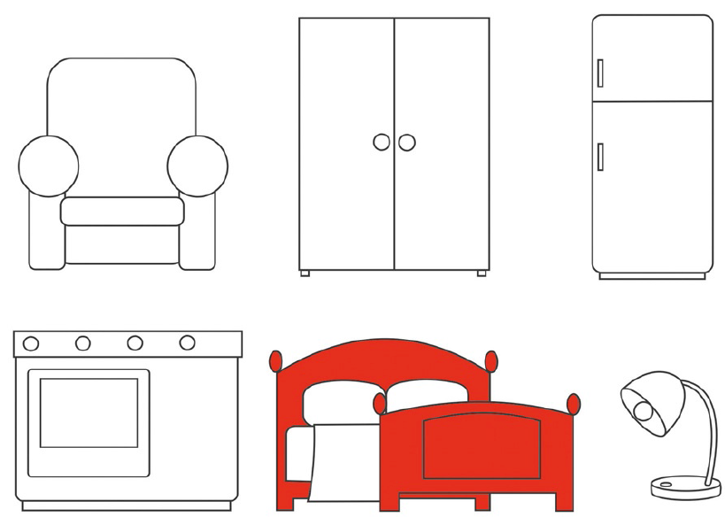

- Listen and write. There is one example.

Menu
Monday _nuts___
1. Tuesday ___________
2. Wednesday ___________
3. Thursday ___________
4. Friday ___________
5. Saturday ___________

School |  | Evaluation
Name _____________ Surname _____________ Class: 5th ____  Date _________________________________________, 20 ___  Signatures _____________________/______________________  (Teacher) (Parent/E.E.) |  | ____%  Muito Bom Bom Suficiente  Insuficiente Muito Insuficiente

Test 3 version A – standard test
Vocabulary
- Look and write the words in the box.
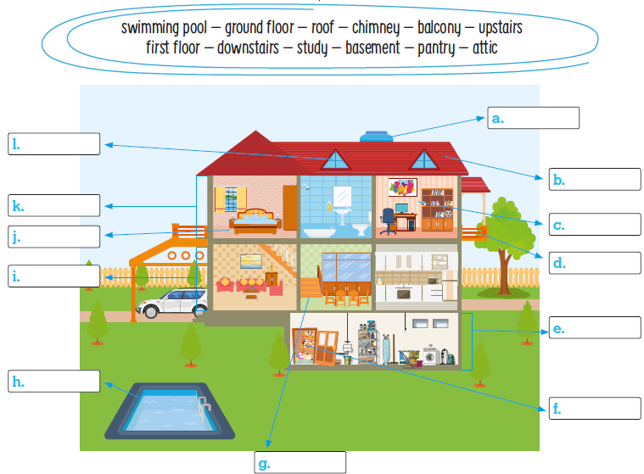

- Look and write.
 |  |  | 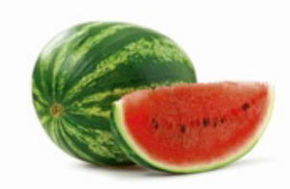 |  | 
- ___________ | - _____________ |  | - ___________ |  | - ______________
 | 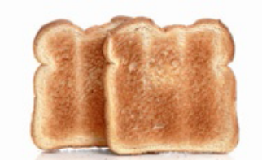 |  |  |  | 
- _______________ |  | - _______________ |  | - ____________ |  | - ___________

Reading
Read the text.
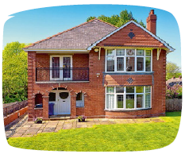
My house
My name is John and I live in England. This is my house. It’s a big
red brick house.
It has got two floors and an attic. Upstairs, on the first floor, there is
a bathroom and there are three bedrooms. On the ground floor
there is a kitchen, a living room, a dining room, a pantry, a hall and
a toilet. Our study is in the attic. The windows of my house are big
and white. There is a big garden in front of the house and a little
swimming pool in the garden behind the house. My mother loves
flowers and there are lots of pretty flowers in the garden.

- Read and write T (True) or F (False). Correct the false sentences.
There is one example.

- John lives in a small house.  John lives in a big house.____________
- It’s a red brick house.  ________________________________________________
- There are three bedrooms, a bathroom and an attic upstairs.
_________________________________________________________________________
- There is a bathroom on the ground floor. ___________________________________________________________________
- There isn’t a study in his house. _________________________________________
- There are two gardens in his house. ______________________________________

- Read and answer the questions.

- Is there a hall in John’s house?
_________________________________________________________________________
- How many floors are there in his house?
_________________________________________________________________________
- Where is the bathroom in your house?
_________________________________________________________________________
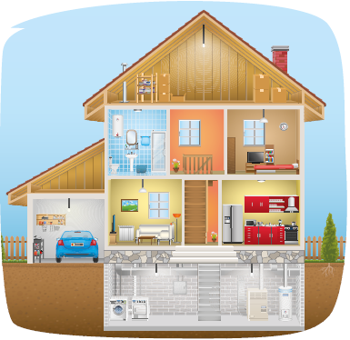
Grammar
- Look, read and write the correct form of the
verb there + to be. There is one example.

- There is a basement.
- _________ there an attic? _________, there _________.
- _________ there a swimming pool? _________, there _________.
- _________ there any bathrooms? _________, there _________ one.
- There _________ a pantry.

- Read and write some or any. There is one example.

- There is some sugar in the pantry but there isn’t any salt.
- There are ________ carrots in the fridge and there are ________ vegetables too.
- There is ________ fruit on the table but there aren’t ________ bananas.
- Is there ________ pizza? No, there isn’t ________.
- Is there ________ jam for breakfast? Yes, there is ________.
- Are there ________ nuts? No, there aren’t ________.

- Read and complete the sentences with because, but, and or so.
There is one example.

- Children like biscuits and milkshakes.
- I don’t like crisps ________ they’re unhealthy.
- I like pasta ________ rice too.
- I like tea ________ I don’t like soft drinks.
- I love cereal bars ________ my mother buys them a lot.
- I only want a soup ________ I’m not hungry.

Writing

- Read and answer about your dream house.

- How many floors are there? _________________________________
- What rooms are there on the ground floor? _____________________
- Is there a swimming pool? __________________________________
- What is your favourite room? ________________________________
- Is there a basement or a pantry? _____________________________

- Look at the picture and describe the house.
__________________________________________________
__________________________________________________
__________________________________________________
__________________________________________________
__________________________________________________

Keep calm and work hard! Happy Valentine’s Day
Your teacher, ____________________________

Answer key and marking criteria
Test 3 version A – answer key and marking criteria

Section | Answer key | Marking criteria
Listening | Question 1: Listen and colour  Answer key: 1. green armchair 2. blue lamp  3. yellow fridge 4. orange cooker  5. brown cupboard | 5 x 2 = 10  2 marks per correct answer.
Listening | Question 2: Listen and write.  Answer key: 1. Tuesday – crisps  2. Wednesday – biscuits 3. Thursday – fruit  4. Friday – cereal bars 5. Saturday – pizza | 5 x 2 = 10  2 marks per correct answer.  -0,5 marks if there is a spelling mistake.
Vocabulary | Question 1: Look and write the words in the box.  Answer key: a. chimney b. roof c. study  d. balcony e. basement f. pantry g. downstairs  h. swimming pool i. ground floor j. upstairs  k. first floor l. attic | 12 x 1 = 12  1 mark per correct answer.  -0,5 marks if there is a spelling mistake.
Vocabulary | Question 2: Look and write.  Answer key: a. sausages b. salad c. watermelon  d. butter e. carrots f. toast g. pasta h. ham | 8 x 1 = 8  2 marks per correct answer.  -0,5 marks if there is a spelling mistake.
Reading | Question 1: Read and write T (True) or F (False).  Correct the false sentences.  Answer key: b. T c. T  d. F (There is a toilet on the ground floor.)  e. F (There is a study in John’s house.) f. T | 5 x 1 = 5 / 2 x 2,5 = 5  1 mark per correct answer for T and F.  Only accept an answer if T or F is written.  0 marks if V is used.  False sentences: 2,5 marks for each accurate  correction.  -0,5 marks if there is a spelling mistake.  -0,5 marks if there is a verb mistake.  -0,5 marks if the word order is incorrect.
Reading | Question 2: Read and answer the questions.  Answer key: a. Yes, there is.  b. There are two floors and an attic. / There are  three floors. c. Personal answer | a./b. 2 x 3 = 6  3 marks per correct  answer.  -0,5 marks if there is a  spelling mistake.  -0,5 marks if there is a  verb mistake.  -0,5 marks if the word  order is incorrect. | c. 1 x 4 = 4  4 marks per correct  answer.  -0,5 marks if there is a  spelling mistake.  -0,5 marks if there is a  verb mistake.  -0,5 marks if the word  order is incorrect.
Grammar | Question 1: Look, read and write the correct form  of the verb there + to be.  Answer key: b. Is, Yes, is c. Is, No, isn’t  d. Are, Yes, is e. isn’t | 10 x 1 = 10  1 mark per correct answer.  -0,5 marks if there is a verb mistake.  -0,5 marks if there is a spelling mistake.
Grammar | Question 2: Look and write some or any.  Answer key: b. some, some c. some, any  d. any, any e. any, some f. any, any | 10 x 0,5 = 5  0,5 marks per correct answer.
Grammar | Question 3: Read and complete the sentences with  because, but, and or so.  Answer key: b. because c. and d. but e. so  f. because | 5 x 1 = 5  1 mark per correct answer.
Writing | Question 1: Read and answer about your dream  house.  Answer key: Personal answer | 5 x 2 = 10  2 marks per correct answer.  -0,5 marks if the word order is incorrect.  -0,5 marks if there are 2 or more spelling mistakes.  -1 mark if there is a verb mistake.
Writing | Question 2: Look at the picture and describe the  house.  Answer key: There are two floors and a basement.  On the first floor, there is a bedroom, a study, a  living room and a toilet. There is a balcony too.  Downstairs, on the ground floor, there is a kitchen,  a hall and a bedroom. In the basement, there is a  pantry and a toilet. | 5 x 2 = 10  2 marks per correct sentence.  -0,5 marks if the word order isn’t correct.  -0,5 marks if there are 2 or more spelling mistakes  in the sentence.  -1 mark if there is a verb mistake.

Listening script
Test 3 version A – listening script

Exercise 1 – Listen and colour. There is one example.
Teacher – Can you see the bed?
Boy – The bed?
Teacher – Yes, the bed. It’s between the cooker and the
lamp.
Boy – Oh. Yes, I can see the bed.
Teacher – Good. Now, colour it red.
Boy – Ok. I’m colouring the bed red.
Can you see the red bed, between the cooker and the
lamp? This is an example. Now, you try.
1.
Teacher – Now find the armchair.
Boy – The armchair? Where is it?
Teacher – The armchair is above the cooker, on the left.
Boy – Yes. I can see the armchair above the cooker.
Teacher – Colour it green.
Boy – Green?
Teacher – Yes. Colour the armchair green.
2.
Teacher – Look at the lamp.
Boy – Is the lamp below the fridge?
Teacher – Yes, that’s the one. Colour it blue.
Boy – So, the lamp below the fridge is blue.
Teacher – Yes, that’s right.
3.
Teacher – Can you see the fridge?
Boy – The fridge… um… yes, it’s above the lamp.
Teacher – Yes, very good. The fridge is above the lamp.
Colour it yellow.
Boy – A yellow fridge, teacher?
Teacher – Yes, it’s a yellow fridge.
Boy – Ok, teacher.
4.
Teacher – Look at the cooker.
Boy – The cooker…
Teacher – Yes, the cooker. It’s next to the bed.
Boy – Yes, I can see the cooker.
Teacher – You choose the colour.
Boy – Ok. Can I colour it orange?
Teacher – Ok.
Boy – I’m colouring it orange then.
5.
Boy – What can I colour next?
Teacher – Can you see the cupboard?
Boy – The cupboard? Where is it?
Teacher – The cupboard is above the bed.
Boy – I can see the cupboard now.
Teacher – Good. Now colour it brown.
Boy – Brown?
Teacher – Yes, colour the cupboard brown.
Boy – Ok. It’s a nice picture, teacher.

Exercise 2 – Listen and write. There is one example.
Girl – Hello.
Boy – Hi! Do you eat the same snack every day?
Girl – Well… no. No, I don’t.
Boy – What’s your favourite snack on Monday?
Girl – My favourite snack on Monday… Let’s see… I really
like nuts.
Boy – Nuts? Is your favourite snack on Monday nuts?
Girl – Yes, that’s right. My favourite snack on Monday is
nuts. They’re yummy and healthy!
Can you see the word “nuts” written after “Monday”?
This is an example. Now you try.
1.
Boy – What about Tuesday? What do you eat on Tuesday?
Girl – On Tuesday, my favourite snack is crisps.
Boy – Crisps? That’s not very healthy!
Girl – But I love crisps and I always eat them on Tuesday!
2.
Boy – How about Wednesday? What’s your favourite snack
on Wednesday?
Girl – On Wednesday… oh, I know. My mother makes
delicious biscuits on Wednesday so I always eat biscuits on
Wednesday.
Boy – Biscuits? Wow. You are lucky! I love eating biscuits
too!
3.
Girl – And on Thursday, I go to the supermarket and buy
fruit. I really like to eat fruit! I love fruit!
Boy – Fruit is really good and healthy for you. I also eat
fruit on Thursday, because I always go to the shops to do
my shopping.
Girl – Do you? That’s great!
4.
Boy – What’s your favourite snack on Friday?
Girl – On Friday I like cereal bars. They give you lots of
energy. On Friday I have sports practice, so I eat a cereal
bar to give me lots of energy!
Boy – Oh! That’s a good idea. I’ve got sports practice at
the weekend too. I can eat cereal bars, just like you. I need
lots of energy!
5.
Boy – Do you eat any special snacks on Saturday?
Girl – Well, I usually go to the cinema with my parents on
Saturday and we always eat pizza!
Boy – You’re very lucky! So, you always eat pizza on
Saturday?
Girl – Yes, I do! My favourite pizza is ham and chicken!
Yummy!

Test 3 version B – easy-to-correct test
School |  | Evaluation
Name _____________ Surname _____________ Class: 5th ____  Date _________________________________________, 20 ___  Signatures _____________________/______________________  (Teacher) (Parent/E.E.) |  | ____%  Muito Bom Bom Suficiente  Insuficiente Muito Insuficiente

Listening
- Listen and colour. There is one example.

- Listen and write. There is one example.
Menu
Monday _nuts___
1. Tuesday ___________
2. Wednesday ___________
3. Thursday ___________
4. Friday ___________
5. Saturday ___________
School  Test 3 version B – easy-to-correct test |  | Evaluation
Name _____________ Surname _____________ Class: 5th ____  Date _________________________________________, 20 ___  Signatures _____________________/______________________  (Teacher) (Parent/E.E.) |  | ____%  Muito Bom Bom Suficiente  Insuficiente Muito Insuficiente
Vocabulary
- Look and match.
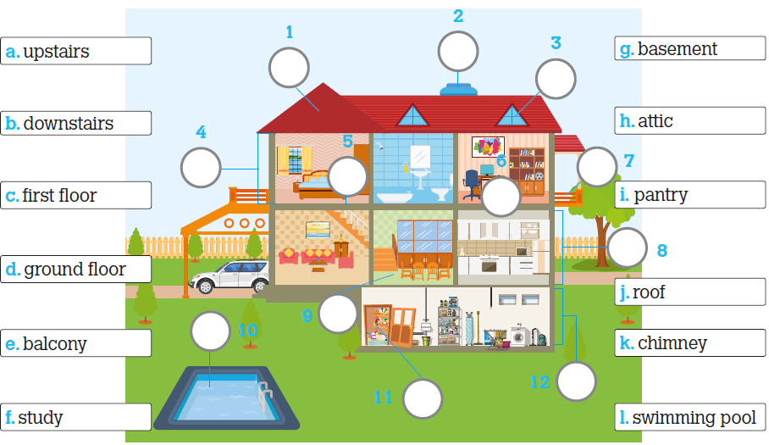

- Look and tick.
a. |  | b. |  | c. | 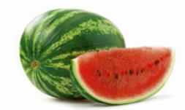 | d. | 
 | 1. sausages |  | 1. mashed potato |  | 1. vegetables |  | 1. butter
 | 2. salad |  | 2. salad |  | 2. pasta |  | 2. chicken
 | 3. butter |  | 3. carrots |  | 3. watermelon |  | 3. jam
e. |  | f. | 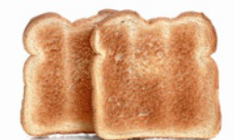 | g. |  | h. | 
 | 1. toast |  | 1. butter |  | 1. vegetables |  | 1. mashed potato
 | 2. ham |  | 2. toast |  | 2. pasta |  | 2. watermelon
 | 3. carrots |  | 3. jam |  | 3. salad |  | 3. ham

Reading
Read the text.
My house
My name is John and I live in England. This is my house. It’s a big
red brick house.
It has got two floors and an attic. Upstairs, on the first floor, there is
a bathroom and there are three bedrooms. On the ground floor
there is a kitchen, a living room, a dining room, a pantry, a hall and
a toilet. Our study is in the attic. The windows of my house are big
and white. There is a big garden in front of the house and a little
swimming pool in the garden behind the house. My mother loves
flowers and there are lots of pretty flowers in the garden.

- Read and write T (True) or F (False). There is one example.

a. John lives in a small house.
b. It’s a red brick house.
c. There are three bedrooms, a bathroom and an attic upstairs.
d. There is a bathroom on the ground floor.
e. There isn’t a study in John’s house.
f. There are two gardens in his house.

- Read and answer the questions.

- Is there a hall in John’s house?
_________________________________________________________________________
- How many floors are there in his house?
There are _________________________________________________________________
- Where is the bathroom in your house?
It’s _______________________________________________________________________

Grammar
- Look, read and write Yes or No.

- There is a basement. Yes___
- There isn’t an attic. __________
- There is a swimming pool. __________
- There is one bathroom. __________
- There is a pantry. __________

- Read and circle. Then, write. There is one example.

- Children like biscuits and milkshakes.
    - so 2. and 3. because
- I don’t like crisps they aren’t healthy.
    - Because 2. so 3. but
- I like pasta vegetables.
    - because 2. but 3. and
- I like tea I don’t like soft drinks.
    - so 2. but 3. because
- I love cereal bars my mother buys them a lot.
    - but 2. so 3. because
- I only want a soup I’m not hungry.
    - because 2. but 3. and

- Read and circle. There is one example.

- There is some / any sugar in the pantry but there isn’t any / some salt.
- Is there some / any jam for breakfast? Yes, there is some / any.
- Are there some / any nuts? No, there aren’t some / any.
- There are some / any carrots in the fridge and some / any vegetables too.
- Is there some / any pizza? No, there isn’t some / any.
- There is some / any fruit on the table but there aren’t some / any bananas.

Writing

- Read and answer about your dream house.

- How many floors are there? ___________________________________________________
- What rooms are there in your dream house? ______________________________________
- Is there a pantry? ___________________________________________________________
- Is there an attic? _______________________________________________________
- Where are the bedrooms? ____________________________________________________

- Look at the picture and describe the house.

There are ____________ and a ____________
on the first _____________________________
_____________________________ and a toilet
There is ________________ too. On the ground
floor __________________________________

Answer key and marking criteria
Test 3 version B – answer key and marking criteria

Section | Answer key | Marking criteria
Listening | Question 1: Listen and colour.  Answer key: 1. green armchair 2. blue lamp  3. yellow fridge 4. orange cooker  5. brown cupboard | 5 x 2 = 10  2 marks per correct answer.
Listening | Question 2: Listen and write.  Answer key: 1. Tuesday – crisps 2. Wednesday –  biscuits 3. Thursday – fruit 4. Friday – cereal bars  5. Saturday – pizza | 5 x 2 = 10  2 marks per correct answer.  -0,5 marks if there is a spelling mistake.
Vocabulary | Question 1: Look and match.  Answer key: a. 5 b. 9 c. 4 d. 8 e. 7 f. 6  g. 12 h. 3 i. 11 j. 1 k. 2 l. 10 | 12 x 1 = 12  1 mark per correct answer.  Only accept one number per answer.
Vocabulary | Question 2: Look and tick.  Answer key: a. 1 b. 2 c. 3 d. 1 e. 3 f. 2  g. 2 h. 3 | 8 x 1 = 8  1 mark per correct answer.  Only accept one tick per answer.
Reading | Question 1: Read and write T (True) or F (False).  Answer key: b. T c. T d. F e. F f. T | 5 x 2 = 10  2 marks per correct answer.  Only accept an answer if T or F is written.  0 marks if V is used.
Reading | Question 2: Read and answer the questions.  Answer key: a. Yes, there is. b. There are two  floors and an attic. / There are three floors. c.  Personal answer | a./b. 2 x 3 = 6  3 marks per correct  answer.  -0,5 marks if there is a  spelling mistake.  -0,5 marks if there is a  verb mistake.  -0,5 marks if the word  order is incorrect. | c. 1 x 4 = 4  4 marks per correct  answer.  -0,5 marks if there is a  spelling mistake.  -0,5 marks if there is a  verb mistake.  -0,5 marks if the word  order is incorrect.
Grammar | Question 1: Look, read and write Yes or No.  Answer key: b. No c. No d. Yes e. No | 5 x 1 = 5  1 mark per correct answer.
Grammar | Question 2: Read and circle. Then, write.  Answer key: b. 1 c. 3 d. 2 e. 2 f. 1 | 5 x 1 = 5  1 mark per correct answer.
Grammar | Question 3: Read and circle.  Answer key: b. any, some c. any, any  d. some, some e. any, any f. some, any | 10 x 1 = 10  1 mark per correct answer.
Writing | Question 1: Read and answer about your dream  house.  Answer key: Personal answer | 5 x 2 = 10  2 marks per correct answer.  -0,5 marks if the word order is incorrect.  -0,5 marks if there are 2 or more spelling mistakes.  -1 mark if there is a verb mistake.
Writing | Question 2: Look at the picture and describe the  house.  Answer key: There are two floors and a basement.  On the first floor, there is a bedroom, a study, a  living room and a toilet. There is a balcony too.  On the ground floor, there is a kitchen, a hall and a  bedroom. In the basement, there is a pantry and a  toilet. | 5 x 2 = 10  2 marks per correct sentence.  -0,5 marks if the word order is incorrect.  -0,5 marks if there are 2 or more spelling mistakes  in the sentence.  -1 mark if there is a verb mistake.

Note: Listening script – see page 70.

School  Test 3 version C – NEE test |  | Evaluation
Name _____________ Surname _____________ Class: 5th ____  Date _________________________________________, 20 ___  Signatures _____________________/______________________  (Teacher) (Parent/E.E.) |  | ____%  Muito Bom Bom Suficiente  Insuficiente Muito Insuficiente
Part I
- Listen and colour.

 | Teacher: Now find the armchair.  Boy: The armchair? Where is it?  Teacher: The armchair is above the  cooker, on the left.  Boy: Yes. I can see the armchair above  the cooker.  Teacher: Colour it green.  Boy: Green?  Teacher: Yes. Colour the armchair green. |  | Teacher: Can you see the fridge?  Boy: The fridge… um… yes, it’s above  the lamp.  Teacher: Yes, very good. The fridge is  above the lamp. Colour it yellow.  Boy: A yellow fridge, teacher?  Teacher: Yes, it’s a yellow fridge.  Boy: Ok, teacher.

 | Teacher: Look at the lamp.  Boy: Is the lamp below the fridge?  Teacher: Yes, that’s the one. Colour it  blue.  Boy: So, the lamp below the fridge is  blue.  Teacher: Yes, that’s right. |  | Teacher: Look at the cooker.  Boy: The cooker…  Teacher: Yes, the cooker. It’s next to the  bed.  Boy: Yes, I can see the cooker.  Teacher: You choose the colour.  Boy: Ok. Can I colour it orange?  Teacher: Ok.  Boy: I’m colouring it orange then.

- Listen and match ( ).
Monday | Tuesday | Wednesday | Thursday | Friday | Saturday

biscuits | fruit | nuts | pizza | pizza | cereal bars

Part II
- Write.

swimming pool | ground floor | roof | chimney | balcony | upstairs
first floor | downstairs | study | basement | pantry | attic

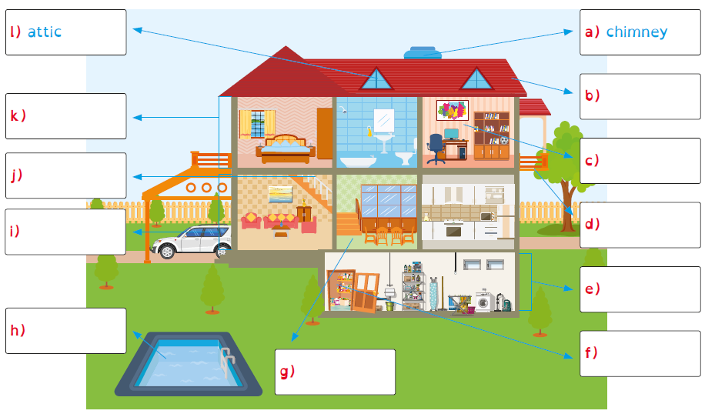

- Write.
- s a     | - s a    | - w a      | - b u    | - c a    

1  2  3  4  5  6  7 | My house  My name is John and I live in England. This is my house. It’s a big red brick house.  It has got two floors and an attic. Upstairs, on the first floor, there is a bathroom  and there are three bedrooms. On the ground floor there is a kitchen, a living room,  a dining room, a pantry, a hall and a toilet. Our study is in the attic. The windows  of my house are big and white. There is a big garden in front of the house and a  little swimming pool in the garden behind the house.  My mother loves flowers and there are lots of pretty flowers in the garden.

- Write T (True) or F (False).

 |  | True | False
a) | John lives in a small house. |  | F
b) | It’s a red brick house.
c) | There are three bedrooms, a bathroom and an attic upstairs.
d) | There is a bathroom on the ground floor.
e) | There isn’t a study in John’s house.
f) | There are two gardens in his house.

- Answer.

a) Is there a hall in John’s house?

b) How many bedrooms are there in your house?

- Write the correct form of the verb there + to be.

 | There | is | a basement.

there an attic?

 | Yes | , there |  | .

there a swimming pool?

 | No | , there |  | .

- Write some or any.

 | There is | some | sugar in the pantry but there isn’t | any | salt.

 | There are |  | carrots in the fridge and there are |  | vegetables too.

 | There is |  | fruit on the table but there aren’t |  | bananas.

 | Is there |  | pizza? No, there isn’t |  | .

 | Is there |  | jam for breakfast? Yes, there is |  | .

- Write.

because | but | and | so | because

 | I don’t like crisps | because | they’re unhealthy.

 | Children like biscuits |  | milkshakes.

 | I like tea |  | I don’t like soft drinks.

 | I love cereal bars |  | my mother buys them a lot.

 | I only want a soup |  | I’m not hungry.

- Answer about your dream house.
How many floors are there?

What rooms are there on the ground floor?

Is there a swimming pool?

What is your favourite room?

Is there a basement or a pantry?
- Describe the house.
There

floors and a basement.

On the first floor, there

and a

. There

, too.

On the ground floor, there |  | .

In the basement, there |  | and a |  | .

Answer key and marking criteria
Test 3 version C – answer key and marking criteria

Section |  | Answer key | Marking criteria
Part I | (Listening) | Question 1: Listen and colour.  Answer key: 1) green armchair 2) blue lamp  3) yellow fridge 4) orange cooker | 4 x 2,5 = 10  2,5 marks per correct answer.
Part I | (Listening) | Question 2: Listen and match.  Answer key: 1) Tuesday – crisps 2) Wednesday –  biscuits 3) Thursday – fruit 4) Friday – cereal bars  5) Saturday – pizza | 5 x 2 = 10  2 marks per correct answer.  -0,5 marks if there is a spelling mistake.
Part II | (Vocabulary) | Question 3: Write.  Answer key: b) roof c) study d) balcony  e) basement f) pantry g) downstairs  h) swimming pool i) ground floor j) upstairs  k) first floor | 10 x 1 = 10  1 mark per correct answer.  -0,5 marks if there is a spelling mistake.
Part II | (Vocabulary) | Question 4: Write.  Answer key: a) sausages b) salad c) watermelon  d) butter e) carrots | 5 x 2 = 10  2 marks per correct answer.  -0,5 marks if there is a spelling mistake.
Part II | (Reading) | Question 5: Write T (True) or F (False).  Answer key: b) T c) T d) F e) F f) T | 5 x 2 = 10  2 marks per correct answer.
Part II | (Reading) | Question 6: Answer.  Answer key: a) Yes, there is. b) Personal answer | a. 1 x 5 = 5  5 marks per correct  answer.  -0,5 marks if there is a  spelling mistake.  -0,5 marks if there is a  verb mistake.  -0,5 marks if the word  order is incorrect. | b. 1 x 5 = 5  5 marks per correct  answer.  -0,5 marks if there is a  spelling mistake.  -0,5 marks if there is a  verb mistake.  -0,5 marks if the word  order is incorrect.
Part II | (Grammar) | Question 7: Write the correct form of the verb  there + to be.  Answer key: b) Is, is c) Is, isn’t | 4 x 2 = 8  2 marks per correct answer.  -0,5 marks if there is a verb mistake.  -0,5 marks if there is a spelling mistake.
Part II | (Grammar) | Question 8: Write some or any.  Answer key: b) some, some c) some, any  d) any, any e) any, some | 8 x 1 = 8  1 mark per correct answer.
Part II | (Grammar) | Question 9: Write.  Answer key: b) and c) but d) so e) because | 4 x 1 = 4  1 mark per correct answer.
Part II | (Writing) | Question 10: Answer about your dream house.  Answer key: Personal answer | 5 x 2 = 10  2 marks per correct answer.  -0,5 marks if the word order is incorrect.  -0,5 marks if there are 2 or more spelling mistakes.  -1 mark if there is a verb mistake.
Part II | (Writing) | Question 11: Describe the house.  Answer key: There are two floors and a basement.  On the first floor, there is a bedroom, a study, a  living room and a toilet. There is a balcony, too.  On the ground floor, there is a kitchen, a hall and a  bedroom. In the basement, there is a pantry and a  toilet. | 5 x 2 = 10  2 marks per correct sentence.  -0,5 marks if the word order is incorrect.  -0,5 marks if there are 2 or more spelling mistakes  in the sentence.  -1 mark if there is a verb mistake.

Note: Students with Specific Learning Disorders may benefit from different marking criteria, namely as far as spelling mistakes are
concerned.

Note: Listening script – see page 70.

School  Test 3 version D – Cambridge-like test |  | Evaluation
Name _____________ Surname _____________ Class: 5th ____  Date _________________________________________, 20 ___  Signatures _____________________/______________________  (Teacher) (Parent/E.E.) |  | ____%  Muito Bom Bom Suficiente  Insuficiente Muito Insuficiente
Part 1
- Listen and colour. There is one example.

- Listen and write. There is one example.
Menu
Monday _nuts___
1. Tuesday ___________
2. Wednesday ___________
3. Thursday ___________
4. Friday ___________
5. Saturday ___________

Part 2

Look at the pictures. Look at the letters. Write the words.
Example:
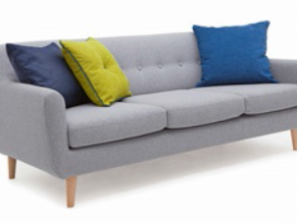 | s o f a | 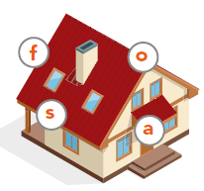
Questions:

 | _ _ _ _ _ _ | 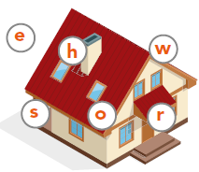

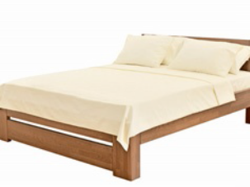 | _ _ _ | 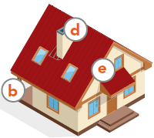

 | _ _ _ _ _ _ _ _ | 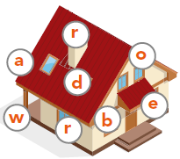
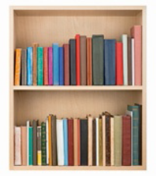 | _ _ _ _ _ _ _ _ | 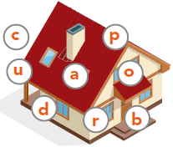
 | _ _ _ _ | 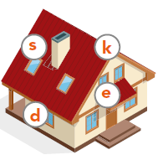

Part 3

Read and choose a word from the box. Write the correct word next to the
numbers 1-5. There is one example.


I love food. I like to go to a fast food restaurant and eat a burger and drink a
strawberry (1)__________ but I also like to eat my mum’s tasty food. She doesn’t
make red meat but she makes (2)________ instead. In the summer I love to eat a
(3)__________ but in the winter I prefer (4) __________ like carrots. I usually eat
fresh (5) ____________ for dessert like an apple or a pear.
Example:
 |    |  |  | 
burger | crisps | milkshake | fruit | mashed potato
 |  |  |  | 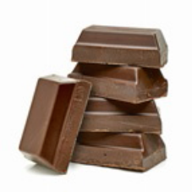
sausages | chicken | salad | vegetables | chocolate

Part 4
Look at the pictures and read the story. Write one-word answers.

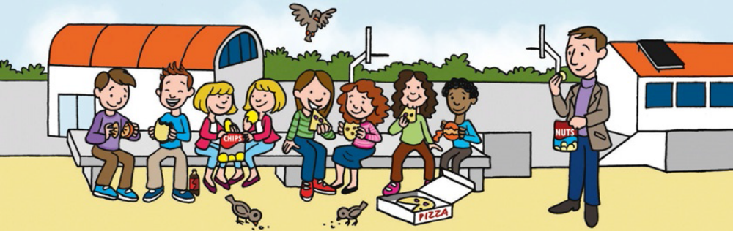

“It’s 5 o’clock, time for tea! Come along to the playground with me,” says the teacher.
“Children eat your tea!” The twins eat a packet of crisps. “Yummy, yummy for our tummy!”
they say. Some children eat healthy snacks like fruit. Others eat a burger or a biscuit.
“Burgers and coke are the best,” says the boy. “Oh no!” says the girl. “Burgers are good
but biscuits are super delicious.”

Examples:
How many birds are there? _ three _____
Where are the children? in the _ playground___
Questions:
- What are the twin sisters eating? _____________________
- Who looks happy? the __________________
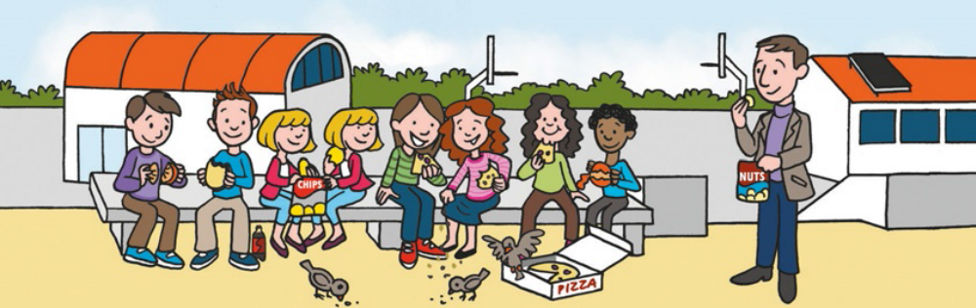

Look at the birds. They like to fly in the sky. They also like to eat tea. What do they want
today? “Children, children! Look at us,” they say. “We are hungry. Please, oh please, can we
have some tea? Is there a biscuit for us?” “Here you are,” says the girl. “Eat and enjoy.”
Then, the bell rings. Time to go back to class. Yipee!

- What is in the box on the floor? a ___________________
- Who is eating a healthy snack? the _________________
- What is the girl between the girls eating pizza holding? a __________________

Marking key:
Test 3 version D – Cambridge-like test
( ) = Acceptable extra words are placed in brackets

/ = A single slash is placed between acceptable
alternative words within an answer

// = A double slash is placed between acceptable
alternative complete answers.

Part 1 – 25 marks  Exercise 1  1 green armchair  2 blue lamp  3 yellow fridge  4 orange cooker  5 brown cupboard  Exercise 2  1 Tuesday – crisps  2 Wednesday – biscuits  3 Thursday – fruit  4 Friday – cereal bars  5 Saturday – pizza | Part 2 – 25 marks  1 shower  2 bed  3 wardrobe  4 cupboard  5 desk  Part 3 – 25 marks  1 milkshake  2 chicken  3 salad  4 vegetables  5 fruit  Part 4 – 25 marks  1 crisps  2 boy  3 pizza  4 teacher  5 biscuit
Note: Listening script – see page 70.

Test 3 version E – alternative/extra test
School |  | Evaluation
Name _____________ Surname _____________ Class: 5th ____  Date _________________________________________, 20 ___  Signatures _____________________/______________________  (Teacher) (Parent/E.E.) |  | ____%  Muito Bom Bom Suficiente  Insuficiente Muito Insuficiente

Listening
- Listen and draw a line. There is one example.
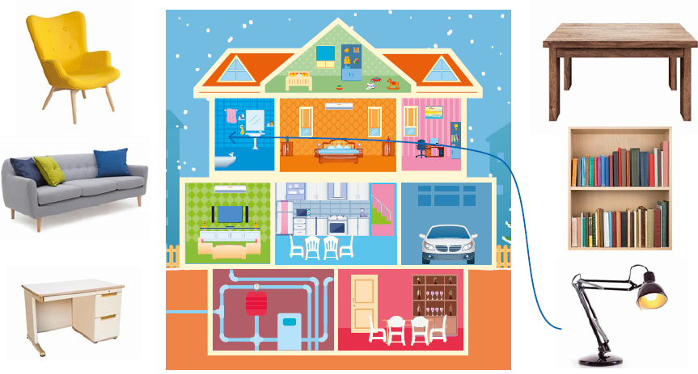

- Listen and circle. There is one example.
 |  |  | 
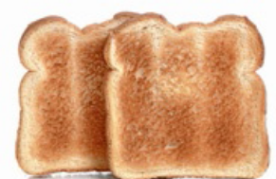 | 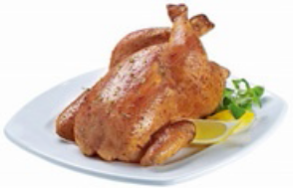 |  | 
 | 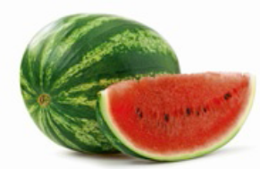 |  | 

Test 3 version E – alternative/extra test
School |  | Evaluation
Name _____________ Surname _____________ Class: 5th ____  Date _________________________________________, 20 ___  Signatures _____________________/______________________  (Teacher) (Parent/E.E.) |  | ____%  Muito Bom Bom Suficiente  Insuficiente Muito Insuficiente

Vocabulary
- Look and draw a line.
a.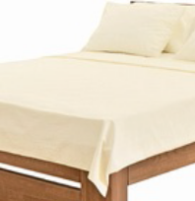 | b.   | c.  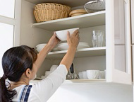 | d.  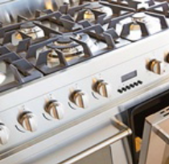 | e.   | f.  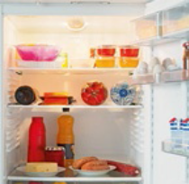
_ _ _ | _ _ _ _ _ _ _ _ | _ _ _ _ _ _ _ _ | _ _ _ _ _ _ | _ _ _ _ _ _ | _ _ _ _ _ _

- Look and write.
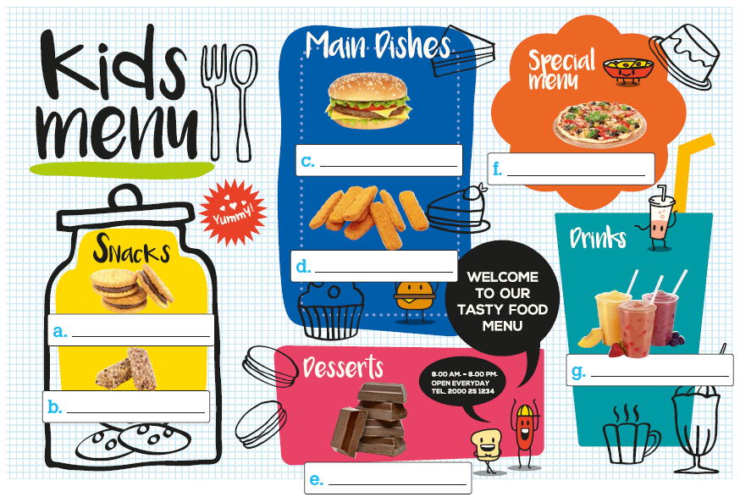

Reading
Read the text.
My house
My name is John and I live in England. This is my house. It’s a big
red brick house.
It has got two floors and an attic. Upstairs, on the first floor, there is
a bathroom and there are three bedrooms. On the ground floor
there is a kitchen, a living room, a dining room, a pantry, a hall and
a toilet. Our study is in the attic. The windows of my house are big
and white. There is a big garden in front of the house and a little
swimming pool in the garden behind the house. My mother loves
flowers and there are lots of pretty flowers in the garden.

- Read and write T (True) or F (False). Correct the false sentences.
There is one example.

- John lives in Wales. John lives in England.____ ________
- His house is small. ________________________________________________________
- On the first floor there is a bathroom. _________________________________________
- There aren’t any bedrooms on the ground floor. ______________________________
- There is a basement in John’s house.______________________________________
- There isn’t a garden. _________________________________________________

- Read and answer the questions.

a. Is there a study in John’s house?
____________________________________________________________________________
b. How many bathrooms are there?
____________________________________________________________________________
c. Where is the kitchen in your house?
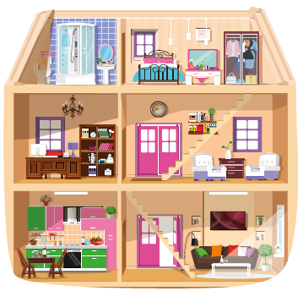
____________________________________________________________________________

Grammar
- Look, read and write the correct form of the
verb there + to be. There is one example.

- There isn’t a basement.
- _____ there a balcony upstairs? _____, there _____.
- _____ there a garden? _____, there _____.
- _____ there a study upstairs? _____, there _____ one.
- There _____ a bathroom in the attic.

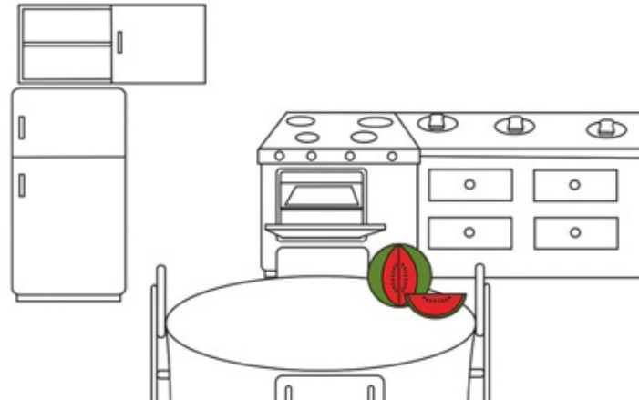
- Read and draw. There is one example.

- The watermelon is on the table.
- The vegetables are between the fridge
and the cooker.
- The carrots are in front of the watermelon.
- The butter is among the toast.
- The chicken is in the oven.
- The jam is in the cupboard, above the fridge.

- Read and complete the sentences with because, but, and or so.
There is one example.

- Children like burgers and pizza.
- I like salad __________ vegetables too.
- I don’t like biscuits __________ they aren’t healthy.
- We are hungry. Let’s eat: chicken __________ pasta!
- I like water __________ I don’t like soft drinks.
- I love nuts __________ my father buys them for me every week.

Writing

- Read and answer about your dream house.

- Is there a swimming pool? ____________________________________________________
- What rooms are there on the first floor? __________________________________________
- Is there an attic? ____________________________________________________________
- How many rooms are there? __________________________________________________
- Are there any gardens? ______________________________________________________


- Look at the picture and describe the children’s lunch today.

_________________________________________________________
_________________________________________________________
_________________________________________________________
_________________________________________________________
_________________________________________________________
_________________________________________________________

Keep calm and work hard! Happy Valentine’s Day!
Your teacher, _________________________________
Answer key and marking criteria
Test 3 version E – answer key and marking criteria

Section | Answer key | Marking criteria
Listening | Question 1: Listen and draw a line.  Answer key: bookcase – attic / sofa – study / desk –  bedroom / armchair – kitchen / table – basement | 5 x 2 = 10  2 marks per correct answer.  Only accept an answer if one line is drawn correctly  per answer.
Listening | Question 2: Listen and circle.  Answer key: 1. sausages 2. chicken 3. pasta  4. vegetables 5. salad | 5 x 2 = 10  2 marks per correct answer.  Only accept an answer if one circle is drawn  correctly per answer.
Vocabulary | Question 1: Look and write.  Answer key: a. bed b. wardrobe c. cupboard  d. cooker e. shower f. fridge | 6 x 1 = 6  1 mark per correct answer.  -0,5 marks if there is a spelling mistake.
Vocabulary | Question 2: Look and write.  Answer key: a. biscuits b. cereal bars c. burger  d. fish fingers e. chocolate f. pizza g. smoothies | 7 x 2 = 14  2 marks per correct answer.  -0,5 marks if there is a spelling mistake.
Reading | Question 1: Read and write T (True) or F (False).  Correct the false sentences.  Answer key: b. F – His house is big. c. T d. T  e. F – There isn’t a basement in John’s house.  f. F – There are two gardens in John’s house. | 5 x 1 = 5 / 3 x 2 = 6  1 mark per correct answer for T and F.  Only accept an answer if T or F is written. 0 marks if  V is used.  False sentences: 2 marks for each accurate  correction.  -0,5 marks if there is a spelling mistake.  -0,5 marks if there is a verb mistake.  -0,5 marks if the word order is incorrect.
Reading | Question 2: Read and answer the questions.  Answer key: a. Yes, there is. b. There is one  bathroom. c. Personal answer | a./b. 2 x 3 = 6  3 marks per correct  answer.  -0,5 marks if there is a  spelling mistake.  -0,5 marks if there is a  verb mistake.  -0,5 marks if the word  order is incorrect. | c. 1 x 3 = 3  3 marks per correct  answer.  -0,5 marks if there is a  spelling mistake.  -0,5 marks if there is a  verb mistake.  -0,5 marks if the word  order is incorrect.
Grammar | Question 1: Look, read and write the correct form  of the verb there + to be.  Answer key: b. Is, No, isn’t c. Is, No, isn’t  d. Is, Yes, is e. is | 10 x 1 = 10  1 mark per correct answer.  -0,5 marks if there is a verb mistake.  -0,5 marks if there is a spelling mistake.
Grammar | Question 2: Read and draw. | 5 x 1 = 5  1 mark per correct answer.  If the right object is drawn in the correct place.
Grammar | Question 3: Read and complete the sentences with  because, but, and or so.  Answer key: b. and c. because d. and e. but  f. so | 5 x 1 = 5  1 mark per correct answer.
Writing | Question 1: Read and answer about your dream  house.  Answer key: Personal answer | 5 x 2 = 10  2 marks per correct answer.  -0,5 marks if the word order is incorrect.  -0,5 marks if there are 2 or more spelling mistakes.  -1 mark if there is a verb mistake.
Writing | Question 2: Look at the picture and describe the  children’s lunch today.  Answer key: This is my lunch box. There is a salad,  ham and some fruit. There are carrots and  vegetables. There are some nuts too. There are soft  drinks. | 5 x 2 = 10  2 marks per correct sentence.  -0,5 marks if the word order is incorrect.  -0,5 marks if there are 2 or more spelling mistakes  in the sentence.  -1 mark if there is a verb mistake.

Listening script
Test 3 version E – listening script

Exercise 1 – Listen and draw a line.
Boy – My best friend has got a new house!
Grandma – A new house? Really?
Boy – Yes. His house is amazing.
Grandma – What is it like?
Boy – Let’s see. The bathroom is upstairs and there is a
lamp in the bathroom, for example.
Grandma – There’s a lamp in the bathroom?
Boy – Yes! It’s really big.
Can you see the line? This is an example. Now you listen
and draw lines.
1.
Grandma – Tell me more about your friend’s amazing
house. Is there a bookcase?
Boy – Yes, grandma! There is a bookcase in the attic.
Grandma – Is there an attic in his house?
Boy – Yes, there is an attic. And there’s a big bookcase in
the attic.
Grandma – And are there any books?
Boys – Yes, grandma, there are lots of books in the
bookcase. My friend loves reading books.
2.
Grandma – Is there a study in your friend’s house?
Boy – Yes! And there is a sofa in the study.
Grandma – A sofa? In the study? Where is the study?
Boy – The study is on the first floor.
Grandma – Great! So, the study is upstairs on the first
floor.
3.
Grandma – Where is your friend’s room?
Boy – It’s upstairs too, near the study. In his bedroom,
there is a desk. He does his homework there.
Grandma – So, his desk is in his bedroom?
Boy – Yes, it’s very big, so I can do my homework there
with him.
Grandma – Of course you can.
4.
Boy – And there is a pretty cool armchair in the kitchen.
Grandma – Where is the kitchen?
Boy – The kitchen is on the ground floor.
Grandma – So, there’s an armchair in the kitchen?
Boy – Yes. My friend’s stepfather reads the newspaper in
the kitchen when his mum cooks dinner.
5.
Grandma – Is there a table?
Boy – Yes. There is a big table in the basement.
Grandma – Basement? There’s a basement too?
Boy – Yes, grandma. It is a big house.
Grandma – What colour is the big table in the basement?
Boy – It’s brown.
Grandma – Your friend’s new house is amazing!

Exercise 2 – Listen and circle.
Boy 1 – I’m hungry. Let’s eat something, Fred.
Fred – I’m hungry too. It’s Saturday and after sports
practice I’m always hungry.
Boy 1 – Me too. Let’s eat some ham!
Fred – Some ham?
Boy 1 – Yes. I love ham. A ham sandwich after practice on
Saturday is always nice.
Fred – Good idea.
Can you see the circle around the picture of ham? This is
an example. Now you try.
1.
Girl – Mum! What’s for lunch? It’s Tuesday and I’m really
hungry!
Mum – We always eat sausages on Tuesday. You know
that!
Girl – Yay! I love sausages. They’re really tasty.
2.
Girl 1 – Ann, look, the school canteen is open. What’s for
lunch today?
Girl 2 – Let’s check the menu. What day is it today?
Girl 1 – Is it Wednesday today?
Girl 2 – Wednesday… here it is! Today’s lunch is chicken!
Yum!
Exercise 2 – Listen and circle.
Boy 1 – I’m hungry. Let’s eat something, Fred.
Fred – I’m hungry too. It’s Saturday and after sports
practice I’m always hungry.
Boy 1 – Me too. Let’s eat some ham!
Fred – Some ham?
Boy 1 – Yes. I love ham. A ham sandwich after practice on
Saturday is always nice.
Fred – Good idea.
Can you see the circle around the picture of ham? This is
an example. Now you try.
1.
Girl – Mum! What’s for lunch? It’s Tuesday and I’m really
hungry!
Mum – We always eat sausages on Tuesday. You know
that!
Girl – Yay! I love sausages. They’re really tasty.
2.
Girl 1 – Ann, look, the school canteen is open. What’s for
lunch today?
Girl 2 – Let’s check the menu. What day is it today?
Girl 1 – Is it Wednesday today?
Girl 2 – Wednesday… here it is! Today’s lunch is chicken!
Yum!
Woman 2 – Let’s go to the supermarket and get some
together then.
5.
Mum – Dinner is ready!
Girl – What’s for dinner today? I’m not very hungry. It’s
Sunday night and I’m tired.
Mum – Yes, I know, so here is a salad for you.
Girl – A salad? That’s a good idea, mum. I really like salads for dinner.

