
Unit 5 What do we love doing and what are we planning?
Test 5 – breakdown

TEST A  Standard | No. of  questions | Types of questions | Marks per  question | Total
Listening  Metas:  L 1, 2, 3, 4, 5 | 2 | 1. Listen and order.  Free time activities (page 114) | 5 x 2 = 10 | 20
Listening  Metas:  L 1, 2, 3, 4, 5 | 2 | 2. Listen and write.  ICT routines (page 122) | 5 x 2 = 10 | 20
Vocabulary  Metas:  ID 8.8 | 2 | 1. Look, read and write Yes or No.  Free time activities (page 118) | 6 x 2 = 12 | 20
Vocabulary  Metas:  ID 8.8 | 2 | 2. Look and write.  Museum routines (page 126) | 8 x 1 = 8 | 20
Reading  Metas:  R 4.1, 4.2, 4.3, 4.5,  4.6 | 2 | 1. Read and write T (True) or F (False). Correct the false sentences.  Sentences related to the text | 5 x 1 = 5  2 x 2,5 = 5 | 20
Reading  Metas:  R 4.1, 4.2, 4.3, 4.5,  4.6 | 2 | 2. Read and answer the questions.  Two comprehension questions about a text and a personal question | 2 x 3 = 6  1 x 4 = 4 | 20
Grammar  Metas: LG 8.11,  8.19, 8.20, 8.21,  8.23, 8.28  Language  awareness | 3 | 1. Read and write the -ing form of the verbs.  Present continuous (pages 116-117) | 5 x 1 = 5 | 20
 | 3 | 2. Read and write the verbs in the present continuous.  Present continuous (pages 116-117, 121) | 10 x 0,5 = 5 | 20
 | 3 | 3. Read and write the verbs in the present simple or the present  continuous.  Present simple and present continuous (pages 128-129) | 10 x 1 = 10 | 20
Writing  Metas: W 5, 6 | 2 | 1. Read and answer about you.  Personal questions | 5 x 2 = 10 | 20
Writing  Metas: W 5, 6 | 2 | 2. Look and describe the picture. | 5 x 2 = 10 | 20
 |  |  |  | 100%

TEST B  Easy-to-correct | No. of  questions | Types of questions | Marks per  question | Total
Listening  Metas:  L 1, 2, 3, 4, 5 | 2 | 1. Listen and order.  Free time activities (page 114) | 5 x 2 = 10 | 20
Listening  Metas:  L 1, 2, 3, 4, 5 | 2 | 2. Listen and write.  ICT routines (page 122) | 5 x 2 = 10 | 20
Vocabulary  Metas:  ID 8.8 | 2 | 1. Look and draw a line.  Free time activities (page 118) | 6 x 2 = 12 | 20
Vocabulary  Metas:  ID 8.8 | 2 | 2. Look and write the missing letters.  Museum routines (page 126) | 8 x 1 = 8 | 20
Reading  Metas:  R 4.1, 4.2, 4.3, 4.5,  4.6 | 3 | 1. Read and write T (True) or F (False).  Sentences related to the text | 5 x 2 = 10 | 20
Reading  Metas:  R 4.1, 4.2, 4.3, 4.5,  4.6 | 3 | 2. Read and answer the questions.  Two comprehension questions about a text and a personal question | 2 x 3 = 6  1 x 4 = 4 | 20
Grammar  Metas: LG 8.11,  8.19, 8.20, 8.21,  8.23, 8.28  Language  awareness | 3 | 1. Read and circle the odd one out.  Present continuous (pages 116-117) | 5 x 1 = 5 | 20
 | 3 | 2. Read and circle the correct verb.  Present continuous (pages 116-117, 121) | 10 x 0,5 = 5 | 20
 | 3 | 3. Read, tick and write: present simple or present continuous?  Present simple and present continuous (pages 128-129) | 4 x 2,5 = 10 | 20
Writing  Metas: W 5, 6 | 2 | 1. Read and answer about you.  Personal questions | 5 x 2 = 10 | 20
Writing  Metas: W 5, 6 | 2 | 2. Look and describe the picture. | 5 x 2 = 10 | 20
 |  |  |  | 100%

TEST C  NEE |  | No. of  questions | Types of questions | Marks per  question | Total
Part I | Listening  Metas:  L 1, 2, 3, 4, 5 | 2 | 1. Listen and order.  Free time activities (page 114) | 4 x 2,5 = 10 | 20
Part I | Listening  Metas:  L 1, 2, 3, 4, 5 | 2 | 2. Listen and match.  ICT routines (page 122) | 5 x 2 = 10 | 20
Part II | Vocabulary  Metas:  ID 8.8 | 2 | 3. Write Yes or No.  Free time activities (page 118) | 5 x 2 = 10 | 20
Part II | Vocabulary  Metas:  ID 8.8 | 2 | 4. Write.  Museum routines (page 126) | 5 x 2 = 10 | 20
Part II | Reading  Metas:  R 4.1, 4.2, 4.3, 4.5, 4.6 | 2 | 5. Write T (True) or F (False).  Sentences related to the text | 4 x 2,5 = 10 | 20
Part II | Reading  Metas:  R 4.1, 4.2, 4.3, 4.5, 4.6 | 2 | 6. Answer.  One comprehension question about a text and a personal question | 1 x 4 = 4  1 x 6 = 6 | 20
 |  |  |  |  | 100%

TEST C  NEE |  | No. of  questions | Types of questions | Marks per  question | Total
Part II | Grammar  Metas: LG 8.11,  8.19, 8.20,  8.21, 8.23, 8.28  Language  awareness | 3 | 7. Write the -ing form of the verbs.  Present continuous (pages 116-117) | 5 x 1 = 5 | 20
Part II |  | 3 | 8. Write the verbs in the present continuous.  Present continuous (pages 116-117, 121) | 8 x 0,5 = 4 | 20
Part II |  | 3 | 9. Write the verbs in the present simple or the present continuous.  Present simple and present continuous (pages 128-129) | 11 x 1 = 11 | 20
Part II | Writing  Metas: W 5, 6 | 2 | 10. Answer about you.  Personal questions | 5 x 2 = 10 | 20
Part II | Writing  Metas: W 5, 6 | 2 | 11. Describe the picture. | 5 x 2 = 10 | 20
 |  |  |  |  | 100%

TEST D  Cambridge-like | No. of  questions | Types of questions | Marks per  question | Total
PART 1  Listening &  Vocabulary  Metas: L 1, 2, 3, 4, 5  ID 8.8 | 2 | 1. Listen and order.  Free time activities (page 114) | 5 x 2,5 = 12,5 | 25
 | 2 | 2. Listen and write.  ICT routines (page 122) | 5 x 2,5 = 12,5 | 25
PART 2  Reading &  Vocabulary  Metas: R 4.3, 4.5,  4.6 ID 8.8 | 1 | Look and read. Write Yes or No.  Free time activities (page 118) | 5 x 5 = 25 | 25
PART 3  Reading,  Vocabulary &  Grammar  Metas: R 4.2, 4.3,  4.6 ID 8.8 LG 8.21 | 1 | Read a text. Choose a word from the box. Write the correct word  next to the numbers 1-5.  ICT routines (page 122) | 5 x 5 = 25 | 25
PART 4  Writing &  Vocabulary  Metas: R 4.1, 4.6  ID 8.8 W 5 | 1 | Read a text. Choose a word from the box. Write the correct word  next to the numbers 1-5.  ICT routines (page 122) | 5 x 5 = 25 | 25
 |  |  |  | 100%

TEST E  Alternative/Extra | No. of  questions | Types of questions |  |  | Marks per  question |  | Total
Listening  Metas:  L 1, 2, 3, 4, 5 | 2 | 1. Listen and colour.  Free time activities (page 118) |  |  | 5 x 2 = 10 |  | 20
Listening  Metas:  L 1, 2, 3, 4, 5 | 2 | 2. Listen and tick.  Museum routines (page 126) |  |  | 5 x 2 = 10 |  | 20
Vocabulary  Metas:  ID 8.8 | 2 | 1. Read, look and draw a line.  Free time activities (page 114) |  |  | 6 x 2 = 12 |  | 20
Vocabulary  Metas:  ID 8.8 | 2 | 2. Look, read and tick.  ICT routines (page 122) |  |  | 8 x 1 = 8 |  | 20
Reading  Metas:  R 4.1, 4.2, 4.3, 4.5,  4.6 | 2 | 1. Read and complete the sentences. Write 1-3 words.  Sentences related to the text |  |  | 5 x 2 = 10 |  | 20
Reading  Metas:  R 4.1, 4.2, 4.3, 4.5,  4.6 | 2 | 2. Read and answer the questions.  Two comprehension questions about a text and a personal question |  |  | 2 x 3 = 6  1 x 4 = 4 |  | 20
Grammar  Metas:  LG 8.11, 8.19, 8.20,  8.21, 8.23, 8.28  Language awareness | 3 | 1. Read and write the verbs in the present continuous.  Present continuous (pages 116-117) |  |  | 5 x 1 = 5 |  | 20
 | 3 | 2. Read and write into, onto or to.  Prepositions of movement (page 126) |  |  | 5 x 1 = 5 |  | 20
 | 3 | 3. Read and circle the correct verbs in the present simple or the  present continuous.  Present simple and present continuous (pages 128-129) |  |  | 10 x 1 = 10 |  | 20
Writing  Metas: W 5, 6  Language awareness | 2 | 1. Read and answer about you.  Personal questions |  |  | 5 x 2 = 10 |  | 20
Writing  Metas: W 5, 6  Language awareness | 2 | 2. Read and write a description of a school trip. |  |  | 5 x 2 = 10 |  | 20
 |  |  |  |  |  |  | 100%
School |  |  |  | Evaluation
Name _____________ Surname _____________ Class: 5th ____  Date _________________________________________, 20 ___  Signatures _____________________/______________________  (Teacher) (Parent/E.E.) |  |  |  | ____%  Muito Bom Bom Suficiente  Insuficiente Muito Insuficiente
Test 5 version A – standard test
Listening
- Listen and order. There is one example.

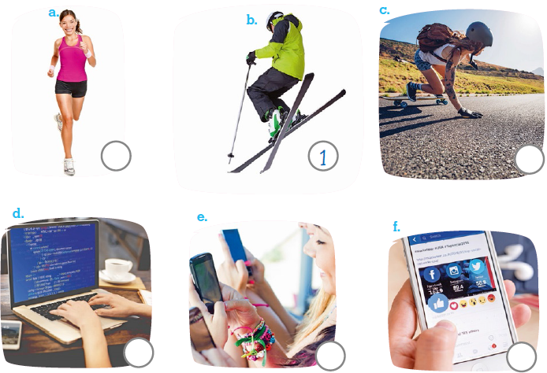

- Listen and write. There is one example.

- Jill and Tony are selecting information about a museum.
- Sam is _________________________ for a school project.
- Anna is _________________________ for her test.
- My parents are _________________________ in the newspaper.
- I’m _________________________ to e-mail my teacher.
- Mary is _________________________ on a job’s website.

School |  | Evaluation
Name _____________ Surname _____________ Class: 5th ____  Date _________________________________________, 20 ___  Signatures _____________________/______________________  (Teacher) (Parent/E.E.) |  | ____%  Muito Bom Bom Suficiente  Insuficiente Muito Insuficiente

Test 5 version A – standard test
Vocabulary
- Look, read and write Yes or No.

- He’s  programming. |  | - He is  singing. |  | - She is  taking  photos. |  | - He is  cooking. |  | - She is  going to theatre. |  | - We are  sightseeing.
 |  |  |  |  |  |  |  |  |  | 

- Look and write.

a.   |  | b.   |  | c.   |  | d.  
e.   |  | f.   |  | g.   |  | h.  

Reading
Read the text.

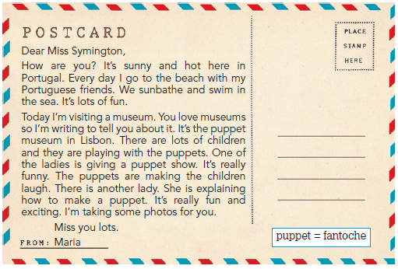

- Read and write T (True) or F (False). Correct the false sentences.

- Maria is in London.
______________________________________________________________________ 
- She doesn’t like going to the beach.
________________________________________________________________
- Today she is swimming in the sea.
________________________________________________________________
- The museum is in Lisbon.
________________________________________________________________
- The puppet show is very funny.
________________________________________________________________

- Read and answer the questions.

- What’s the weather like? _____________________________________________________
- Who is playing with the puppets? _______________________________________________
- What do you do on holiday? ___________________________________________________

Grammar
- Read and write the -ing form of the verbs. There is one example.
- go going____ d. swim ______________
- write ______________ e. stop ______________
- study ______________ f. watch ______________

- Read and write the verbs in the present continuous. There is one example.

- I am writing (write) a postcard to my family.
- __________ your mother __________ (listen) to music at the moment?
- What are you __________ (do)? I _______ _______ (chat) online with my friends.
- Look! ________ they _______ (study) English? No, ________ they _____ _____. They
(register) on The British Museum’s website.

- Read and write the verbs in the present simple or the present continuous.
There are two examples.

- They usually play computer games but at the moment they __________ (play)
console games.
- ‘Look! That’s my sister! She __________ (read) the signs now.’
- Lucy sometimes __________ (hang out) with her friends at the park.
- ‘ Are we __________ (have) an English lesson now?’
- Tom __________ (not go) to the cinema every day.
- ‘__________ you __________ (study) at the weekend?’

Writing

- Read and answer about you.

- How are you feeling today? ___________________________________________________
- What is your teacher doing? __________________________________________________
- What do you like doing at the weekend? _________________________________________
- Is there anything you don’t like doing? ___________________________________________
- Is there a dance club at your school? ____________________________________________

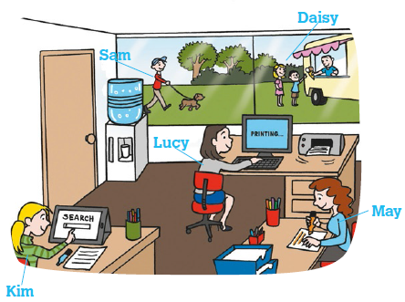
- Look and describe the picture. What are they doing?
____________________________________________
____________________________________________
____________________________________________
____________________________________________
____________________________________________

Keep calm and work hard!
Happy summer holidays!
Your teacher, ____________________________

Answer key and marking criteria
Test 5 version A – answer key and marking criteria

Section | Answer key | Marking criteria
Listening | Question 1: Listen and order.  Answer key: a. 3 c. 5 d. 2 e. 4 f. 6 | 5 x 2 = 10  2 marks per correct answer.  Only accept an answer if one number is written  correctly per answer.
Listening | Question 2: Listen and write.  Answer key: b. printing a/the file c. underlining  information d. highlighting information e. saving  the file f. filling in the registration form | 5 x 2 = 10  2 marks per correct answer.  -0,5 marks if there is a spelling mistake.
Vocabulary | Question 1: Look, read and write Yes or No.  Answer key: a. No b. No c. Yes d. Yes e. No  f. Yes | 6 x 2 = 12  2 marks per correct answer.  -0,5 marks if there is a spelling mistake.
Vocabulary | Question 2: Look and write.  Answer key: a. buy a ticket b. closed c. press  the button d. wait in a queue e. open f. choose  the floor g. push h. buy a souvenir | 8 x 1 = 8  1 mark per correct answer.  -0,5 marks if there are one/two spelling mistakes.  Automatically get 0 if there are 2 or more spelling  mistakes.
Reading | Question 1: Read and write T (True) or F (False).  Correct the false sentences.  Answer key: a. False – Maria is in Lisbon.  b. False – She likes going to the beach. c. True  d. True e. True | 2 x 2,5 = 5 / 5 x 1 = 5  1 mark per correct answer for T and F.  Only accept an answer if T or F is written.  0 marks if V is written.  False sentences: 2,5 marks for each accurate  correction.  -0,5 marks if there is a spelling mistake.  -0,5 marks if there is a verb mistake.  -0,5 marks if the word order is incorrect.
Reading | Question 2: Read and answer the questions.  Answer key: a. It’s sunny and hot. b. The children  are playing with the puppets. c. Personal answer | a./b. 2 x 3 = 6  3 marks per correct  answer.  -0,5 marks if there is a  spelling mistake.  -0,5 marks if there is a  verb mistake.  -0,5 marks if the word  order is incorrect. | c. 1 x 4 = 4  4 marks per correct  answer.  -0,5 marks if there is a  spelling mistake.  -0,5 marks if there is a  verb mistake.  -0,5 marks if the word  order is incorrect.
Grammar | Question 1: Read and write the -ing form of the  verbs.  Answer key: b. writing c. studying d. swimming  e. stopping f. watching | 5 x 1 = 5  1 mark per correct answer.  Automatically get 0 if there is a mistake related to  the spelling rules of the verb.
Grammar | Question 2: Read and write the verbs in the  present continuous.  Answer key: b. Is, listening c. doing, am chatting  d. Are, studying, aren’t, are registering | 10 x 0,5 = 5  0,5 marks per correct answer.  Only accept an answer if the verb to be and the  -ing form are conjugated/written properly.
Grammar | Question 3: Read and write the verbs in the  present simple or the present continuous.  Answer key: a. are playing b. is reading  c. hangs out d. having e. doesn’t go  f. Do, study | 10 x 1 = 10  1 mark per correct answer.  Each verb/part of the verb is worth 1 mark.  Only accept an answer if verbs are conjugated/  written properly.  -0,5 marks if there is a spelling mistake.
Writing | Question 1: Read and answer about you.  Answer key: Personal answer | 5 x 2 = 10  2 marks per correct answer.  -0,5 marks if the word order is incorrect.  -0,5 marks if there are 2 or more spelling mistakes.  -1 mark if there is a verb mistake.
Writing | Question 2: Look and describe the picture. What  are they doing?  Answer key: Kim is surfing online. Lucy is printing a  file. May is highlighting information for school. Sam  is walking his dog. Daisy is waiting in a queue to  buy an ice cream. | 5 x 2 = 10  2 marks per correct sentence.  -0,5 marks if the word order is incorrect.  -0,5 marks if there are 2 or more spelling mistakes  in the sentence.  -1 mark if there is a verb mistake.

Listening script
Test 5 version A – listening script

Exercise 1 – Listen and order.
1.
Woman – What’s your name and what do you like doing in
your free time?
Man – I’m Jack and my favourite hobby is skiing.
Woman – Do you like snow sports then?
Man – Yes. I really like snow sports and skiing is my
favourite. How about you? Do you like skiing?
Woman – No. It’s too cold for me. Hee, hee.
Can you see the number one under the picture of the
man skiing? This is an example. Now, you try.
2.
Boy – Hi. My name is Nick.
Girl – Hi Nick. Wow! What are you doing?
Boy – I’m programming a new computer game!
Girl – I like games! Programming looks difficult! There are
so many numbers and symbols!
Boy – Well, programming is like Maths! It’s really cool.
3.
Girl 1 – What’s your name? What do you like doing on
Saturday morning?
Girl 2 – I’m Ann and I love jogging on Saturday morning.
Girl 1 – How early do you go jogging?
Girl 2 – I go very early when the park is quiet.
Girl 1 – That sounds very relaxing. Can I go with you on
Saturday?
4.
Girl 1 – Hello girls! You look busy now! What are you
doing?
Girl 2 – We’re chatting with our friends online.
Girl 1 – What are you chatting about?
Girl 2 – The Shawn Mendes concert on Saturday. Do you
want to come?
5.
Boy – Hi. Is that a new skateboard?
Girl – Yes, it’s my birthday present. I love skateboarding.
Boy – I don’t like skateboarding. It’s too difficult.
Girl – No, it’s not! It’s super fun. I can teach you!
Boy – Ok! I can try, but I’m not sure that I can do it.
6.
Woman – Jack, I need your help.
Jack – Now? I’m surfing the net now.
Woman – Great, I need your help online.
Jack – Ok. What do you need to know?
Woman – Can you find information about Madame
Tussauds, in London? How expensive are the tickets?
Jack – Wait. I’m surfing online to find out. Oh, here it is!
Tickets are thirty-nine pounds!
Woman – Oh, that’s really expensive! Thank you!

Exercise 2 – Listen and write.
Man – Hi Jill. Hi Tony. What are you doing?
Jill – Hi! We’re selecting information about a museum.
Tony – Yes. There is a school trip to a museum this week
and this is our homework.
Man – What information are you selecting?
Jill – The price of the tickets and the opening times.
Man – Very good.
Can you see ’selecting information’ written in a? This is an
example. Now you try.
1.
Mother – Hi Sam. What’s that?
Sam – Hi mum. This is my school project. I’m printing the
file now.
Mother – What is your project about?
Sam – It’s about my dream job. I’m printing it now.
Mother – Well done.
2.
Lucy – What are you doing, Anna?
Anna – I’m underlining the information for the test.
Lucy – Why are you doing that?
Anna – Well, first I write everything that is important and
then I underline the really important ideas.
Lucy – That’s a good idea.
3.
Charlie – Mum! Dad! What are you doing?
Mum – We are highlighting information in the newspaper.
Charlie – What about?
Dad – We’re looking for houses in the newspaper so we’re
highlighting the ones we like.
Charlie – That’s great! Let’s see… Oh, I like this one!
4.
Father – What are you doing, John?
John – Hi dad. I’m saving this file.
Father – What file is that?
John – It’s my History homework. I need to send it to my
teacher, but I need to save it first.
Father – Yes, that’s a good idea.
5.
Jack – Hi Mary.
Mary – Hi Jack.
Jack – What are you doing?
Mary – I’m filling in the registration form on this website.
Jack – What website?
Mary – It’s a jobs website. First, I need to fill in the
website’s registration form. I want to be a hairdresser!
Jack – What a great idea. I need a haircut.
Mary – Hee, hee!

School |  | Evaluation
Name _____________ Surname _____________ Class: 5th ____  Date _________________________________________, 20 ___  Signatures _____________________/______________________  (Teacher) (Parent/E.E.) |  | ____%  Muito Bom Bom Suficiente  Insuficiente Muito Insuficiente
Test 5 version B – easy-to-correct test
Listening
- Listen and order. There is one example.

- Listen and write. There is one example.

- Jill and Tony are selecting information about a museum.
- Sam is _________________________ for a school project.
- Anna is _________________________ for her test.
- My parents are _________________________ in the newspaper.
- I’m _________________________ to e-mail my teacher.
- Mary is _________________________ on a job’s website.

School  Test 5 version B – easy-to-correct test |  | Evaluation
Name _____________ Surname _____________ Class: 5th ____  Date _________________________________________, 20 ___  Signatures _____________________/______________________  (Teacher) (Parent/E.E.) |  | ____%  Muito Bom Bom Suficiente  Insuficiente Muito Insuficiente
Vocabulary
- Look and draw a line.
singing | taking a  photo |  | sightseeing | cooking |  | writing a  blog | dancing

- Look and write the missing letters.

a. |  | b. |  | c. |  | d.
b _ _ a _ _ _ k_ _ |  | c _ _ _ _ _ |  | _ _ _ l |  | w _ _ _ in _ _ _ _ _ _
e. |  | f. |  | g. |  | h.
o _ _ _ |  | c _ _ _ _ _ a _ _ _ _ _ |  | p _ _ _ |  | b _ _ a _ _ _ _ _ _ _ _

Reading
Read the text.

- Read and write T (True) or F (False).

- Maria is in London. _________________
- She doesn’t like going to the beach. _________________
- Today she is swimming in the sea. _________________
- The museum is in Lisbon. _________________
- The puppet show is very funny. _________________

- Read and answer the questions.

- What’s the weather like?
It’s _________________ and _________________.
- Who is playing with the puppets?
The _________________ are playing with the puppets.
- What do you do on holiday?
I ____________________________________________.

Grammar
- Read and circle the odd one out. There is one example.

- writing / making / taking / watching
- playing / studying / lying / crying
- crying / jogging / running / swimming
- stopping / speaking / doing / listening
- tying / lying / dying / crying
- chatting / programming / seeing / skiing

- Read and circle the correct verb. There is one example.

- I am writing / are writing a postcard to my family.
- Is / Are your mother listening / listen to music at the moment?
- What are you do / doing? I am chatting / is chatting online with my friends.
- Look! Is / Are they studying / study English? No, they isn’t / aren’t. They are
registering / is registering on The British Museum’s website.
- Ann is relaxing / are relaxing at the park now.
- I is listening / am listening to podcasts.

- Read, tick and write: present simple or present continuous? There is one example.

- They usually play computer games.
are playing | play | plays
- At the moment they ____________ console games.
are playing | play | plays
- Lucy sometimes ____________ with her friends at the park.
hangs out | is hanging out | are hanging out
- Tom ____________ to the cinema every day.
isn’t going | aren’t going | doesn’t go
- ’ ____________ you ____________ at the weekend?’
Do / study | Are / studying | Does / study

Writing

- Read and answer about you.

- What’s the weather like today? __________________________________
- What is your teacher doing now? ________________________________
- Do you like surfing online? _____________________________________
- What’s your favourite weekend routine? ___________________________
- Are you feeling happy today? ___________________________________
- Look and describe the picture.
What are they doing?

Kim ____________ online.
Lucy ____________ for school.
May ____________ at the moment.
Sam ____________ his dog outside.
Daisy ____________ in a queue to buy
an ice cream.

Keep calm and work hard! Happy summer holidays!
Your teacher, ________________________________

Answer key and marking criteria
Test 5 version B – answer key and marking criteria

Section | Answer key | Marking criteria
Listening | Question 1: Listen and order.  Answer key: a. 3 c. 5 d. 2 e. 4 f. 6 | 5 x 2 = 10  2 marks per correct answer.  Only accept an answer if one number is written  correctly per answer.
Listening | Question 2: Listen and write.  Answer key: b. printing the file c. underlining  information d. highlighting information  e. saving the file f. filling in the registration form | 5 x 2 = 10  2 marks per correct answer.
Vocabulary | Question 1: Look and draw a line.  Answer key: a. writing a blog b. dancing  c. taking a photo d. cooking e. singing  f. sightseeing | 6 x 2 = 12  2 marks per correct answer.  Only accept an answer if one line is drawn correctly  per answer.
Vocabulary | Question 2: Look and write the missing letters.  Answer key: a. buy a ticket b. closed c. pull  d. wait in a queue e. open f. choose a floor  g. push h. buy a souvenir | 8 x 1 = 8  1 mark per correct answer.  -0,5 marks if there is a spelling mistake.  Automatically get 0 if there are 2 or more spelling  mistakes.
Reading | Question 1: Read and write T (True) or F (False).  Answer key: a. False b. False c. True d. True  e. True | 5 x 2 = 10  1 mark per correct answer for T and F.  Only accept an answer if T or F is written.  0 marks if V is used.
Reading | Question 2: Read and answer the questions.  Answer key: a. It’s sunny and hot. b. The children  are playing with the puppets. c. Personal answer | a./b. 2 x 3 = 6  3 marks per correct  answer.  -0,5 marks if there is a  spelling mistake.  -0,5 marks if there is a  verb mistake.  -0,5 marks if the word  order is incorrect. | c. 1 x 4 = 4  4 marks per correct  answer.  -0,5 marks if there is a  spelling mistake.  -0,5 marks if there is a  verb mistake.  -0,5 marks if the word  order is incorrect.
Grammar | Question 1: Read and circle the odd one out.  Answer key: b. lying c. crying d. stopping  e. crying f. seeing | 5 x 1 = 5  1 mark per correct answer.  Only accept an answer if there is only one circle per  answer.
Grammar | Question 2: Read and circle the correct verb.  Answer key: b. Is, listening c. doing, am chatting  d. Are, studying, aren’t, are registering  e. is relaxing f. am listening | 10 x 0,5 = 5  0,5 marks per correct answer.  Only accept an answer if there is only one circle per  answer.
Grammar | Question 3: Read, tick and write: present simple or  present continuous?  Answer key: b. are playing c. hangs out  d. doesn’t go e. Do / study | 4 x 2,5 = 10  2,5 marks per correct answer.  Only accept an answer if there is only a tick per  answer.
Writing | Question 1: Read and answer about you.  Answer key: Personal answer | 5 x 2 = 10  2 marks per correct answer.  -0,5 marks if the word order is incorrect.  -0,5 marks if there are 2 or more spelling mistakes.  -1 mark if there is a verb mistake.
Writing | Question 2: Look and describe the picture. What  are they doing?  Answer key: Kim is surfing online. Lucy is printing a  file for school. May is highlighting information at  the moment. Sam is walking his dog. Daisy is  waiting in a queue to buy an ice cream. | 5 x 2 = 10  2 marks per correct sentence.  -0,5 marks if the word order is incorrect.  -0,5 marks if there are 2 or more spelling mistakes  in the sentence.  -1 mark if there is a verb mistake.

Note: Listening script – see page 128.

School  Test 5 version C – NEE test |  | Evaluation
Name _____________ Surname _____________ Class: 5th ____  Date _________________________________________, 20 ___  Signatures _____________________/______________________  (Teacher) (Parent/E.E.) |  | ____%  Muito Bom Bom Suficiente  Insuficiente Muito Insuficiente
Part I
- Listen and order.
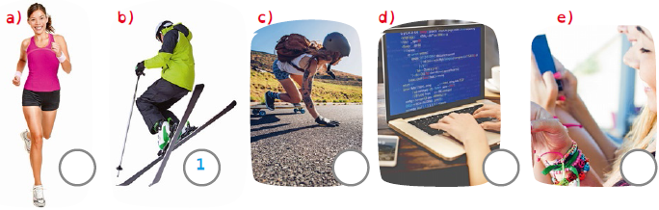

 | Boy: Hi. My name is Nick.  Girl: Hi Nick. Wow! What are you doing?  Boy: I’m programming a new computer game!  Girl: I like games! Programming looks difficult! There are so many  numbers and symbols!  Boy: Well, programming is like Maths! It’s really cool.

 | Girl 1: What’s your name? What do you like doing on Saturday morning?  Girl 2: I’m Ann and I love jogging on Saturday morning.  Girl 1: How early do you go jogging?  Girl 2: I go very early when the park is quiet.  Girl 1: That sounds very relaxing. Can I go with you on Saturday?

 | Girl 1: Hello girls. You look busy now! What are you doing?  Girl 2: We’re chatting with our friends online.  Girl 1: What are you chatting about?  Girl 2: The Shawn Mendes concert on Saturday. Do you want to come?

 | Boy: Hi. Is that a new skateboard?  Girl: Yes, it’s my birthday present. I love skateboarding.  Boy: I don’t like skateboarding. It’s too difficult.  Girl: No, it’s not! It’s super fun. I can teach you!  Boy: Ok! I can try, but I’m not sure that I can do it.

- Listen and match ( ).
Jill and  Tony are | Sam is | Anna is | My parents  are | I’m | Mary is

highlighting  information. | filling in the  registration  form. | selecting  information. | saving the  file. | underlining  information. | printing  the file.

Part II
- Write Yes or No.

- He’s  programming. | - He is  singing. | - She is  taking  photos. | - He is  cooking. | - She is  going to the theatre. | - We are  sightseeing.
No

- Write.

a) |  | b) |  | c) |  | d) |  | e) |  | f)
buy a  ticket |  | c _ _ _ _ _ |  | _ _ _ l |  | w _ _ _ in _ _ _ _ _ _ |  | o _ _ _ |  | c _ _ _ _ _ a f _ _ _ _

1  2  3  4  5  6  7  8  9  10 | Dear Miss Symington,  How are you? It’s sunny and hot here in Portugal. Every day I go to the beach with  my Portuguese friends. We sunbathe and swim in the sea. It’s lots of fun.  Today I’m visiting a museum. You love museums so I’m writing to tell you about it.  It’s the puppet museum in Lisbon. There are lots of children and they are playing  with the puppets. One of the ladies is giving a puppet show. It’s really funny. The  puppets are making the children laugh. There is another lady. She is explaining how  to make a puppet. It’s really fun and exciting. I’m taking some photos for you.  Miss you lots.  Maria

- Write T (True) or F (False).

 |  | True | False
a) | Maria is in London. |  | F
b) | She doesn’t like going to the beach.
c) | Today she is swimming in the sea.
d) | The museum is in Lisbon.
e) | The puppet show is very funny.

- Answer.

a) What’s the weather like?

b) What do you do on holiday?

- Write the -ing form of the verbs.

 | go | _Going__ |  | - swim | ________
 | write | ________ |  | - stop | ________
 | study | ________ |  | - watch | ________

- Write the verbs in the present continuous.

 | I |  | (write) a postcard to my family.

 |  | your mother |  | (listen) to music at the moment?

 | What are you |  | (do)? I |  | (chat) online with my friends.

 | Look! |  | they |  | (study) English? No, they |  | .

 | They |  | (register) on The British Museum’s website.

- Write the verbs in the present simple or the present continuous.

 | They usually | play | (play) computer games but at the moment they

(play) console games.

 | ’Look! That’s my sister! She |  | (read) the signs now.’

 | Lucy sometimes |  | (hang out) with her friends at the park.

 | ’ |  | we |  | (have) an English lesson now?’

 | Tom |  | (not go) to the cinema every day.

 | ’ |  | you |  | (study) at the weekend?’

- Answer about you.

How are you feeling today?

What is your teacher doing?

What do you like doing at the weekend?

Is there anything you don’t like doing?

Is there a dance club at your school?
- Describe the picture. What are they doing?

a) Kim |  | online.

b) Lucy |  | a file.

c) May |  | info for school.

d) Sam |  | his dog.

e) Daisy |  | to buy an
ice cream.

Answer key and marking criteria
Test 5 version C – answer key and marking criteria

Section |  | Answer key | Marking criteria
Part I | (Listening) | Question 1: Listen and order.  Answer key: a) 3 c) 5 d) 2 e) 4 | 4 x 2,5 = 10  2,5 marks per correct answer.  Only accept an answer if one number is written  correctly per answer.
Part I | (Listening) | Question 2: Listen and match.  Answer key: Sam is printing the file. / Anna is  underlining information. / My parents are  highlighting information / I’m saving the file. / Mary  is filling in the registration form. | 5 x 2 = 10  2 marks per correct answer.
Part II | (Vocabulary) | Question 3: Write yes or no.  Answer key: b) No c) Yes d) Yes e) No f) Yes | 5 x 2 = 10  2 marks per correct answer.  -0,5 marks if there is a spelling mistake.
Part II | (Vocabulary) | Question 4: Write.  Answer key: b) closed c) pull d) wait in a queue  e) open f) choose a floor | 5 x 2 = 10  2 marks per correct answer.  -0,5 marks if there are one/two spelling mistakes.  Automatically get 0 if there are 2 or more spelling  mistakes.
Part II | (Reading) | Question 5: Write T (True) or F (False).  Answer key: b) False c) True d) True e) True | 4 x 2,5 = 10  2,5 marks per correct answer for writing T and F.  Only accept an answer if T or F is written.  0 marks if V is written.
Part II | (Reading) | Question 6: Answer.  Answer key: a) It’s sunny and hot.  b) Personal answer | a. 1 x 4 = 4  4 marks per correct  answer.  -0,5 marks if there is a  spelling mistake.  -0,5 marks if there is a  verb mistake.  -0,5 marks if the word  order is incorrect. | b. 1 x 6 = 6  6 marks per correct  answer.  -0,5 marks if there is a  spelling mistake.  -0,5 marks if there is a  verb mistake.  -0,5 marks if the word  order is incorrect.
Part II | (Grammar) | Question 7: Write the -ing form of the verbs.  Answer key: b) writing c) studying d) swimming  e) stopping f) watching | 5 x 1 = 5  1 mark per correct answer.  -0,5 marks if there is a spelling mistake, that is not  related to the spelling rules of the verb.  Automatically get 0 if there is a mistake related to  the spelling rules of the verb.
Part II | (Grammar) | Question 8: Write the verbs in the present  continuous.  Answer key: b) Is, listening c) doing, am chatting  d) Are, studying, aren’t e) are registering | 8 x 0,5 = 4  0,5 marks per correct answer.  Only accept an answer if the verb to be and the  -ing form are conjugated/written properly.
Part II | (Grammar) | Question 9: Write the verbs in the present simple  or the present continuous.  Answer key: a) are playing b) is reading  c) hangs out d) having e) doesn’t go  f) Do, study | 11 x 1 = 11  1 mark per correct answer.  Each verb/part of the verb is worth 1 mark.  Only accept an answer if verbs are conjugated/  written properly.  -0,5 marks if there is a spelling mistake.
Part II | (Writing) | Question 10: Answer about you.  Answer key: Personal answer | 5 x 2 = 10  2 marks per correct answer.  -0,5 marks if the word order is incorrect.  -0,5 marks if there are 2 or more spelling mistakes.  -1 mark if there is a verb mistake.
Part II | (Writing) | Question 11: Describe the picture. What are they  doing?  Answer key: a) Kim is surfing online. b) Lucy is  printing a file. c) May is highlighting information  for school. d) Sam is walking his dog.  e) Daisy is waiting in a queue to buy an ice cream. | 5 x 2 = 10  2 marks per correct sentence.  -0,5 marks if the word order is incorrect.  -0,5 marks if there are 2 or more spelling mistakes.  -1 mark if there is a verb mistake.

Note: Students with Specific Learning Disorders may benefit from different marking criteria, namely as far as spelling mistakes are
concerned.

Note: Listening script – see page 128.

School  Test 5 version D – Cambridge-like test |  | Evaluation
Name _____________ Surname _____________ Class: 5th ____  Date _________________________________________, 20 ___  Signatures _____________________/______________________  (Teacher) (Parent/E.E.) |  | ____%  Muito Bom Bom Suficiente  Insuficiente Muito Insuficiente
Part 1
- Listen and order. There is one example.

- Listen and write. There is one example.

- Jill and Tony are selecting information about a museum.
- Sam is _________________________ for a school project.
- Anna is _________________________ for her test.
- My parents are _________________________ in the newspaper.
- I’m _________________________ to e-mail my teacher.
- Mary is _________________________ on a job’s website.

Part 2

- Look and read. Write Yes or No. There are two examples.

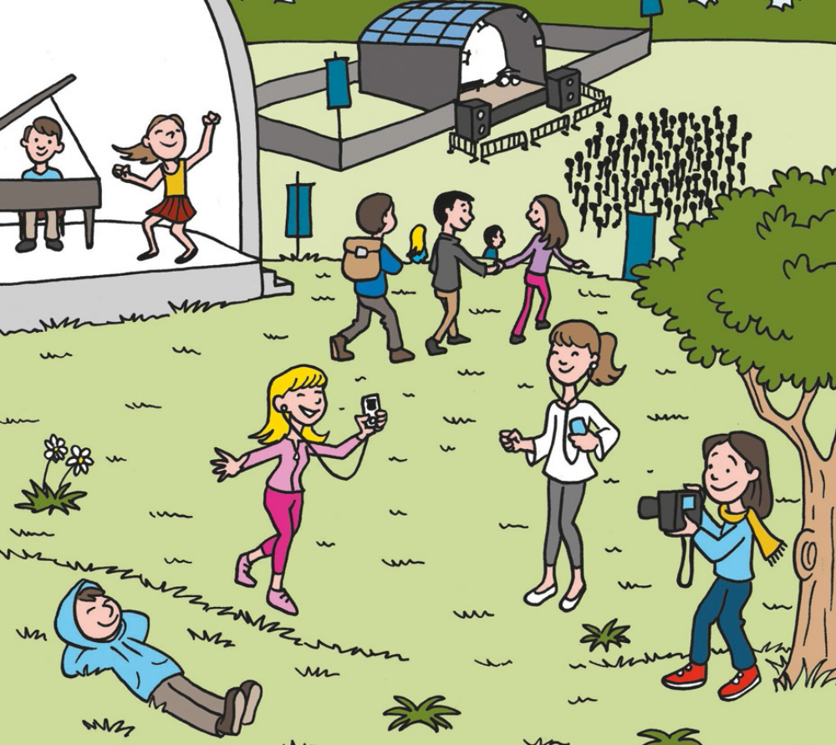

Examples:
The girls are wearing leggings. They are listening to podcasts. _ Yes ______
The girl is wearing a scarf. She is walking the dog. _ No________
Questions:
- There is a boy singing in the park. _____________________
- The people are going to the theatre. _____________________
- There is a girl standing next to a tree. She is taking photos. _____________________
- The boy is wearing a blue hoodie. He is relaxing. _____________________
- There is a girl wearing a red skirt. She is dancing. _____________________

Part 3

Read a text. Choose a word from the box. Write the correct word next to the
numbers 1-5. There is one example.


Today it is Sunday. I’m planning my summer holidays today. I’m surfing different websites at
the moment. I’m doing research to choose a great place.
Let’s go to Italy! I’m looking for important information for my holiday. I’m (1)______________
and pasting it in a document to show my family! I’m (2) ______________ in pink so that
they can easily see the important information. I’m also (3) ______________ the file
on my computer so that I can see it later. Now, I’m booking our hotel so I’m
(4) ______________ on the hotel’s website and I’m (5) ______________ the registration
form. They need my name and address so I can book our hotel. Italy is a fantastic place. We
are going to love our holiday there!

Example:
 |  |  |  | 
doing  research | pasting  information | saving  (the file) | surfing online | choosing a  destination
 |  |  |  | 
highlighting  information | printing the  file | filling in (the  registration  form) | copying  information | registering  (on a website)

Part 4
Look at the pictures and read the story. Write one-word answers.
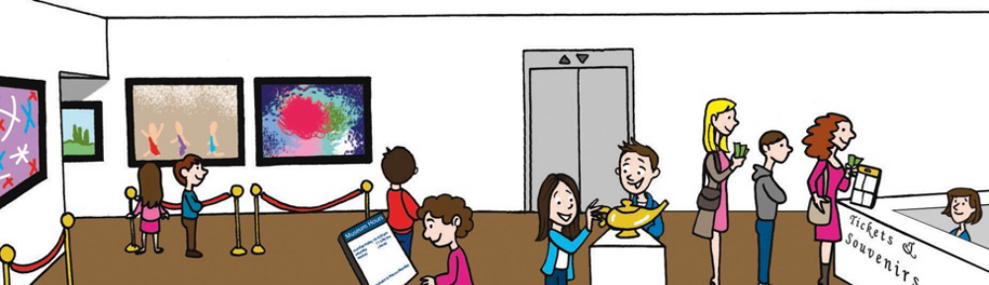

It’s the end of the school year and we are visiting a museum today. The teacher is standing
in a queue but we are in the entrance of a museum. We are feeling very excited so we are
looking around. The teacher says museums are magical places. Is this true? I can see
paintings on the wall and an old lamp on a table. Do you think it’s magical?

Examples:
Where are the children? in a museum_____
How are they feeling? _ excited______
Questions:
- What is the teacher doing? waiting in a ____________
- How many paintings are there? there are _____________
- What is the girl with the curly brown hair doing? reading the ____________
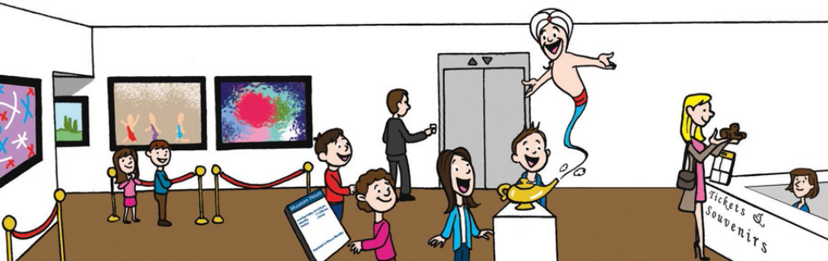

“Welcome to our museum! What do you want to do today? Your wish is my command.”
“We want to see your museum!” say the children. “We want to see something magical!”
says Ann. “Then, go to the first floor and start your visit. See you later!” says the genie.

- What is the man doing? calling a ______________
- The visit starts on the _________________ floor

Marking key:
Test 5 version D – Cambridge-like test
( ) = Acceptable extra words are placed in brackets

/ = A single slash is placed between acceptable
alternative words within an answer

// = A double slash is placed between acceptable
alternative complete answers.

Part 1 – 25 marks  Exercise 1  a. 3  c. 5  d. 2  e. 4  f. 6  Exercise 2  b. printing the file  c. underlining information  d. highlighting information  e. saving the file  f. filling in the registration form | Part 2 – 25 marks  1 No  2 No  3 Yes  4 Yes  5 Yes  Part 3 – 25 marks  1 copying information  2 highlighting information  3 saving  4 registering  5 filling in  Part 4 – 25 marks  1 queue  2 four (paintings on the wall)  3 signs  4 lift  5 first / 1st
Note: Listening script – see page 128.

School  Test 5 version E – alternative/extra test |  | Evaluation
Name _____________ Surname _____________ Class: 5th ____  Date _________________________________________, 20 ___  Signatures _____________________/______________________  (Teacher) (Parent/E.E.) |  | ____%  Muito Bom Bom Suficiente  Insuficiente Muito Insuficiente

Listening
- Listen and colour. There is one example.

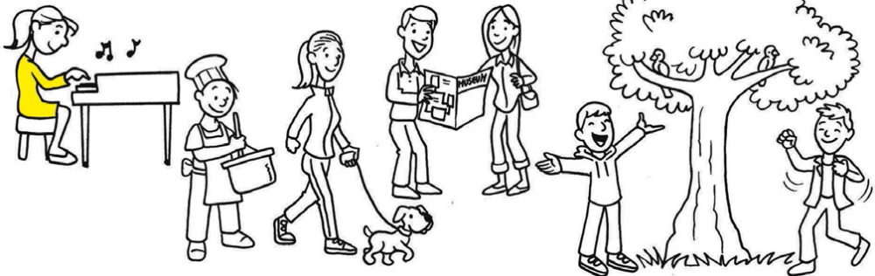

- Listen and circle. There is one example.

 |  |  | 1. |  |  | 2.
a. | b. | c. | a. | b. | c. | a. | b. | c.
 |  |  |  |  |  |  | 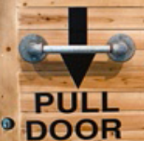 | 
3. |  |  | 4. |  |  | 5.
a. | b. | c. | a. | b. | c. | a. | b. | c.
 |  |  |  |  |  |  |  | 

School |  | Evaluation
Name _____________ Surname _____________ Class: 5th ____  Date _________________________________________, 20 ___  Signatures _____________________/______________________  (Teacher) (Parent/E.E.) |  | ____%  Muito Bom Bom Suficiente  Insuficiente Muito Insuficiente
Test 5 version E – alternative/extra test
Vocabulary
- Read, look and draw a line.
a. He’s  surfing. | b. He is  rollerblading. | c. He is  playing  volleyball. | d. She is  skateboarding. | e. They are  chatting  online. | f. She is  skiing.

1.   | 2.   | 3.   | 4.   | 5.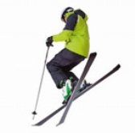 | 6.  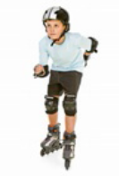

- Look, read and tick.

a. |  | b. |  | c. |  | d. | 
 | 1. highlighting info |  | 1. choosing a  destination |  | 1. copying info |  | 1. buying a  souvenir
 | 2. selecting  information |  | 2. surfing online |  | 2. saving the file |  | 2. printing the file
 | 3. registering on a  website |  | 3. doing research |  | 3. pasting info |  | 3. doing research
e. |  | f. |  | g. |  | h. | 
 | 1. highlighting info |  | 1. selecting  information |  | 1. doing research |  | 1. selecting  information
 | 2. filling in a  registration  form |  | 2. saving a file |  | 2. choosing a  destination |  | 2. copying info
 | 3. underlining info |  | 3. printing a file |  | 3. printing the file |  | 3. saving a file

Reading
Read the text.

- Read and complete the sentences. Write 1-3 words.

- Maria _____________ beach every day.
- She is visiting a _____________ today.
- Children are playing with _____________.
- One of the ladies is giving a _____________.
- Puppets make _____________ laugh.

- Read and answer the questions.

- What’s the weather like?
_________________________________________________________________________.
- What is Maria doing for Miss Symington?
_________________________________________________________________________.
- Do you like visiting museums?
_________________________________________________________________________.

Grammar
- Read and write the verbs in the present continuous. There is one example.

- She is studying (study) Portuguese.
- They ______________ (not / listen) to music right now.
- He ______________ (jog) in the park.
- ______________ you ______________ (print) that file?
- We ______________ (save) it.

- Read and write into, onto or to. There is one example.

- He’s walking into the classroom.
- The cat is jumping _____________ the open box.
- I’m travelling _____________ England today.
- The dog is jumping _____________ the sofa.
- They’re going _____________ school today.
- The books are falling _____________ the floor.´

- Read and circle the correct verbs in the present simple or the present continuous. There is one example.

- They usually do / are doing research online but they print / are printing the file now.
- Do / Are Jane and Nick jogging / jog every day? No, they don’t / aren’t.
- Is / Does Tom relax / relaxing in the park at the moment? Yes, he is / does.
- Jack reads / is reading a book about Australia now.
- Lucy and her mother never play / are playing the piano. They always listen / are
listening to podcasts.
Writing

- Read and answer about you.

- How early do you get up? _________________________________
- How many students are there in your class? __________________
- How interesting are your History lessons? ____________________
- How difficult is this test? __________________________________
- How expensive are the tickets to go to the cinema? ____________

- Read and write a description of a school trip. Use the information in the boxes.
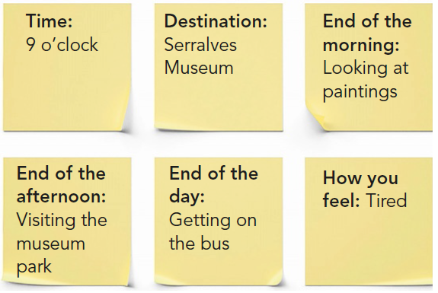
_________________________________________________
_________________________________________________
_________________________________________________
_________________________________________________
_________________________________________________
_________________________________________________
_________________________________________________
_________________________________________________
_________________________________________________
_________________________________________________
_________________________________________________
_________________________________________________

Keep calm and work hard!
Happy summer holidays!
Your teacher, _________________________________

Answer key and marking criteria
Test 5 version E – answer key and marking criteria

Section | Answer key | Marking criteria
Listening | Question 1: Listen and colour.  Answer key: 1. blue trousers 2. pink blouse  3. red blazer 4. purple tracksuit 5. green hoodie | 5 x 2 = 10  2 marks per correct answer.
Listening | Question 2: Listen and tick.  Answer key: 1. c 2. c 3. a 4. c 5. b | 5 x 2 = 10  2 marks per correct answer.  Only accept an answer if there is one tick per  answer.
Vocabulary | Question 1: Read, look and draw a line.  Answer key: a. 3 b. 6 c. 4 d. 1 e. 2 f. 5 | 6 x 2 = 12  2 marks per correct answer.  Only accept an answer if one line is drawn correctly  per answer.
Vocabulary | Question 2: Look, read and tick.  Answer key: a. 2 b. 2 c. 3 d. 1 e. 1 f. 3  g. 1 h. 2 | 8 x 1 = 8  1 mark per correct answer.  Only accept an answer if there is one tick per  answer.
Reading | Question 1: Read and complete the sentences.  Write 1-3 words.  Answer key: a. goes to the b. museum  c. (the) puppets d. puppet show e. children | 5 x 2 = 10  2 marks per correct answer.  -0,5 marks if there is a spelling mistake.
Reading | Question 2: Read and answer the questions.  Answer key: a. It’s sunny and hot. b. Maria is  taking photos (for her/Miss Symington).  c. Personal answer | a./b. 2 x 3 = 6  3 marks per correct  answer.  -0,5 marks if there is a  spelling mistake.  -0,5 marks if there is a  verb mistake.  -0,5 marks if the word  order is incorrect. | c. 1 x 4 = 4  4 marks per correct  answer.  -0,5 marks if there is a  spelling mistake.  -0,5 marks if there is a  verb mistake.  -0,5 marks if the word  order is incorrect.
Grammar | Question 1: Read and write the verbs in the  present continuous.  Answer key: b. aren’t listening c. is jogging  d. Are, printing e. are saving | 5 x 1 = 5  1 mark per correct answer.
Grammar | Question 2: Read and write into, onto or to.  Answer key: b. into c. to d. onto e. to  f. onto | 5 x 1 = 5  1 mark per correct answer.
Grammar | Question 3: Read and circle the correct verbs in the  present simple or the present continuous.  Answer key: a. are printing b. Do, jog, don’t  c. Is, relaxing, is d. is reading e. play, listen | 10 x 1 = 10  1 mark per correct answer.  Only accept an answer if one word is circled per  answer.
Writing | Question 1: Read and answer about you.  Answer key: Personal answers | 5 x 2 = 10  2 marks per correct answer.  -0,5 marks if the word order is incorrect.  -0,5 marks if there are 2 or more spelling mistakes.  -1 mark if there is a verb mistake.
Writing | Question 2: Read and write a description of a  school trip. Use the information in the box.  Answer key: It’s 9 o’clock and we’re visiting  Serralves Museum now. It’s the end of the morning  and we’re looking at paintings. It’s the end of the  afternoon and we’re visiting the museum park. It’s  the end of the day and we’re getting on the bus.  We’re very tired. | 5 x 2 = 10  2 marks per correct sentence.  -0,5 marks if the word order is incorrect.  -0,5 marks if there are 2 or more spelling mistakes  in the sentence.  -1 mark if there is a verb mistake.

Listening script
Test 5 version E – listening script

Exercise 1 – Listen and colour.
Man – Look. The girl is playing the piano.
Boy – Yes. She is very pretty.
Man – Can you see her dress? Colour it yellow.
Boy – Ok. The girl is wearing a lovely yellow dress.
Man – Yes.
Can you see the girl wearing a yellow dress? This is an
example. Now you try.
1.
Man – Can you see the cook’s hat? Now look at the man.
Boy – Yes, I can see him. He’s cooking.
Man – True. Can you colour his trousers blue?
Boy – Ok. The cook is wearing blue trousers now.
Man – Well done.
2.
Man – Look. The man and woman are sightseeing.
Boy – Yes. They’re visiting a museum. Can I colour the
lady’s blouse?
Man – Yes, what colour do you like?
Boy – Can I colour it pink? Pink is a pretty colour.
Man – That sounds good. Colour the lady’s blouse pink,
then.
Boy – Done. The lady is now wearing a pink blouse.
3.
Man – Ok. Why don’t we colour the boy’s blazer now?
Boy – What’s he doing? Is he dancing?
Man – Yes, he is. That’s the boy I’m looking at. Colour his
blazer red.
Boy – Ok. The boy is wearing a red blazer and he is
dancing.
Man – Great.
4.
Man – Now, can you see a dog? Now look at the girl. She’s
walking the dog.
Boy – Is she wearing a tracksuit?
Man – Yes, that’s her.
Boy – Can I choose the colour of her tracksuit? Can I
colour it purple?
Man – Of course, you can. Colour the tracksuit purple.
Boy – Ok.
5.
Man – Now, can you see a tree? There are two birds in the
tree and there is a boy next to the tree. He is singing.
What is he wearing?
Boy – He’s wearing a hoodie, right?
Man – Yes, he is. Colour his hoodie green.
Boy – Excuse me?
Man – Colour his hoodie green.
Boy – Ah… ok! The boy is wearing a green hoodie.
Man – Well done! You colour in very well!
Boy – Thanks!

Exercise 2 – Listen and tick.
Girl – Hi Jack. What are you doing?
Boy – Hey. I’m buying a ticket to go to the cinema.
Girl – What film do you want to see?
Boy – An adventure film.
Girl – That’s great. Can I go too?
Boy – Yes. I can buy a ticket for you too.
Girl – See you later, then.
Can you see the tick next to the letter b? This is an
example. Now you try.
1.
Man 1 – What floor is the dinosaur exhibition on?
Man 2 – The dinosaur exhibition is on the second floor.
Man 1 – Thanks. Can you call the lift, please?
Man 2 – Ok.
Man 1 – Thank you.
2.
Woman – Excuse me, can you help me?
Man – Of course. What is it?
Woman – I can’t see very well. I haven’t got my glasses.
Can you choose the floor for me?
Man – What floor do you want?
Woman – The third floor, please. I love to see the
paintings there.
Man – Ok.
Woman – Thank you.
3.
Man – Can you hold that door, please?
Woman – Of course!
Man – Thanks for holding the door. I’m a bit late today!
Woman – Are you always late?
Man – No, I’m never late but I am today, so thank you
again for holding the door.
Woman – My pleasure!
4.
Man – Let’ visit The Serralves Museum. It’s over there.
Woman – The Serralves Museum? How expensive are the
tickets?
Man – Why don’t you ask that man?
Woman – Because I have to wait in a queue and it’s very
long at the moment.
Man – How long is the queue?
Woman – Look, there are ten people standing in the
queue now.
Man – Ok. Let’s go then. We can google it online.
5.
Boy – I’m lost. Where is the souvenir shop?
Girl – Why don’t we look for the signs?
Boy – Good idea. Where are the signs?
Girl – Look. There they are. What do they say? Where is
the shop?
Boy – The souvenir shop is on the ground floor. Let’s go.
This way, please!
Girl – I’m coming…

