Test 1 – standard test
School |  | Evaluation
Name _____________ Surname _____________ Class: 5th ____  Date _________________________________________, 20 ___  Signatures ____________________/______________________  (Teacher) (Parent/E.E.) |  | ____%  Muito Bom Bom Suficiente  Insuficiente Muito Insuficiente

Listening

- Listen and circle. There is one example.

- How old is Maria? 1. young 2. middle-aged 3. old
- How tall is Ben? 1. short 2. medium height 3. tall
- What does Sally look like? 1. chubby 2. handsome 3. pretty
- How tall is Ann? 1. short 2. medium height 3. tall
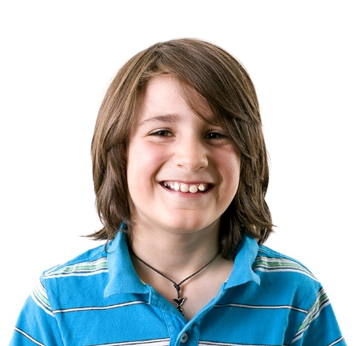
- What does Grace look like? 1. thin 2. slim 3. fat

- Listen and write. There is one example.

- Name: Paul____
- Surname: _____________________
- Isn’t wearing: ________________________________
- Is wearing: ________________________________ and trainers
- Favourite colour: _____________________________

School |  | Evaluation
Name _____________ Surname _____________ Class: 5th ____  Date _________________________________________, 20 ___  Signatures ____________________/______________________  (Teacher) (Parent/E.E.) |  | ____%  Muito Bom Bom Suficiente  Insuficiente Muito Insuficiente
Test 1 – standard test
Vocabulary
- Label the pictures. Use the words in the box.
straight freckles bald wavy moustache beard
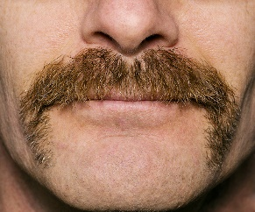 | 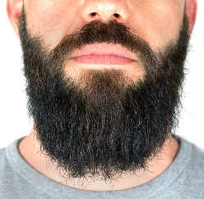 | 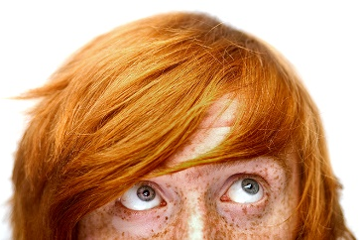
- ___________ | - ____________ | - ___________
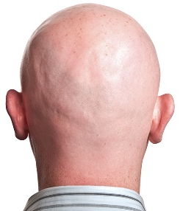 | 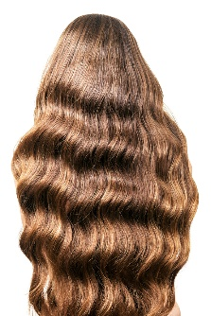 | 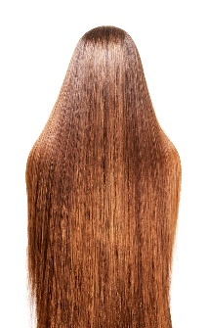
- ____________ | - ___________ | - ___________

- Look and write.

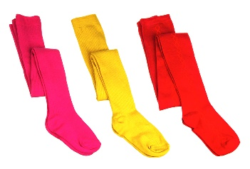 | 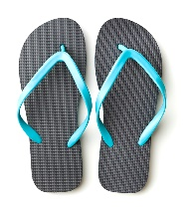 |  | 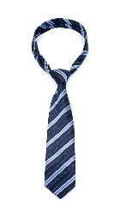 |  | 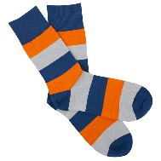
- ______________ | - _____________ |  | - ___________ |  | - ____________
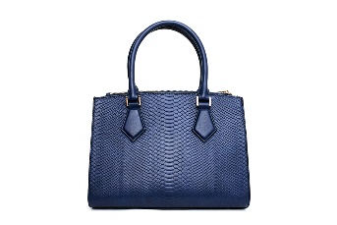 |  | 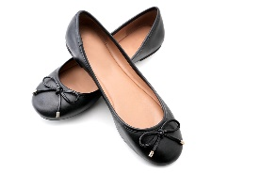 |  | 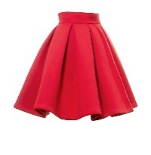
- _______________ |  | - _______________ |  | - _______________

Reading
Read the text.
New school, new friends!
My name is Mike and my surname is Spencer. I’m from England. I am ten years old and I’m attending a new school in London this year. It’s a really big school and my new class is great. I’m in class 5B. There are 24 students in my new class: 10 boys and 14 girls. The teachers are nice and friendly. Jack is one of my new classmates. He’s also new at school. He’s Scottish. He’s eleven years old and this is what he looks like: he is short and thin. He’s got short straight brown hair and green eyes. His face is long. He always wears jeans and t-shirts or hoodies, just like I do! He says they are his favourite clothes!

- Read and draw a line. There is one example.
- Mike’s new classmate 1. is long.
- Jack is from 2. Scotland.
- He’s got straight 3. brown hair.
- His face 4. class 5B.
- They are in 5. is Jack.
- There are 6. 10 boys and 14 girls in class 5B.

- Read and answer the questions.
- How old is Jack?
_____________________________________________________________
- What are his favourite clothes?
_____________________________________________________________
- What are your favourite clothes?
_____________________________________________________________

Grammar
- Read and write the correct form of the verb to be. There is one example.
- Mike is from England.
- He _____________ (not) ten years old.
- _____________ his school big? Yes, it _____________.
- His new friend _____________ (not) English. He _________ Scottish.
- _______ they in the same class? Yes, they _____________.
- Mike and his friend _______ in class 5B.
- She ______ eleven years old.
- Jack’s favourite clothes _____________ (not) shirts.

- Look and write the dates. There is one example.
- 4/ 02 4th (fourth) February____ d. 2/ 09 __________________________
- 15/ 06 ______________________ e. 12/ 10 __________________________
- 21/ 08 ______________________ f. 30/ 12 __________________________

- Look and write. Choose one word. There is one example.
- We (Her / We / I) are Ben and Tim. _____ (My / Our / His) suits are grey. _____ (They / It / My) are really smart.
- Dan has got a new shirt. _____ (Its / His / Our) shirt is green. _____ (They / It / My) is cute.
- _____ (She / I / They) am Grace and this is _____ (my / her / his) new raincoat.
- These are Daisy’s leggings. _____ (His / Her / Our) leggings are cool. _____ (He / It /They) are red.
- Fred, where is _____ (their / your / his) blazer? Don’t forget to wear _____ (they / it / we)!

Writing
- Read and answer the questions about you.
- Are you short? ______________________________________________________
- What is your face like? ________________________________________________
- Have you got short wavy brown hair? _____________________________________
- What are your eyes like? ______________________________________________
- What’s your favourite colour? ___________________________________________

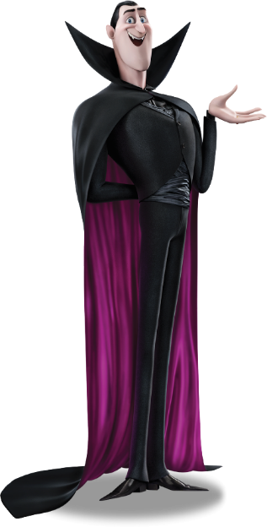
- Look at Dracula in the Hotel Transylvania film and write his profile (20-30 words). Use the words in the box.
__________________________________________________
Height: tall
Weight: slim
Face: long
Eyes: round, blue
Hair: short, straight
black
__________________________________________________
__________________________________________________
__________________________________________________
__________________________________________________

Good luck! Happy Halloween!

Answer key and marking criteria
Test 1 – answer key and marking criteria | Listening script
Aprendizagens Essenciais:
Áreas temáticas:  - Gostos e preferências pessoais  - Descrição física | Compreensão oral:  - Identificar a ideia global de pequenos textos orais  - Seguir conversas sobre assuntos que lhe são familiares, articuladas de forma lenta, clara e pausada | Compreensão escrita:  - Seguir instruções elementares  - Compreender mensagens curtas e simples (postais, mensagens de texto, posts/tweets, blogs, emails) sobre assuntos do seu interesse | Interação escrita:  - Preencher um formulário (online ou em formato papel) simples com informação pessoal básica e preferências pessoais básicas  - Pedir e dar informação pessoal de forma simples  - Pedir e dar informação sobre gostos e preferências de uma forma simples  Produção escrita:  - Descrever-se a si e à família  - Redigir mensagens e notas pessoais

Section | Answer key | Marking criteria
Listening | Question 1: Listen and circle.  Answer key: b. 3 c. 3 d. 1 e. 2 | 4 x 2 = 8  2 marks per correct answer.  Only accept an answer if one option is circled per question.
Listening | Question 2: Listen and write.  Answer key:  b. Brown  c. grey trousers  d. jeans  e. blue | 4 x 3 = 12  3 marks per correct answer.  -0,5 marks if there is a spelling mistake.
Vocabulary | Question 1: Label the pictures  Answer key: a. moustache b. beard c. freckles  d. bald e. wavy f. straight | 6 x 1 = 6  1 mark per correct answer.  Only accept an answer if one line is drawn correctly per answer.
Vocabulary | Question 2: Look and write.  Answer key: a. stockings b. flip-flops c.  tie d. socks e. handbag f. ballerinas g. skirt | 7 x 2 = 14  2 marks per correct answer.  -0,5 marks if there is a spelling mistake.
Reading | Question 1: Read and draw a line.  Answer key: b. 2 c. 3 d. 1 e. 4 f. 6 | 5 x 2 = 10  2 marks per correct answer.  Only accept an answer if one line is drawn correctly  per answer.
Reading | Question 2: Read and answer the questions.  Answer key:  a. Jack is eleven years old.  b. His favourite clothes are jeans, t-shirts and hoodies.  c. Personal answer: My favourite clothes are... | a./b. 2 x 3 = 6  3 marks per correct  answer.  -0,5 marks if there is a  spelling mistake.  -0,5 marks if there is a  verb mistake.  -0,5 marks if the word  order isn’t correct. | c. 1 x 4 = 4  4 marks per a correct  answer.  -0,5 marks if there is a  spelling mistake.  -0,5 marks if there is a  verb mistake.  -0,5 marks if the word  order isn’t correct.
Grammar | Question 1: Read and write the correct form of the verb to be.  Answer key: b. isn’t c. Is, is d. isn’t, is e. Are, are f. are g. is, h. aren’t | 10 x 1= 10  1 mark per correct answer.  -0,5 marks if there is a spelling mistake.
Grammar | Question 2: Look and write the dates.  Answer key: b. 15th (fifteenth) June  c. 21st (twenty-first) August d. 2nd (second) September e. 12th (twelfth) October f. 30th (thirtieth) December | 5 x 1 = 5  1 mark per correct answer.  -0,5 marks if there is a spelling mistake.
Grammar | Question 3: Look and write. Choose one word.  Answer key: a. Our, They b. His, It c. I, my  d. Her, They e. your, it | 10 x 0,5 = 5  0,5 marks per correct answer.
Writing | Question 1: Read and answer the questions about  you.  Answer key: Personal answer | 5 x 2 = 10  2 marks per correct answer.  -0,5 marks if the word order isn’t correct.  -0,5 marks if there are 2 or more spelling mistakes.  -1 mark if there is a verb mistake.
Writing | Question 2: Look at Dracula in the Hotel Transylvania film and write his profile (20-30 words). Use the words in the box.  Answer key – suggested answer: Dracula is tall  and slim. His face is long. He’s got round blue eyes.  He has got short straight black hair. | 10  2 marks per correct sentence.  -0,5 marks if the word order isn’t correct.  -0,5 marks if there are 2 or more spelling mistakes in the sentence.  -1 mark if there is a verb mistake.

Listening script

Exercise 1: Listen and circle. There is one example.
1.
My name’s Maria. I’m 55. I’m not young and I’m not old, so I guess that you can say that I’m middle aged now. I’m a happy middle-aged woman.
Can you see the circle in number 2? This is an example. Now, you try.
2.
Man: Is that Ben over there?
Woman: Yes, I think it’s him. Ben is really tall and that boy is really tall too, so I think that is Ben.
3.
Woman: Who is your best friend?
Man: My best friend is Sally.
Woman: Oh really! What does she look like?
Man: Well, I think that she is very pretty. She has got long curly hair. I like curly hair, so I think she is pretty.
4.
My name’s Ann. I’m in class 5E. The girls in my class are all very tall, but I’m not. I’m short. My best friend is short too, so that’s ok.
5.
My mum’s name is Grace. I think she’s very pretty. She’s tall and she’s really slim. She’s a model. Models are slim, aren’t they?

Exercise 2: Listen and write. There is one example.

Man: My dad’s name is Paul and my name is Paul too. Yes, that’s right. My dad and I have got the same name.
Woman: Can you see the word Paul in a? This is an example. Now you try!
Man: Let me tell you a bit more about me. My surname is Brown. Let me spell that for you that’s B-R-O-W-N. Brown. It’s Saturday today so I’m not wearing my grey trousers. I only wear grey trousers during the week when I go to school. Today I’m wearing my jeans and my trainers. I like to feel comfortable at the weekend, so I always wear jeans and trainers. My t-shirt is blue because blue is my favourite colour. Do you like blue too?

