CASA DA AULA – CENTRO DE EXPLICAÇÕES
School |  | Evaluation
Name _____________ Surname _____________ Class: 5th ____  Date _________________________________________, 20 ___  Signatures _____________________/______________________  (Teacher) (Parent/E.E.) |  | ____%  Muito Bom Bom Suficiente  Insuficiente Muito Insuficiente

Listening
- Listen and tick the correct answer. Which is Tom’s bedroom?

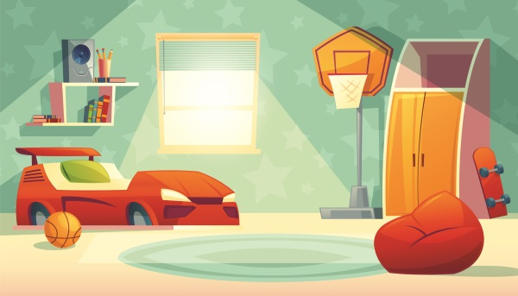 | 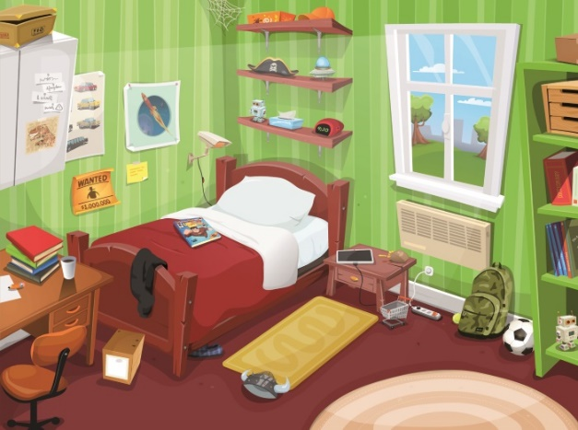

- Listen and complete the text about Ann’s house.

Hi! I’m Ann and I live in a a._____________ with my parents, my grandparents and my sister. It is on the b.______________ floor. It the entrance there is a small c.__________. On the left there is a d.____________ to the bedrooms. On the right there is a e._______________ and next to it there is a living room and a f._______________. Opposite the living room there is a g.____________. There are two h._______________ and a study. My favourite room is the i._______________ because there is a big TV set there where I play video games with my dad.


I love my home!

School |  | Evaluation
Name _____________ Surname _____________ Class: 5th ____  Date _________________________________________, 20 ___  Signatures _____________________/______________________  (Teacher) (Parent/E.E.) |  | ____%  Muito Bom Bom Suficiente  Insuficiente Muito Insuficiente

Vocabulary

- Look and label the routines.

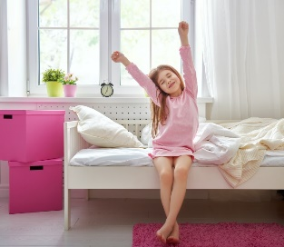 |  |  | 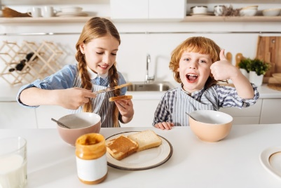
- ______________ | - _____________ | - ______________ | - ______________
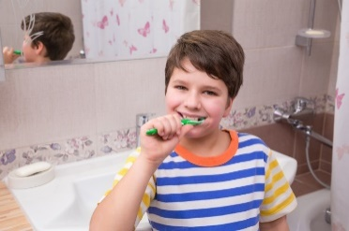 |  |  | 
- ______________ | - _____________ | - ______________ | - _____________

- Look and write the time.

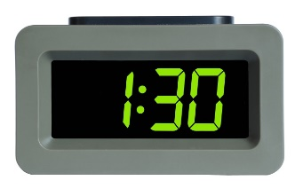  - _______________  _________________ |   - _______________  _________________ | 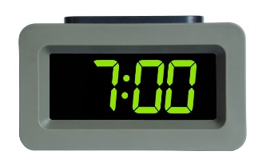  - _______________  _________________ | 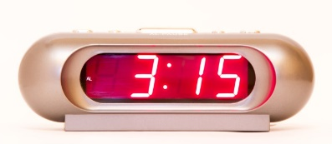  - ________________  __________________

Reading
Read the dialogue between Grace and Pete.

Grace’s house
Pete: Hello, Grace! Let’s do our English homework and answer these questions. Are you ready?
Grace: Yes!
Pete: Ok, tell me about your house. Where is it?
Grace: It’s in London. My address is 44, King Street.
Pete: And how big is your house? How many rooms are there?
Grace: It is very big. There are two toilets, a kitchen, a hall, a pantry, two living rooms, a study and a big dining room downstairs. And upstairs there are six bedrooms and six bathrooms.
Pete: Wow! Is there a garden?
Grace: Yes, of course there is. There is a big garden and a swimming pool too. I spend a lot of my time there. There are also two garages and a big basement.
Pete: What a wonderful house! I think it is a dream house! What colour is it?
Grace: It’s white.
Pete: Ok, thanks!
Grace: It is your turn now, Pete. Are you ready?

- Read and write T (True) or F (False). Correct the false sentences.
There is one example.

- Grace lives in Oxford.  Grace lives in London.__________________
- She lives in a small house.  ___________________________________________
- There are six bathrooms in her house. __________________________________
- There is a pantry on the ground floor. ___________________________________
- There isn’t a study in Grace’s house. ___________________________________
- There is one garage in her house. _____________________________________

- Read and answer the questions.

- Is there an attic in Grace’s house?
___________________________________________________________________
- How many bedrooms are there in her house?
___________________________________________________________________
- What colour is your house?
___________________________________________________________________

Grammar
- Look, read and write the correct form of the verb there + to be.
There is one example.

- There is a big garden.
- ______________ a basement? Yes, _____________.
- ______________ an attic? No, _______________.
- ______________ any bathrooms? Yes, ______________ six.

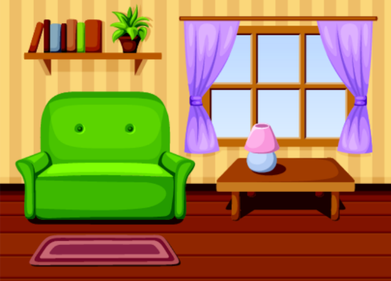
- Look at the picture and write the correct preposition of place: next to, on, in front of and behind. There is one example.

- There is a table in front of the window.
- There is a pot plant ___________ the shelf.
- There is a lamp ___________ the table.
- There is a rug ___________ the armchair.
- There is an armchair ___________ the table.
- There is a window ___________ the table.

- Read and complete the sentences with because, but, and or so.
There is one example.

- Children like games and birthday parties.
- I don’t like playing basketball _________ it is difficult.
- I like reading books __________ playing mobile games.
- I like playing the piano, ________ I don’t like playing the guitar.
- I love my bedroom, ________ it is my favourite place in the house.

Writing
- Read and answer about you.

- Where do you live? ___________________________________________________
- What’s your favourite room? ____________________________________________
- What’s your favourite object in your room? _________________________________
- Where do you study? __________________________________________________
- What colour is your bed? _______________________________________________

- Describe your bedroom (20-30 words).
__________________________________________________
Mention:
- size
- objects in your room and place
- your likes/dislikes

__________________________________________________
__________________________________________________
__________________________________________________
__________________________________________________
Good luck!
Your teacher, ___________________________

Answer key and marking criteria
Aprendizagens Essenciais
Áreas Temáticas  - Gostos e preferências pessoais  - Rotinas diárias | Compreensão Oral  - Identificar a ideia global de pequenos textos orais  - Seguir conversas sobre assuntos que lhe são familiares, articuladas de forma lenta, clara e pausada | Compreensão Escrita  - Seguir instruções elementares  - Compreender mensagens curtas e simples (postais, mensagens de texto, posts/tweets, blogs, emails) sobre assuntos do seu interesse | Interação Escrita  - Preencher um formulário (online ou em formato papel) simples com informação pessoal básica e preferências pessoais básicas  - Pedir e dar informação pessoal de forma simples  Produção Escrita  - Descrever uma imagem usando there is/there are  - Redigir mensagens e notas pessoais

Section | Answer key | Marking criteria
Listening  MC L5 Compreender discursos simples, articulados de forma clara e pausada  MC L5.3 Entender informações que lhe são dadas  MC L5.6 Identificar a ideia global de pequenos textos orais  MC ID8.7 Identificar as divisões da casa e o mobiliário | Question 1: Listen and tick the correct answer. Which is Tom’s bedroom?  Answer key: a. | 1 x 2 = 2  2 marks per correct answer  Only accept an answer if there is only one correct answer.
 | Question 2: Listen and complete the text about Ann’s house.  Answer key:  a. flat  b. third  c. hall  d. corridor  e. kitchen  f. dining room  g. toilet  h. bathrooms  i. living room | 9 x 2 = 18  2 marks per correct answer  Only accept an answer if there is only one correct answer.
Vocabulary  MC ID8.5 Identificar rotinas diárias | Question 1: Look and label the routines.  Answer key:  a. get up  b. have a shower  c. get dressed  d. have breakfast  e. brush/clean my teeth  f. go to school  g. have lunch  h. watch TV | 8 x 1 = 8  1 mark per correct answer  -0,5 marks if there is a spelling mistake
Vocabulary  MC ID8.5 Identificar rotinas diárias | Question 2: Look and write the time.  Answer key:  a. It’s half past one.  b. It’s a quarter to five.  c. It’s seven o’clock.  d. It’s a quarter past three. | 4 x 3 = 12  3 marks per correct answer  -0,5 marks if there is a spelling mistake  -0,5 marks if the subject is missing  -0,5 marks if the verb is incorrect/missing
Reading  MC R4 Compreender textos breves e simples  MC R4 Reconhecer informação que lhe é familiar | Question 1: Read and write T (True) or F (False).  Correct the false sentences.  Answer key:  b. F – She lives in a big house.  c. T  d. T  e. F – There is a study in Grace’s house.  f. F – There are two garages in her house. | 5 x 1 = 5 / 3 x 2 = 6  1 mark per correct answer for T and F  Only accept an answer if T or F is written; 0 marks if V is used  False sentences: 2 marks for each accurate correction  -0,5 marks if there is a spelling mistake  -0,5 marks if there is a verb mistake  -0,5 marks if the word order is incorrect
 | Question 2: Read and answer the questions.  Answer key:  a. No, there isn’t.  b. There are six bedrooms (in her house).  c. Personal answer: My house is (colour). | 3 x 3 = 9  3 marks per correct  answer  -0,5 marks if there is a  spelling mistake  -0,5 marks if there is a  verb mistake  -0,5 marks if the word  order is incorrect
Grammar  MC LG8.17 Usar os verbos to be, there + to be, e to have got, no present simple, nas formas affirmativa, negativa e interrogativa  MC LG8.14 Usar at, in front of, behind, opposite, under, above, below (place)  MC LG8.8 Usar because e so  MC LG8.29 Apropriar-se de novos itens lexicais, relacionados com as áreas temáticas previstas no domínio intercultural | Question 1: Look, read and write the correct form  of the verb there + to be.  Answer key:  b. Is there / there is.  c. Is there / there isn’t.  d. Are there / there are | 6 x 1 = 6  1 mark per correct answer  -0,5 marks if there is a verb mistake  -0,5 marks if there is a spelling mistake  -0,5 marks if the “there” is missing
 | Question 2: Look at the picture and write the correct preposition of place: next to, on, in front of and behind.  Answer key:  b. on  c. on  d. in front of  e. next to  f. behind | 5 x 2 = 10  2 marks per correct answer  -0,5 marks if there is a spelling mistake
 | Question 3: Read and complete the sentences with  because, but, and or so.  Answer key:  b. because  c. and  d. but  e. so | 4 x 1 = 4  1 mark per correct answer  -0,5 marks if there is a spelling mistake
Writing  MC W5 Produzir, com ajuda, frases simples  MC W6 Produzir um texto simples, de 20 a 30 palavras  MC W6.1 Descrever uma imagem usando there is/ there are | Question 1: Read and answer about you.  Answer key: Personal answer  a. I live in a...  b. My favourite room is...  c. My favourite object in my room is…  d. I study in the...  e. My bed is... | 5 x 2 = 10  2 marks per correct answer  -0,5 marks if the word order is incorrect  -0,5 marks if there are 2 or more spelling mistakes  -1 mark if there is a verb mistake
 | Question 2: Describe your bedroom.  Answer key: Personal answer  My bedroom is small / big.  In my bedroom there is a/an… and a/an…  There’s a/an (on… next to the… in front of… opposite...)  There are (on… next to the… in front of… opposite...)  I like/love my bedroom! | 5 x 2 = 10  2 marks per correct sentence  -0,5 marks if the word order is incorrect  -0,5 marks if there are 2 or more spelling mistakes in the sentence  -1 mark if there is a verb mistake

Listening script

Hello! I’m Tom. I live in a big house with my family. My favourite room is my bedroom. It is very cool! In my bedroom there is a bed, of course, and a window with a great view of the garden. It is very sunny in my bedroom. I like my bedroom because I can study, read or practice basketball there. Yes… there is a basketball hoop in my bedroom for me to play basketball! I also love my bed… do you know why? Well, because it looks like a car! It’s a different bed, isn’t it?

Hi! I’m Ann and I live in a flat with my parents, my grandparents and my sister. It is on the third floor. In the entrance there is a small hall. On the left there is a corridor to the bedrooms. On the right there is a kitchen and next to it there is a living room and a dining room. Opposite the living room there is a toilet. There are two bathrooms and a study. My favourite room is the living room because there is a big TV set there where I play video games with my dad. I love my home!

