School |  | Evaluation
Name ____________ Surname ____________ Class: 5th ____  Date _______________________________________, 20 ___  Signatures __________________ / _____________________  (Teacher) (Parent/E.E.) |  | ____%  Muito Bom Bom Suficiente  Insuficiente Muito Insuficiente

Test 1 – standard test
Listening

- Listen and circle. There is one example.

- What does Mary look like? 1. fat 2. pretty 3. short
- What does Jenny’s hair look like? 1. curly 2. straight 3. short
- How old is Peter? 1. old 2. middle-aged 3. young
- How tall is Sara? 1. short 2. medium-height 3. tall
- What does Grace look like? 1. thin 2. slim 3. fat


- Listen and write. There is one example.

- Name: John
- Surname: _______________________________________
- Height: _________________________________________
- Favourite colour: _________________________________
- Favourite clothes: ________________________ and jeans

School |  | Evaluation
Name ____________ Surname ____________ Class: 5th ____  Date _______________________________________, 20 ___  Signatures __________________ / _____________________  (Teacher) (Parent/E.E.) |  | ____%  Muito Bom Bom Suficiente  Insuficiente Muito Insuficiente
Test 1 – standard test
Vocabulary
- Circle the correct word.
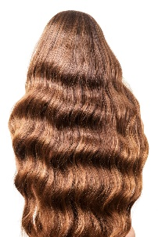 | 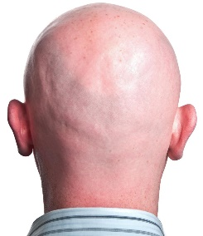 | 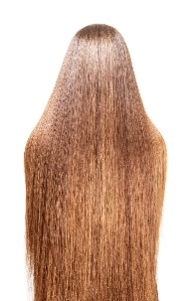
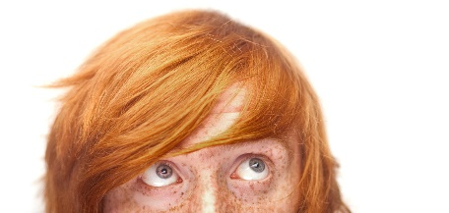  - a. wavy / straight | 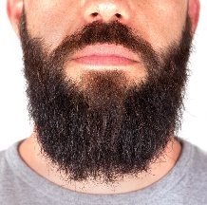  - b. beard / bald | 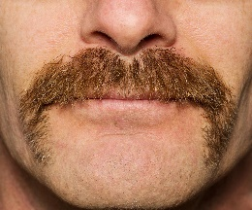  - c. curly / straight
- d. freckles / moustache | - e. freckles / beard | - f. moustache / bald

- Look and write.
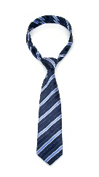 | 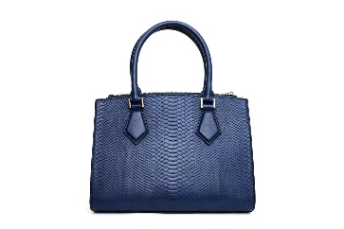 |  | 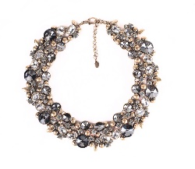 |  | 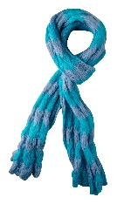
a. _____________ | b. _____________ |  | c. _____________ |  | d. _____________
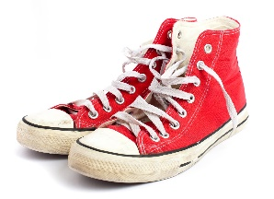 |  | 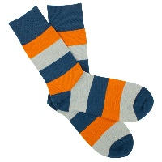 |  | 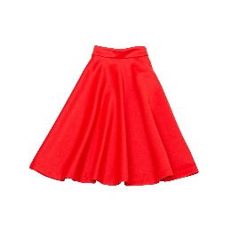
e. ______________ |  | f. ______________ |  | g. ______________

Reading
Test 1 – standard test
Read the text.
My New School…
My name is Jennifer and my surname is Smithson. I’m from the USA. I am ten years old and I’m attending a new school in Los Angeles this year. It’s a small school and my new class is great. I’m in class 5D. There are 24 students in my new class. There are 12 boys and 12 girls. My teachers are really nice and friendly. Jack is my best friend. He’s new like me. He’s English. He’s eleven years old and he is tall and thin. He’s got short curly brown hair and blue eyes. His face is long. He always wears jeans and a hoodie. Sometimes he wears a shirt. His favourite colour is blue. I like blue too. He says that blue hoodies are his favourite clothes!

- Read and write TRUE (T) or FALSE (F). There is one example.
- Jennifer is eleven years old. FALSE (F)
- She is English. _________
- Her school is a big school. _________
- There are 24 students in class 5D. _________
- Her teachers aren’t very nice. _________
- Jack is from England. _________

- Read and answer the questions.
- How old is Jack?
_____________________________________________________________
- Does Jack wear shirts?
_____________________________________________________________
- What are your favourite clothes?
_____________________________________________________________
Grammar
Test 1 – standard test
- Read and write the correct form of the verb to be. There is one example.
- Jennifer is from England.
- She _____________ (not) very tall.
- _____________ her school big? No, it _____________.
- Jack’s eyes _____________ (not) green. They _________ blue.
- _______ Jennifer and Jack in the same class? Yes, they _____________.
- The children _______ in class 5D.
- I ______ eleven years old.
- My favourite clothes _____________ (not) jeans.

- Look and write the dates. There is one example.
- 4 / 02 4th (fourth) February___ d. 01 / 12 __________________________
- 13 / 05 _____________________ e. 15 / 03 __________________________
- 12 / 09 _____________________ f. 30 / 07 __________________________

- Look and write. Choose one word. There is one example.
- We (Her / We / I) are Ana and Sue. _____ (My / Our / His) hair is brown. _____ (They / It / My) is long and curly.
- Mark has got a cool shirt. _____ (Its / His / Our) shirt is green. _____ (They / It / My) isn’t very big.
- _____ (She / I / They) am Sally and this is _____ (my / her / his) new raincoat.
- This is Maria’s sweatshirt. _____ (His / Her / Our) sweatshirt is cool. _____ (He / It / They) is red.
- Fred, where is _____ (their / your / his) jacket? Please put _____ (they / it / we) on!
Writing
Test 1 – standard test
- Read and answer the questions about you.
- Are you tall?
______________________________________________________
- What is your face like?
______________________________________________________
- Have you got short straight hair?
______________________________________________________
- What are your eyes like?
______________________________________________________
- What’s your favourite colour?
______________________________________________________
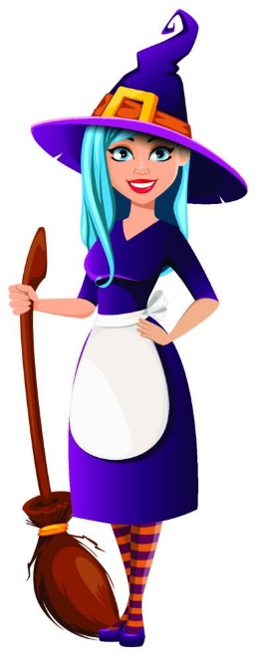
- Look at Wendy the witch and write her profile (20-30 words).
Use the words in the box.
__________________________________________
__________________________________________
__________________________________________
__________________________________________
__________________________________________
__________________________________________
Height: tall
Weight: slim
Face: round
Eyes: round, blue
Hair: long, straight, blue
__________________________________________

Good luck! Happy Halloween!
Answer key and marking criteria

Aprendizagens Essenciais
Áreas temáticas  - Gostos e preferências pessoais  - Descrição física | Compreensão oral  - Identificar a ideia global de pequenos textos orais  - Seguir conversas sobre assuntos que lhe são familiares, articuladas de forma lenta, clara e pausada | Compreensão escrita  - Seguir instruções elementares  - Compreender mensagens curtas e simples (postais, mensagens de texto, posts/tweets, blogs, emails) sobre assuntos do seu interesse | Interação escrita  - Preencher um formulário (online ou em formato papel) simples com informação pessoal básica e preferências pessoais básicas  - Pedir e dar informação pessoal de forma simples  - Pedir e dar informação sobre gostos e preferências de uma forma simples  Produção escrita  - Descrever-se a si e à família  - Redigir mensagens e notas pessoais

Section | Answer key | Marking criteria
Listening | Question 1: Listen and circle.  Answer key: b. 1 c. 3 d. 3 e. 2 | 4 x 2 = 8  2 marks per correct answer.  Only accept an answer if one option is circled per question.
Listening | Question 2: Listen and write.  Answer key: b. Adams c. medium-height d. red e. t-shirts | 4 x 3 = 12  3 marks per correct answer.  -0,5 marks if there is a spelling mistake.
Vocabulary | Question 1: Circle the correct word.  Answer key: a. wavy b. bald c. straight d. freckles e. beard f. moustache | 6 x 1 = 6  1 mark per correct answer.  Only accept an answer if one line is drawn correctly per answer.
Vocabulary | Question 2: Look and write.  Answer key: a. tie b. handbag c.  necklace d. scarf e. high-tops f. socks g. skirt | 7 x 2 = 14  2 marks per correct answer.  -0,5 marks if there is a spelling mistake.
Reading | Question 1: Read and write TRUE (T) or FALSE (F).  Answer key: b. F c. F d. T e. F f. T | 5 x 2 = 10  2 marks per correct answer.
Reading | Question 2: Read and answer the questions.  Answer key: a. Jack is eleven years old. b. Yes, he does. c. Personal answer: My favourite clothes are... | a./b. 2 x 3 = 6  3 marks per correct answer.  -0,5 marks if there is a spelling mistake.  -0,5 marks if there is a verb mistake.  -0,5 marks if the word order isn’t correct. | c. 1 x 4 = 4  4 marks per correct answer.  -0,5 marks if there is a spelling mistake.  -0,5 marks if there is a verb mistake.  -0,5 marks if the word order isn’t correct.
Grammar | Question 1: Read and write the correct form of the verb to be.  Answer key: b. isn’t/is not c. Is, is not/isn’t d. aren’t/are not, are e. Are, are f. are g. am h. aren’t/are not | 10 x 1= 10  1 mark per correct answer.  -0,5 marks if there is a spelling mistake.
Grammar | Question 2: Look and write the dates.  Answer key: b. 13th (thirteenth) May  c. 12th (twelfth) September d. 1st (first) December e. 15th (fifteenth) March f. 30th (thirtieth) July | 5 x 1 = 5  1 mark per correct answer.  -0,5 marks if there is a spelling mistake.
Grammar | Question 3: Look and write. Choose one word.  Answer key: a. Our, It b. His, It c. I, my d. Her, It e. your, it | 10 x 0,5 = 5  0,5 marks per correct answer.  No spelling mistakes are accepted.
Writing | Question 1: Read and answer the questions about you.  Answer key: Personal answer | 5 x 2 = 10  2 marks per correct answer.  -0,5 marks if the word order isn’t correct.  -0,5 marks if there are 2 or more spelling mistakes.  -1 mark if there is a verb mistake.
Writing | Question 2: Look at Wendy the witch and write her profile (20-30 words). Use the words in the box.  Answer key – suggested answer: Wendy is tall and slim. Her face is round. She has got round blue eyes. She has got long straight blue hair. | 10  2 marks per correct sentence.  -0,5 marks if the word order isn’t correct.  -0,5 marks if there are 2 or more spelling mistakes in the sentence.  -1 mark if there is a verb mistake.

Listening script

Exercise 1: Listen and circle. There is one example.

1.
My name’s Mary. I’m twenty-one. I’m tall and slim. All my friends think I am pretty. They say I am a pretty girl. My boyfriend thinks I am pretty, too.
Can you see the circle in number 2? This is an example. Now, you try.
2.
Man: Is that Jenny over there?
Woman: Yes, that’s her. She has got long curly black hair, so I think that is her! I love her long curly hair.
3.
Woman: Who is your best friend?
Man: My best friend is Peter.
Woman: Oh really! What does he look like?
Man: Well, he’s tall and he’s slim. He’s also very young. He’s twelve years old. All the girls in my class think that he is handsome, so he’s a young handsome boy.
4.
My name’s Sara. I’m in class 5D. The girls in my class are all a bit short. I play basketball, so I am not short. I am tall. Basketball players are usually tall.
5.
My mum’s name is Grace. She’s middle-aged. She isn’t very tall. She’s medium-height. She isn’t fat. She is slim. I think that she’s pretty. I love her very much.

Exercise 2: Listen and write. There is one example.

Man: My name is John. That’s J O H N, John. I like my name. I think John is a nice name.
Woman: Can you see the word John in a? This is an example. Now you try!
Man: My surname is Adams. That’s A D A M S, Adams. So, my full name is John Adams. I’m medium-height and I’m a bit chubby. My favourite colour is red. I love wearing red t-shirts and blue jeans. When it’s cold, I usually wear a jumper to school. I have got brown eyes and short black hair.

