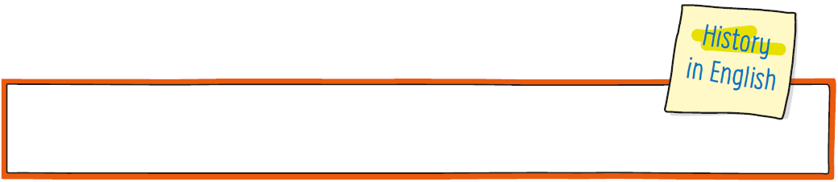
CLIL worksheet
Unit 1 European predictions in the XIV century

Name: ______________________________________________________________ Class: 5 _____

- Look and match .

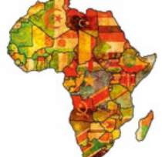 | 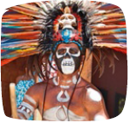 | 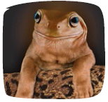 | 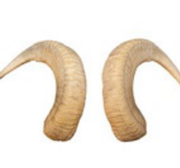 |  | 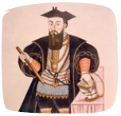
- weird | - continent | - races | - navigators | - exotic | - horns

- Stop  and think .
In the XIV century do you think Europeans know what people around the world look
like?
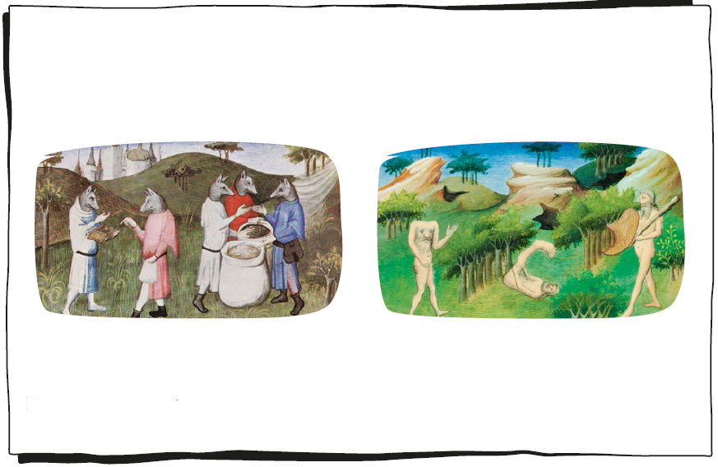
Figure 1 The Book of Marvels and Travels, John Mandeville Figure 2 The Book of the Marvels of the World, Marco Polo
Indigenous beings are very strange! Some people think they have got strange human
bodies with animal heads or that their heads are on their chests. Other people imagine
that they have got one leg, one eye, one ear or horns on their heads.
Imagine it’s the XIV century. Most people still don’t know what the world and other
races look like. It’s only in the XV century that Europe enters the age of the Discoveries
and that European navigators start to discover different continents and races. This is
what Europeans imagine that indigenous beings look like in the XIV century:

- Read and write True (T) or False (F).
- In the XIV century Europeans travel around the world. _________
- Europeans don’t know what indigenous people look like. _________
- They think indigenous people look like Europeans. _________
- They think indigenous people can have animal heads. _________
- Some people think that indigenous people have got weird bodies. _________
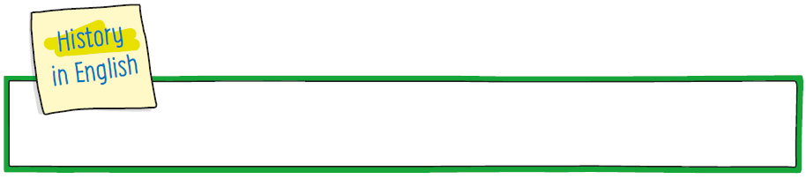
CLIL worksheet
Unit 2 Jobs in the Middle Ages
Name: ______________________________________________________________ Class: 5 _____

- Stop and think .
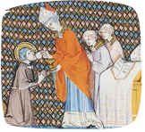 | 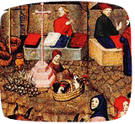 | 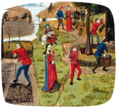 | 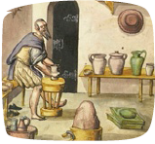 | 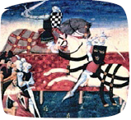
- merchants | - clergy | - craftsmen | - nobles | - labourers

- Stop and think .
What are typical jobs today?
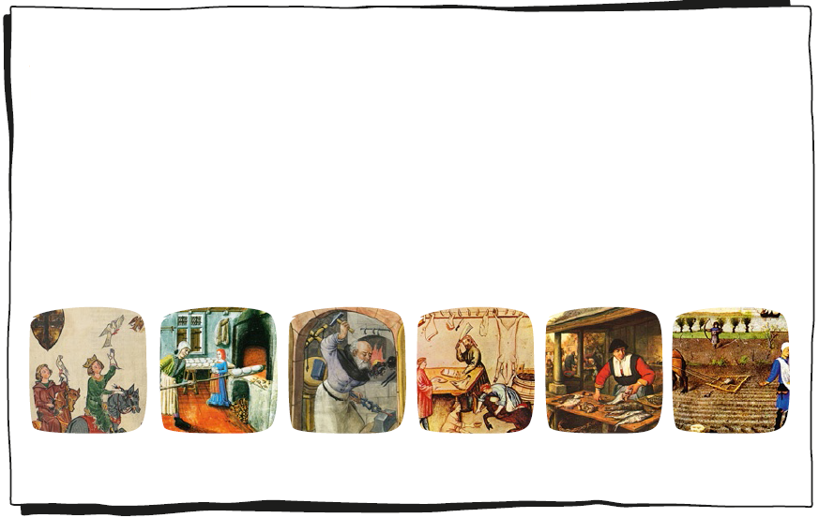
falconer baker blacksmith butcher fishmonger peasant
The Middle Ages is the period from the V century to the end of the XV century. It is
the period before the fall of the Roman Empire in the East. Life is very different in the
Middle Ages. Let’s look at people’s jobs. There are different types of people with
different types of jobs…
• Nobles and kings don’t work.
• The clergy serve the church. They are priests, bishops and cardinals.
• Merchants sell things like spices, food, wine, cloths, fur and jewels.
• Craftsmen like blacksmiths, labourers and farmers work for the nobles.
Here are some popular jobs in the Middle Ages:

- Read and write Yes or No.
- There are butchers in the Middle Ages. _________
- Bakers are clergymen. _________
- Merchants sell things to people. _________
- Fishmongers are merchants. _________
- Farmers work in the nobles’ fields. _________


CLIL worksheet
Unit 3 Roman influences
Name: ______________________________________________________________ Class: 5 _____

- Look and match .

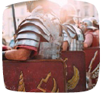 | 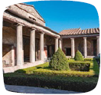 | 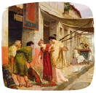 | 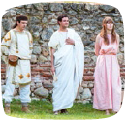 | 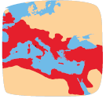 | 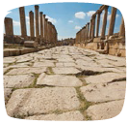
- empire | - Romans | - road | - soldiers | - courtyard | - shop

- Stop and think .
What are typical Portuguese houses like?

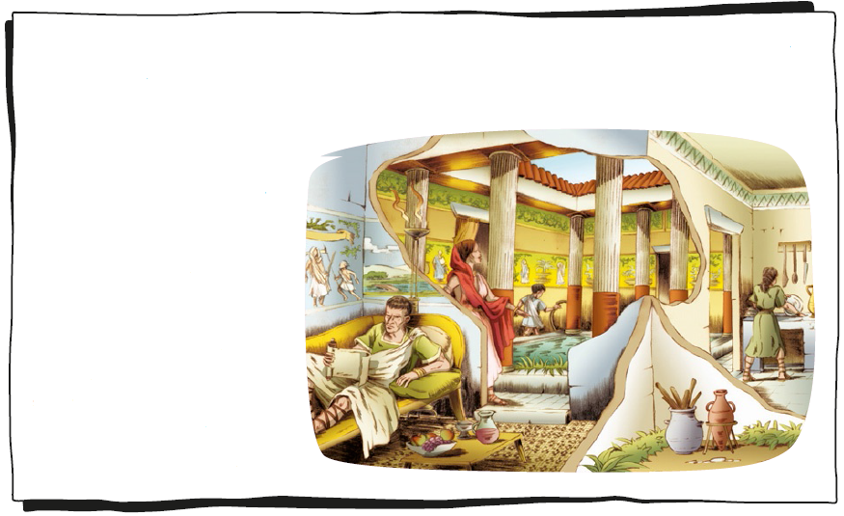
The Romans are from Rome. They have got a big and powerful empire. The Romans
build roads so they can travel between cities in the Roman Empire. They speak Latin
and teach people in the Roman Empire to speak Latin too. They build Roman cities
and houses. Poor people
live in an apartment-like
building called an insulae.
Rich people live in a big
and beautiful Roman house
called a domus. A domus
has got a door from the
street that opens into a
courtyard called an atrium.
The back of a Roman house
is called a peristyle and it
has got toilets, kitchens,
shops and rooms for slaves.

- Read and write Yes or No.
- A domus is a Roman house. _________
- Poor people live in a domus. _________
- A domus has got a courtyard. _________
- There are shops in a domus. _________
- The kitchens and toilets are at the front of a domus. _________
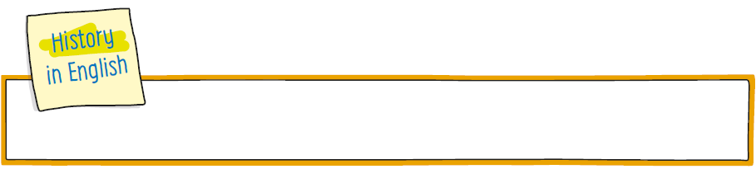
CLIL worksheet
Unit 4 A typical day on board a caravel

Name: ______________________________________________________________ Class: 5 _____

- Look and match .

 | 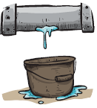 | 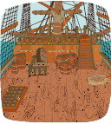 |  | 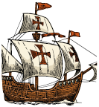 | 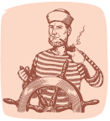
- caravel | - sailor | - pump | - leak | - deck | - rope

- Stop and think .
What are the typical tasks of a sailor?

- Read and write the words in the boxes in the gaps below.
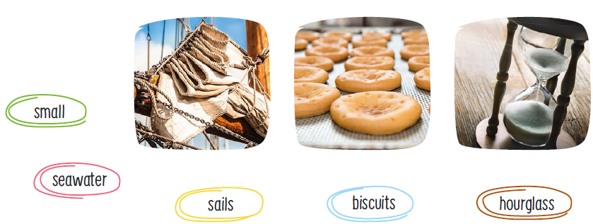
Life on board a caravel is hard. The ship is a._________ and crowded. There are
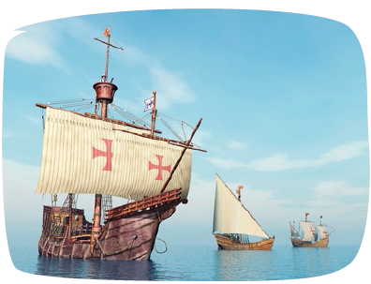
groups of sailors called a “watch”. Each watch works for four hours and then rests.
There is a ship boy who controls the time
with an b._________. Every day sailors
pump the c._________ out of the ship
because all wooden boats leak a bit. Then,
they scrub the decks and move the sails.
Next, they mend the d._________ and
ropes. The crew only eats one meal every
day because there isn’t a lot of food on
board. They usually eat old e._________
and fish and ordinary sailors always sleep on
the open deck.
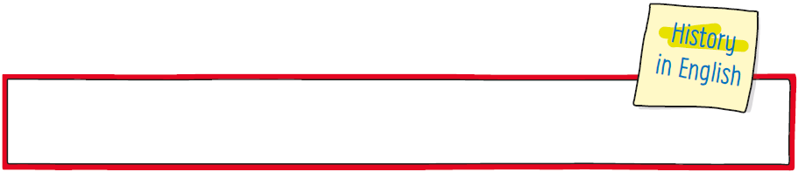
CLIL worksheet
Unit 5 A noble’s free time activities

Nome: ______________________________________________________________ Class: 5 _____

- Look and match .

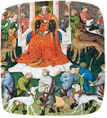 | 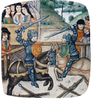 | 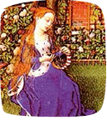 | 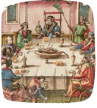 | 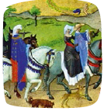 | 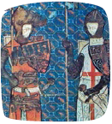
- embroidery | - horseback  riding | - hounds | - jousting | - knights | - feasts

- Stop and think .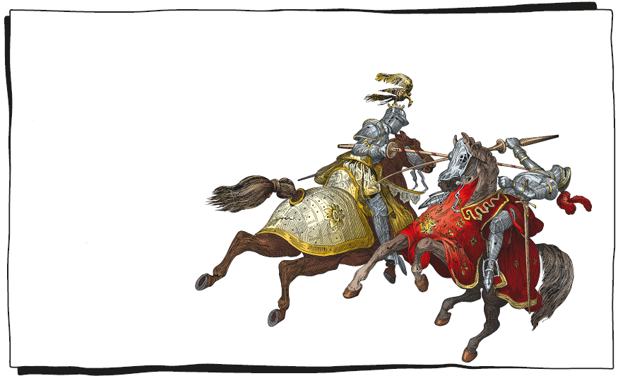
It’s the Middle Ages. Nobles have fun in many ways. Noble ladies read, write poetry,
embroider and play musical instruments. All nobles love to go horseback riding and
hunting. This helps them train to fight their
enemies. They ride their horses and use hounds
and hawks to help them hunt wild animals like
deer and foxes. They also like to watch the
knights jousting. They think
jousting is very exciting
and that knights are
very brave! In the
evenings, they play cards
and throw big feasts
with lots of food and
music. Nobles love to
dance and have fun
just like we do!
- Read and write True (T) or False (F).
- Nobles have lots of fun. _________
- Noble ladies don’t embroider. _________
- Noble ladies don’t go hunting. _________
- Jousting is a popular activity in the Middle Ages. _________
- Feasts are an important free time activity in the Middle Ages. _________

